**MINISTRY OF EDUCATION AND TRAINING**

**FPT UNIVERSITY**

Capstone Project Document

**iSuperMarket Bot**

|  |  |
| --- | --- |
| **Group 6** | |
| **Group members** | Lê Minh Mẫn – Team Leader – SE61239  Nguyễn Việt Tiến – Team Member – SE61316  Nguyễn Thành Phúc – Team Member - SE61296 |
| **Supervisor** | Mr. Kieu Trong Khanh Kiều Trọng Khánh |
| **Ext. Supervisor** | N/A |
| **Capstone Project code** | ISMB |

-Ho Chi Minh City, Sepetember 2016-

*This page is intentionally left blank*

# Table of Contents

Table of Contents 3

List of Tables 7

List of Figures 12

Definitions, Acronyms, and Abbreviations 17

A. Introduction 18

1. Project Information 18

2. Introduction 18

3. Current Situation in Viet Nam 18

4. Problem Definition 19

5. Proposed Solution 19

5.1. Feature functions 19

5.2. Advantages and disadvantages 20

6. Functional Requirements 20

7. Role and Responsibility 21

B. Software Project Management Plan 22

1. Problem Definition 22

1.1. Name of this Capstone Project 22

1.2. Problem Abstract 22

1.3. Project Overview 22

2. Project Organization 25

2.1. Roles and Responsibilities 25

2.2. Software Process Model 26

2.3. Tools and Techniques 27

3. Project Management Plan 27

3.1. Software development life cycle 27

3.2. Phase Detail 28

3.3. All Meeting Minutes 30

4. Coding Convention 30

C. Software Requirement Specification 32

1. User Requirement Specification 32

1.1. Guest Requirement 32

1.2. Authenticated User Requirement 32

1.3. Administator Requirement 32

1.4. Staff Requirement 32

1.5. ISMB Engine Requirement 32

1.6. Auto Handler Requirement 32

1.7. Scheduler Requirement 32

2. System Requirement Specification 33

2.1. External Interface Requirement 33

2.2. System Overview Use Case 34

2.3. List of Use Cases 35

3. Software System Attribute 86

3.1. Usability 86

3.2. Reliability 87

3.3. Availability 87

3.4. Security 87

3.5. Maintainability 87

3.6. Portability 87

3.7. Performance 87

4. Conceptual Diagram 88

D. Software Design Description 90

1. Design Overview 90

2. System Architectural Design 90

2.1. Terminology 90

2.2. System Architecture Design Level 0 90

2.3. System Architecture Design Level 1 94

2.4. ISMB Engine Architecture Description 98

2.5. Web Application Architecture Description 98

2.6. Web Service Architecture Description 99

2.7. Mobile Application Architecture Description 99

3. Component Diagram 100

4. Detailed Description 102

4.1. Class Diagram 102

4.2. Class Diagram Explanation 104

4.3. Interaction Diagram 111

5. User Interface Design 151

5.1. Component Interface 151

5.2. User Interface Design 153

6. Database Design 202

6.1. Entity Relationship Diagram 202

6.2. Data Dictionary 203

7. Algorithms 203

7.1. AES Encryption 203

7.2. MD5 Hashing 204

7.3. Identify Floor 204

7.4. Calculate Coordinates 206

7.5. Identify Area 212

7.6. Define Synonym Name 214

E. System Implementation & Test 216

1. Introduction 216

1.1. Overview 216

1.2. Test Approach 216

2. Database Relationship Diagram 216

2.1. Physical Diagram 216

2.2. Data Dictionary 217

3. Performance Measures 223

3.1. ISMB Engine Connecting Speed 223

3.2. Mobile Application Detection Speed & Accuracy 224

4. Test Plan 224

4.1. Features to be tested 224

4.2. Features not to be tested 224

5. System Testing Test Case 225

5.1. Communication Diagram 226

5.2. Test cases 227

F. Software User’s Manual 233

1. Installation Guide 233

1.1. Setting up environment at server side 233

1.2. Deployment at Server Side 233

1.3. Deployment at Client Side 235

2. User Guide 237

2.1. ISMB Engine 237

2.2. Mobile Application for Customer 237

2.3. Mobile Application for Staff 243

2.4. Web Application 250

G. Appendix 270

# List of Tables

Table 1 - Roles and Responsibility 21

Table 2 - Hardware Requirement for Server 24

Table 3 - Hardware Requirement for Mobile 24

Table 4 - Hardware Requirement for Estimote Beacon 25

Table 5 - Software Requirements for Development 25

Table 6 - Roles and Responsibilities Details 26

Table 7 - Tools and Techniques 27

Table 8 - Software Development Life Cycle Detail 28

Table 9 - Phase 1: Requirement Analysis 29

Table 10 - Phase 2: Design 29

Table 11 - Phase 3: Implementation 29

Table 12 - Phase 4: Testing 29

Table 13 - Phase 5: Maintenance 30

Table 14 - Conceptual Diagram Data Dictionary 89

Table 15 - Components Diagram Data Dictionary 101

Table 16 - Class Diagram Data Dictionary 104

Table 17 - Category class attributes explanation 104

Table 18 - Category class methods explanation 104

Table 19 - Promotion class attributes explanation 104

Table 20 - Promotion class methods explanation 104

Table 21 - Floor class attributes explanation 104

Table 22 - Floor class methods explanation 105

Table 23 - Area class attributes explanation 105

Table 24 - Area class methods explanation 105

Table 25 - Beacon class attributes explanation 105

Table 26 - Beacon class methods explanation 105

Table 27 - Product class attributes explanation 106

Table 28 - Product class methods explanation 106

Table 29 - Customer class attributes explanation 106

Table 30 - Customer class methods explanation 106

Table 31 - Device Token class attributes explanation 107

Table 32 - Device Token class methods explanation 107

Table 33 - History class attributes explanation 107

Table 34 - History class methods explanation 107

Table 35 - Category_Product class attributes explanation 107

Table 36 - Category_Product class methods explaination 107

Table 37 - WeightedHistory class attributes explanation 108

Table 38 - WeightedHistory class methods explanation 108

Table 39 - Promotion_Product class attributes explanation 108

Table 40 - Promotion_Product class methods explanation 108

Table 41 - Relating Product class attributes explanation 108

Table 42 - Relating Product class methods explanation 108

Table 43 - Area_Beacon class attributes explanation 109

Table 44 - Area_Beacon class methods explanation 109

Table 45 - Synonym class attributes explanation 109

Table 46 - Synonym class methods explanation 109

Table 47 - Employee class attributes explanation 109

Table 48 - Employee class methods explanation 110

Table 49 - Role class attributes explanation 110

Table 50 - Role class methods explanation 110

Table 51 - Status class attributes explanation 110

Table 52 - Status class methods explanation 110

Table 53 - Chat Log class attributes explanation 110

Table 54 - Chat Log class methods explanation 111

Table 55 - Component Interface 152

Table 56 - <Mobile Application for Customer> Login Buttons/Hyperlinks 153

Table 57 - <Mobile Application for Customer> Insert Phone Number Fields 154

Table 58 - <Mobile Application for Customer> Insert Phone Number Buttons/Hyperlinks 154

Table 59 - <Mobile Application for Customer> Menu Fields 155

Table 60 - <Mobile Application for Customer> Menu Buttons/Hyperlinks 155

Table 61 - <Mobile Application for Customer> View Cart Fields 156

Table 62 -<Mobile Application for Customer> View Cart Buttons/Hyperlinks 156

Table 63 - <Web Application for Customer> Change Phone Number Fields 157

Table 64 - <Web Application for Customer> Change Phone Number Buttons/Hyperlinks 157

Table 65 - <Mobile Application for Customer> View Location Fields 158

Table 66 - <Mobile Application for Customer> View Location Buttons/Hyperlinks 158

Table 67 - <Mobile Application for Customer> Notify Nearby Product Fields 159

Table 68 - <Mobile Application for Staff> Login Fields 160

Table 69 - <Mobile Application for Staff> Login Buttons/Hyperlinks 160

Table 70 - <Mobile Application for Staff> Beacon Management Fields 161

Table 71 - <Mobile Application for Staff> Beacon Management Buttons/Hyperlinks 162

Table 72 - <Mobile Application for Staff> Add Beacon Fields 163

Table 73 - <Mobile Application for Staff> Add Beacon Buttons/Hyperlinks 163

Table 74 - <Mobile Application for Staff> Update Beacon Fields 164

Table 75 - <Mobile Application for Staff> Update Beacon Buttons/Hyperlinks 165

Table 76 - <Mobile Application for Staff> Area Management Fields 165

Table 77 - <Mobile Application for Staff> Area Management Buttons/Hyperlinks 166

Table 78 - <Mobile Application for Staff> Add Area Fields 167

Table 79 - <Mobile Application for Staff> Add Area Buttons/Hyperlinks 167

Table 80 - <Mobile Application for Staff> Update Area Fields 168

Table 81 - <Mobile Application for Staff> Update Area Buttons/Hyperlinks 169

Table 82 - <Web Application> Login Fields 169

Table 83 - <Web Application > Login Buttons/Hyperlinks 169

Table 84 - <Web Application> Account Management Fields 170

Table 85 - <Web Application> Account Management Buttons/Hyperlinks 170

Table 86 - <Web Application> Add Account Fields 171

Table 87 - <Web Application > Add Account Buttons/Hyperlinks 171

Table 88 - <Web Application> Deactivate Account Buttons/Hyperlinks 172

Table 89 - <Web Application> Activate Account Buttons/Hyperlinks 173

Table 90 - <Web Application> Update Profile Fields 173

Table 91 - <Web Application> Update Profile Buttons/Hyperlinks 173

Table 92 - <Web Application> Beacon Management Fields 174

Table 93 - <Web Application> Beacon Management Fields 174

Table 94 - <Web Application> Delete Beacon Buttons/Hyperlinks 175

Table 95 - <Web Application> Product Management Fields 175

Table 96 - <Web Application> Product Management Buttons/Hyperlinks 176

Table 97 - <Web Application> Add Product Fields 176

Table 98 - <Web Application> Add Products Buttons/Hyperlinks 177

Table 99 - <Web Application> Update Product Fields 177

Table 100 - <Web Application> Update Product Buttons/Hyperlinks 178

Table 101 - <Web Application> View Product Details Fields 178

Table 102 - <Web Application> View Product Details Buttons/Hyperlinks 179

Table 103 - <Web Application> Relation Porduct Fields 179

Table 104 - <Web Application> Relation Product Buttons/Hyperlinks 180

Table 105 - <Web Application> Import Products From Excel Fields 180

Table 106 - <Web Application> Import Products From Excel Buttons/Hyperlinks 180

Table 107 - <Web Application> Deactivate Product Buttons/Hyperlinks 181

Table 108 - <Web Application> Activate Product Buttons/Hyperlinks 182

Table 109 - <Web Application> Area Management Fields 182

Table 110 - <Web Application> Area Management Buttons/Hyperlinks 182

Table 115 - <Web Application> Delete Area Buttons/Hyperlinks 183

Table 116 - <Web Application> Promotion Management Fields 184

Table 117 - <Web Application> Promotion Management Buttons/Hyperlinks 184

Table 118 - <Web Application> Add Promotion Fields 185

Table 119 - <Web Application> Add Promotion Buttons/Hyperlinks 185

Table 120 - <Web Application> Update Promotion Fields 186

Table 121 - <Web Application> Update Promotion Buttons/Hyperlinks 186

Table 122 - <Web Application> Delete Promotion Buttons/Hyperlinks 187

Table 123 - <Web Application> Promotion Items Management Fields 187

Table 124 - <Web Application> Promotion Items Management Fields 188

Table 125 - <Web Application> Floor Management Fields 188

Table 126 - <Web Application> Floor Management Buttons/Hyperlinks 189

Table 127 - <Web Application> Add Floor Fields 189

Table 128 - <Web Application> Add Floor Buttons/Hyperlinks 189

Table 129 - <Web Application> Update Floor Fields 190

Table 130 - <Web Application> Update Floor Buttons/Hyperlinks 190

Table 131 - <Web Application> Delete Floor Buttons/Hyperlinks 191

Table 132 - <Web Application> Category Management Fields 192

Table 133 - <Web Application> Category Management Buttons/Hyperlinks 192

Table 134 - <Web Application> Add Category Fields 192

Table 135 - <Web Application> Add Category Buttons/Hyperlinks 193

Table 136 - <Web Application> Update Category Fields 193

Table 137 - <Web Application> Update Category Buttons/Hyperlinks 193

Table 138 - <Web Application> Delete Category Buttons/Hyperlinks 194

Table 139 - <Web Application> Original Word Management Fields 195

Table 140 - <Web Application> Original Word Management Buttons/Hyperlinks 195

Table 141 - <Web Application> Add Orignal Word Fields 195

Table 142 - <Web Application> Add Original Word Buttons/Hyperlinks 196

Table 143 - <Web Application> Update Original Word Fields 196

Table 144 - <Web Application> Update Original Word Buttons/Hyperlink 196

Table 145 - <Web Application> Delete Original Word Buttons/Hyperlinks 197

Table 146 - <Web Application> Synonym Management Fields 198

Table 147 - <Web Application> Synonym Management Buttons/Hyperlinks 198

Table 148 - <Web Application> Add Synonym Fields 198

Table 149 - <Web Application> Add Synonym Buttons/Hyperlinks 199

Table 150 - <Web Application> Update Synonym Fields 199

Table 151 - <Web Application> Update Synonym Buttons/Hyperlinks 199

Table 152 - <Web Application> Delete Synonym Buttons/Hyperlinks 200

Table 153 - <Web Application> Log Management Fields 201

Table 154 - <Web Application> Log Management Buttons/Hyperlinks 201

Table 155 - <Web Application> Delete Log Buttons/Hyperlinks 201

Table 156 - Entity Relationship Diagram Data Dictionary 203

Table 157 - Physical Diagram Data Dictionary 218

Table 158 – Attributes Data Dictionay 223

Table 159 – Chat with ISMB Server speed test cases 223

Table 160 - ISMB Engine Connecting Speed Test Result 223

Table 161 – Mobile Application Area Detection Speed & Accuracy Test Result 224

Table 162 - ISMB Enginge Test Cases 232

Table 163 – Mobile Application Test Cases 232

Table 164 - <Customer> Login by Facebook Account UG 237

Table 165 - <Customer> Enter Phone Number UG 238

Table 166 - <Customer> View Cart UG 239

Table 167 - <Customer> Change Phone Number UG 240

Table 168 - <Customer> View Location UG 241

Table 169 - <Customer> Notify Nearby Product UG 242

Table 170 - <Staff> Login UG 243

Table 171 - <Staff> Manage Beacon UG 244

Table 172 - <Staff> Add Beacon UG 245

Table 173 - <Staff> Update Beacon UG 246

Table 174 - <Staff> Manage Area UG 247

Table 175 - <Staff> Add Area UG 248

Table 176 - <Staff> Update Area UG 249

Table 177 - <Admin> Manage Account UG 250

Table 178 - <Admin> Add Account UG 251

Table 179 - <Admin> Deactivate Account UG 251

Table 180 - <Admin> Activate Account UG 252

Table 181 - <Admin/Staff> Update Profile UG 252

Table 182 - <Staff> Manage Beacon UG 253

Table 183 - <Staff> Delete Beacon UG 253

Table 184 - <Staff> Manage Product UG 254

Table 185 - <Staff> Add Product UG 254

Table 186 - <Staff> Update Product UG 255

Table 187 - <Staff> Deactivate Product UG 256

Table 188 - <Staff> Activate Product UG 256

Table 189 - <Staff> Mapping Retaling Product UG 257

Table 190 - <Staff> Import Data UG 257

Table 191 - <Staff> Mange Area UG 258

Table 194 - <Staff> Delete Area UG 258

Table 195 - <Staff> Manage Promotion UG 259

Table 196 - <Staff> Add Promotion UG 259

Table 197 - <Staff> Update Promotion UG 260

Table 198 - <Staff> Delete Promotion UG 261

Table 199 - <Staff> Add Items For Promotion UG 261

Table 200 - <Staff> Manage Floor UG 262

Table 201 - <Staff> Manage Floor UG 262

Table 202 - <Staff> Update Floor UG 263

Table 203 - <Staff> Delete Floor UG 263

Table 204 - <Staff> Manage Category UG 264

Table 205 - <Staff> Add Category UG 264

Table 206 - <Staff> Update Category UG 265

Table 207 – <Staff> Manage Original Word UG 265

Table 208 - <Staff> Add Original Word UG 266

Table 209 - <Staff> Update Original Word UG 266

Table 210 - <Staff> Delete Original Word UG 267

Table 211 - <Staff> Manage Synonym UG 267

Table 212 - <Staff> Add Synonym UG 268

Table 213 - <Staff> Update Synonym UG 268

Table 214 - <Staff> Delete Synonym UG 269

# List of Figures

Figure 1 - Modified Waterfall Development Model 27

Figure 2 - System Overview Usecase 35

Figure 3 - <Guest> Overview Use Cases 36

Figure 4 - <Guest> Login UCD 36

Figure 5 - < Authenticated User> Overview Use Cases 37

Figure 6 - <Authenticated User > Update Profile UCD 37

Figure 7 - <Authenticated User > Logout UCD 38

Figure 8 - <Admin> Overview Use Cases 39

Figure 9 - < Admin> Create Account UCD 39

Figure 10 - < Admin> Deactivate Account UCD 41

Figure 11 - <Admin> Activate Account UCD 42

Figure 12 - <Staff> Overview Use Cases 44

Figure 13 - <Staff> Add Product UCD 45

Figure 14 - <Staff> Update Product UCD 46

Figure 15 - <Staff> Import Data UCD 48

Figure 16 - <Staff> Deactivate Product UCD 49

Figure 17 - <Staff> Activate Product UCD 51

Figure 18 - <Staff> Mapping Relating Products UCD 52

Figure 19 - <Staff> Delete Mapped Relating Products 53

Figure 20 - <Staff> Add Promotion UCD 54

Figure 21 - <Staff> Update Promotion UCD 56

Figure 22 - <Staff> Delete Promotion UCD 57

Figure 23 - <Staff> Add Product For Promotion UCD 58

Figure 24 - <Staff> Remove Product from Promotion UCD 60

Figure 25 - <Staff> Add Information UCD 61

Figure 26 - <Staff> Update Information UCD 64

Figure 27 - <Staff> Delete Information UCD 68

Figure 28 - <Staff> Delete Log UCD 70

Figure 29 - <Staff> Add Original Word UCD 71

Figure 30 - <Staff> Update Original Word UCD 72

Figure 31 - <Staff> Delete Original Word UCD 74

Figure 32 - <Staff> Add Synonym UCD 75

Figure 33 -<Staff> Update Synonym UCD 76

Figure 34 - <Staff> Delete Synnonym UCD 78

Figure 35 - <Customer> Overview Use Cases 79

Figure 36 - <Customer> Insert Phone UCD 79

Figure 37 - <Customer> Change Phone UCD 80

Figure 38 - <Scheduler> Overview Use Cases 81

Figure 39 - <Scheduler> Train by Synonyms UCD 81

Figure 40 - <Auto Hanlder> Overview Use Cases 83

Figure 41 - <Auto Handler> Indentify Floor UCD 83

Figure 42 - <Auto Handler> Indentify Area UCD 84

Figure 43 - <Auto Handler> Detect Product UCD 86

Figure 44 - Conceptual Diagram 89

Figure 45 - System Architecture Design Level 0 – Part 1 92

Figure 46 - System Architecture Design Level 0 – Part 2 93

Figure 47 - System Architecture Design Level 0 – Part 3 93

Figure 48 - System Architecture Design Level 0 – Part 4 94

Figure 49 - System Architecture Desgin Level 1 – ISMB Engine 95

Figure 50 - System Architecture Design Level 1 – Web Application – Part 1 96

Figure 51 - System Architecture Design Level 1 – Web Application – Part 2 96

Figure 52 - System Architecture Design Level 1 – Web Service 97

Figure 53 - System Architecture Design Level 1 – Mobile Application – Part 1 97

Figure 54 - System Architecture Design Level 1 – Mobile Application – Part 2 98

Figure 55 - System Architecture Design Level 1 – Mobile Application – Part 3 98

Figure 56 - System Architecture Design Level 1 – Mobile Application – Part 4 99

Figure 57 – Component Diagram 101

Figure 58 - Class Diagram 103

Figure 59 - <ISMB Enginge> Process with api – Interaction diagram 112

Figure 60 - <Staff> Import Data SD 113

Figure 61 - <Staff> Insert Product SD 114

Figure 62 - <Staff> Update Product UI 115

Figure 63 - <Staff> Deactivate Product SD 116

Figure 64 - <Staff> Activate Product SD 117

Figure 65 - <Staff> Mapping Relating Products SD 118

Figure 66 - <Staff> Delete Mapping between Products SD 119

Figure 67 - <Staff> Insert Promotion SD 120

Figure 68 - <Staff> Update Promotion SD 121

Figure 69 - <Staff> Delete Promotion SD 122

Figure 70 - <Staff> Mapping Product with Promotion 123

Figure 71 - <Staff> Delete Mapping between Product and Promotion 124

Figure 72 - <Staff> Insert Original Word SD 125

Figure 73 - <Staff> Update Original Word 126

Figure 74 - <Staff> Delete Original Word 127

Figure 75 - <Staff> Insert Synonym SD 128

Figure 76 - <Staff> Update Synonym SD 129

Figure 77 - <Staff> Delete Synonym SD 130

Figure 78 - <Staff> Insert Beacon AD 131

Figure 79 - <Staff> Insert Area AD 132

Figure 80 - <Staff> Insert Category SD 133

Figure 81 - <Staff> Insert Floor SD 134

Figure 82 - <Staff> Update Beacon AD 135

Figure 83 - <Staff> Update Area AD 136

Figure 84 - <Staff> Update Category SD 137

Figure 85 - <Staff> Update Floor SD 138

Figure 86 - <Staff> Delete Beacon SD 139

Figure 87 - <Staff> Delete Area SD 140

Figure 88 - <Staff> Delete Category SD 141

Figure 89 -<Staff> Delete Floor SD 142

Figure 90 - <Staff> Delete Log SD 143

Figure 91 - <Admin> Create Acount SD 144

Figure 92 - <Admin> Activate/Deactive Account 145

Figure 93 - <Scheduler> Train by Synonym SD 146

Figure 94 - <Customer> Insert Phone AD 147

Figure 95 - <Customer> Change Phone AD 148

Figure 96 - <Auto Handler> Indentify Floor AD 149

Figure 97 - <Auto Handler> Indentify Area 150

Figure 98 - <Auto Handler> Detect Product AD 151

Figure 99 - Login UI 154

Figure 100 - Insert Phone Number UI 155

Figure 101 - Menu UI 156

Figure 102 - View Cart UI 157

Figure 103 - Change Phone Number UI 158

Figure 104 - View Location UI 159

Figure 105 - Notify Nearby Product UI 160

Figure 106 – Login UI 161

Figure 107 - Beacon Management UI 162

Figure 108 - Add Beacon UI 163

Figure 109 - Update Beacon UI 165

Figure 110 - Area Management UI 166

Figure 111 - Add Area UI 167

Figure 112 - Update Area UI 169

Figure 113 - Login UI 170

Figure 114 - Account Management UI 171

Figure 115 - Add Account UI 172

Figure 116 - Deactivate Account UI 173

Figure 117 - Activate Account UI 173

Figure 118 - Update Profile UI 174

Figure 119 - Beacon Management UI 175

Figure 120 - Delete Beacon UI 175

Figure 121 - Product Management UI 176

Figure 122 - Add Product UI 177

Figure 123 - Update Product UI 178

Figure 124 - View Product Details UI 179

Figure 125 - Relation Product UI 180

Figure 126 – Import Products From Excel UI 181

Figure 127 - Deactive Product UI 182

Figure 128 – Activate Product UI 182

Figure 129 - Area Management UI 183

Figure 132 - Delete Area UI 184

Figure 133 - Promotion Management UI 184

Figure 134 - Add Promotion UI 185

Figure 135 - Update Promotion UI 186

Figure 136 - Delete Promotion UI 187

Figure 137 - Promotion Items Management 188

Figure 138 - Floor Management UI 189

Figure 139 - Add Floor UI 190

Figure 140 - Update Floor UI 191

Figure 141 - Delete Floor UI 192

Figure 142 - Category Management UI 192

Figure 143 - Add Category UI 193

Figure 144 - Update Category UI 194

Figure 145 Delete Category UI 195

Figure 146 - Original Word Management UI 195

Figure 147 - Add Orignal Word UI 196

Figure 148 - Update Original Word UI 197

Figure 149 - Delete Original Word UI 198

Figure 150 - Synonym Management UI 198

Figure 151 - Add Synonym UI 199

Figure 152 - Update Synonym UI 200

Figure 153 - Delete Synonym UI 201

Figure 154 - Log Management UI 201

Figure 155 - Delete Log UI 202

Figure 156 – Entity Relationship Diagram 203

Figure 157 – Detect Floor Beacons Arrangement 206

Figure 158 - Detect Floor Flowcart 207

Figure 159 – Ax axis rotation 209

Figure 160 - Intersection of 3 spheres 210

Figure 161 – Calculate Coordinate Flowchart 212

Figure 162 - Area Arrangement 213

Figure 163 - Customer in an Area 214

Figure 164 - Identify Area Flowchart 214

Figure 165 - Define Synonym Name Flow Chart 216

Figure 166 – Physical Diagram 218

Figure 167 - Communication Diagram 227

Figure 168 - <Customer> Login by Facebook Account UG 238

Figure 169 - <Customer> Enter Phone Number UG 239

Figure 170 - <Customer> View Cart UG 240

Figure 171 - <Customer> Change Phone Number UG 241

Figure 172 - <Customer> View Location UG 242

Figure 173 - <Customer> Notify Nearby Product UG 243

Figure 174 - <Staff> Login UG 244

Figure 175 - <Staff> Manage Beacon UG 245

Figure 176 - <Staff> Add Beacon UG 246

Figure 177 - <Staff> Update Beacon UG 247

Figure 178 - <Staff> Manage Area UG 248

Figure 179 - <Staff> Add Area UG 249

Figure 180 - <Staff> Update Area UG 250

Figure 181 - < Admin > Manage Account UG 251

Figure 182 - <Admin> Add Account UG 251

Figure 183 - <Admin> Deactivate Account UG 252

Figure 184 - <Admin> Activate Account UG 252

Figure 185 - <Admin/Staff> Update Profile UG 253

Figure 186 - <Staff> Manage Beacon UG 253

Figure 187 - <Staff> Delete Beacon UG 254

Figure 188 - <Staff> Manage Product UG 254

Figure 189 - <Staff> Add Product UG 255

Figure 190 - <Staff> Update Product UG 256

Figure 191 - <Staff> Deactivate Product UG 257

Figure 192 - <Staff> Activate Product UG 257

Figure 193 - <Staff> Mapping Relating Product UG 257

Figure 194 - <Staff> Import Data UG 258

Figure 195 - <Staff> Manage Area UG 258

Figure 198 - <Staff> Delete Area UG 259

Figure 199 - <Staff> Manage Promotion UG 259

Figure 200 - <Staff> Add Promotion UG 260

Figure 201 - <Staff> Update Promotion UG 261

Figure 202 - <Staff> Delete Promotion UG 261

Figure 203 - <Staff> Add Items For Promotion UG 262

Figure 204 - <Staff> Manage Floor UG 262

Figure 205 - <Staff> Manage Floor UG 263

Figure 206 - <Staff> Update Floor UG 263

Figure 207 - <Staff> Delete Floor UG 264

Figure 208 - <Staff> Manage Category UG 264

Figure 209 - <Staff> Add Category UG 265

Figure 210 - <Staff> Update Category UG 265

Figure 211 - <Staff> Delete Category UG 266

Figure 212 - <Staff> Delete Category UG 266

Figure 213 - <Staff> Manage Original Word UG 266

Figure 214 - <Staff> Add Original Word UG 267

Figure 215 - <Staff> Update Original Word UG 267

Figure 216 - <Staff> Delete Original Word UG 268

Figure 217 - <Staff> Manage Synonym UG 268

Figure 218 - <Staff> Add Synonym UG 269

Figure 219 - <Staff> Update Synonym UG 269

Figure 220 - <Staff> Delete Synonym UG 270

# Definitions, Acronyms, and Abbreviations

|  |  |
| --- | --- |
| **Name** | **Definition** |
| ISMB | iSuperMarket Bot |
| BOM | Board of Management |
| BLE | Bluetooth Less Energy |
| DAO | Data Access Object |
| NLP | Natural Language Processing |
| Webhook | HTTP Callback (Real time update) that enables apps to subscribe to changes in certain pieces of data and receive updates in real time. When a change occurs, an HTTP POST request will be sent to a callback URL belonging to that app. |
| Phrases | Groups of words that is part of, rather than the whole of, a sentence |
| Entities | The collections of words and phrases that has relating meaning. |
| Synonyms | Words that have the same meaning |

# Introduction

## Project Information

Project name: iSuperMarket Bot

• Project Code: ISMB

• Product Type: Web Application & Engine

• Start Date: 5-Sep-2016

• End Date: 12-Dec-2016

## Introduction

The supermarket is large and have huge amounts of products. Although the products are divided into categories, but it's still difficult for customers to locate where the products are held. In additional, the information on the products are usually printed in small texts, which is not easy to read. The last to mention is about the promotion. The customers cannot be active to search for which promotions are appropriate for themselves.

iBeacon is a new innovative technology, which allows mobile device to listen to the signal from the Estimote Beacons, then determine the location of the beacons on a micro local scale. The beacons can also deliver full information that it contains.

Another technology is the Messenger Platform of Facebook API. This API is suitable to build a bot that can answer messages automatically and intelligently. By using Facebook Messenger, users can ask for information about the products and receive the answer immediately. The bot can be trained to be more intelligent.

After the research, we found out that iBeacon technology and Message Platform of Facebook API would be a great combination to solve for our idea. We will build a chat bot based on Facebook Messenger. This bot can tell users the location of products. When users come near to that product, our system will notify the users and also give them the information about that product, such as price, expiry date and appropriate promotions, etc.

We hope that our solution will help the users, especially housewives, the most convenient way of shopping.

## Current Situation in Viet Nam

Because of the variety of products in the supermarket, finding a product is a problem to the customers. People always take a lot of time moving around to find the products they need at the supermarket. Another way is to ask the staffs for the product. Either asking the staffs or moving around have its own advantages. For example, customers can meet many kinds of products then widening their choices. But for the busy customers, these methods are wasting time. Our idea may help them shopping in a more convienient way.

On the other hand, customers have no way to know if the products they want are sold in the supermarket or not, unless they come directly to the supermarket. They always need to go to the supermarket and consider what to buy.

The supermarket is using only text or pictures for their advertisement, which is not intuitive and effective.

## Problem Definition

Below are disadvantages of the current situation:

* **Cost wasting:** the supermarket must have a call center to solve customers’ demands. It wastes time and human resources.
* **Information is overview:** due to the huge number of customers. The supermarket staff just can provide the information in a brief way, but lack of usage instructions, so that the customers may not know how to use the products.
* **Lack/wrong information:** supermarket has a lot of promotions, but customers unable to fully update the information, so that they may miss the promotions that appropriate to their needs.

## Proposed Solution

Our proposed solution is to build a system named “ISMB”. The application support user when they find location of products base on combining smartphone devices and iBeacon. It helps users to have the newest information promotion. The application uses chat bot engine integrating with Messenger Platform, which can suggest for users find products depend on their demand and read the origin of the product and more (such as the expired date, the brand, …). The application also train bot to make it more intelligent

ISMB system includes a web application and android mobile application with following functions:

### Feature functions

* Web application (for admin and staff):
* Manage product: User can insert, update or delete information relating to products.
* Manage area User can manage areas by manipulating areas’ information
* Manage promotion: User can insert, update or delete information relating to promotions.
* Manage category: User can insert, update or delete information relate to categories.
* Manage beacon: User can manage beacon by manipulating beacon information.
* Train bot: insert, update, delete synonyms.
* Engine bot:
* Use api.ai: Connect with api.ai to understand nature language when user ask.
* Use Facebook Messenger Platform: Send and response message combine api.ai.
* Send the information about product, their location in supermarket and also the promotions of the supermarket through Facebook Messenger platform.
* Mobile application (for customer):
* Detect users are in which area in the supermarket based on beacons
* Notify users when their devices are nearby their needed products based on beacons.
* Mobile application (for staff):
* Manage beacon: insert and update information of beacon.
* Manage area: insert and update information of area.

### Advantages and disadvantages

* *Advantages*
* Reduce time to find a location of items but still ensure business, users need to reply their clients request, the bot can do it automatically the natural language syntax of the users that wants to ask information about the product location when they go to supermarket.
* The application allows the users can see all the information of products when they approach nearly.
* *Disadvantages*
* Smartphone must always have both Bluetooth and internet connection to get data from iBeacons.
* User need to train the system manually, it can not learn by it-self yet.
* Run on Facebook, that is also our disadvantage. This is we totally depend on this platform and can not run in others social network.

## Functional Requirements

Function requirements of the system are listed as below:

* Staff component:
* Manage information: User can insert, update or delete information relate to product in supermarket.
* Manage area: User can insert, update or delete information relate to area in supermarket.
* Manage category: User can insert, update or delete information relate to category of product.
* Manage promotion: User can insert, update or delete information relate to promotion of the supermarket.
* Manage synonym: User can insert, update or delete information relate to synonym for training bot.
* Manage log: Information log for training bot.
* Manage beacon: manipulate the information of the Beacons.
* Update profile.
* Admin component:
* Create staff account.
* Update profile.
* Enging Bot component:
* Connect with Google Vision Api to detect product in images.
* Connect with Api.ai and FPT Vietnamese Accentizer to process natural language.
* Reply message through Facebook Messenger platform.
* Send the information about product, their location in supermarket and also the promotions of the supermarket through Facebook Messenger platform.
* Mobile component:
* Detect users are in which area in the supermarket based on beacon.
* Notify users when their devices are nearby their needed products based on beacon.

## Role and Responsibility

|  |  |  |  |  |
| --- | --- | --- | --- | --- |
| No | Full Name | Role | Position | Contact |
| 1 | Kieu Trong Khanh | Project Manager | Instructor | khanhkt@fpt.edu.vn |
| 2 | Le Minh Man | Developer | Leader | manlmse61239@.fpt.edu.vn |
| 3 | Nguyen Viet Tien | Developer | Member | tiennvse61316@fpt.edu.vn |
| 4 | Nguyen Thanh Phuc | Developer | Member | phucntse61296@fpt.edu.vn |

Table 1 - Roles and Responsibility

# Software Project Management Plan

## Problem Definition

### Name of this Capstone Project

* Official Name: iSuperMarket Bot.
* Vietnamese Name: Chatbot hỗ trợ đi siêu thị thông minh.
* Abbreviation: ISMB.

### Problem Abstract

We provide a system that can answer automatically the natural language syntax of users that wants to know information about the products and find products’ location when they go to the supermarket. Our system also allows users to preview and be suggested about promotions of the supermarket.

However, at starting point, there are some problems for developing our system:

* iBeacon and Messenger Platform is new technologies for us, it takes a lot of time to study SDK and API.
* The newest official SDK of Estimote Beacon is not stable, sometimes it causes the application to crash.
* According to Estimote Beacon’s document, it categorizes the beacons into 4 **proximity zones** (<http://developer.estimote.com/ibeacon/tutorial/part-3-ranging-beacons/#proximity-estimation>). But it does not provide the exact proximity zones in number. Therefore, we must test to determine the zones.
* We use Messenger Platform to build a bot that can answer users’ questions. But Messenger Platform does not support processing natural language. Therefor, we must combine it with Api.ai, a framework which can help processing natural language.
* Api.ai does not support machine learning for Vietnamese, so we must define by ourselves.

### Project Overview

#### Current Situation

Below are the problems encountered in this project:

* **New technologies**: Because the projcect uses Estimote Beacon and Messgenger Platform, we must study SDK and API to apply them.
* **Unclear document**: Due to the unclear Estimote Beacon’s documents, we must do some tests to determine the proximity zones.
* **Lack of syntax**: We cannot cover all syntax of Vietnamese language.
* **Vietnamese language:** Api.ai does not support official machine learning for Vietnamese, so we have to define by ourselves.

#### The Proposed System

The system is intended for users to preview the information of products that corresponse to their needs and promotions of the supermarket through Facebook Messenger. The system also shows the products’ location to users and take adavantages of iBeacon to notify them when they are nearby the products in the supermarket.

##### Website

BOM website is a place that users can monitors, configures, manipulates data and training bot.

* *For Admin:*
  + Manage account for staff.
* *For Staff;*
  + Manage products.
  + Manage promotions.
  + Manage areas.
  + Manage categories.
  + Manage logs to training bot.
  + Manage synonym to training bot.
  + Manage beacons.

##### Engine Bot

* Process image using Google Vision Api.
* Process natural language from customer using FPT Vietnamese Accentizer and Api.ai framework. Convert the sentence into word entities, understand it as an request of customer and give back the customer a suitable response.
* Can study the synonym of existed entities when the ownsers train for bot.
* Processing with messenger platform, engine can send and receive message with structure and handle many type of message from text message, attachment,…

##### Web Service

* Update data for mobile application
* Sync data between mobile application and server.

##### Mobile Application

* *For Customers****:***
* Detect users are in which areas in the supermarket.
* Notify users when they’re near their needed products.
* *For Staff****:***
* Manage beacons.
* Manage areas.

#### Boundaries of the System

* The system can be used by anyone with a Android devices which supports Bluetooth v4.0 BLE and has internet connection.
* The language of system is Vietnamese.
* The complete product includes:
* The engine bot combines Facebook Messenger Platform, Google Vision Api, FPT Vietnamese Accentizer and Api.ai which can process image and natural language, and transfer response message to help customers preview information about products, products’ location in the supermarket and promotions of the supermarket.
* A web application to manage information and training bot.
* A mobile application for customer to detect customers’ are in which area and notify when customers are nearby their needed products.
* A moile application for staff to manage beacons and areas.

#### Future Plans

* Build our own chat mobile application.
* Running on multiple platforms (iOS).
* Speech can be combined with google api support Vietnamese and many languages.
* System will apply machine learning to make bot learn by themselves.
* Deploy ISMB system to multiple supermarkets.

#### Development Environment

##### Hardware requirements

**For Server**

|  |  |  |
| --- | --- | --- |
| **Windows** | **Minimum Requirements** | **Recommended** |
| **Internet Connection** | Cable, Wi-Fi (4 Mbps) | Cable, Wi-Fi (8 Mbps) |
| **Operating System** | Window Server 2008 | Window Server 2012 R2 |
| **Computer Processor** | Intel® Xeon ® 1.4GHz | Intel® Xeon ® Quad Core  (12M Cache, 2.50 GHz) |
| **Computer Memory** | 1GB RAM | 2GB or more |

Table 2 - Hardware Requirement for Server

**For Mobile**

|  |  |  |
| --- | --- | --- |
| **Mobile** | **Minimum Requirements** | **Recommended** |
| **Internet Connection** | 2 Mbps | 4 Mbps |
| **Operating System** | Android 4.4: Kitkat | Android 5.5.1: Lolipop |
| **Hardware** | Bluetooth 4.0 | Bluetooth 4.0 |
| **Memory** | 150MB | 150MB or more |

Table 3 - Hardware Requirement for Mobile

**For Estimote Beacon**

| **Name** | **Description** |
| --- | --- |
| **Identification (model number etc.)** | Estimote model REV.D3.4 Radio Beacon |
| **Frequency range** | 2400 Mhz to 2483.5 Mhz |
| **No. of preset switchable channels** | 40 |
| **No. of voice/data/TV channels** | 40 Data channels  (including 3 advertising channels) |
| **Tx-Rx channel separation** | 2 Mhz |
| **Adjacent channel separation** | 2 Mhz |
| **Frequency stability** | <20ppm |
| **2nd Harmonic radiation's** | <25 dBuV |
| **Mode of emission** | not more than 20 DB |
| **Bandwidth of emission** | 500 KHz |
| **Type of modulation to be required** | GFSK |
| **Power output** | 4 dBm |
| **Sensitivity** | -93 dBm |
| **CPU** | 32-bit ARM® Cortex M0 |
| **Flash memory** | 256 kB |

Table 4 - Hardware Requirement for Estimote Beacon

Reference:

<https://community.estimote.com/hc/en-us/articles/204092986-Technical-specification-of-Estimote-Beacons-and-Stickers>

##### Software requirements

|  |  |  |
| --- | --- | --- |
| **Software** | **Name/Version** | **Description** |
| Modeling tool | Start UML 5.0 | Used to implement website, web service and bot engine |
| IDE | IntelliJ 2016.2  Android Studio 2.2 | Programming tools |
| DBMS | MySQL 5.7.11 | Used to create and manage database for the system |
| Source Control | SourceTree 1.9.6.1 | Used for source control |
| Web Browser | Chrome 47 or above | Testing browser |
| Testing OS | Android 5.5.1: Lolipop | Testing client operating system |

Table 5 - Software Requirements for Development

## Project Organization

### Roles and Responsibilities

| **No** | **Full name** | **Role in Group** | **Responsibilities** |
| --- | --- | --- | --- |
| **1** | Kiều Trọng Khánh | Project manager | * Specify user requirement * Control the development process * Give out technique and business analysis support |
| **2** | Lê Minh Mẫn | Team Leader, BA, DEV, Tester | * Managing process * Clarifying requirements * Prepare documents * GUI Design * Designing database * Coding * Create test plan * Testing |
| **3** | Nguyễn Việt Tiến | Team Member, BA, DEV, Tester | * Clarifying requirements * Prepare documents * GUI Design * Designing database * Coding * Create test plan * Testing |
| **4** | Nguyễn Thành Phúc | Team Member, BA, DEV, Tester | * Clarifying requirements * Prepare documents * GUI Design * Designing database * Coding * Create test plan * Testing |

Table 6 - Roles and Responsibilities Details

### Software Process Model

Project is developed under modified waterfall model (SASHIMI)

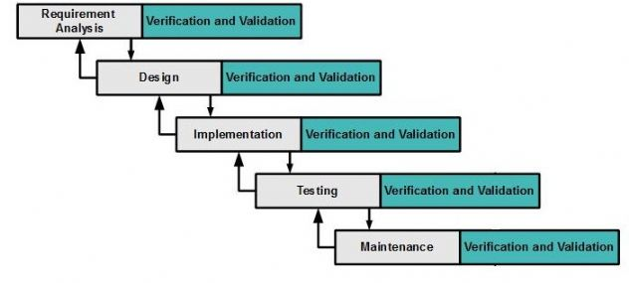

Figure 1 - Modified Waterfall Development Model

For more information: <http://www.waterfall-model.com/sashimi-waterfall-model/>

Explaination: We use Modified Waterfall Development Model for our project development because:

* Business is clear and can be implemented.
* We need to have output documents following school’s schcedule.
* Architecture design which is made from Design phase may be changed during Implementation phase because some of delelopment supporting features of Android, Messenger Platform and iBeacon may be known during the implementation, and it may change the architecture.
* Some functions may be updated or changed during Implentation phase, requiring design document should be updated.
* Some funtions may need to be updated during Testing phase.

### Tools and Techniques

|  |  |
| --- | --- |
| **Tool / Technique** | **Name /version** |
| **Front-end IDE** | Android Studio 2.2 |
| **Back-end IDE** | IntelliJ 2016.2 |
| **Front-end technology** | HTML5, CSS, JavaScript, JQuery, Ajax, Android |
| **Back-end technology** | Java 1.8, Spring 4.2.3, Api.ai 2.0.3, Facebook Graph api 2.6 |
| **Managing database** | MySQL 5.7.11 |
| **Managing the project** | SourceTree 1.9.6.1 |
| **Managing documents, reports, models and diagrams** | Microsoft Office 2016 |

Table 7 - Tools and Techniques

## Project Management Plan

### Software development life cycle

| **Phase** | **Description** | **Deliverables** | **Resource needed** | **Dependencies and**  **Constrains** | **Risks** |
| --- | --- | --- | --- | --- | --- |
| **Requirement Analysis** | - Collect requirements from customer.  -Identify and clarify requirements for the system in general. | -Introduction of proposed system.  -Software requirement specification.  -Project Task Plan.  - Prototypes | 20 man- days | N/A | - Missing requirement  - Unclear scope of  project  - Lack of member share  of understand |
| **Design** | - Architecture design for the system  - Detail design using top-down break down  - Choose Architecture style | - Software Design Document  - Base code structure  - Technology notes | 20 man- days | Depend on  “Requirement  Analysis” | - Lack of experience.  - Not fulfil requirement. |
| **Implementation** | - Coding system core functions and other features with GUI  - Unit test | - Main user’s functions on mobile and website | 50 man- days | Depend on “Design”. | - Lack of experience and knowledge.  - Human mistake. |
| **Testing** | - Integration test the system  - Alpha test  - Correct bugs  - Beta test  - Acceptance test | - Test document | 20 man- days | Depend on  “Implementation” | - Lack of experience  - Missing test case |
| **Maintenance** | - Deploy on sever and mobile | - Installation guide.  - User Manual  - User Manual | 10 man- days | Depend on  “Testing” | - Lack of experience. |

Table 8 - Software Development Life Cycle Detail

### Phase Detail

#### Phase 1: Requirement Analysis

| **Task** | **Description** | **Author** |
| --- | --- | --- |
| **1. Collect requirements** | Find which systems currently provide similar service, their strengths and weakness. | ManLM, TienNV, PhucNT |
| **2. Identify and clarify main functions.** | Define which main functions system should provide. | ManLM, TienNV, PhucNT |
| **3. Create System**  **Introduction.** | Complete Introduction Report. | PhucNT |
| **4. Software Project**  **Management Plan.** | Prepare Project Management Plan. | ManLM |
| **5. Prototype.** | Build a prototype of proposed system (Website/Mobile). | ManLM, TienNV, PhucNT, |
| **6. SRS** | Create SRS document. | ManLM, TienNV, PhucNT |

Table 9 - Phase 1: Requirement Analysis

#### Phase 2: Design

| **Task** | **Description** | **Author** |
| --- | --- | --- |
| **1. Detailed Design** | Compare new document with existed documents of system. | ManLM, TienNV, PhucNT |
| **2. Database Design** | Based on parsed data to recommendation.  Based on other needs to recommendation. | ManLM, TienNV, PhucNT |
| **3. Technology research** | Study Messenger Platform  Study Api.ai  Study Beacon SDK | ManLM, TienNV, PhucNT |
| **4. Design Document** | Create software design document | ManLM, TienNV, PhucNT |

Table 10 - Phase 2: Design

#### Phase 3: Implementation

|  |  |  |
| --- | --- | --- |
| **Task** | **Description** | **Author** |
| 1. **ISMB Engine functions** | Implement function of ISMB Engine | ManLM, TienNV |
| **2. Front-end web functions** | Implement front-end functions on web | ManLM, TienNV, PhucNT |
| **3. Back-end web functions** | Implement back-end functions on web | ManLM, TienNV, PhucNT |
| **4. Mobile functions** | Implement mobile application | ManLM, PhucNT |
| **5. Unit testing** | Write test case and testing for web functions | TienNV |
| Write test case and testing for mobile functions | PhucNT |

Table 11 - Phase 3: Implementation

#### Phase 4: Testing

|  |  |  |
| --- | --- | --- |
| **Task** | **Description** | **Author** |
| **1. Integration testing** | Write test case and testing systems | ManLM, TienNV, PhucNT |
| **2. Alpha testing** | Do alpha test with customer | ManLM, TienNV, PhucNT |

Table 12 - Phase 4: Testing

#### Phase 5: Maintenance

|  |  |  |
| --- | --- | --- |
| **Task** | **Description** | **Author** |
| **1. Installation guide** | Write installation guide | ManLM |
| **2. User Manual** | Write user manual | TienNV, PhucNT |

Table 13 - Phase 5: Maintenance

### All Meeting Minutes

* <https://github.com/manlmwork/meeting-minutes> (Security: Must be a member of GitHub Repository).

## Coding Convention

Java: Using to develop website and web service.

Android: Using to develop mobile application. Because team choose android native to develop the mobile application so the coding convention is based on Java.

Summary:

* *Naming Convention:*
* Variable name should be short yet meaningful. If the name is more than one word, it must be in mixed case, starting word with a lowercase. -Constants name should be all uppercase with words separated by underscores.
* Methods name should be verbs, in mixed case with the first word lowercase, the first letter of each internal word capitalized.
* Class name should be nouns, in mixed case with the first letter of each internal word capitalized.
* *Package and import statements:*
* Package statement is the first non-comment line.
* Import statement is after package statement.
* *Constant:*
* Numerical constants should not be coded directly.
* *Variable Assignments:*
* Avoid assigning several variables to the same value in a single statement.
* *Comments:*
* Using /* */ for block comments.
* Using // for line comments.
* *Return statements*:
* A return statement with a value should not use parentheses.
* Using Java coding convention from:

<http://www.oracle.com/technetwork/java/codeconvtoc-136057.html>

* Using Android codding convention form:

<https://source.android.com/source/code-style.html>

References:

**Code Conventions for the Java TM Programming Language**

Revised April 20, 1999

[http://www.oracle.com/technetwork/java/codeconvtoc](http://www.oracle.com/technetwork/java/codeconvtoc-136057.html)-[136057.html](http://www.oracle.com/technetwork/java/codeconvtoc-136057.html)

# Software Requirement Specification

## User Requirement Specification

### Guest Requirement

* Login: guest uses username and password to login into the system to become staff or admin and use some functions based on role after login.
* Guest also is the person who can chat with Facebook Messenger which is processed by ISMB Engine.

### Authenticated User Requirement

* Logout: when finish all activities at website staff and admin can log out of the system.
* Update profile.

### Administator Requirement

* Provide account for staff.

### Staff Requirement

* Manage information of system such as Product, Promotion, Category, Area, Floor, Beacon and Synonym.
* Check log.

### ISMB Engine Requirement

ISMB is an engine support to send/receive message to Facebook and using Api.ai framework to process natural language. ISMB can show products’ information and promotions following customers’ demand. ISMB engine has following function:

* Handle message of user from Webhooks.
* Handle response from Api.ai.
* Handle response from FPT Vietnamese Accentizer.
* Handle respone from Google Vision Api.

### Auto Handler Requirement

* Detect customers are in which floor of the supermarket.
* Detect customers are in which area in the supermarket
* Detect nearby products to notify customers.

### Scheduler Requirement

* Train bot more intelligent by knowing synonyms.

## System Requirement Specification

### External Interface Requirement

#### User Interface

* Use English on website and Vietnamese on Mobile application.

#### Hardware Interface

* Android smartphone supports Bluetooth 4.0 low energy.
* Estimote beacons (<http://estimote.github.io/Android-SDK/JavaDocs>).

#### Software Interface

* Facebook Messenger Platform.
* Api.ai.
* Estimote SDK.
* Google Vision Api.
* Fpt Vietnamese Accentizer.

#### Communication Protocol

* Use HTTP protocol 1.1 for communication between the web browser and the web server.
* Use HTTP protocol 1.1 for communication between the mobile application and the web server.
* Use Bluetooth 4.0 (BLE - Bluetooth Less Energy) protocol for communication between the estimate beacons with the mobile application.
* Use HTTPS protocol 1.1 for communication between Facebook Messenger and the Webhook server (Engine).

### System Overview Use Case

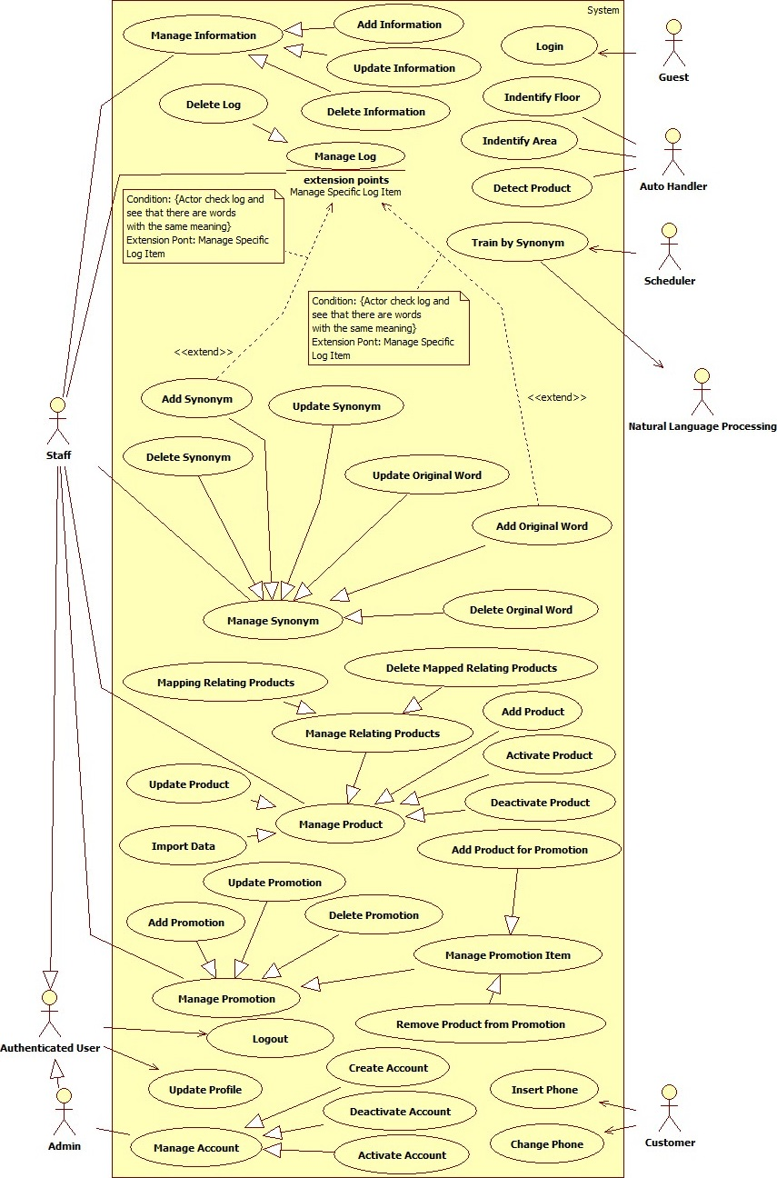

Figure 2 - System Overview Usecase

### List of Use Cases

#### <Guest> Overview Use Cases

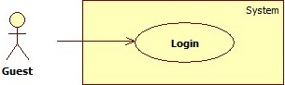

Figure 3 - <Guest> Overview Use Cases

##### <Guest> Login <UC_01>

**Use Case Diagram**



Figure 4 - <Guest> Login UCD

**Use Case Specification**

|  |  |  |  |
| --- | --- | --- | --- |
| **USE CASE – UC_01** | | | |
| **Use Case No.** | 01 | **Use Case Version** | 1.0 |
| **Use Case Name** | Login | | |
| **Author** | PhucNT | | |
| **Date** | 06/09/2016 | **Priority** | Normal |
| **Actor:**   * Guest   **Summary:**   * This use case allows guest to log in to system.   **Goal:**   * System authenticates is actor a member of the system, from there authorizes actor to use functions based on role.   **Triggers:**   * Guest sends command to login to system.   **Preconditions:** N/A  **Postconditions:**   * **Success**: Guest logged in the system. * **Fail**: Show error message.   **Main Success Scenario:**   |  |  |  | | --- | --- | --- | | **Step** | **Actor Action** | **System Response** | | 1 | Guest sends login command. | System authenticates and authorizes account.  [Alternative 1] |   **Alternatives Scenario:**   | **No** | **Actor Action** | **System Response** | | --- | --- | --- | | 1 | Guest inputs wrong username or password | System shows message ““Invalid username or password!” |   **Exceptions:** N/A  **Relationships:**  N/A  **Business Rules:**   * When actor send login command, system authenticates username and password:   + Password is md5 hashed. * If username and password is correct, system authorizes username belong to which role and redirect to appropriate view. | | | |

#### <Authenticated User> Overview Use Cases

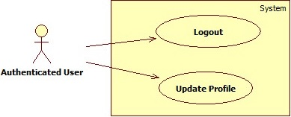

Figure 5 - < Authenticated User> Overview Use Cases

##### <Authenticated User> Update Profile <UC_02>

**Use Case Diagram**

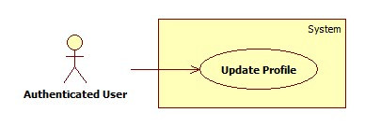

Figure 6 - <Authenticated User > Update Profile UCD

**Use Case Specification**

|  |  |  |  |
| --- | --- | --- | --- |
| **USE CASE – UC_02** | | | |
| **Use Case No.** | 02 | **Use Case Version** | 1.0 |
| **Use Case Name** | Update profile | | |
| **Author** | PhucNT | | |
| **Date** | 06/09/2016 | **Priority** | Normal |
| **Actor:**   * Authenticated User   **Summary:**   * This use case allows actor to update their profile.   **Goal:**   * System updates actor’s profile in storage.   **Triggers:**   * Actor sends command to view profile.   **Preconditions:**   * Actor must be an authenticated user in system.   **Post Conditions:**   * **Success:** User profile was updated. * **Fail:** Error message is displayed.   **Main Success Scenario:**   |  |  |  | | --- | --- | --- | | **Step** | **Actor Action** | **System Response** | | 1 | Actor sends command to view profile. | Show form to update user profile:   * “Phone”: text input, contain user’s phone, length [10, 11], required. | | 2 | Actor sends command to update profile. | System validates information.  Update new informantion into storage.  [Exception 1] |   **Alternative Scenario:** N/A  **Exceptions:**   |  |  |  | | --- | --- | --- | | **No** | **Cause** | **System Response** | | 1 | Missing required fields. | System shows error message to ask user  input missing required fields. |   **Relationships:**  N/A  **Business Rules:**   * Account’s information will be updated in the system with inputted information. * Phone must have 10 or 11 digits, each digit must be a number from 0 to 9. | | | |

##### <Authenticated User> Logout <UC_03>

**Use Case Diagram**

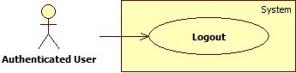

Figure 7 - <Authenticated User > Logout UCD

**Use Case Specification**

|  |  |  |  |
| --- | --- | --- | --- |
| **USE CASE – UC_03** | | | |
| **Use Case No.** | 03 | **Use Case Version** | 1.0 |
| **Use Case Name** | Logout | | |
| **Author** | PhucNT | | |
| **Date** | 06/09/2016 | **Priority** | Normal |
| **Actor:**   * Authenticated User   **Summary:**   * This use case allows actor to log out of the system.   **Goal:**   * System removes user’s session.   **Triggers:**   * Actor sends command to log out of the system.   **Preconditions:**   * User logged in the system.   **Postconditions:**   * Success: User’s session was removed. * Fail: N/A.   **Main Success Scenario:**   |  |  |  | | --- | --- | --- | | **Step** | **Actor Action** | **System Response** | | 1 | Actor sends command to logout. | Check if user’s session exists.  Removes current session of user.  Redirect to login view. |   **Alternative Scenario:** N/A  **Exception:** N/A  **Relationships:**  N/A  **Business Rules:**   * After log out of system, user will have “Guest” role and need to log in again to use system’s function. | | | |

#### <Admin> Overview Use Cases

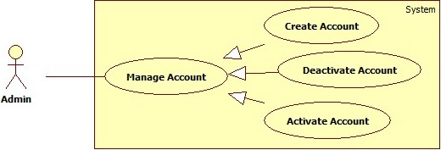

Figure 8 - <Admin> Overview Use Cases

##### <Admin> Create Account <UC_04>

**Use Case Diagram**

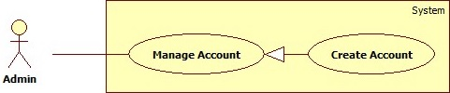

Figure 9 - < Admin> Create Account UCD

**Use Case Specification**

|  |  |  |  |
| --- | --- | --- | --- |
| **USE CASE – UC_04** | | | |
| **Use Case No.** | 04 | **Use Case Version** | 1.0 |
| **Use Case Name** | Create Account | | |
| **Author** | PhucNT | | |
| **Date** | 06/09/2016 | **Priority** | Normal |
| **Actor:**   * Admin   **Summary:**   * This use case allows Admin to create new account.   **Goal:**   * System adds new account into storage.   **Triggers:**   * Admin sends command to create new account.   **Preconditions:**   * User must log in the system with Admin role.   **Post Conditions:**   * **Success:** New account is created. * **Fail:** Error message is displayed.   **Main Success Scenario:**   |  |  |  | | --- | --- | --- | | **Step** | **Actor Action** | **System Response** | | 1 | Admin sends command to view create new account form. | Show form to input new account:   * Username: blank input text, required, length [6,255] * Role: check option, not required (check if that account is admin role). | | 2 | Admin inputs information.  Admin sends command to create new account. | System validates information.  Generates email and password for new account.  Add new account to storage.  [Alternative 1, 2] |   **Alternative Scenario:**   |  |  |  | | --- | --- | --- | | **No** | **Actor Action** | **System Response** | | 1 | Missing required fields. | System shows error message to ask user  input missing required fields. | | 2 | Username is already existed. | Display “Username is already existed!” message. |   **Exceptions:** N/A  **Relationships:**  N/A  **Business Rules:**   * Each username must be unique in the system. * Email is generated with username and “@ISMB.com” domain and unique in system. * Password is generated with 8 random characters. * Password must be hashed with md5. | | | |

##### <Admin> Deactivate Account <UC_05>

**Use Case Diagram**

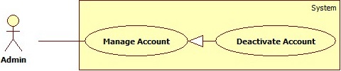

Figure 10 - < Admin> Deactivate Account UCD

**Use Case Specification**

|  |  |  |  |
| --- | --- | --- | --- |
| **USE CASE – UC_05** | | | |
| **Use Case No.** | 05 | **Use Case Version** | 1.0 |
| **Use Case Name** | Deactivate Account | | |
| **Author** | ManLM | | |
| **Date** | 06/09/2016 | **Priority** | Normal |
| **Actor:**   * Admin   **Summary:**   * This use case allows admin to deactivate account.   **Goal:**   * Account’s status is changed to DEACTIVED in storage.   **Triggers:**   * Actor sends command to deactivate account.   **Preconditions:**   * Actor must log in the system with Admin role. * Account’s status is ACTIVED.   **Post Conditions:**   * **Success:** Account’s status was change to DEACTIVED. * **Fail:** Error message is displayed.   **Main Success Scenario:**   |  |  |  | | --- | --- | --- | | **Step** | **Actor Action** | **System Response** | | 1 | Actor sends command to deactivate account.. | System shows confirmation popup. | | 2 | Admin sends command to confirm.  [Alternative 1] | System changes account’s status to DEACTIVED and updates account in storage. |   **Alternative Scenario:**   |  |  |  | | --- | --- | --- | | **No** | **Actor Action** | **System Response** | | 1 | Admin sends command to cancel. | Popup disappear and nothing change. |   **Exceptions:** N/A  **Relationships:**  N/A  **Business Rules:**   * Admin cannot self-deactivate. * Deativated account cannot log in the system. | | | |

##### <Admin> Activate Account <UC_06>

**Use Case Diagram**

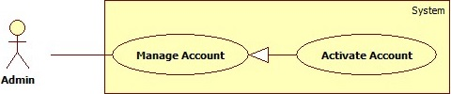

Figure 11 - <Admin> Activate Account UCD

**Use Case Specification**

|  |  |  |  |
| --- | --- | --- | --- |
| **USE CASE – UC_06** | | | |
| **Use Case No.** | 06 | **Use Case Version** | 1.0 |
| **Use Case Name** | Deactivate Account | | |
| **Author** | ManLM | | |
| **Date** | 06/09/2016 | **Priority** | Normal |
| **Actor:**   * Admin   **Summary:**   * This use case allows admin to activate account.   **Goal:**   * Account’s status is changed to ACTIVED in storage.   **Triggers:**   * Actor sends command to activate account.   **Preconditions:**   * Actor must log in the system with Admin role. * Account’s status is DEACTIVED.   **Post Conditions:**   * **Success:** Account’s status was change to ACTIVED. * **Fail:** Error message is displayed.   **Main Success Scenario:**   |  |  |  | | --- | --- | --- | | **Step** | **Actor Action** | **System Response** | | 1 | Actor sends command to activate account. | System shows confirmation popup. | | 2 | Admin sends command to confirm.  [Alternative 1] | System changes account’s status to ACTIVED and updates account in storage. |   **Alternative Scenario:**   |  |  |  | | --- | --- | --- | | **No** | **Actor Action** | **System Response** | | 1 | Admin sends command to cancel. | Popup disappear and nothing change. |   **Exceptions:** N/A  **Relationships:**  N/A  **Business Rules:** N/A | | | |

#### <Staff> Overview Use Cases

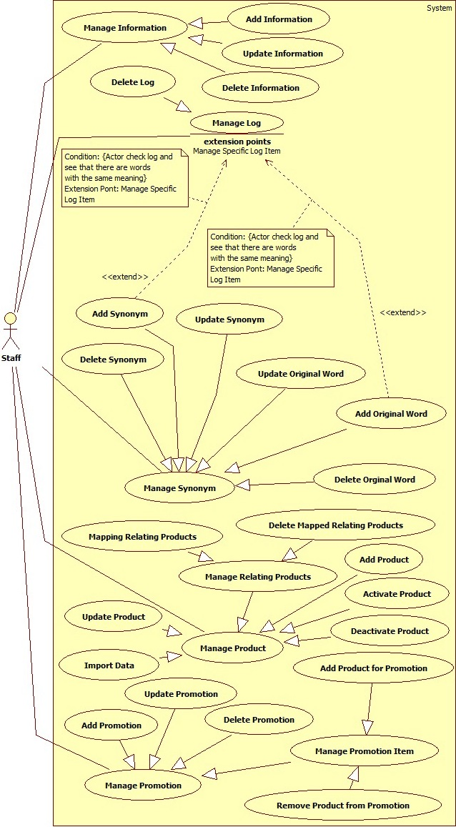

Figure 12 - <Staff> Overview Use Cases

##### <Staff> Add Product <UC_07>

**Use Case Diagram**

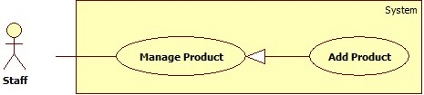

Figure 13 - <Staff> Add Product UCD

**Use Case Specification**

|  |  |  |  |
| --- | --- | --- | --- |
| **USE CASE – UC_07** | | | |
| **Use Case No.** | 07 | **Use Case Version** | 1.0 |
| **Use Case Name** | Add Product | | |
| **Author** | TienNV | | |
| **Date** | 14/09/2016 | **Priority** | Normal |
| **Actor:**   * Staff   **Summary:**   * This use case allows Staff to add new product.   **Goal:**   * To add data of product into system.   **Triggers:**   * Staff sends request to add new product.   **Preconditions:**   * User were authorized access to the system with Staff role.   **Post Conditions:**   * **Success:** New product was inserted to storage. * **Fail:** Error message is displayed.   **Main Success Scenario:**   |  |  |  | | --- | --- | --- | | **No** | **Actor Action** | **System Response** | | 1 | Staff sends command to insert new product. | Show form to input new product, requires the following fields.   * Code: blank text input, required, length [10] * Name: blank text input, required, length [80] * Image: image file, required, maximum size is 3MB. * Price: blank number input, required, range in [0 – 1,000,000,000] * Details: blank text area input, required, length [255] * Area: drop down list able to choose, not required * Category: multiple selection drop down list able to choose, not required. | | 2 | Staff inputs form. |  | | 3 | Staff sends “Add” command.  [Alternative 1] | System inserts product into storage.  [Exception 1]  [Exception 2]  [Exception 3] |   **Alternative Scenario:**   |  |  |  | | --- | --- | --- | | **No** | **Actor Action** | **System Response** | | 1 | Staff sends command cancel their action. | Clear form. |   **Exceptions:**   |  |  |  | | --- | --- | --- | | **No** | **Cause** | **System Response** | | 1 | Missing required fields. | Display message to suggest user input all the required fields. | | 2 | Product code already exists | Display warning message to notify that inputted product code already exists in storage | | 2 | Product name already exists | Display warning message to notify that inputted product name already exists in storage |   **Relationships:**N/A  **Business Rules:**   * Each product’s code must be unique. * Each product’s name must be unique. * Product must be belong to only one area. * Image type: should be JPG or PNG. | | | |

##### <Staff> Update Product <UC_08>

**Use Case Diagram**

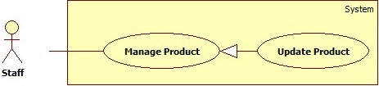

Figure 14 - <Staff> Update Product UCD

**Use Case Specification**

|  |  |  |  |
| --- | --- | --- | --- |
| **USE CASE – UC_08** | | | |
| **Use Case No.** | 08 | **Use Case Version** | 1.0 |
| **Use Case Name** | Update Product | | |
| **Author** | TienNV | | |
| **Date** | 14/09/2016 | **Priority** | Normal |
| **Actor:**   * Staff   **Summary:**   * This use case allows Staff can update product.   **Goal:**   * To correct product information in the system.   **Triggers:**   * Staff sends request to update product.   **Preconditions:**   * User were authorized access to the system with Staff role.   **Post Conditions:**   * **Success:** New product information was updated to storage. * **Fail:** Error message is displayed.   **Main Success Scenario:**   |  |  |  | | --- | --- | --- | | **No** | **Actor Action** | **System Response** | | 1 | Staff send request to update product. | Show product information for actor able to view and edit, it includes following fields:   * Code: text input contains product code, required, length [10] * Name: text input contains product name, required, length [80] * Image: image file, required, maximum size is 3MB. * Price: number input contains product price, required, range in [0 - 1000000000] * Details: blank text input, required, length [255] * Area: drop down list able to choose, not required * Category: multiple selection drop down list able to choose, not required | | 2 | Staff inputs form. |  | | 3 | Staff sends “update” command.  [Alternative 1] | System update product in storage.  [Exception 1]  [Exception 2] |   **Alternative Scenario:**   |  |  |  | | --- | --- | --- | | **No** | **Actor Action** | **System Response** | | 1 | Staff sends command cancel their action. | Clear form. |   **Exceptions:**   |  |  |  | | --- | --- | --- | | **No** | **Cause** | **System Response** | | 1 | Missing required fields. | Display message to suggest user input all the required fields. | | 2 | Product name already exists | Display warning message to notify that inputted name already exists in storage |   **Relationships:** N/A  **Business Rules:**   * Each product’s code must be unique. * Each product’s name must be unique. * Product must be belong to only one area. * Image type: should be JPG or PNG. | | | |

##### <Staff> Import Data <UC_09>

**Use Case Diagram**

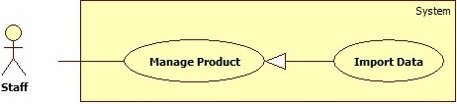

Figure 15 - <Staff> Import Data UCD

**Use Case Specification**

|  |  |  |  |
| --- | --- | --- | --- |
| **USE CASE – UC_09** | | | |
| **Use Case No.** | 09 | **Use Case Version** | 1.0 |
| **Use Case Name** | Import data | | |
| **Author** | TienNV | | |
| **Date** | 07/09/2016 | **Priority** | Normal |
| **Actor:**   * Staff   **Summary:**   * This use case allows Staff to import products from excel file.   **Goal:**   * To add new data of products into storage and update an existing data.   **Triggers:**   * Staff sends request import data.   **Preconditions:**   * User were authorized access to the system with Staff role.   **Post Conditions:**   * **Success:** Data of new products were inserted to storage and data of existing products was updated. Success message will be shown * **Fail:** Error message is displayed.   **Main Success Scenario:**   |  |  |  | | --- | --- | --- | | **Step** | **Actor Action** | **System Response** | | 1 | Staff selects excel file.  Staff send “import data” command. | System read excel file and save data into storage.  [Exception 1] |   **Alternative Scenario: N/A**  **Exceptions:**   |  |  |  | | --- | --- | --- | | **No** | **Actor Action** | **System Response** | | 1 | File is not excel file type. | Display warning message to notify that incorrect file type. |   **Relationships:** N/A  **Business Rules:**   * File import data must be excel file. * Excel template file must be follow format ISMB_Data_Template.xls file.   <https://drive.google.com/open?id=0B1br9KKyTlJPTjlLQjFxTVBCSE0>   * Format of file with each row:   1: Code (String)  2: Name (String)  3: Details (String)  4: Price (number)  5: Category (String)  6: Area name (String)   * Each code must be unique in the system. * Each name must be unique in the system. | | | |

##### <Staff> Deactivate Product <UC_10>

**Use Case Diagram**

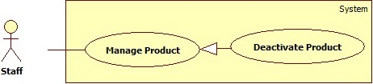

Figure 16 - <Staff> Deactivate Product UCD

**Use Case Specification**

|  |  |  |  |
| --- | --- | --- | --- |
| **USE CASE – UC_10** | | | |
| **Use Case No.** | 10 | **Use Case Version** | 1.0 |
| **Use Case Name** | Deactivate product | | |
| **Author** | TienNV | | |
| **Date** | 08/09/2016 | **Priority** | Normal |
| **Actor:**   * Staff   **Summary:**   * This use case allows Staff can deactivate product.   **Goal:**   * Product’s status is changed to DEACTIVED in storage.   **Triggers:**   * Staff sends request to deactivate product.   **Preconditions:**   * Actor must log in the system with Staff role. * Account’s status is ACTIVED.   **Post Conditions:**   * **Success:** Product’s status was change to DEACTIVED. * **Fail:** Error message is displayed.   **Main Success Scenario:**   |  |  |  | | --- | --- | --- | | **Step** | **Actor Action** | **System Response** | | 1 | Staff chooses product to deactivate.  Staff sends request deactivate product. | System shows confirmation popup. | | 2 | Staff sends command to confirm.  [Alternative 1] | System changes productt’s status to DEACTIVED and updates product in storage. |   **Alternative Scenario:**   |  |  |  | | --- | --- | --- | | **No** | **Actor Action** | **System Response** | | 1 | Staff sends command to cancel. | Popup disappear and nothing change. |   **Exception:** N/A  **Relationships:**  N/A  **Business Rules:**   * Product only change status from active to deactive, product does not remove from system. * Original name and synonyms of product must be removed from api.ai before deactivate product. * Api.ai’s data and system’s data must be synchronous. | | | |

##### <Staff> Activate Product <UC_11>

**Use Case Diagram**

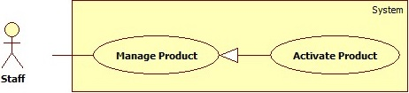

Figure 17 - <Staff> Activate Product UCD

**Use Case Specification**

|  |  |  |  |
| --- | --- | --- | --- |
| **USE CASE – UC_11** | | | |
| **Use Case No.** | 11 | **Use Case Version** | 1.0 |
| **Use Case Name** | Activate product | | |
| **Author** | TienNV | | |
| **Date** | 08/09/2016 | **Priority** | Normal |
| **Actor:**   * Staff   **Summary:**   * This use case allows Staff can activate product.   **Goal:**   * Product’s status is changed to ACTIVED in storage.   **Triggers:**   * Staff sends request to activate product.   **Preconditions:**   * Actor must log in the system with Staff role. * Account’s status is ACTIVED.   **Post Conditions:**   * **Success:** Product was activated into the system. * **Fail:** Error message is displayed.   **Main Success Scenario:**   |  |  |  | | --- | --- | --- | | **Step** | **Actor Action** | **System Response** | | 1 | Staff choose product to activate.  Staff send request activate product. | System shows confirmation popup. | | 2 | Staff sends command to confirm.  [Alternative 1] | System changes productt’s status to ACTIVED and updates product in storage. |   **Alternative Scenario:**   |  |  |  | | --- | --- | --- | | **No** | **Actor Action** | **System Response** | | 1 | Staff cancel action activate product. | Popup disappear and nothing change. |   **Exception:** N/A  **Relationships:**  N/A  **Business Rules:**   * Original name and synonyms of product must be added again into api.ai before activate product. * Api.ai’s data and system’s data must be synchronous. | | | |

##### <Staff> Mapping Relating Products <UC_12>

**Use Case Diagram**

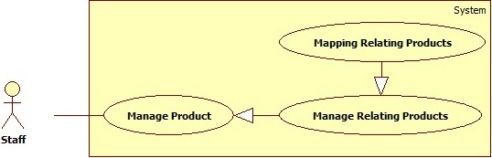

Figure 18 - <Staff> Mapping Relating Products UCD

**Use Case Specification**

|  |  |  |  |
| --- | --- | --- | --- |
| **USE CASE – UC_12** | | | |
| **Use Case No.** | 12 | **Use Case Version** | 1.0 |
| **Use Case Name** | Add relating product | | |
| **Author** | TienNV | | |
| **Date** | 08/09/2016 | **Priority** | Normal |
| **Actor:**   * Staff   **Summary:**   * This use case allow staff to add relating products for each product.   **Goal:**   * Help customer to have extra suggest products from initial product.   **Triggers:**   * Staff sends add relating product commands.   **Preconditions:**   * User were authorized access to the system with Staff role.   **Postconditions:**   * **Success:** Initial product has extra a suggest product. * **Fail:** Error message is displayed.   **Main Success Scenario:**   |  |  |  | | --- | --- | --- | | **Step** | **Actor Action** | **System Response** | | 1 | Staff sends add relating product command | System adds relationship between products. |   **Alternative Scenario:** N/A  **Exception:** N/A  **Relationships:**  N/A  **Business Rules:**   * Deactivated products must not be visible to user. | | | |

##### <Staff> Delete Mapped Relating Products <UC_13>

**Use Case Diagram**

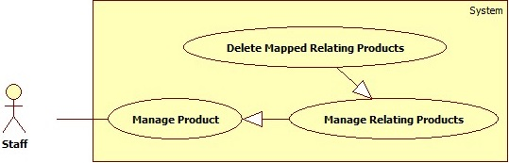

Figure 19 - <Staff> Delete Mapped Relating Products

**Use Case Specification**

|  |  |  |  |
| --- | --- | --- | --- |
| **USE CASE – UC_13** | | | |
| **Use Case No.** | 13 | **Use Case Version** | 1.0 |
| **Use Case Name** | Delete relating product | | |
| **Author** | TienNV | | |
| **Date** | 08/09/2016 | **Priority** | Normal |
| **Actor:**   * Staff   **Summary:**   * This use case allow staff to delete relating product for each product.   **Goal:**   * Delete incorrect relationship between products.   **Triggers:**   * Staff sends delete relating product commands.   **Preconditions:**   * User were authorized access to the system with Staff role.   **Postconditions:**   * **Success**: Initial product delete a suggest product. * **Fail:** Error message is displayed.   **Main Success Scenario:**   |  |  |  | | --- | --- | --- | | **Step** | **Actor Action** | **System Response** | | 1 | Staff sends delete relating product command | System deletes relationship between products. |   **Alternative Scenario:** N/A  **Exception:** N/A  **Relationships:**  N/A  **Business Rules:**   * Deactivated products must not be visible to user. | | | |

##### <Staff> Add Promotion <UC_14>

**Use Case Diagram**

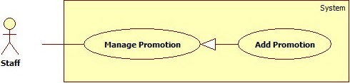

Figure 20 - <Staff> Add Promotion UCD

**Use Case Specification**

|  |  |  |  |
| --- | --- | --- | --- |
| **USE CASE – UC_14** | | | |
| **Use Case No.** | 14 | **Use Case Version** | 1.0 |
| **Use Case Name** | Add Promotion | | |
| **Author** | TienNV | | |
| **Date** | 14/09/2016 | **Priority** | Normal |
| **Actor:**   * Staff   **Summary:**   * This use case allows Staff to add new promotion.   **Goal:**   * Help customers to know new promotion of supermarket.   **Triggers:**   * Staff sends request to add new promotion.   **Preconditions:**   * User were authorized access to the system with Staff role.   **Post Conditions:**   * **Success:** New promotion was inserted to storage. * **Fail:** Error message is displayed.   **Main Success Scenario:**   |  |  |  | | --- | --- | --- | | **No** | **Actor Action** | **System Response** | | 1 | Staff sends command to insert new promotion. | Show form to input new promotion, requires the following fields.   * Name: blank text input, required, length [80] * Discount rate: blank number input, required, range in [0 - 100] * Details: blank text input, required, length [160] * Start: blank date input, required * End: blank date input, required | | 2 | Staff inputs form. |  | | 3 | Staff sends “Add” command.  [Alternative 1] | System inserts promotion into storage.  [Exception 1]  [Exception 2] |   **Alternative Scenario:**   |  |  |  | | --- | --- | --- | | **No** | **Actor Action** | **System Response** | | 1 | Staff sends command cancel their action. | Clear form. |   **Exception:**   |  |  |  | | --- | --- | --- | | **No** | **Cause** | **System Response** | | 1 | Missing required fields. | Display message to suggest user input all the required fields. | | 2 | End date is sooner than start date | Display warning message to notify that end date must be later than start date |   **Relationships:** N/A  **Business Rules:**   * Promotion should have start date and end date in the future. * End date must be later than start date. * If the promotion does not involve discount, discount rate must be input as 0. | | | |

##### <Staff> Update Promotion <UC_15>

**Use Case Diagram**

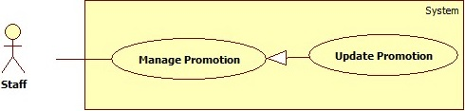

Figure 21 - <Staff> Update Promotion UCD

**Use Case Specification**

|  |  |  |  |
| --- | --- | --- | --- |
| **USE CASE – UC_08** | | | |
| **Use Case No.** | 08 | **Use Case Version** | 1.0 |
| **Use Case Name** | Update promotion | | |
| **Author** | TienNV | | |
| **Date** | 14/09/2016 | **Priority** | Normal |
| **Actor:**   * Staff   **Summary:**   * This use case allows Staff to update promotion.   **Goal:**   * To correct promotion information IN the system.   **Triggers:**   * Staff sends request to update promotion.   **Preconditions:**   * User were authorized access to the system with Staff role.   **Post Conditions:**   * **Success:** New promotion information was updated to storage. * **Fail:** Error message is displayed.   **Main Success Scenario:**   |  |  |  | | --- | --- | --- | | **No** | **Actor Action** | **System Response** | | 1 | Staff send request to update promotion. | Show promotion information for actor able to view and edit, it includes following fields:   * Name: text input contains promotion’s name, required, length [80] * Discount rate: number input contains promotion’s discount rate, required, range in [0 - 100] * Details: text input contains promotion’s details, required, length [160] * Start: date input contains promotion’s start date, required * End: date input contains promotion’s end date, required | | 2 | Staff inputs form. |  | | 3 | Staff sends “update” command.  [Alternative 1] | System update promotion in storage.  [Exception 1]  [Exception 2] |   **Alternative Scenario:**   |  |  |  | | --- | --- | --- | | **No** | **Actor Action** | **System Response** | | 1 | Staff sends command cancel their action. | Clear form. |   **Exception:**   |  |  |  | | --- | --- | --- | | **No** | **Cause** | **System Response** | | 1 | Missing required fields. | Display message to suggest user input all the required fields. | | 2 | End date is sooner than start date | Display warning message to notify that end date must be later than start date |   **Relationships:** N/A  **Business Rules:**   * Promotion should have start date and end date in the future. * End date must be later than start date. * If the promotion does not involve discount, discount rate must be input as 0. | | | |

##### <Staff> Delete Promotion <UC_16>

**Use Case Diagram**

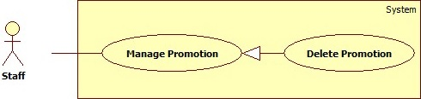

Figure 22 - <Staff> Delete Promotion UCD

**Use Case Specification**

|  |  |  |  |
| --- | --- | --- | --- |
| **USE CASE – UC_16** | | | |
| **Use Case No.** | 16 | **Use Case Version** | 1.0 |
| **Use Case Name** | Delete Promotion | | |
| **Author** | TienNV | | |
| **Date** | 14/09/2016 | **Priority** | Normal |
| **Actor:**   * Staff   **Summary:**   * This use case allows Staff to delete promotion.   **Goal:**   * To remove incorrect promotion.   **Triggers:**   * Staff sends request to delete promotion.   **Preconditions:**   * The user was authorized access to the system with Staff role.   **Post Conditions:**   * **Success:** Promotion was deleted in storage. * **Fail:** Error message is displayed.   **Main Success Scenario:**   |  |  |  | | --- | --- | --- | | **Step** | **Actor Action** | **System Response** | | 1 | Staff choose promotion to delete.  Staff send request to delete promotion. | System shows the popup for staff to confirm. | | 2 | Staff sends command to confirm.  [Alternative 1] | System deletes promotion in storage. |   **Alternative Scenario:**   |  |  |  | | --- | --- | --- | | **No** | **Actor Action** | **System Response** | | 1 | Staff cancel action delete information. | Popup disappear and nothing change. |   **Exception:** N/A  **Relationships:** N/A  **Business Rules:**   * Related data with the promotion must be deleted first. * Cannot delete promotions which have end date sooner than current date. | | | |

##### <Staff> Add Product For Promotion <UC_17>

**Use Case Diagram**

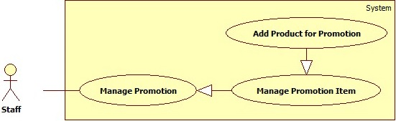

Figure 23 - <Staff> Add Product For Promotion UCD

**Use Case Specification**

|  |  |  |  |
| --- | --- | --- | --- |
| **USE CASE – UC_17** | | | |
| **Use Case No.** | 17 | **Use Case Version** | 1.0 |
| **Use Case Name** | Add product for promotion | | |
| **Author** | TienNV | | |
| **Date** | 08/09/2016 | **Priority** | Normal |
| **Actor:**   * Staff   **Summary:**   * This use case allow staff to add product for promotion.   **Goal:**   * Help customer to know which products are having promotion.   **Triggers:**   * Staff sends add product for promotion commands.   **Preconditions:**   * User were authorized access to the system with Staff role.   **Postconditions:**   * **Success**: Product will be added in this promotion. * **Fail:** Error message is displayed.   **Main Success Scenario:**   |  |  |  | | --- | --- | --- | | **Step** | **Actor Action** | **System Response** | | 1 | Staff selects products in multiple selection drop down. |  | | 2 | Staff sends add product for promotion command. | System adds relationship between products and promotion.  [Exception 1] |   **Alternative Scenario:** N/A  **Exceptions:**   |  |  |  | | --- | --- | --- | | **No** | **Cause** | **System Response** | | 1 | Missing required multiple selection drop down field. | Display message to suggest user select products in the multiple selection drop down required field. |   **Relationships:**  N/A  **Business Rules:**   * Deactivated products must not be visible to user. * Added products in promotion can not appear in multiple selection drop down. * Selected Products in multiple selection drop down can not select again. | | | |

##### <Staff> Remove Product From Promotion <UC_18>

**Use Case Diagram**

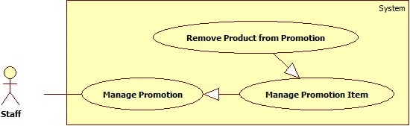

Figure 24 - <Staff> Remove Product from Promotion UCD

**Use Case Specification**

|  |  |  |  |
| --- | --- | --- | --- |
| **USE CASE – UC_18** | | | |
| **Use Case No.** | 18 | **Use Case Version** | 1.0 |
| **Use Case Name** | Delete product in promotion | | |
| **Author** | TienNV | | |
| **Date** | 08/09/2016 | **Priority** | Normal |
| **Actor:**   * Staff   **Summary:**   * This use case allow staff to delete product for promotion.   **Goal:**   * Staff delete incorrect products in promotion.   **Triggers:**   * Staff sends delete product in promotion commands.   **Preconditions:**   * User were authorized access to the system with Staff role.   **Postconditions:**   * Success: Product will be deleted in promotion.   **Main Success Scenario:**   |  |  |  | | --- | --- | --- | | **Step** | **Actor Action** | **System Response** | | 1 | Staff send delete product in promotion command | System deletes relationship between products and promotion. |   **Exceptions:** N/A  **Relationships:**  N/A  **Business Rules:**   * Deactivated products must not be visible to user. | | | |

##### <Staff> Add Information <UC_19>

**Use Case Diagram**

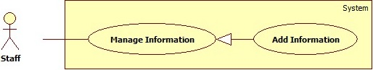

Figure 25 - <Staff> Add Information UCD

**Use Case Specification**

|  |  |  |  |
| --- | --- | --- | --- |
| **USE CASE – UC_19** | | | |
| **Use Case No.** | 19 | **Use Case Version** | 1.0 |
| **Use Case Name** | Add Information | | |
| **Author** | TienNV | | |
| **Date** | 14/09/2016 | **Priority** | Normal |
| **Actor:**   * Staff   **Summary:**   * This use case allows Staff to add new information. * Information can be: Beacon, area, floor, category.   **Goal:**   * To add data into the system.   **Triggers:**   * Staff sends request to add new information.   **Preconditions:**   * User were authorized access to the system with Staff role.   **Post Conditions:**   * **Success:** New information was inserted to storage. * **Fail:** Error message is displayed.   **Main Success Scenario:**   |  |  |  | | --- | --- | --- | | **Step** | **Actor Action** | **System Response** | | 1 | [Alternative 1]  [Alternative 2]  [Alternative 3]  [Alternative 4] |  | | 2 | Staff sends “Add” command.  [Alternative 5] | System inserts information into storage.  [Exception 1]  [Exception 2] |   **Alternative 1:**   |  |  |  | | --- | --- | --- | | **Step** | **Actor Action** | **System Response** | | 1 | Staff selecst a beacon to insert. | Show form to input new beacon, requires the following fields.   * UuId: text input contain’s beacon UUID, required, read only, length [36] * Minor: number input contains beacon’s minor, required, auto generated, range in [0 - 65535] * Major: number input contains beacon’s major, required, range in [1 - 2] * x: blank number input, required, range in [0 - 1000] * y: blank number input, required, range in [0 - 1000] * z: blank number input, required, range in [0 - 50] * Floor Beacon: checkbox, not required * Floor: drop down list able to choose, not required | | 2 | Staff inputs form. |  |   **Alternative 2:**   |  |  |  | | --- | --- | --- | | **Step** | **Actor Action** | **System Response** | | 1 | Staff sends command to insert new area. | Show form to input new area, requires the following fields.   * Name: blank text input, required, length [40] * Weight: blank number input, required, range in [0 - 1000] * Floor: drop down list able to choose, required * Beacon minor 1: drop down list able to choose, required * Beacon minor 2: drop down list able to choose, required * Beacon minor 3: drop down list able to choose, required * Beacon minor 4: drop down list able to choose, required | | 2 | Staff inputs form. |  |   **Alternative 3:**   |  |  |  | | --- | --- | --- | | **Step** | **Actor Action** | **System Response** | | 1 | Staff sends command to insert new floor. | Show form to input new floor, requires the following fields.   * Name: blank text input, required, length [20] | | 2 | Staff inputs form. |  |   **Alternative 4:**   |  |  |  | | --- | --- | --- | | **Step** | **Actor Action** | **System Response** | | 1 | Staff sends command to insert new category. | Show form to input new floor, requires the following fields.   * Name: blank text input, required, length [80] | | 2 | Staff inputs form. |  |   **Alternative 5:**   |  |  |  | | --- | --- | --- | | **Step** | **Actor Action** | **System Response** | | 1 | Staff sends command cancel their action. | Close form without change anything. |   **Exception:**   |  |  |  | | --- | --- | --- | | **No** | **Cause** | **System Response** | | 1 | Missing required fields. | Display message to suggest user input all the required fields. | | 2 | Information already exists | Display warning message to notify that inputted information already exists in storage |   **Relationships:** N/A  **Business Rules:**   * Beacon: * There are 2 types of beacons in our system:   + ***Floor Beacon:***     - Used to identify floor.     - When insert beacon, if “Flood Beacon” checkbox is checked, that beacon will be inserted as ***Floor Beacon***.     - Value of major will be auto set as 2.     - On each floor, ***Floor Beacons*** should be located near the stairs or elevator, distance about 1 meter and atleast 3 beacons.     - ***Floor Beacons*** on each floor must be located lower than half of the height of that floor.     - 2 ***Floor Beacons*** located on 2 consecutive floors must have the same x and y coordinates.   + ***Area Beacon:***     - Used to identify area.     - When insert beacon, if “Flood Beacon” checkbox is not checked, that beacon will be inserted as ***Area Beacon.***     - Value of major will be auto set as 1.     - ***Area Beacons*** on each floor must be located with the same height.     - An area must have 4 ***Area Beacons***.     - An area must be a square or rectangle and should has max length and width at 10 meters. * Area: * Each area’s name must be unique. * Eeach area must be located in a floor. * Each area must have four different beacon minors. * Floor: * Each floor’s name must be unique. * Category: * Each category’s name must be unique. * Each category should represent more than one product. | | | |

##### <Staff> Update Information <UC_20>

**Use Case Diagram**

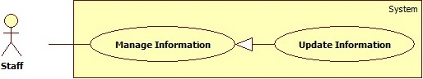

Figure 26 - <Staff> Update Information UCD

**Use Case Specification**

|  |  |  |  |
| --- | --- | --- | --- |
| **USE CASE – UC_20** | | | |
| **Use Case No.** | 20 | **Use Case Version** | 1.0 |
| **Use Case Name** | Update Information | | |
| **Author** | TienNV | | |
| **Date** | 14/09/2016 | **Priority** | Normal |
| **Actor:**   * Staff   **Summary:**   * This use case allows Staff can update information. * Information can be: Beacon, area, floor, category.   **Goal:**   * To correct information on the system.   **Triggers:**   * Staff sends request to update information.   **Preconditions:**   * User were authorized access to the system with Staff role.   **Post Conditions:**   * **Success:** Information was updated to storage. * **Fail:** Error message is displayed.   **Main Success Scenario:**   |  |  |  | | --- | --- | --- | | **Step** | **Actor Action** | **System Response** | | 1 | [Alternative 1]  [Alternative 2]  [Alternative 3]  [Alternative 4] |  | | 2 | Staff sends “update” command.  [Alternative 5] | System update information in storage.  [Exception 1]  [Exception 2] |   **Alternative 1:**   |  |  |  | | --- | --- | --- | | **No** | **Actor Action** | **System Response** | | 1 | Staff send request to update beacon. | Show beacon information for actor able to view and edit, it includes following fields:   * UuId: text input contain’s beacon UUID, required, read only, length [36] * Minor: number input contains beacon’s minor, required, auto generated, range in [0 - 65535] * Major: number input contains beacon’s major, required, range in [1 - 2] * x: number input contains beacon’s x, required, range in [0 - 1000] * y: number input contains beacon’s y, required, range in [0 - 1000] * z: number input contains beacon’s z, required, range in [0 - 50] * Floor Beacon: checkbox, not required. | | 2 | Staff inputs form. |  |   **Alternative 2:**   |  |  |  | | --- | --- | --- | | **No** | **Actor Action** | **System Response** | | 1 | Staff sends command to update area. | Show area information for actor able to view and edit, it includes following fields:   * Name: text input contains area name, required, length [40] * Location: text input contains area location, required, length [15] * Weight: number input contains area weight, required, range in [0 - 1000] * Floor: drop down list able to choose, not required * Beacon minor 1: drop down list able to choose, required * Beacon minor 2: drop down list able to choose, required * Beacon minor 3: drop down list able to choose, required * Beacon minor 4: drop down list able to choose, required | | 2 | Staff inputs form. |  |   **Alternative 3:**   |  |  |  | | --- | --- | --- | | **No** | **Actor Action** | **System Response** | | 1 | Staff sends command to update floor. | Show floor information for actor able to view and edit, it includes following fields:   * Name: text input contains floor name, required, length [20] | | 2 | Staff inputs form. |  |   **Alternative 4:**   |  |  |  | | --- | --- | --- | | **No** | **Actor Action** | **System Response** | | 1 | Staff sends command to update category. | Show category information for actor able to view and edit, it includes following fields:   * Name: text input contains category name, required, length [80]. | | 2 | Staff inputs form. |  |   **Alternative 5:**   |  |  |  | | --- | --- | --- | | **No** | **Actor Action** | **System Response** | | 1 | Staff sends command cancel their action. | Form without change anything |   **Exception:**   |  |  |  | | --- | --- | --- | | **No** | **Cause** | **System Response** | | 1 | Missing required fields. | Display message to suggest user input all the required fields. | | 2 | Information already exists | Display warning message to notify that inputted information already exists in storage |   **Relationships:** N/A   * Beacon: * There are 2 types of beacons in our system***:***   + ***Floor Beacon:***     - Used to identify floor.     - When insert beacon, if “Flood Beacon” checkbox is checked, that beacon will be inserted as ***Floor Beacon***.     - Value of major will be auto set as 2.     - On each floor, ***Floor Beacons*** should be located near the stairs or elevator, distance about 1 meter and atleast 3 beacons.     - ***Floor Beacons*** on each floor must be located lower than half of the height of that floor.     - 2 ***Floor Beacons*** located on 2 consecutive floors must have the same x and y coordinates.   + ***Area Beacon:***     - Used to identify area.     - When insert beacon, if “Flood Beacon” checkbox is not checked, that beacon will be inserted as ***Area Beacon.***     - Value of major will be auto set as 1.     - ***Area Beacons*** on each floor must be located with the same height.     - An area must have 4 ***Area Beacons***.     - An area must be a square or rectangle and should has max length and width at 10 meters. * Area: * Each area’s name must be unique. * Eeach area must be located in a floor. * Each area must have four different beacon minors. * Floor: * Each floor’s name must be unique. * Category: * Each category’s name must be unique. * Each category should represent more than one product. | | | |

##### <Staff> Delete Information <UC_21>

**Use Case Diagram**

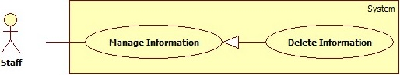

Figure 27 - <Staff> Delete Information UCD

**Use Case Specification**

|  |  |  |  |
| --- | --- | --- | --- |
| **USE CASE – UC_21** | | | |
| **Use Case No.** | 21 | **Use Case Version** | 1.0 |
| **Use Case Name** | Delete Information | | |
| **Author** | TienNV | | |
| **Date** | 14/09/2016 | **Priority** | Normal |
| **Actor:**   * Staff   **Summary:**   * This use case allows Staff can delete the information. * Information can be: Beacon, area, floor, category.   **Goal:**   * To remove unused or incorrect information.   **Triggers:**   * Staff sends request to delete information.   **Preconditions:**   * The user was authorized access to the system with Staff role.   **Post Conditions:**   * **Success:** Information was deleted in storage.   **Main Success Scenario:**   |  |  |  | | --- | --- | --- | | **Step** | **Actor Action** | **System Response** | | 1 | Staff choose information to delete.  Staff send request to delete information. | System shows the popup for staff to confirm. | | 2 | Staff sends command to confirm.  [Alternative 1] | System deletes information in storage.  Display successful message. |   **Alternative Scemario:**   |  |  |  | | --- | --- | --- | | **No** | **Actor Action** | **System Response** | | 1 | Staff cancel action delete information. | Popup disappear and nothing change. |   **Exception:** N/A  **Relationships:**  N/A  **Business Rules:**   * Beacon: * A beacon only can be deleted if it does not match with the any areas or floors. * Area: * An area only can be deleted if it does not match with any products. * Floor: * A floor only can be deleted if it does not match with any areas. | | | |

##### <Staff> Delete Log <UC_22>

**Use Case Diagram**

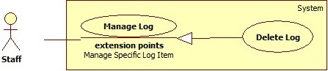

Figure 28 - <Staff> Delete Log UCD

**Use Case Specification**

|  |  |  |  |
| --- | --- | --- | --- |
| **USE CASE – UC_22** | | | |
| **Use Case No.** | 22 | **Use Case Version** | 1.0 |
| **Use Case Name** | Delete log | | |
| **Author** | TienNV | | |
| **Date** | 09/09/2016 | **Priority** | Normal |
| **Actor:**   * Staff   **Summary:**   * This use case allows actor can remove unnecessary log.   **Goal:**   * System un-tracks handled log or un-useable log.   **Triggers:**   * User sends command to delete log.   **Preconditions:**   * User were authorized access to the system with Staff role.   **Post Conditions:**   * **Success**: Log’s status was changed to “DEELTED”. * **Fail**: Error message is displayed.   **Main Success Scenario:**   |  |  |  | | --- | --- | --- | | **Step** | **Actor Action** | **System Response** | | 1 | Staff sends command to delete the specified log. | Show confirmation popup. | | 2 | Staff sends command to confirm.  [Alternative 1] | Display successful message. |   **Alternative Scenario:**   |  |  |  | | --- | --- | --- | | **No** | **Actor Action** | **System Response** | | 1 | Staff sends command to cancel. | Close confirm dialog. |   **Exceptions:** N/A  **Relationships:** N/A  **Business Rules:**   * Log is record when chat bot does not find any products that match customer’s message or when customer send feedback about search result. * Deleted log will have “DELETED” status. * Deleted log will not be able to show to user anymore * All log must be kept for tracking. * After deleted log, it can not be undo. | | | |

##### <Staff> Add Original Word <UC_23>

**Use Case Diagram**

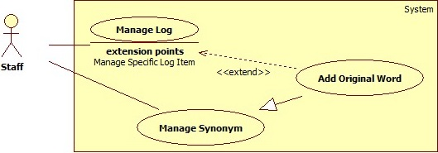

Figure 29 - <Staff> Add Original Word UCD

**Use Case Specification**

|  |  |  |  |
| --- | --- | --- | --- |
| **USE CASE – UC_23** | | | |
| **Use Case No.** | 23 | **Use Case Version** | 2.0 |
| **Use Case Name** | Add Original Word | | |
| **Author** | TienNV | | |
| **Date** | 09/09/2016 | **Priority** | Normal |
| **Actor:**   * Staff   **Summary:**   * This use case allows actor to add new original word.   **Goal:**   * System has new original word in storage to use to training bot more intelligent.   **Triggers:**   * Staff sends command to add new original word.   **Preconditions:**   * User must log in the system with Staff role.   **Post Conditions:**   * **Success**: New original word were saved. * **Fail**: Error message is displayed.   **Main Success Scenario:**   |  |  |  | | --- | --- | --- | | **Step** | **Actor Action** | **System Response** | | 1 | Staff sends command to show add new original word form. | Show form to input new orginal word:   * Original word: blank text input, required, length [1,255] | | 2 | Staff inputs an original words and sends commad to add new original word.  [Alternative 1] | Check if word is already existed.  Save original word to storage.  Display successful message.  [Exceptions 1, 2] |   **Alternative Scenario:**   |  |  |  | | --- | --- | --- | | **No** | **Actor action** | **System Response** | | 1 | Staff sends command to cancel. | Close form, without change anything. |   **Exceptions:**   |  |  |  | | --- | --- | --- | | **No** | **Cause** | **System Response** | | 1 | Length of “Original word” is not in range. | Display message “Length of Original word must be from 1 to 255 characters”. | | 2 | Original word is duplicated with another item. | Display message “Word is already existed”. |   **Relationships:**   * Extend from “Manage Log” use case   + Condition: Actor checks log and see that there are words with the same meaning.   + Extension Point: Manage Specific Log Item.   **Business Rules:**   * Add suitable original word with context in supermarket. * Original words are unique. | | | |

##### <Staff> Update Original Word <UC_24>

**Use Case Diagram**

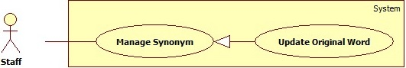

Figure 30 - <Staff> Update Original Word UCD

**Use Case Specification**

|  |  |  |  |
| --- | --- | --- | --- |
| **USE CASE – UC_24** | | | |
| **Use Case No.** | 24 | **Use Case Version** | 2.0 |
| **Use Case Name** | Update Original Word | | |
| **Author** | TienNV | | |
| **Date** | 09/09/2016 | **Priority** | Normal |
| **Actor:**   * Staff   **Summary:**   * This use case allows actor to update original word.   **Goal:**   * System has corrected original word in storage to use to training bot more intelligent.   **Triggers:**   * Staff sends command to update original word.   **Preconditions:**   * User must log in the system with Staff role.   **Post Conditions:**   * **Success**: original word word were saved * **Fail**: Error message is displayed.   **Main Success Scenario:**   |  |  |  | | --- | --- | --- | | **Step** | **Actor Action** | **System Response** | | 1 | Staff sends command to update original word. | Show form to update orginal word:   * Original word: text input, contains current origina word, required, length [1,255] | | 2 | Staff inputs information and sends commad to update original word.  [Alternative 1] | Check if word is already existed  Update original word to storage.  Display successful message.  [Exception 1, 2,] |   **Alternative Scenario:**   |  |  |  | | --- | --- | --- | | **No** | **Actor action** | **System Response** | | 1 | Staff sends command to cancel. | Close form, without change anything. |   **Exceptions:**   |  |  |  | | --- | --- | --- | | **No** | **Cause** | **System Response** | | 1 | Length of “Original word” is not in range. | Display message “Length of Original word must be from 1 to 255 characters”. | | 2 | Original word is duplicated with another item. | Display message “Word is already existed”. |   **Relationships:**  N/A  **Business Rules:**   * Original words are unique. | | | |

##### <Staff> Delete Original Word <UC_25>

**Use Case Diagram**

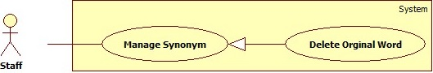

Figure 31 - <Staff> Delete Original Word UCD

**Use Case Specification**

|  |  |  |  |
| --- | --- | --- | --- |
| **USE CASE – UC_25** | | | |
| **Use Case No.** | 25 | **Use Case Version** | 2.0 |
| **Use Case Name** | Delete Original Word | | |
| **Author** | TienNV | | |
| **Date** | 09/09/2016 | **Priority** | Normal |
| **Actor:**   * Staff   **Summary:**   * This use case allows staff to delete original word.   **Goal:**   * Remove incorrect word to prevent system from using wrong data to training bot.   **Triggers:**   * Staff sends command to delete original word.   **Preconditions:**   * User must log in the system with Staff role.   **Post Conditions:**   * **Success**: Original word was deleted out of the system * **Fail**: Error message is displayed.   **Main Success Scenario:**   |  |  |  | | --- | --- | --- | | **Step** | **Actor Action** | **System Response** | | 1 | Staff sends command to delete original word | Show confirmation popup: “Are you sure?”. | | 2 | Send command to cofirm.  [Alternative 1] | Removes original word from storage  Display successful message. |   **Alternative Scenario:**   |  |  |  | | --- | --- | --- | | **No** | **Actor action** | **System Response** | | 1 | Actor cancels action delete information. | Popup disappear and nothing change. |   **Exceptions:** N/A  **Relationships:**  N/A  **Business Rules:**   * Must delete all synonyms of original word. | | | |

##### <Staff> Add Synonym <UC_26>

**Use Case Diagram**

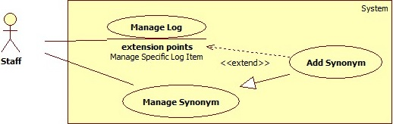

Figure 32 - <Staff> Add Synonym UCD

**Use Case Specification**

|  |  |  |  |
| --- | --- | --- | --- |
| **USE CASE – UC_26** | | | |
| **Use Case No.** | 26 | **Use Case Version** | 2.0 |
| **Use Case Name** | Add Synonym | | |
| **Author** | TienNV | | |
| **Date** | 09/09/2016 | **Priority** | Normal |
| **Actor:**   * Staff   **Summary:**   * This use case allows staff to add synonym for an original word.   **Goal:**   * System has new synonym in storage to use to training bot more intelligent   **Triggers:**   * Staff sends command to view synonyms of an original word.   **Preconditions:**   * User must log in the system with Staff role.   **Post Conditions:**   * **Success**: Synonym were saved * **Fail**: Error message is displayed.   **Main Success Scenario:**   |  |  |  | | --- | --- | --- | | **Step** | **Actor Action** | **System Response** | | 1 | Staff sends command to view synonyms of an original words. | Show table of synonyms of selected original word. | | 2 | Staff sends command to show add new synonym form. | Show form to input new synonym:   * Synonym: blank text input, required, length [1,255] | | 3 | Staff inputs an synonym and sends commad to add new original word.  [Alternative 1] | Check if word is already existed  Save synonym to storage.  Display successful message.  [Exception 1, 2] |   **Alternative Scenario:**   |  |  |  | | --- | --- | --- | | **No** | **Cause** | **System Response** | | 1 | Staff sends command to cancel. | Close form, without change anything. |   **Exception:**   |  |  |  | | --- | --- | --- | | **No** | **Cause** | **System Response** | | 1 | Length of “Synonym” is not in range. | Display message “Length of Synonym must be from 1 to 255 characters”. | | 2 | Synonym is duplicated with another item. | Display message “Word is already existed”. |   **Relationships:**   * Extend from “Manage Log” use case   + Condition: Actor checks log and see that there are words with the same meaning.   + Extension Point: Manage Specific Log Item.   **Business Rules:**   * Add suitable synonym word with context in supermarket. * Synonyms are unique. | | | |

##### <Staff> Update Synonym <UC_27>

**Use Case Diagram**

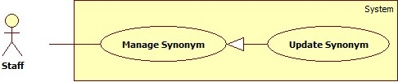

Figure 33 -<Staff> Update Synonym UCD

**Use Case Specification**

|  |  |  |  |
| --- | --- | --- | --- |
| **USE CASE – UC_27** | | | |
| **Use Case No.** | 27 | **Use Case Version** | 2.0 |
| **Use Case Name** | Update Synonym | | |
| **Author** | TienNV | | |
| **Date** | 09/09/2016 | **Priority** | High |
| **Actor:**   * Staff   **Summary:**   * This use case allows staff to update synonym.   **Goal:**   * System has corrected synonym in storage to use to training bot more intelligent.   **Triggers:**   * Staff sends command function train by updating synonym.   **Preconditions:**   * User must log in the system with Staff role.   **Post Conditions:**   * **Success**: Synonym was updated. * **Fail**: Error message is displayed.   **Main Success Scenario:**   |  |  |  | | --- | --- | --- | | **Step** | **Actor Action** | **System Response** | | 1 | Staff sends command to view synonyms of an original words. | Show table of synonyms of selected original word. | | 2 | Staff sends command to update synonym of selected original words. | Show form to update synonym:   * Synonym: blank text input, required, length [1,255] | | 3 | Staff inputs information and sends commad to update synonym.  [Alternative 1] | Check if word is already existed  Update synonym to database.  Display successful message.  [Exception 1, 2] |   **Alternative Scenario:**   |  |  |  | | --- | --- | --- | | **No** | **Actor action** | **System Response** | | 1 | Staff sends command to cancel. | Close form, without change anything. |   **Exceptions:**   |  |  |  | | --- | --- | --- | | **No** | **Cause** | **System Response** | | 1 | Length of “Synonym” is not in range. | Display message “Length of Synonym must be from 1 to 255 characters”. | | 2 | Synonym is duplicated with another item. | Display message “Word is already existed”. |   **Relationships:**  N/A  **Business Rules:**   * Synonyms are unique. | | | |

##### <Staff> Delete Synonym <UC_28>

**Use Case Diagram**

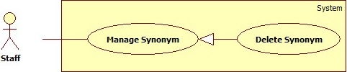

Figure 34 - <Staff> Delete Synnonym UCD

**Use Case Specification**

|  |  |  |  |
| --- | --- | --- | --- |
| **USE CASE – UC_28** | | | |
| **Use Case No.** | 28 | **Use Case Version** | 2.0 |
| **Use Case Name** | Delete Synonym | | |
| **Author** | TienNV | | |
| **Date** | 09/09/2016 | **Priority** | Normal |
| **Actor:**   * Staff   **Summary:**   * This use case allows staff to delete original synonym.   **Goal:**   * Remove incorrect word to prevent system from using wrong data to training bot.   **Triggers:**   * Staff sends command to delete synonym.   **Preconditions:**   * User must log in the system with Staff role.   **Post Conditions:**   * **Success**: Synonym was deleted out of the system * **Fail**: Error message is displayed.   **Main Success Scenario:**   |  |  |  | | --- | --- | --- | | **Step** | **Actor Action** | **System Response** | | 1 | Staff sends command to delete synonym | Show confirmation popup: “Are you sure?”. | | 2 | Send command to cofirm.  [Alternative 1] | Removes synonym from storage  Display successful message. |   **Alternative Scenario:**   |  |  |  | | --- | --- | --- | | **No** | **Actor action** | **System Response** | | 1 | Actor cancels action delete information. | Popup disappear and nothing change. |   **Exceptions:** N/A  **Relationships:**  N/A  **Business Rules:** N/A | | | |

#### <Customer> Overview Use Cases

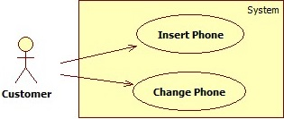

Figure 35 - <Customer> Overview Use Cases

##### <Customer> Insert Phone <UC_29>

**Use Case Diagram**

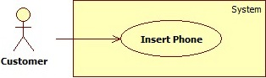

Figure 36 - <Customer> Insert Phone UCD

**Use Case Specification**

|  |  |  |  |
| --- | --- | --- | --- |
| **USE CASE – UC_29** | | | |
| **Use Case No.** | 29 | **Use Case Version** | 1.0 |
| **Use Case Name** | Insert Phone | | |
| **Author** | PhucNT | | |
| **Date** | 10/09/2016 | **Priority** | High |
| **Actor:**   * Customer   **Summary:**   * This use case allows customer to add phone number.   **Goal:**   * Add phone number to connect to chatbot   **Triggers:**   * Customer logged in to facebook on android application.   **Preconditions:**   * User must log in the system with Customer role.   **Post Conditions:**   * **Success**: Phone number were saved * **Fail**: Error message is displayed.   **Main Success Scenario:**   |  |  |  | | --- | --- | --- | | **Step** | **Actor Action** | **System Response** | | 1 | Customer logged in to facebook on android application. | Show texbox dialog.   * Phone number: blank numberic input, required, length [10, 13]. | | 2 | Customer inputs phone number and sends commad to add phone number. | Add phone number to local storage and map with facebook chatbot id.  Display successful message. |   **Alternative Scenario:** N/A  **Exception:** N/A  **Relationships:**  N/A  **Business Rules:**   * Customer must add phone number to tracking cart on chatbot. * Phone must have 10 to 13 numbers from 0 to 9. | | | |

##### <Customer> Change Phone <UC_30>

**Use Case Diagram**

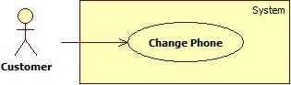

Figure 37 - <Customer> Change Phone UCD

**Use Case Specification**

|  |  |  |  |
| --- | --- | --- | --- |
| **USE CASE – UC_30** | | | |
| **Use Case No.** | 30 | **Use Case Version** | 1.0 |
| **Use Case Name** | Change Phone | | |
| **Author** | PhucNT | | |
| **Date** | 10/09/2016 | **Priority** | Normal |
| **Actor:**   * Customer   **Summary:**   * This use case allows customer to update phone number.   **Goal:**   * Change phone number to connect with chatbot by phone number.   **Triggers:**   * Customer sends command to view phone number.   **Preconditions:**   * User must log in the system with Customer role.   **Post Conditions:**   * **Success**: Phone number was updated. * **Fail**: Error message is displayed.   **Main Success Scenario:**   |  |  |  | | --- | --- | --- | | **Step** | **Actor Action** | **System Response** | | 1 | Customer sends command to view phone number | Show texbox dialog.   * Phone number: blank numberic input, required, length [10,13] | | 2 | Customer inputs phone number and sends commad to update phone number. | Update phone number to local storage and map with facebook chatbot id.  Display successful message. |   **Alternative Scenario:** N/A  **Exceptions:** N/A  **Relationships:**  N/A  **Business Rules:**   * Customer must add phone number to tracking cart on chatbot. * Phone must be has 10 to 13 numbers from 0 to 9. | | | |

#### <Scheduler> Overview Use Cases

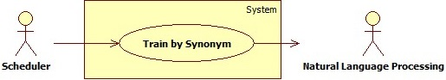

Figure 38 - <Scheduler> Overview Use Cases

##### <Scheduler> Train by Synonyms <UC_31>

**Use Case Diagram**



Figure 39 - <Scheduler> Train by Synonyms UCD

**Use Case Specification**

|  |  |  |  |
| --- | --- | --- | --- |
| **USE CASE – UC_31** | | | |
| **Use Case No.** | 31 | **Use Case Version** | 1.0 |
| **Use Case Name** | Train by Synonym | | |
| **Author** | ManLM | | |
| **Date** | 10/09/2016 | **Priority** | High |
| **Actor:**   * Timer   **Summary:**   * This use case allows actor create synonym of products’ name/categories’ name on api.ai.   **Goal:**   * Training bot more intelligent by know synonyms.   **Triggers:**   * The scheduler hit configured time.   **Preconditions:**   * N/A   **Post Conditions:**   * **Success:** Logs was analized and save in database. * **Fail:** Error message is recorded in system log.   **Main Success Scenario:**   |  |  |  | | --- | --- | --- | | **Step** | **Actor Action** | **System Response** | | 1 | Server checks the current time. If it hits configured time, synonym name creating process starts. | Get all products’ name/categories’ name.  Create synonym names for each product’s name/category’s name according to synonyms that were saved in storage.  Send all created synonym names to api.ai. |   **Exceptions:** N/A  **Relationships:**  N/A.  **Business Rules:**   * Must be executed everyday at configured time. * All synonym names will be re-created each time scheduler executes. | | | |

#### <Auto Handler> Overview Use Cases

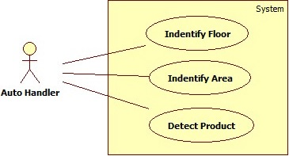

Figure 40 - <Auto Hanlder> Overview Use Cases

##### <Auto Handler> Indentify Floor <UC_32>

**Use Case Diagram**

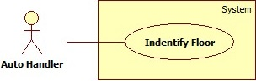

Figure 41 - <Auto Handler> Indentify Floor UCD

**Use Case Specification**

|  |  |  |  |
| --- | --- | --- | --- |
| **USE CASE – UC_32** | | | |
| **Use Case No.** | 32 | **Use Case Version** | 1.0 |
| **Use Case Name** | Indentify Floor | | |
| **Author** | PhucNT | | |
| **Date** | 11/09/2016 | **Priority** | Normal |
| **Actor:**   * Auto handler   **Summary:**   * This use case allows system to calculate customer in on which floor.   **Goal:**   * To indentify customer’s current location in the supermarket.   **Triggers:**   * Auto handler sends command to find area.   **Preconditions:**   * Area is mapped with Estimote Beacons.   **Post Conditions:**   * **Success**: Area name will be shown in customer’s device * **Fail**: Error message is displayed.   **Main Success Scenario:**   |  |  |  | | --- | --- | --- | | **Step** | **Actor Action** | **System Response** | | 1 | Auto handler sends command to indentify floor. | Calculate distance to beacon to determine current floor. |   **Alternative Scenario:** N/A  **Exceptions:** N/A  **Relationships:**  N/A  **Business Rules:**   * Beacon: * There are 2 types of beacons in our system***:***   + ***Floor Beacon:***     - Used to identify floor.     - When insert beacon, if “Flood Beacon” checkbox is checked, that beacon will be inserted as ***Floor Beacon***.     - Value of major will be auto set as 2.     - On each floor, ***Floor Beacons*** should be located near the stairs or elevator, distance about 1 meter and atleast 3 beacons.     - ***Floor Beacons*** on each floor must be located lower than half of the height of that floor.     - 2 ***Floor Beacons*** located on 2 consecutive floors must have the same x and y coordinates.   + ***Area Beacon:***     - Used to identify area.     - When insert beacon, if “Flood Beacon” checkbox is not checked, that beacon will be inserted as ***Area Beacon.***     - Value of major will be auto set as 1.     - ***Area Beacons*** on each floor must be located with the same height.     - An area must have 4 ***Area Beacons***.     - An area must be a square or rectangle and should has max length and width at 10 meters. * The default floor is the floor when the beacon which has the smallest altitude (z) is located. | | | |

##### <Auto Handler> Indentify Area <UC_33>

**Use Case Diagram**

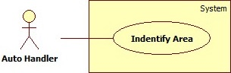

Figure 42 - <Auto Handler> Indentify Area UCD

**Use Case Specification**

|  |  |  |  |
| --- | --- | --- | --- |
| **USE CASE – UC_33** | | | |
| **Use Case No.** | 33 | **Use Case Version** | 1.0 |
| **Use Case Name** | Indentify Area | | |
| **Author** | PhucNT | | |
| **Date** | 11/09/2016 | **Priority** | Normal |
| **Actor:**   * Auto handler   **Summary:**   * This use case allows customer to know current area.   **Goal:**   * Customer knows current location in supermarket.   **Triggers:**   * Auto handler sends command to find area.   **Preconditions:**   * Area is mapped with Estimote Beacons.   **Post Conditions:**   * **Success**: Area name will be shown in customer’s device * **Fail**: Error message is displayed.   **Main Success Scenario:**   |  |  |  | | --- | --- | --- | | **Step** | **Actor Action** | **System Response** | | 1 | Auto handler sends command to indentify area | Calculate the customer’s position.  Show area name. |   **Alternative Scenario:** N/A  **Exceptions:** N/A  **Relationships:**  N/A  **Business Rules:**   * Beacon: * There are 2 types of beacons in our system***:***   + ***Floor Beacon:***     - Used to identify floor.     - When insert beacon, if “Flood Beacon” checkbox is checked, that beacon will be inserted as ***Floor Beacon***.     - Value of major will be auto set as 2.     - On each floor, ***Floor Beacons*** should be located near the stairs or elevator, distance about 1 meter and atleast 3 beacons.     - ***Floor Beacons*** on each floor must be located lower than half of the height of that floor.     - 2 ***Floor Beacons*** located on 2 consecutive floors must have the same x and y coordinates.   + ***Area Beacon:***     - Used to identify area.     - When insert beacon, if “Flood Beacon” checkbox is not checked, that beacon will be inserted as ***Area Beacon.***     - Value of major will be auto set as 1.     - ***Area Beacons*** on each floor must be located with the same height.     - An area must have 4 ***Area Beacons***.     - An area must be a square or rectangle and should has max length and width at 10 meters. | | | |

##### <Auto Handler> Detect Product <UC_34>

**Use Case Diagram**

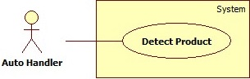

Figure 43 - <Auto Handler> Detect Product UCD

**Use Case Specification**

|  |  |  |  |
| --- | --- | --- | --- |
| **USE CASE – UC_34** | | | |
| **Use Case No.** | 34 | **Use Case Version** | 1.0 |
| **Use Case Name** | Detect product | | |
| **Author** | PhucNT | | |
| **Date** | 11/09/2016 | **Priority** | Normal |
| **Actor:**   * Auto handler   **Summary:**   * This use case allows customer to be notified when go into product in cart’s area.   **Goal:**   * Customer knows product in cart located in current area   **Triggers:**   * Auto handler sends command to detect product.   **Preconditions:**   * Area is mapped with Estimote Beacons.   **Post Conditions:**   * **Success**: Push notification to customer when go into product area * **Fail**: Error message is displayed.   **Main Success Scenario:**   |  |  |  | | --- | --- | --- | | **Step** | **Actor Action** | **System Response** | | 1 | Auto handler sends command to detect product | Find current area  Find with product in cart in current area  Push notification:   * Area name * List of product detected. |   **Alternative Scenario:** N/A  **Exceptions:** N/A  **Relationships:**  N/A  **Business Rules:**   * Eeach Products must belongs to only one area. * Beacon: * There are 2 types of beacons in our system***:***   + ***Floor Beacon:***     - Used to identify floor.     - When insert beacon, if “Flood Beacon” checkbox is checked, that beacon will be inserted as ***Floor Beacon***.     - Value of major will be auto set as 2.     - On each floor, ***Floor Beacons*** should be located near the stairs or elevator, distance about 1 meter and atleast 3 beacons.     - ***Floor Beacons*** on each floor must be located lower than half of the height of that floor.     - 2 ***Floor Beacons*** located on 2 consecutive floors must have the same x and y coordinates.   + ***Area Beacon:***     - Used to identify area.     - When insert beacon, if “Flood Beacon” checkbox is not checked, that beacon will be inserted as ***Area Beacon.***     - Value of major will be auto set as 1.     - ***Area Beacons*** on each floor must be located with the same height.     - An area must have 4 ***Area Beacons***.     - An area must be a square or rectangle and should has max length and width at 10 meters. | | | |

## Software System Attribute

### Usability

#### Graphic User Interface

* On BOM website, all the texts, labels, alerts and messages will be written in English.
* On mobile application, all the texts, labels, alerts and messages will be written in Vietnamese.

#### Usability

* The system is easy to use. It will need about 1 hour for training admin to use the BOM website to take manage on the beacons.
* It will take about 30 minutes for training staff to use the application to track product group item in the supermarket.

#### Installation

* User can follow installation and manual guide for installation. If there are any problems, user cans contacts developer for helping.

### Reliability

* Mobile devices can approximate their distance to Estimote Beacons based on received signal strength through radio wave. However, distance readings are prone to fluctuation because they depend on a number of external factors. On average, the measurement has accuracy rate at 70-80% of the actual distance.
* The system uses Estimote Beacon with high accuracy sensors (temperature and motion) the delay time for mobile application recognize the Estimote Beacon sensors can be 1-2s.
* The number of sending notification failure are 1 time per 100 notifications.

### Availability

* System is divided into modules, if a function is down, it will not influence others

### Security

* Each role of user has a specific permission to interact with system.
* System always checks authorization and authenticated before doing anything.
* Only admin can grant permission to other roles.

### Maintainability

* The system is divided into separated modules.
* The code is easy to maintain and upgrade.

### Portability

* The web application is running on Windows 7 or above.
* Any mobile that support Bluetooth 4.0 (BLE – Bluetooth Less Energy) and Android version 4.4 Kit Kat or above.
* Providing easy installation.

### Performance

* Requests from web application are responded in less than 10 seconds at 8 Mbps bandwidth speed.
* System response message for Facbook User depend on Facebook messenger response.
* Mobile application can return result of the information from the beacons through calling API after a rage from 0.3 to 0.5 second at 8 Mbps bandwidth speed.

## Conceptual Diagram

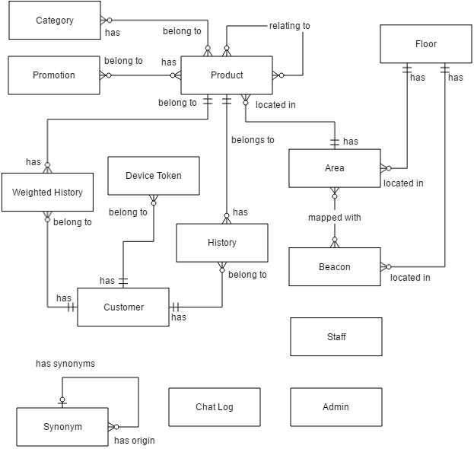

Figure 44 - Conceptual Diagram

| **Entity Data Dictionary: Describe content of all entities** | |
| --- | --- |
| **Entity Name** | **Description** |
| Category | Contains information of category. |
| Promotion | Contains information of promotion. |
| Floor | Contains information of floor. |
| Area | Contains information of area. |
| Beacon | Contains information of beacon. |
| Product | Contains information of product. |
| Customer | Contains information of customer. |
| Device Token | Contains customers’ deivce token. |
| History | Contains customers’ adding to cart history. |
| Weighted History | Contains the number of times a product was added to cart, use to suggest promotion for customers. |
| Synonym | Contains original words and its synonyms. |
| Admin | Contains information of admin. |
| Staff | Contains information of staff. |
| Chat Log | Contains customers’ chat message when they send feedback. |

Table 14 - Conceptual Diagram Data Dictionary

# Software Design Description

## Design Overview

This document describes the technical and user interface design of ISMB System. It includes the architectural design, the detailed design of common functions and business functions and the design of database model.

* The architectural design describes the overall architecture of the system and the architecture of each main component and subsystem.
* The detailed design describes static and dynamic structure for each component and functions. It includes class diagram, class explanations and sequence diagrams for each use cases.
* The database design describes the relationships between entities and details of each entity.
* Document overview:
  + Section 2: gives an overall description of the system architecture design.
  + Section 3: gives component diagrams that describes the connection and integration of the system.
  + Section 4: gives the detail design description which includes class diagram, class explanation and sequence diagram to details the application functions.
  + Section 5: describes screen design.
  + Section 6: describes a fully attributed ERD.
  + Section 7: describes algorithms.

## System Architectural Design

### Terminology

* + ISMB Server, Web Application, Web Service and Mobile Application are implemented by our team.
  + Messenger Platform, Api.ai, FPT Accetizer, Google Vision Api and Cloud Messaging are existing platforms.

### System Architecture Design Level 0

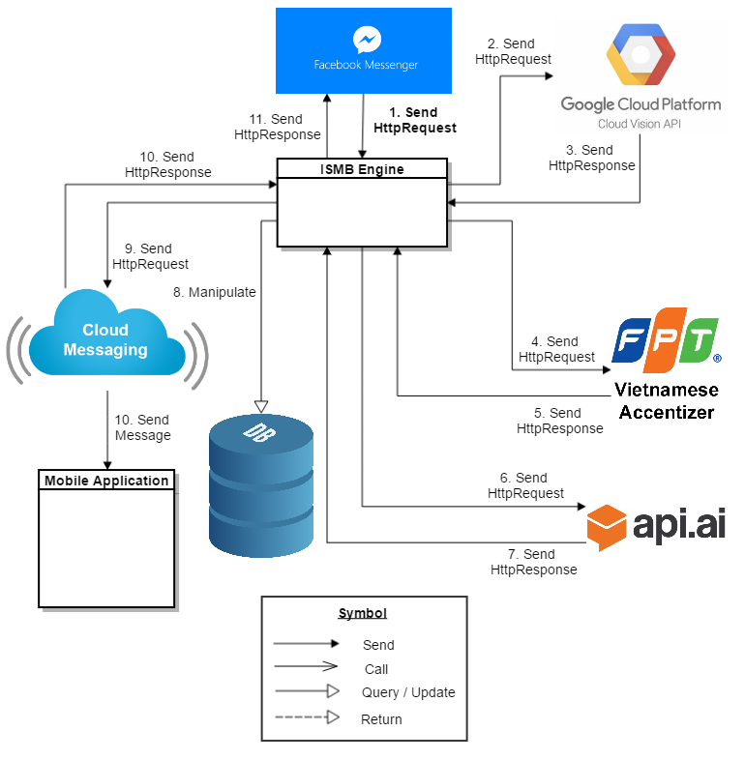

Figure 45 - System Architecture Design Level 0 – Part 1

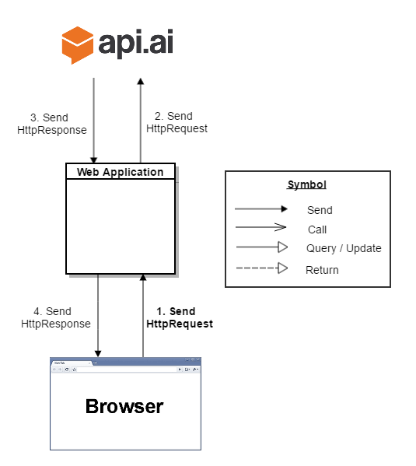

Figure 46 - System Architecture Design Level 0 – Part 2

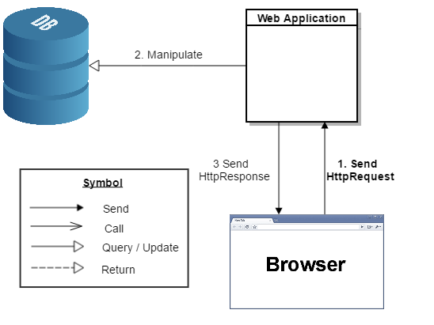

Figure 47 - System Architecture Design Level 0 – Part 3

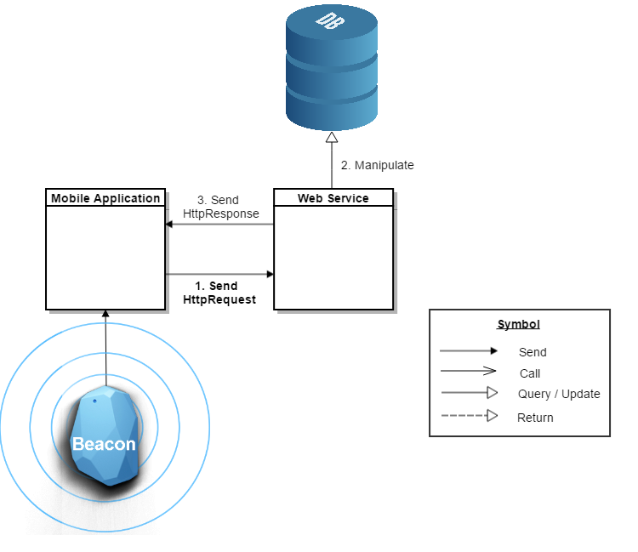

Figure 48 - System Architecture Design Level 0 – Part 4

### System Architecture Design Level 1

#### ISMB Engine

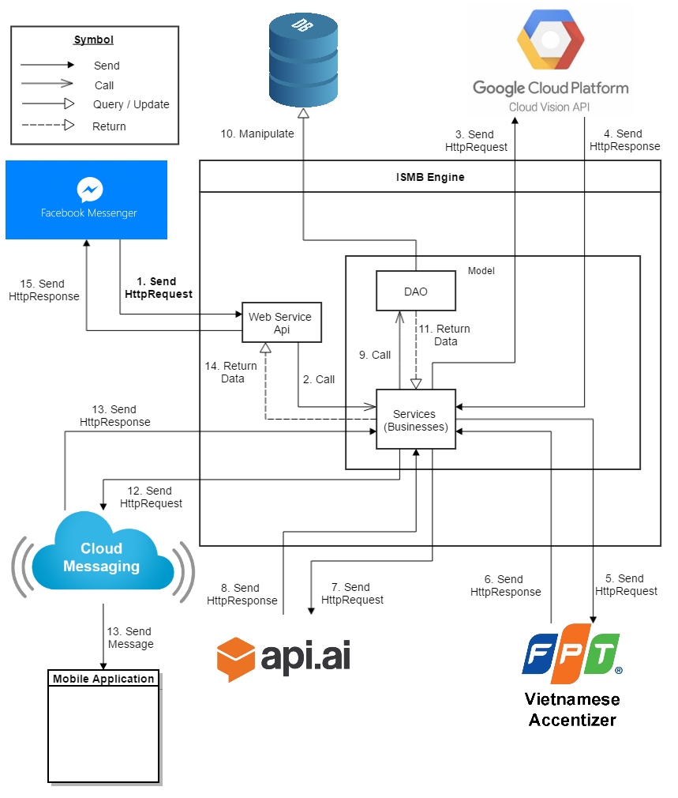

Figure 49 - System Architecture Desgin Level 1 – ISMB Engine

#### Web Application

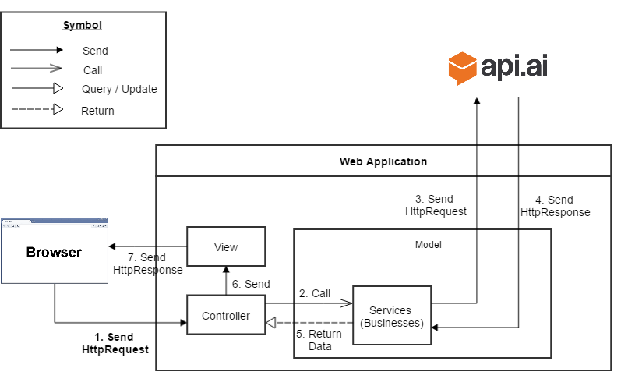

Figure 50 - System Architecture Design Level 1 – Web Application – Part 1

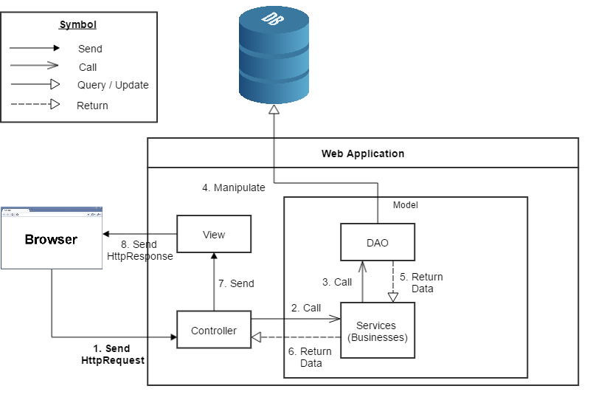

Figure 51 - System Architecture Design Level 1 – Web Application – Part 2

#### Web Service

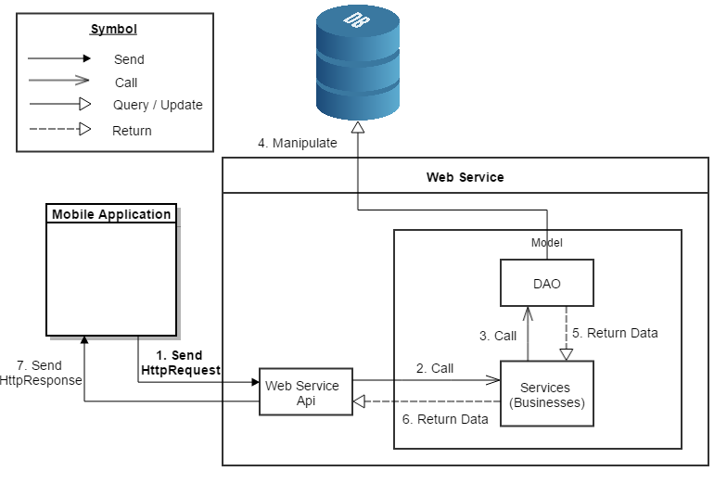

Figure 52 - System Architecture Design Level 1 – Web Service

#### Mobile Application

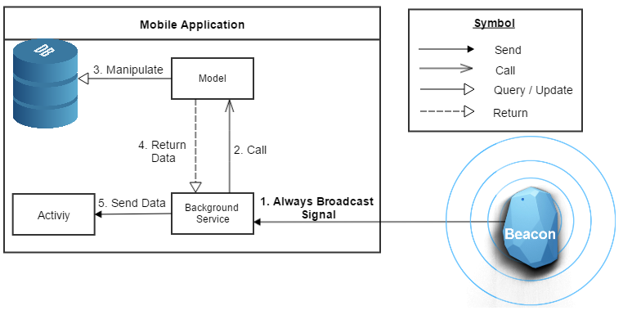

Figure 53 - System Architecture Design Level 1 – Mobile Application – Part 1

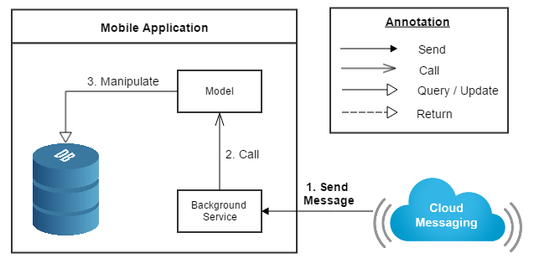

Figure 54 - System Architecture Design Level 1 – Mobile Application – Part 2

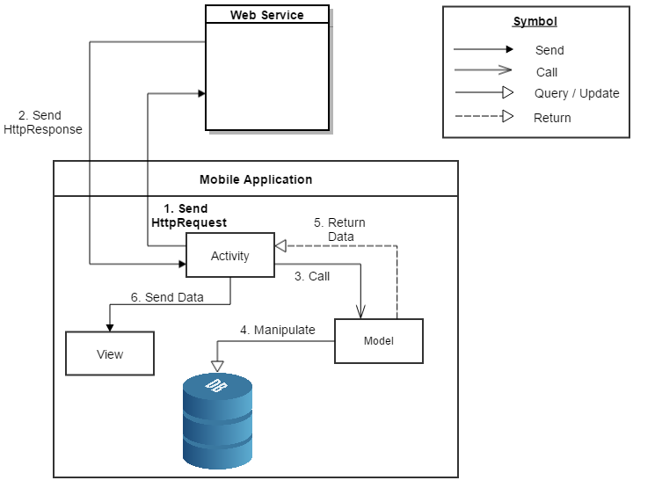

Figure 55 - System Architecture Design Level 1 – Mobile Application – Part 3

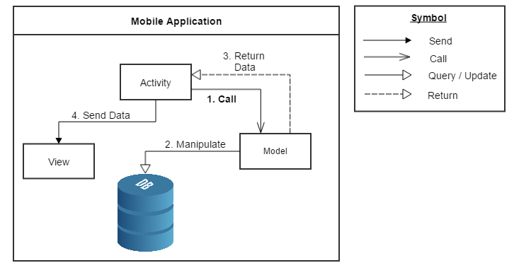

Figure 56 - System Architecture Design Level 1 – Mobile Application – Part 4

### ISMB Engine Architecture Description

ISMB Engine is developed from Spring MVC architecture style beacause:

* + It provides comprehensive infrastructure support for developing Java enterprise level applications. Spring also enables the developer to create high performing, easily testable, reusable and loose coupling enterprise Java application.
  + Spring enables the developers to develop the enterprise applications using POJOs (Plain Old Java Object). The benefit of developing the applications using POJO is, that we do not need an enterprise container such as an application server, but we have the option of using a robust servlet container.
  + Spring provides a very clean division between controllers and JavaBean models.

### Web Application Architecture Description

Web Application is developed from Spring MVC architecture style beacause:

* + It provides comprehensive infrastructure support for developing Java enterprise level applications. Spring also enables the developer to create high performing, easily testable, reusable and loose coupling enterprise Java application.
  + Spring enables the developers to develop the enterprise applications using POJOs (Plain Old Java Object). The benefit of developing the applications using POJO is, that we do not need an enterprise container such as an application server, but we have the option of using a robust servlet container.
  + Spring provides a very clean division between controllers, JavaBean models, and views.

### Web Service Architecture Description

We choose Restful Web Service model as main model because of following advantages:

* + In the future, our application may expand for other platforms as well. Web service provides reusable API that can be called by any platforms, so that our system could easily expand.
  + Beacon is a newly developed technology; its SDK is changing frequently. When does, we only need to update mobile application without affecting other components.

Web Service is developed from Spring MVC architecture style beacause:

* + It provides comprehensive infrastructure support for developing Java enterprise level applications. Spring also enables the developer to create high performing, easily testable, reusable and loose coupling enterprise Java application.
  + Spring enables the developers to develop the enterprise applications using POJOs (Plain Old Java Object). The benefit of developing the applications using POJO is, that we do not need an enterprise container such as an application server, but we have the option of using a robust servlet container.
  + Spring provides a very clean division between controllers and JavaBean models.

### Mobile Application Architecture Description

The application is developed as an Android native application. In general, the application architecture conforms to Android architecture.

*Reference: Android Developer Guider – Application Fundamentals*

[*http://developer.android.com/guide/components/fundamentals.html*](http://developer.android.com/guide/components/fundamentals.html)

Our team chooses Android because of following reasons:

* + Android is currently the most common mobile platforms in the world, and it doesn’t have any signs of slowing down. As we want to maximize our potential users, choosing Android will give us the highest popularity market.
  + Developing other mobile platforms (such as iOS or Windows Phone) may require specific expensive devices and tools. On the other hand, Android development can be done on either Mac, Windows or Linux devices with free tools.
  + Native Android applications are developed using Java programing language. Our team is strong at Java and chooses it as the main programing language.

## Component Diagram

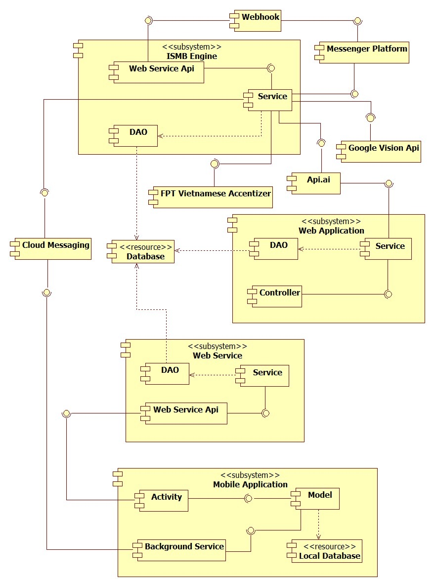

Figure 57 – Component Diagram

|  |  |
| --- | --- |
| **Component Dictionary: Describe Components** | |
| **Component Name** | **Description** |
| ISMB Engine | Component handles message from facebook users. |
| Web Application | Component to controll the system and training bot. |
| Web Service | Component provide api for mobile application to interact with the system. |
| Mobile Application | Component handles customers’ activities. |
| Database | Component to store data of the system. |
| Messenger Platform | Component to send message to and receive message from facebook user, provided by Facebook. |
| Webhook | Component handles interactions between Messenger Platform and ISMB Engine. |
| Google Vision Api | Component to detect product in images. |
| FPT Vietnamese Accentizer | Component to add Vietnamese accent into a senetence or phrase (Example: ca phe -> cà phê), provide by FPT. |
| Api.ai | Component to analyze natural language and response prametters that the system need to handle, proviced by Api.ai |
| Cloud Messaging | Coponent sends message from ISMB Engine to Mobile Application. |
| Controller | Component handles request from web. |
| Web Service Api | Component hanldes request from other components. |
| Service | Component handles business logic. |
| DAO | Component that do the interaction between the system and database. |
| Activity | Component handles customers’ interactions. |
| Model | Component handles business logic and interaction with local database. |
| Background Service | Component to run tasks in background. |

Table 15 - Components Diagram Data Dictionary

## Detailed Description

### Class Diagram

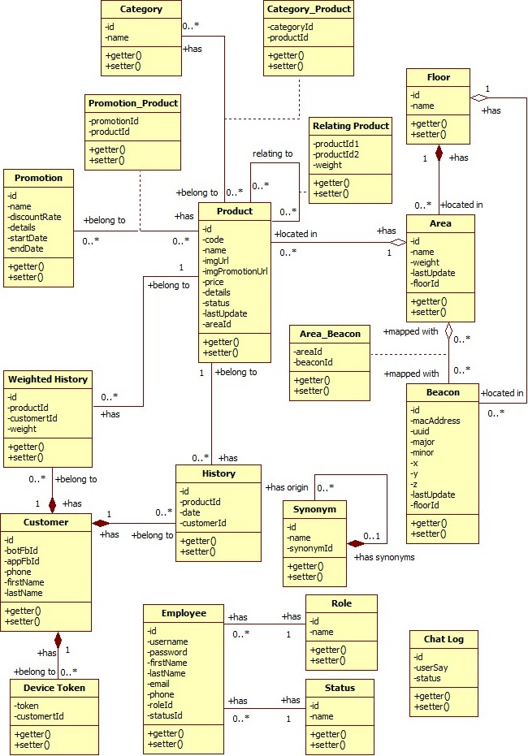

Figure 58 - Class Diagram

| **Class Dictionary: Describe Classes** | | |
| --- | --- | --- |
| **Class name** | **Mapping class with conceptual diagram** | **Description** |
| Category | Category | Contains the information of category. |
| Promotion | Promotion | Contains the information of promotion. |
| Floor | Floor | Contains the information of floor. |
| Area | Area | Contains the information of area. |
| Beacon | Beacon | Contains the information of beacon. |
| Product | Product | Contains the information of product. |
| Customer | Customer | Contains the information of customer. |
| Device Token | DeviceToken | Contains token of customers’ devices. Token is used for authentication and send message. |
| History | History | Contains the add to cart history of customer. |
| Weighted History | WeightedHistory | Contains the number of times a product was added to cart, use to suggest promotion for customers. |
| Category_Product | N/A | Contains mapping between category and product. |
| Promotion_Product | N/A | Contains mapping between promotion and product. |
| Relating Product | N/A | Contains relationship between products, use to suggest product to customer. |
| Area_Beacon | N/A | Contains mapping between area and beacon. |
| Synonym | Synonym | Contains the information of synonym. |
| Employee | Admin, Staff | Contains the information of account in web admin. Combine Admin and Staff entity from conceptual diagram. |
| Role | N/A | Contains information of Employee’s role. |
| Status | N/A | Contains information of Employee’s status. |
| Chatlog | Chatlog | Contains customer’s chat message when they send feedback. |

Table 16 - Class Diagram Data Dictionary

### Class Diagram Explanation

#### Category

##### Attributes

|  |  |  |  |
| --- | --- | --- | --- |
| **Attribute** | **Type** | **Visibility** | **Description** |
| id | int | Private | Unique id of category. |
| name | String | Private | Unique name of category. |

Table 17 - Category class attributes explanation

##### Methods

|  |  |  |  |
| --- | --- | --- | --- |
| **Method** | **Return type** | **Visibility** | **Description** |
| Getter | Attribute type | Public | Get attribute value. |
| Setter | Void | Public | Set value of attribute. |

Table 18 - Category class methods explanation

#### Promotion

##### Attributes

|  |  |  |  |
| --- | --- | --- | --- |
| **Attribute** | **Type** | **Visibility** | **Description** |
| id | long | Private | Unique id of promotion. |
| name | String | Private | Name of promotion. |
| discountRate | int | Private | The percentage of discount. |
| details | String | Private | Details of promotion. |
| startDate | long | Private | The date promotion start. |
| endDate | long | Private | The date promotion end. |

Table 19 - Promotion class attributes explanation

##### Methods

|  |  |  |  |
| --- | --- | --- | --- |
| **Method** | **Return type** | **Visibility** | **Description** |
| Getter | Attribute type | Public | Get attribute value. |
| Setter | Void | Public | Set value of attribute. |

Table 20 - Promotion class methods explanation

#### Floor

##### Attributes

|  |  |  |  |
| --- | --- | --- | --- |
| **Attribute** | **Type** | **Visibility** | **Description** |
| id | int | Private | Unique id of floor. |
| name | String | Private | Name of floor. |

Table 21 - Floor class attributes explanation

##### Methods

|  |  |  |  |
| --- | --- | --- | --- |
| **Method** | **Return type** | **Visibility** | **Description** |
| Getter | Attribute type | Public | Get attribute value. |
| Setter | Void | Public | Set value of attribute. |

Table 22 - Floor class methods explanation

#### Area

##### Attributes

|  |  |  |  |
| --- | --- | --- | --- |
| **Attribute** | **Type** | **Visibility** | **Description** |
| id | int | Private | Unique id of area. |
| name | String | Private | Name of area. |
| weight | Int | Private | Weight of area in supermarket, use to suggest which area to go first. |
| lastUpdate | long | Private | Time of last record update. |
| floorId | Int | Private | The unique id of floor. |

Table 23 - Area class attributes explanation

##### Methods

|  |  |  |  |
| --- | --- | --- | --- |
| **Method** | **Return type** | **Visibility** | **Description** |
| Getter | Attribute type | Public | Get attribute value. |
| Setter | Void | Public | Set value of attribute. |

Table 24 - Area class methods explanation

#### Beacon

##### Attributes

|  |  |  |  |
| --- | --- | --- | --- |
| **Attribute** | **Type** | **Visibility** | **Description** |
| id | int | Private | Unique id of promotion. |
| macAddress | String | Private | Unique mac address of beacon. |
| uuid | String | Private | uuid of beacon. |
| major | int | Private | Major number of beacon. |
| minor | int | Private | Minor number of beacon. |
| x | double | Private | Longitude of beacon (Ox axis). |
| y | double | Private | Lattitude of beacon (Oy axis). |
| z | double | Private | Altitude of beacon (Oz axis). |
| lastUpdate | long | Private | Time of last record update. |
| floorId | Int | Private | The unique id of floor. |

Table 25 - Beacon class attributes explanation

##### Methods

|  |  |  |  |
| --- | --- | --- | --- |
| **Method** | **Return type** | **Visibility** | **Description** |
| Getter | Attribute type | Public | Get attribute value. |
| Setter | Void | Public | Set value of attribute. |

Table 26 - Beacon class methods explanation

#### Product

##### Attributes

| **Attribute** | **Type** | **Visibility** | **Description** |
| --- | --- | --- | --- |
| id | long | Private | Unique id of product. |
| code | String | Private | Unique code of product. |
| name | String | Private | Name of product. |
| imgUrl | String | Private | Image url of product. |
| imgPromotionUrl | String | Private | Image url of product when has promotion |
| price | double | Private | Price of product. |
| details | String | Private | Details of product. |
| status | boolean | Private | Status of product. |
| lastUpdate | long | Private | Time of last record update. |
| areaId | int | Private | Unique id of area. |

Table 27 - Product class attributes explanation

##### Methods

|  |  |  |  |
| --- | --- | --- | --- |
| **Method** | **Return type** | **Visibility** | **Description** |
| Getter | Attribute type | Public | Get attribute value. |
| Setter | Void | Public | Set value of attribute. |

Table 28 - Product class methods explanation

#### Customer

##### Attributes

|  |  |  |  |
| --- | --- | --- | --- |
| **Attribute** | **Type** | **Visibility** | **Description** |
| id | long | Private | Unique id of customer. |
| botFbId | String | Private | Unique id of customer’s facebook account when chat with bot. |
| appFbId | String | Private | Unique id of customer’s facebook account when login mobile application. |
| phone | String | Private | Unique phone number of customer. |
| firstName | String | Private | First name of customer. |
| lastName | String | Private | Last name of customer. |

Table 29 - Customer class attributes explanation

##### Methods

|  |  |  |  |
| --- | --- | --- | --- |
| **Method** | **Return type** | **Visibility** | **Description** |
| Getter | Attribute type | Public | Get attribute value. |
| Setter | Void | Public | Set value of attribute. |

Table 30 - Customer class methods explanation

#### Device Token

##### Attributes

|  |  |  |  |
| --- | --- | --- | --- |
| **Attribute** | **Type** | **Visibility** | **Description** |
| token | String | Private | Unique token that device registers with server. |
| customerId | long | Private | Unique id of customer. |

Table 31 - Device Token class attributes explanation

##### Methods

|  |  |  |  |
| --- | --- | --- | --- |
| **Method** | **Return type** | **Visibility** | **Description** |
| Getter | Attribute type | Public | Get attribute value. |
| Setter | Void | Public | Set value of attribute. |

Table 32 - Device Token class methods explanation

#### History

##### Attributes

|  |  |  |  |
| --- | --- | --- | --- |
| **Attribute** | **Type** | **Visibility** | **Description** |
| id | long | Private | Unique id of history. |
| produtcId | long | Private | Unique id of product. |
| date | long | Private | Time when history is recorded. |
| customerId | long | Private | Unique id of customer. |

Table 33 - History class attributes explanation

##### Methods

|  |  |  |  |
| --- | --- | --- | --- |
| **Method** | **Return type** | **Visibility** | **Description** |
| Getter | Attribute type | Public | Get attribute value. |
| Setter | Void | Public | Set value of attribute. |

Table 34 - History class methods explanation

#### Category_Product

##### Attributes

|  |  |  |  |
| --- | --- | --- | --- |
| **Attribute** | **Type** | **Visibility** | **Description** |
| categorynId | long | Private | Unique id of category. |
| productId | long | Private | Unique id of product. |

Table 35 - Category_Product class attributes explanation

##### Methods

|  |  |  |  |
| --- | --- | --- | --- |
| **Method** | **Return type** | **Visibility** | **Description** |
| Getter | Attribute type | Public | Get attribute value. |
| Setter | Void | Public | Set value of attribute. |

Table 36 - Category_Product class methods explaination

#### Weighted History

##### Attributes

| **Attribute** | **Type** | **Visibility** | **Description** |
| --- | --- | --- | --- |
| id | long | Private | Unique id of history. |
| produtcId | long | Private | Unique id of product. |
| customerId | long | Private | Unique id of customer. |
| weight | int | Private | Number of times a product is add to cart, use to suggest promotion for customer. |

Table 37 - WeightedHistory class attributes explanation

##### Methods

|  |  |  |  |
| --- | --- | --- | --- |
| **Method** | **Return type** | **Visibility** | **Description** |
| Getter | Attribute type | Public | Get attribute value. |
| Setter | Void | Public | Set value of attribute. |

Table 38 - WeightedHistory class methods explanation

#### Promotion_Product

##### Attributes

|  |  |  |  |
| --- | --- | --- | --- |
| **Attribute** | **Type** | **Visibility** | **Description** |
| promotionId | long | Private | Unique id of promotion. |
| productId | long | Private | Unique id of product. |

Table 39 - Promotion_Product class attributes explanation

##### Methods

|  |  |  |  |
| --- | --- | --- | --- |
| **Method** | **Return type** | **Visibility** | **Description** |
| Getter | Attribute type | Public | Get attribute value. |
| Setter | Void | Public | Set value of attribute. |

Table 40 - Promotion_Product class methods explanation

#### Relating Product

##### Attributes

|  |  |  |  |
| --- | --- | --- | --- |
| **Attribute** | **Type** | **Visibility** | **Description** |
| productId1 | long | Private | Unique id of product. |
| productId2 | long | Private | Unique id of product. |
| weight | int | Private | Relevance between 2 products. |

Table 41 - Relating Product class attributes explanation

##### Methods

|  |  |  |  |
| --- | --- | --- | --- |
| **Method** | **Return type** | **Visibility** | **Description** |
| Getter | Attribute type | Public | Get attribute value. |
| Setter | Void | Public | Set value of attribute. |

Table 42 - Relating Product class methods explanation

#### Area_Beacon

##### Attributes

| **Attribute** | **Type** | **Visibility** | **Description** |
| --- | --- | --- | --- |
| areaId | int | Private | Unique id of area. |
| beaconId | int | Private | Unique id of beacon. |

Table 43 - Area_Beacon class attributes explanation

##### Methods

|  |  |  |  |
| --- | --- | --- | --- |
| **Method** | **Return type** | **Visibility** | **Description** |
| Getter | Attribute type | Public | Get attribute value. |
| Setter | Void | Public | Set value of attribute. |

Table 44 - Area_Beacon class methods explanation

#### Synonym

##### Attributes

|  |  |  |  |
| --- | --- | --- | --- |
| **Attribute** | **Type** | **Visibility** | **Description** |
| id | int | Private | Unique id of a word. |
| name | int | Private | Unique id of a word. |
| synonymId | int | Private | Unique id of a word which is a synonym of this word. |

Table 45 - Synonym class attributes explanation

##### Methods

|  |  |  |  |
| --- | --- | --- | --- |
| **Method** | **Return type** | **Visibility** | **Description** |
| Getter | Attribute type | Public | Get attribute value. |
| Setter | Void | Public | Set value of attribute. |

Table 46 - Synonym class methods explanation

#### Employee

##### Attributes

|  |  |  |  |
| --- | --- | --- | --- |
| **Attribute** | **Type** | **Visibility** | **Description** |
| id | int | Private | Unique id of employee. |
| username | int | Private | Unique username of employee. |
| password | int | Private | Password of employee |
| firstName | String | Private | First name of employee. |
| lastName | String | Private | Last name of employee. |
| email | String | Private | Email of employee. |
| phone | String | Private | Phone number of employee. |
| roleId | int | Private | Unique id of role. |
| statusId | int | Private | Unique id of status. |

Table 47 - Employee class attributes explanation

##### Methods

|  |  |  |  |
| --- | --- | --- | --- |
| **Method** | **Return type** | **Visibility** | **Description** |
| Getter | Attribute type | Public | Get attribute value. |
| Setter | Void | Public | Set value of attribute. |

Table 48 - Employee class methods explanation

#### Role

##### Attributes

|  |  |  |  |
| --- | --- | --- | --- |
| **Attribute** | **Type** | **Visibility** | **Description** |
| id | int | Private | Unique id of role. |
| name | int | Private | Unique name of role. |

Table 49 - Role class attributes explanation

##### Methods

|  |  |  |  |
| --- | --- | --- | --- |
| **Method** | **Return type** | **Visibility** | **Description** |
| Getter | Attribute type | Public | Get attribute value. |
| Setter | Void | Public | Set value of attribute. |

Table 50 - Role class methods explanation

#### Status

##### Attributes

|  |  |  |  |
| --- | --- | --- | --- |
| **Attribute** | **Type** | **Visibility** | **Description** |
| id | int | Private | Unique id of status. |
| name | int | Private | Unique name of status. |

Table 51 - Status class attributes explanation

##### Methods

|  |  |  |  |
| --- | --- | --- | --- |
| **Method** | **Return type** | **Visibility** | **Description** |
| Getter | Attribute type | Public | Get attribute value. |
| Setter | Void | Public | Set value of attribute. |

Table 52 - Status class methods explanation

#### Chat Log

##### Attributes

|  |  |  |  |
| --- | --- | --- | --- |
| **Attribute** | **Type** | **Visibility** | **Description** |
| id | long | Private | Unique id of chat log. |
| userSay | String | Private | Chat message of customer. |
| status | int | Private | Status of chat log. |

Table 53 - Chat Log class attributes explanation

##### Methods

|  |  |  |  |
| --- | --- | --- | --- |
| **Method** | **Return type** | **Visibility** | **Description** |
| Getter | Attribute type | Public | Get attribute value. |
| Setter | Void | Public | Set value of attribute. |

Table 54 - Chat Log class methods explanation

### Interaction Diagram

#### ISMB Engine

**Summary:** This diagram show how the enginge interact.

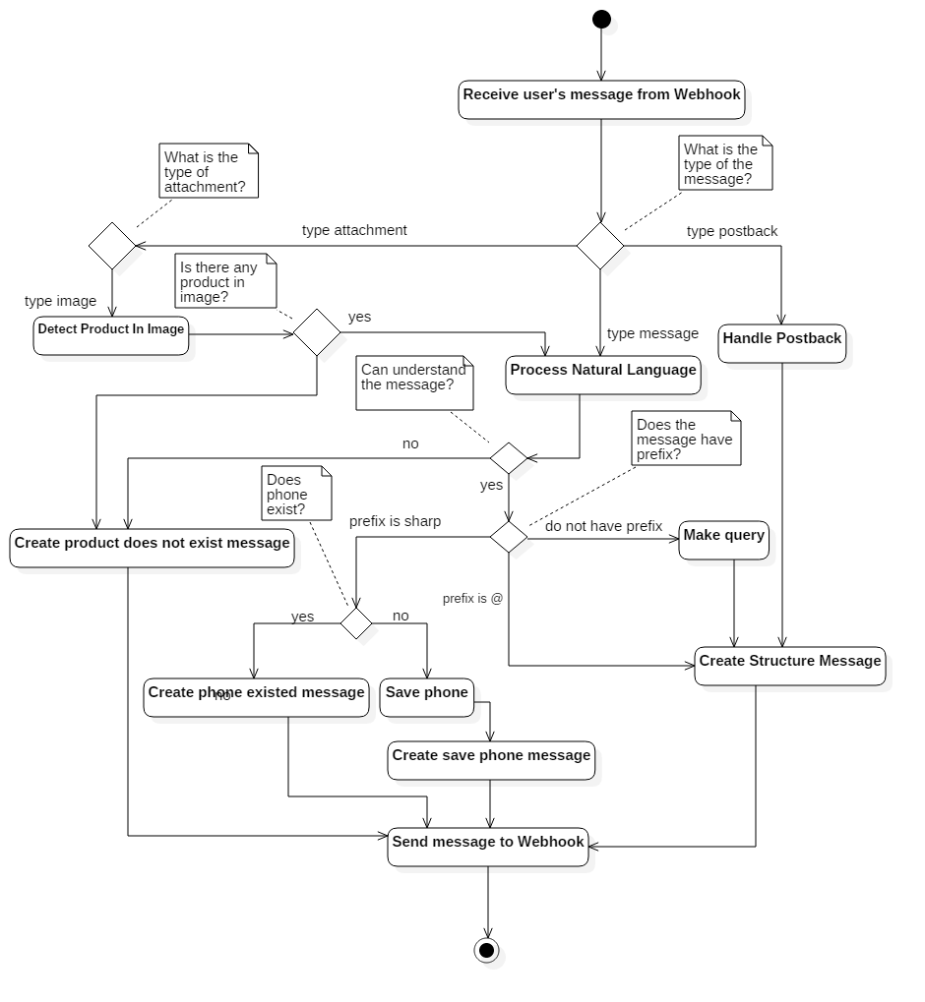

Figure 59 - <ISMB Enginge> Process with api – Interaction diagram

*Ref:* [*http://www.uml-diagrams.org/activity-diagrams-controls.html*](http://www.uml-diagrams.org/activity-diagrams-controls.html)

#### <Staff> Import Data

**Summary:** This diagram show how Staff imports products from excel file.

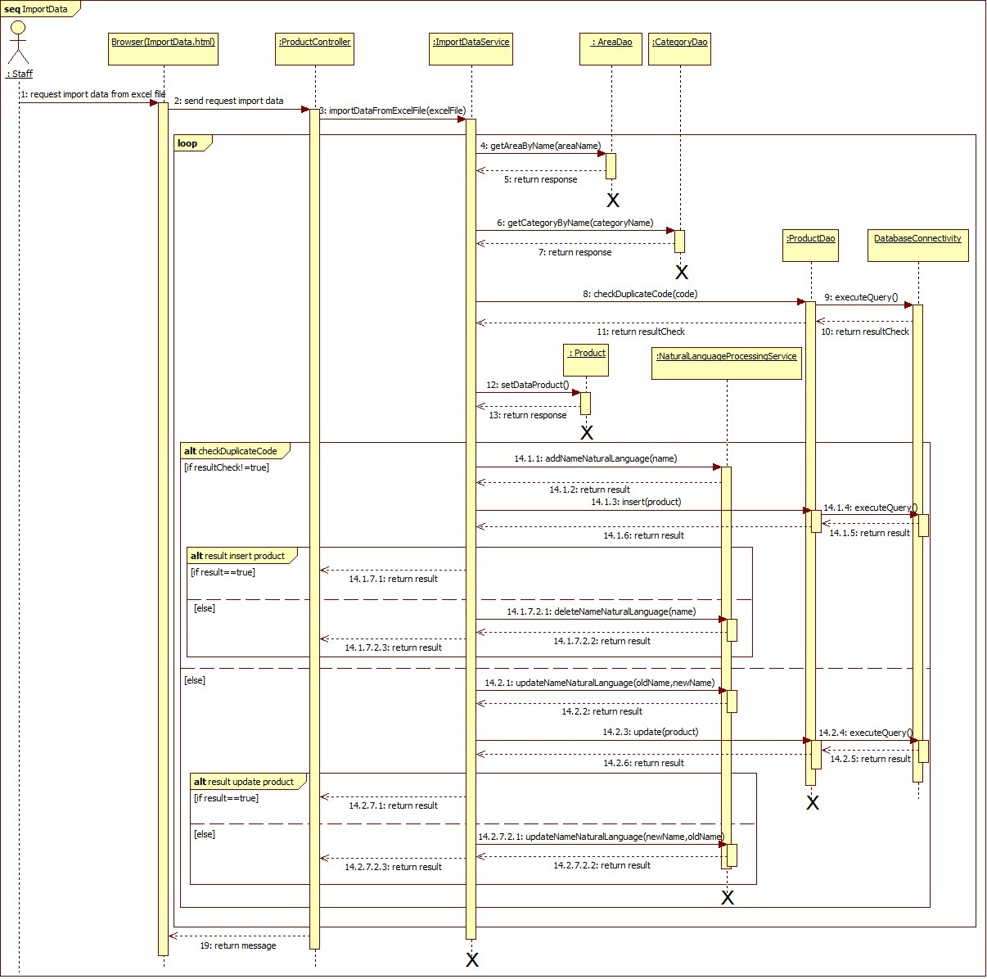

Figure 60 - <Staff> Import Data SD

#### <Staff> Insert Product

**Summary:** This diagram show how Staff inserts Product.

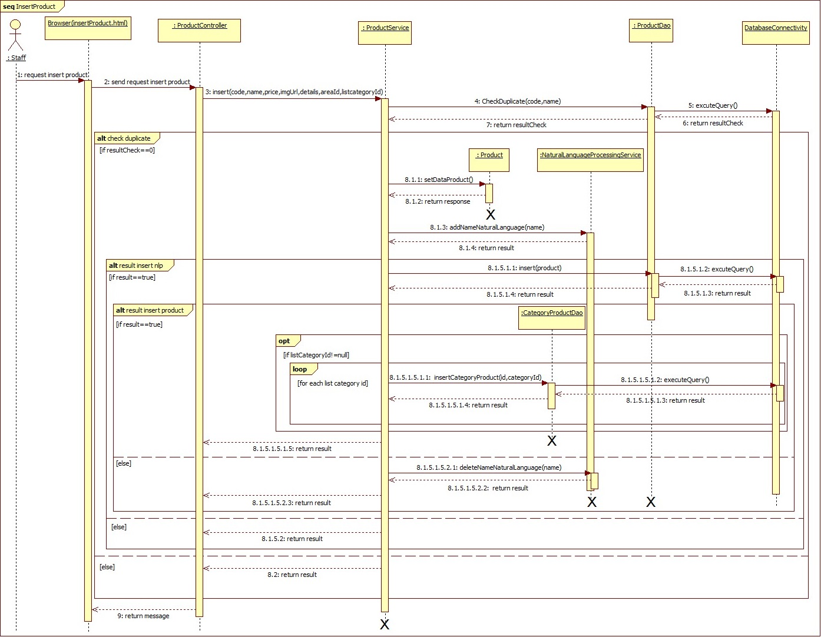

Figure 61 - <Staff> Insert Product SD

#### <Staff> Update Product

**Summary:** This diagram show how Staff updates Product.

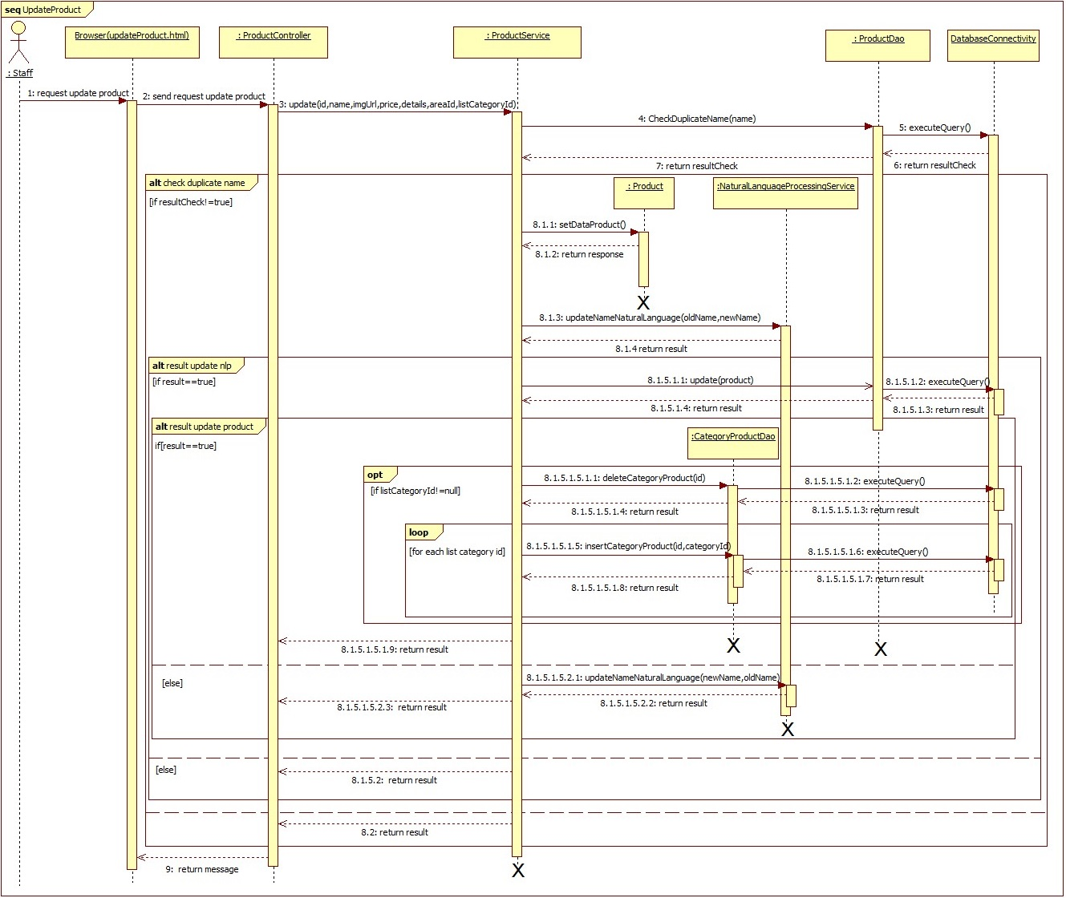

Figure 62 - <Staff> Update Product UI

#### <Staff> Deactivate Product

**Summary:** This diagram show how Staff deactivates product.

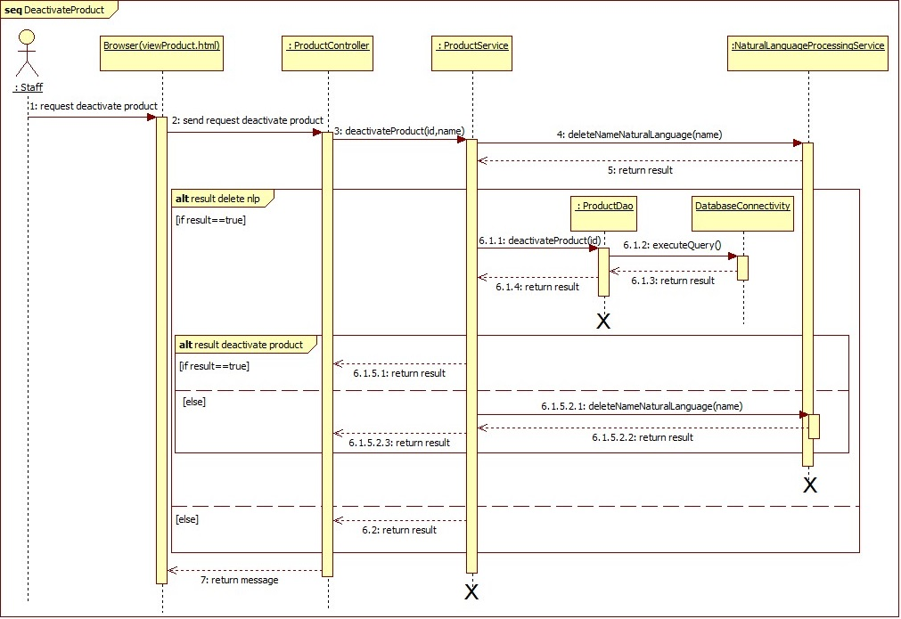

Figure 63 - <Staff> Deactivate Product SD

#### <Staff> Activate Product

**Summary:** This diagram show how Staff activates product.

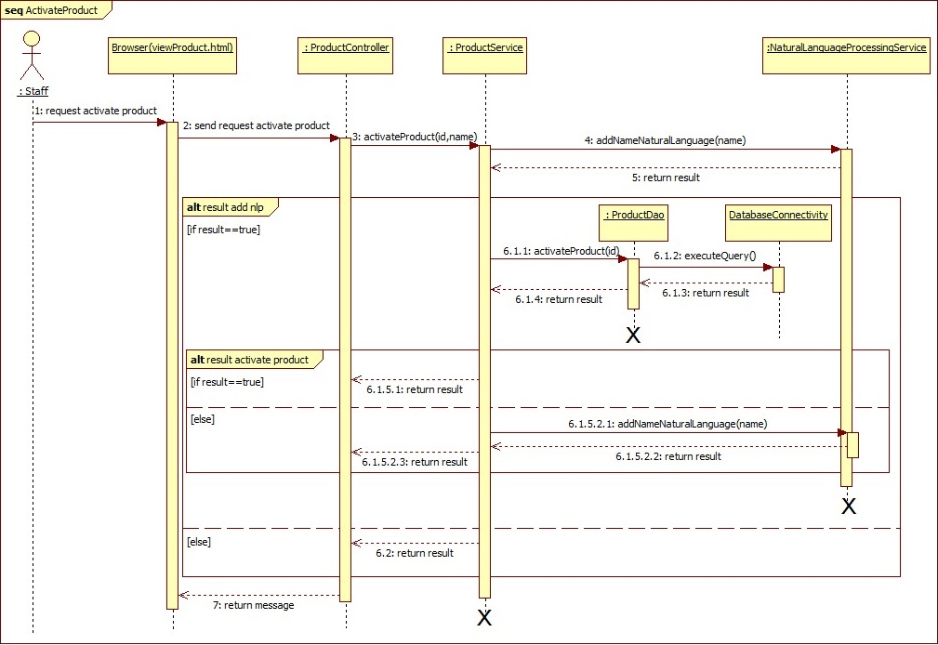

Figure 64 - <Staff> Activate Product SD

#### <Staff> Mapping Relating Products

**Summary:** This diagram show how Staff mapping Relating Products.

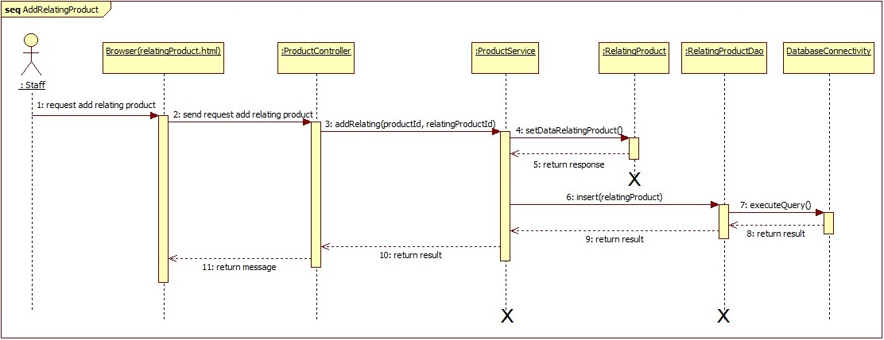

Figure 65 - <Staff> Mapping Relating Products SD

#### <Staff> Delete Mapping between Products

**Summary:** This diagram show how Staff deletes Mapping between Products.

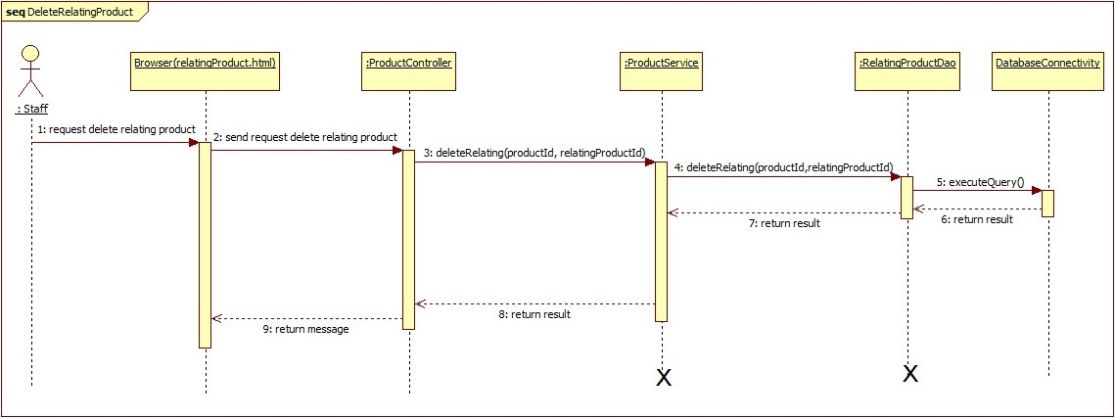

Figure 66 - <Staff> Delete Mapping between Products SD

#### <Staff> Insert Promotion

**Summary:** This diagram show how Staff inserts Prmotion.

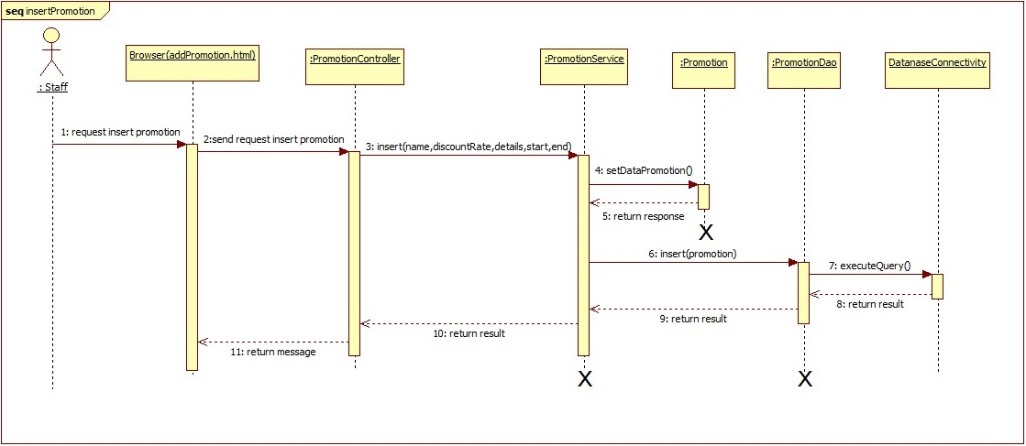

Figure 67 - <Staff> Insert Promotion SD

#### <Staff> Update Promotion

**Summary:** This diagram show how Staff updates Promotion.

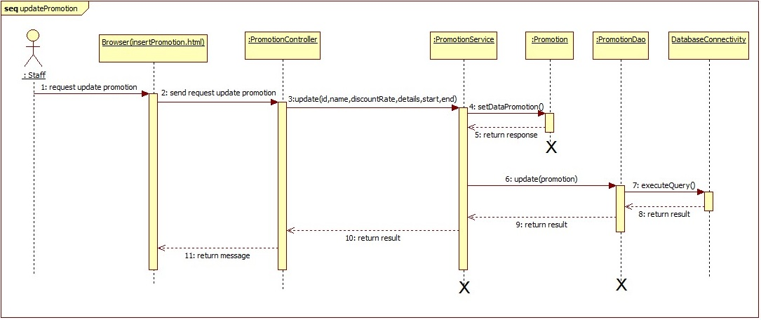

Figure 68 - <Staff> Update Promotion SD

#### <Staff> Delete Promotion

**Summary:** This diagram show how Staff deletes Promotion.

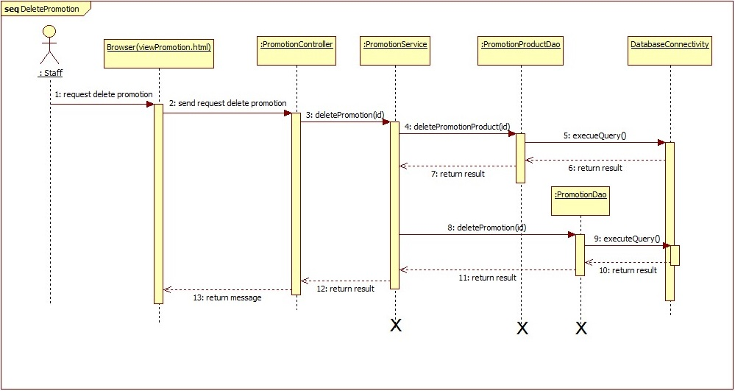

Figure 69 - <Staff> Delete Promotion SD

#### <Staff> Mapping Product with Promotion

**Summary:** This diagram show how Staff mapping Product with Promotion.

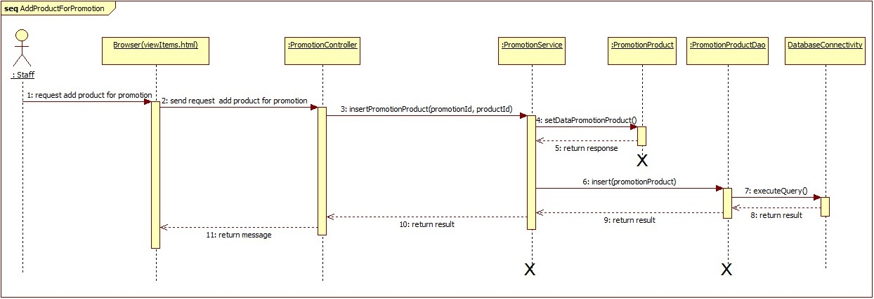

Figure 70 - <Staff> Mapping Product with Promotion

#### <Staff> Delete Mapping between Product and Promotion

**Summary:** This diagram show how Staff deletes Mapping between Product and Promotion.

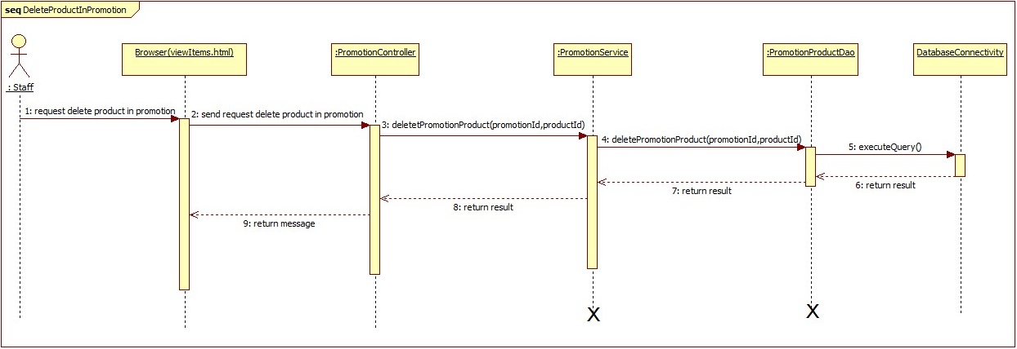

Figure 71 - <Staff> Delete Mapping between Product and Promotion

#### <Staff> Insert Original Word

**Summary:** This diagram show how Staff inserts Original Word.

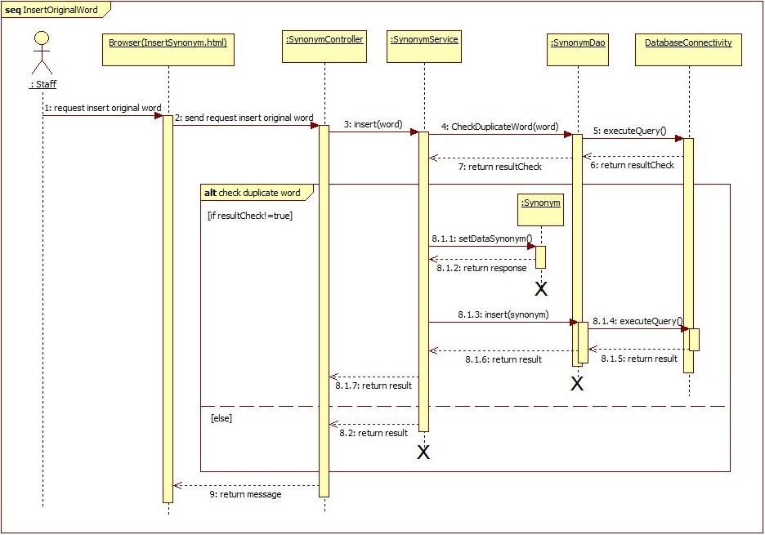

Figure 72 - <Staff> Insert Original Word SD

#### <Staff> Update Original Word

**Summary:** This diagram show how Staff updates Original Word.

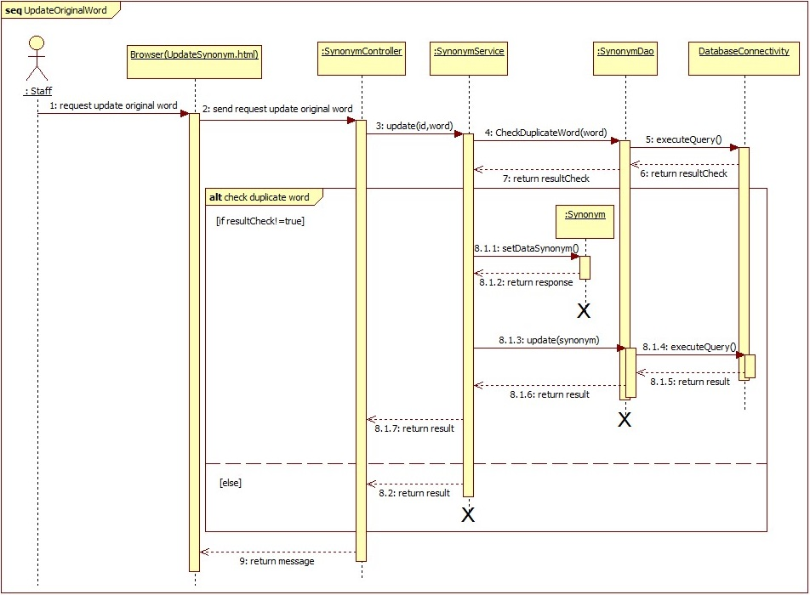

Figure 73 - <Staff> Update Original Word

#### <Staff> Delete Original Word

**Summary:** This diagram show how Staff deletes Original Word.

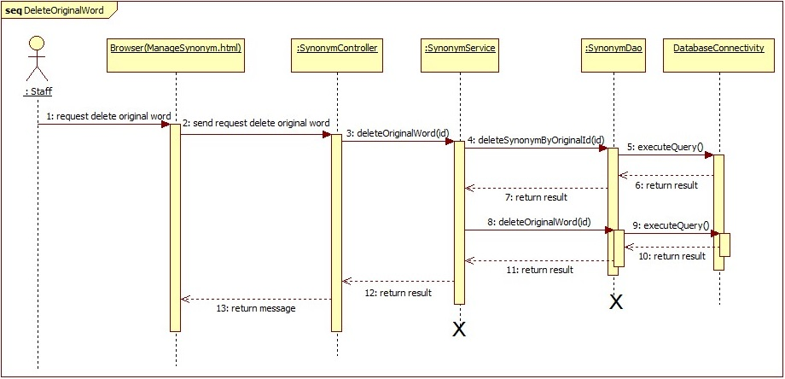

Figure 74 - <Staff> Delete Original Word

#### <Staff> Insert Synonym

**Summary:** This diagram show how Staff inserts Synonym.

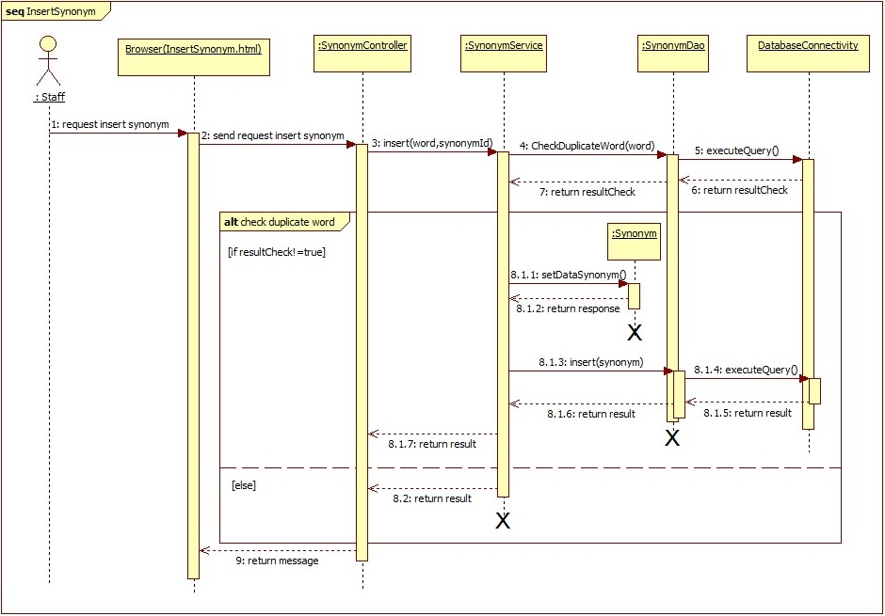

Figure 75 - <Staff> Insert Synonym SD

#### <Staff> Update Synonym

**Summary:** This diagram show how Staff updates Synonym.

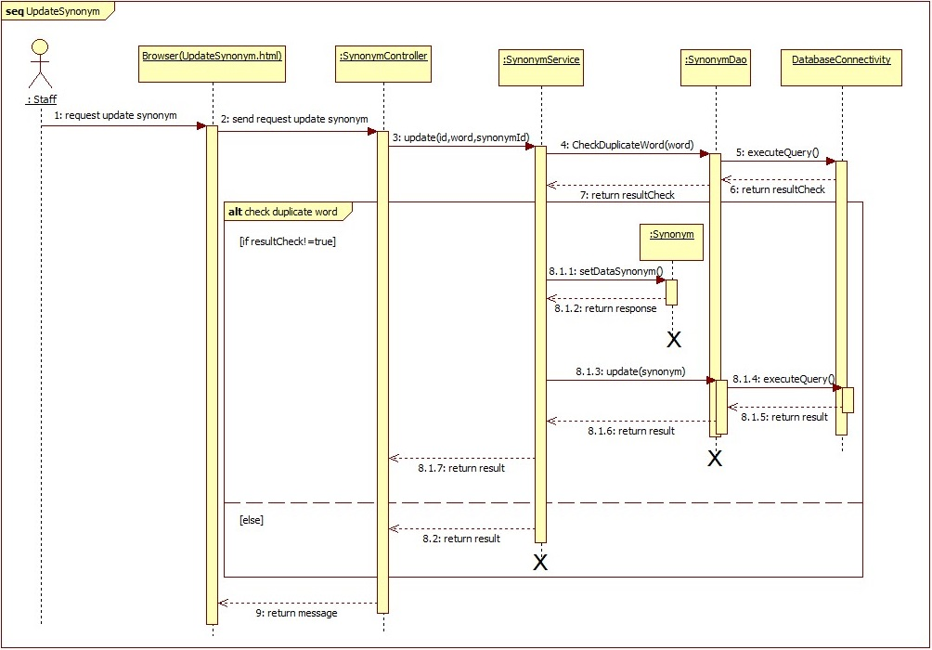

Figure 76 - <Staff> Update Synonym SD

#### <Staff> Delete Synonym

**Summary:** This diagram show how Staff deletes Synonym.

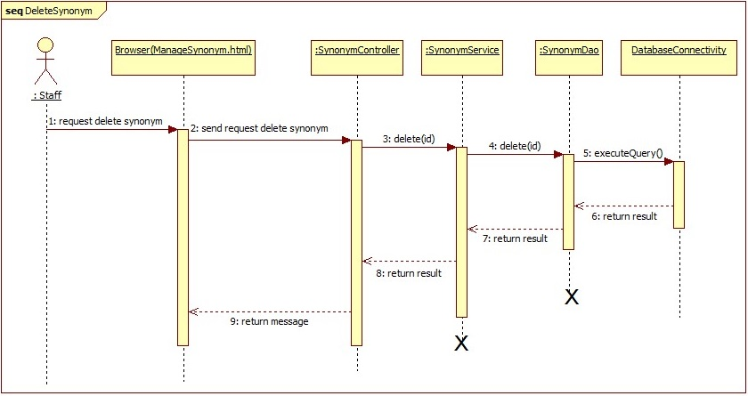

Figure 77 - <Staff> Delete Synonym SD

#### <Staff> Insert Information

##### Insert Beacon

**Summary:** This diagram show how Staff inserts Beacon.

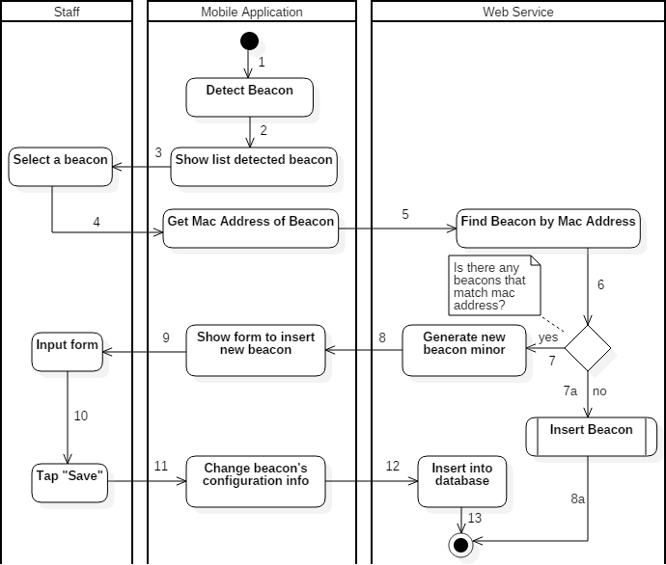

Figure 78 - <Staff> Insert Beacon AD

##### Insert Area

**Summary:** This diagram show how Staff inserts Area.

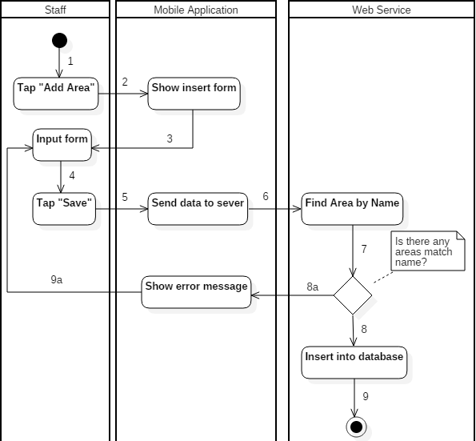

Figure 79 - <Staff> Insert Area AD

##### Insert Category

**Summary:** This diagram show how Staff inserts Category

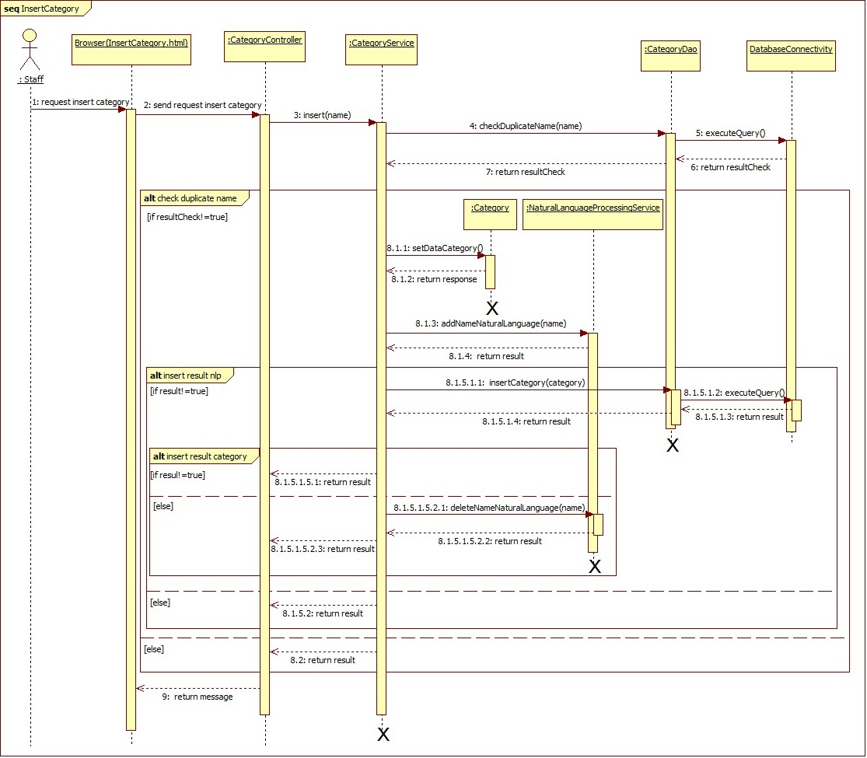

Figure 80 - <Staff> Insert Category SD

##### Insert Floor

**Summary:** This diagram show how Staff inserts Floor.

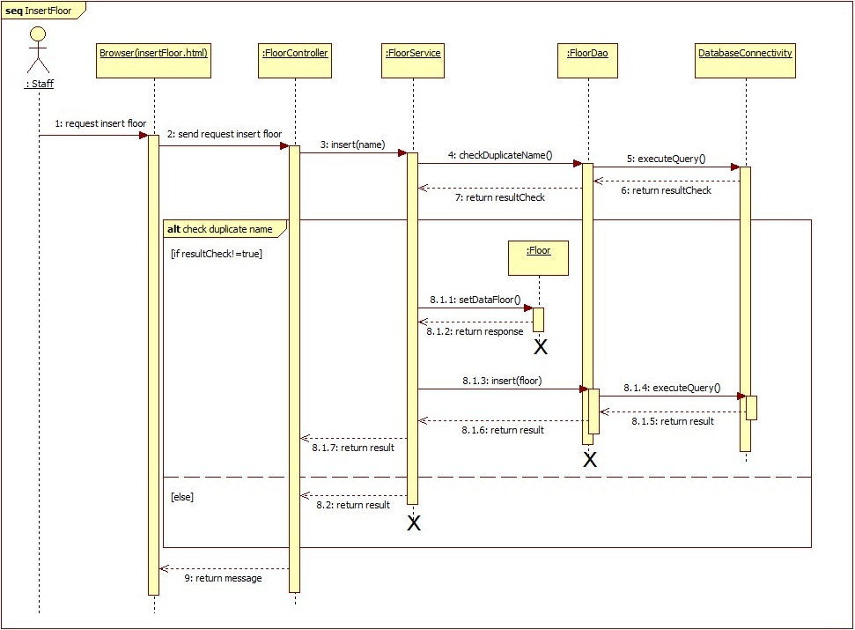

Figure 81 - <Staff> Insert Floor SD

#### <Staff> Update Information

##### Update Beacon

**Summary:** This diagram show how Staff updates Beacon.

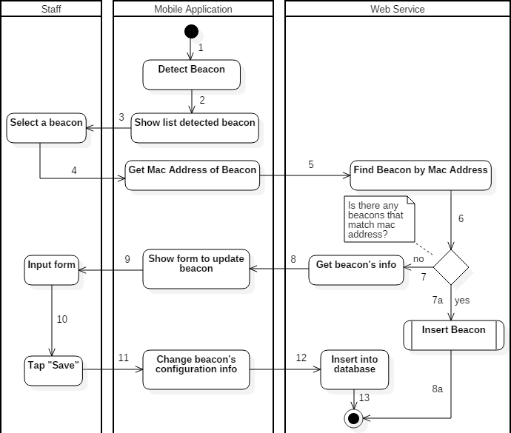

Figure 82 - <Staff> Update Beacon AD

##### Update Area

**Summary:** This diagram show how Staff updates Area.

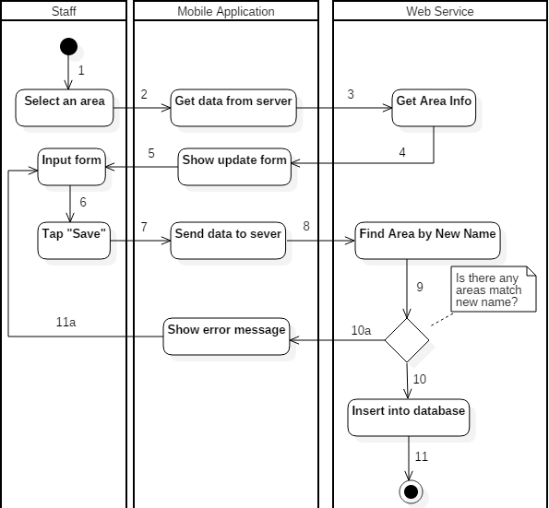

Figure 83 - <Staff> Update Area AD

##### Update Category

**Summary:** This diagram show how Staff updates Category.

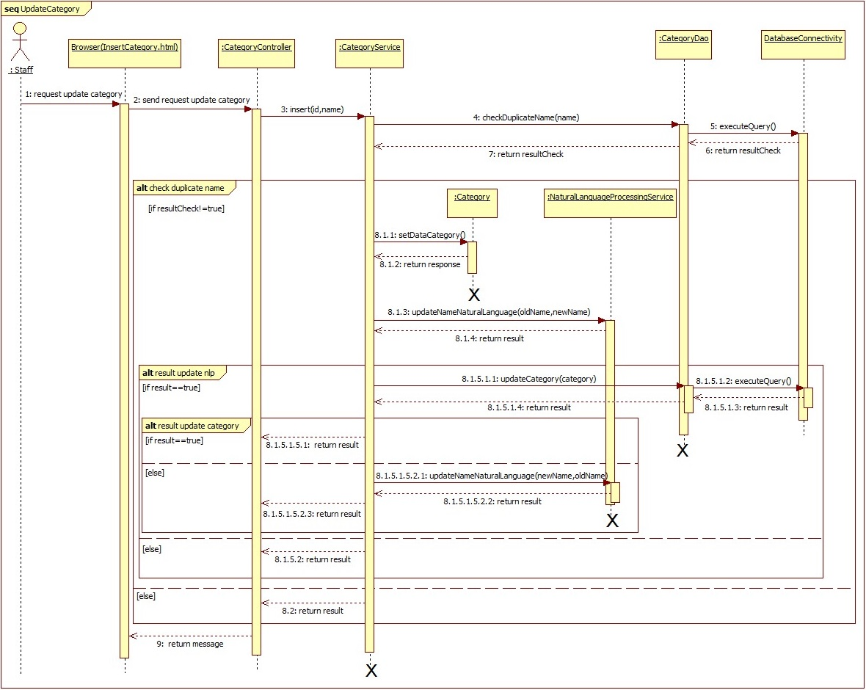

Figure 84 - <Staff> Update Category SD

##### Update Floor

**Summary:** This diagram show how Staff updates Floor.

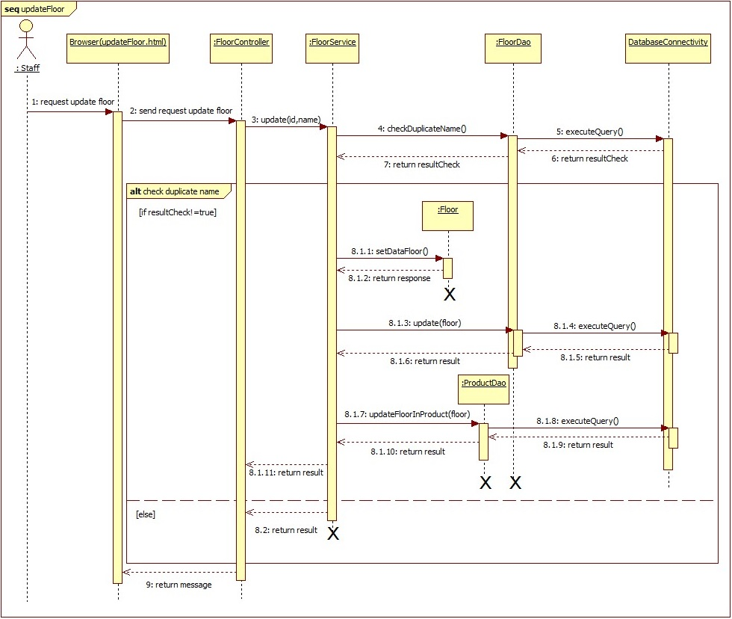

Figure 85 - <Staff> Update Floor SD

#### <Staff> Delete Information

##### Delete Beacon

**Summary:** This diagram show how Staff deletes Beacon.

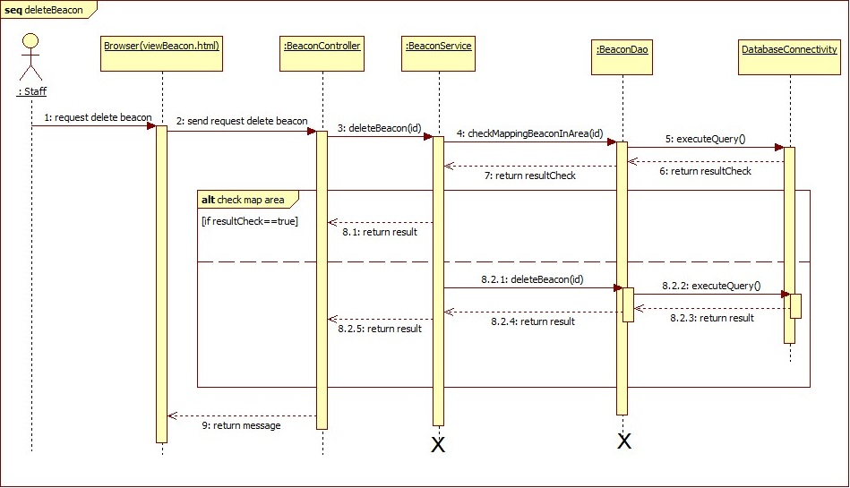

Figure 86 - <Staff> Delete Beacon SD

##### Delete Area

**Summary:** This diagram show how Staff deletes Area.

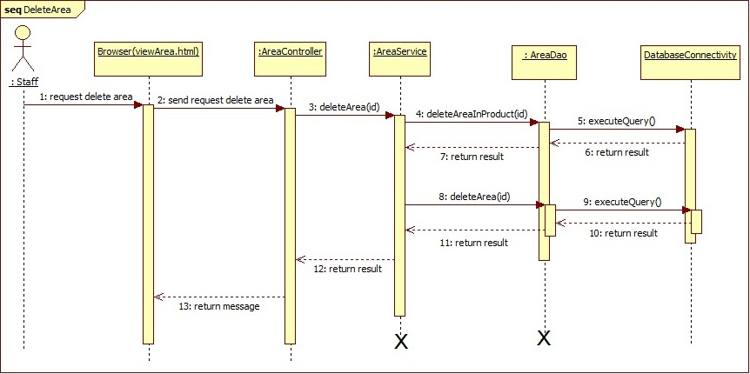

Figure 87 - <Staff> Delete Area SD

##### Delete Category

**Summary:** This diagram show how Staff deletes Category.

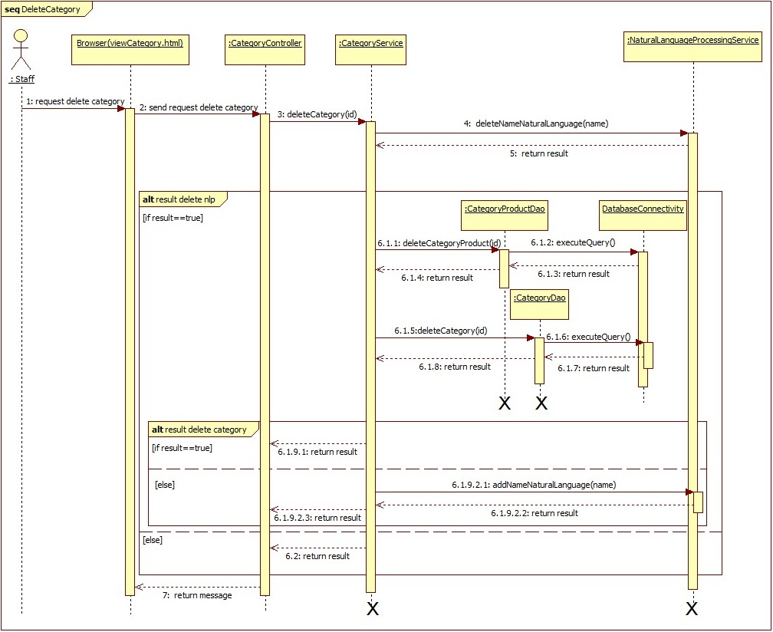

Figure 88 - <Staff> Delete Category SD

##### Delete Floor

**Summary:** This diagram show how Staff deletes Floor.

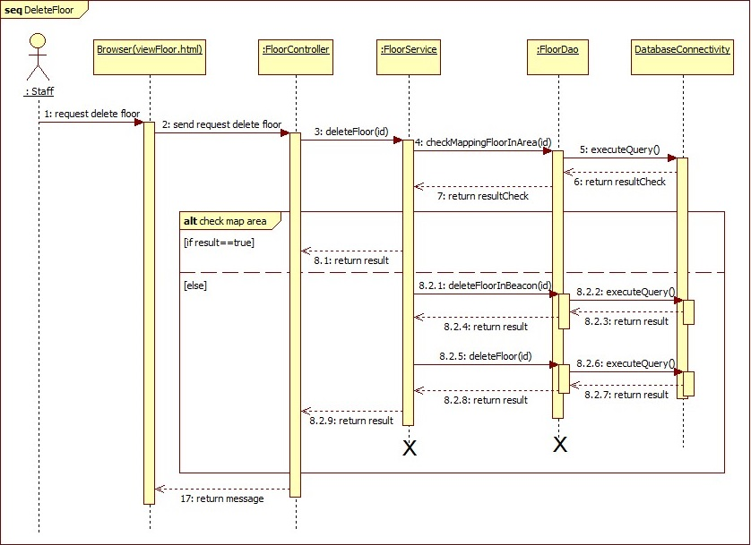

Figure 89 -<Staff> Delete Floor SD

#### <Staff> Delete Log

**Summary:** This diagram show how Staff deletes Log.

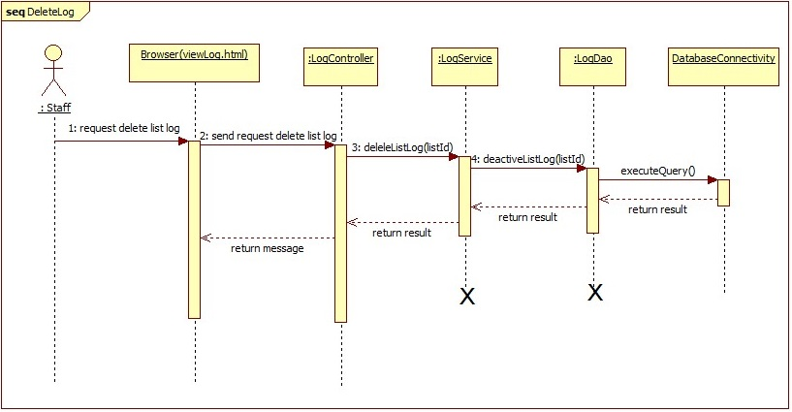

Figure 90 - <Staff> Delete Log SD

#### <Admin> Create Account

**Summary:** This diagram show how Admin creates account.

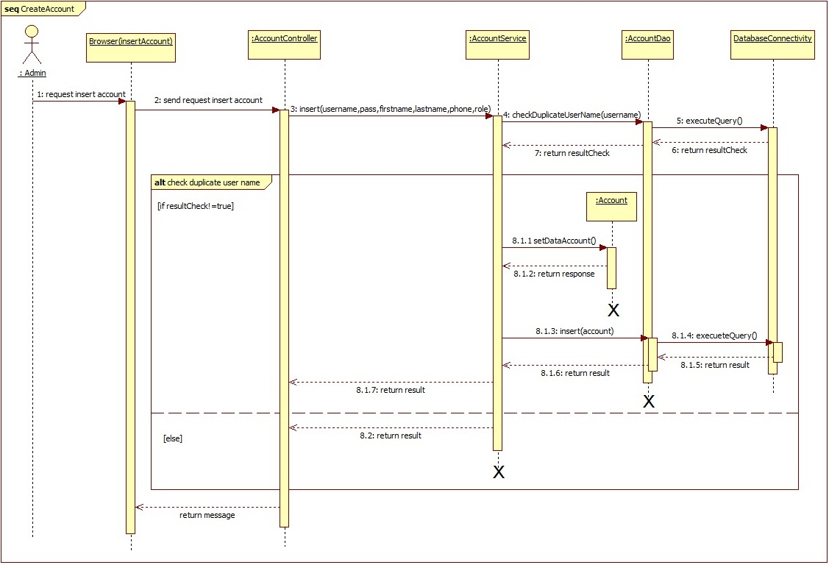

Figure 91 - <Admin> Create Acount SD

#### <Admin> Activate/Deactivate Account

**Summary:** This diagram show how Admin activate/deactivate account.

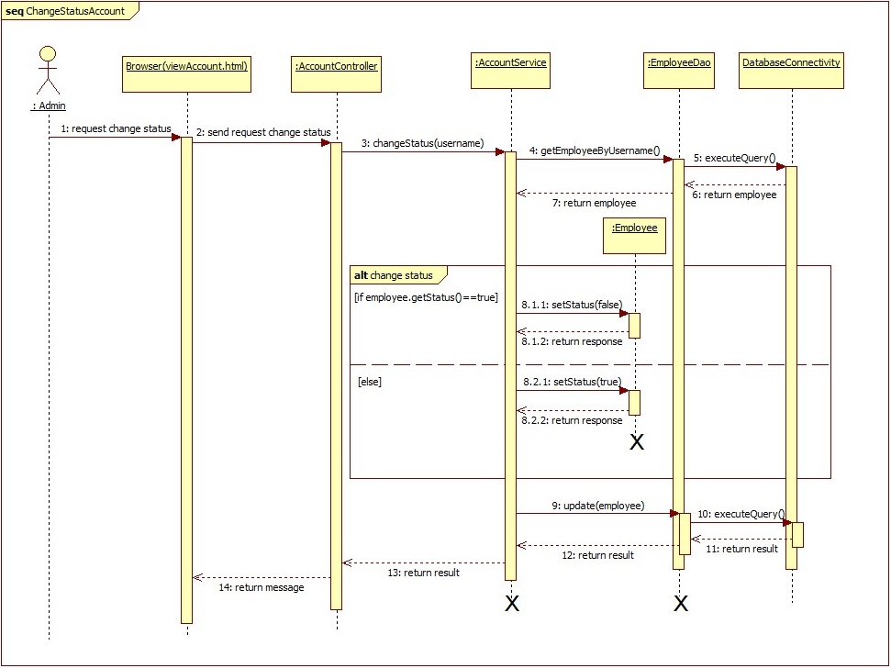

Figure 92 - <Admin> Activate/Deactive Account

#### <Scheduler> Train by Synonym

**Summary:** This diagram show how Scheduler train bot by synonym.

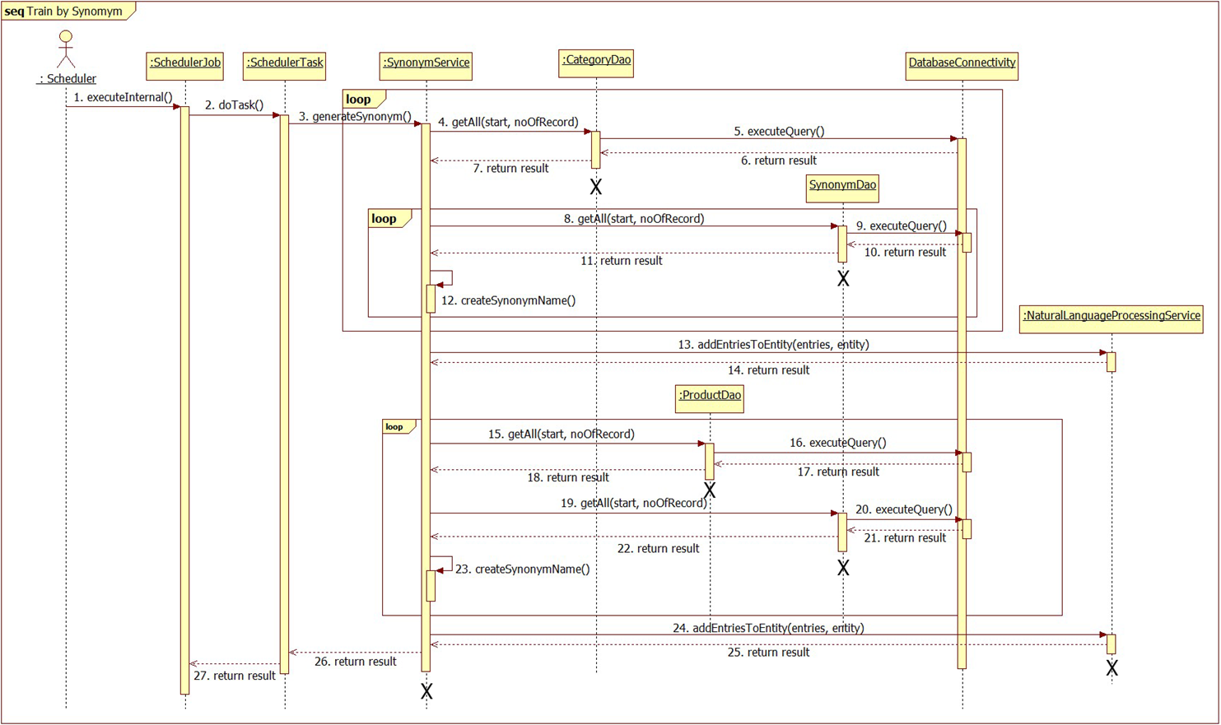

Figure 93 - <Scheduler> Train by Synonym SD

#### <Customer> Insert Phone

**Summary:** This diagram show how Customer inserts Phone number.

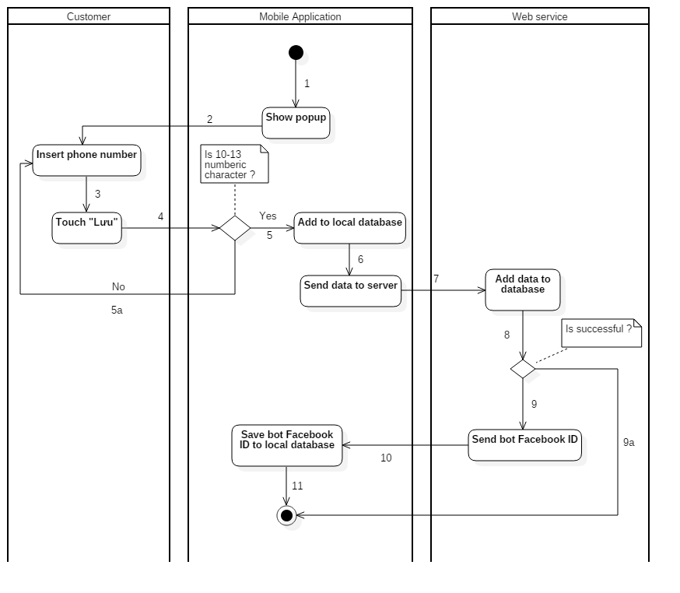

Figure 94 - <Customer> Insert Phone AD

#### <Customer> Change Phone

**Summary:** This diagram show how Customer change Phone number.

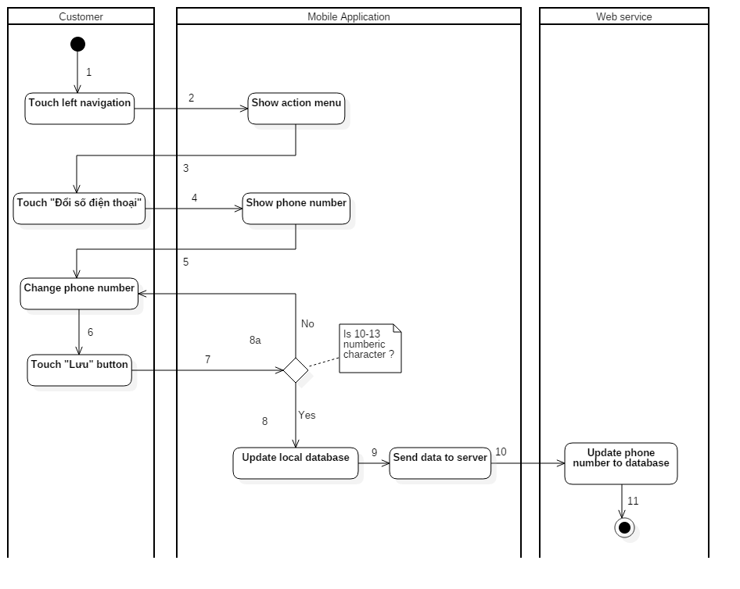

Figure 95 - <Customer> Change Phone AD

#### <Auto Handler> Indentify Floor

**Summary:** This diagram show the process of indentify customer is in which floor.

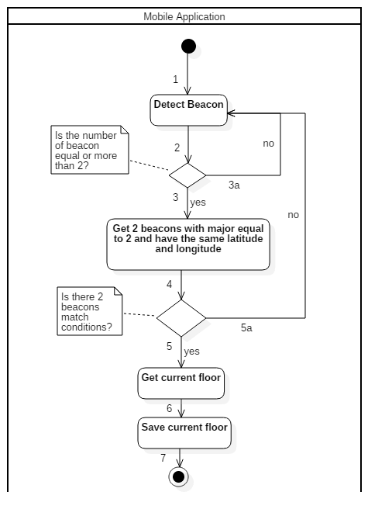

Figure 96 - <Auto Handler> Indentify Floor AD

#### <Auto Handler> Indentify Area

**Summary:** This diagram show the process of indentify customer is in which area.

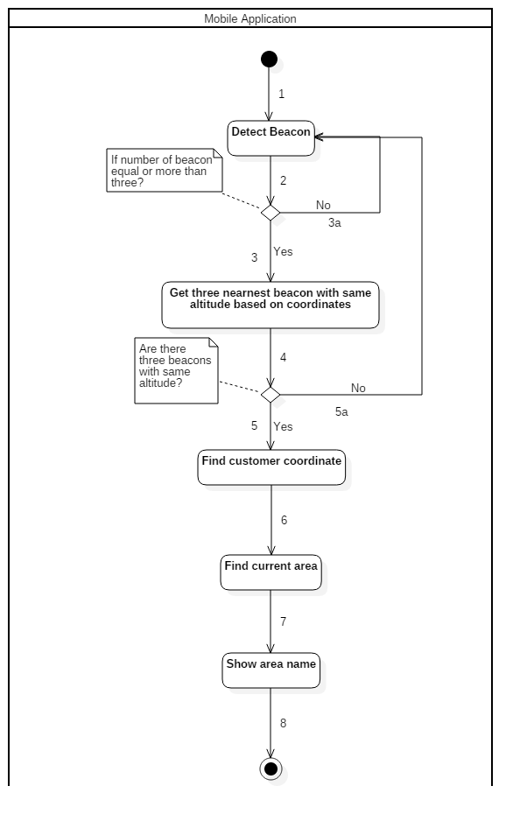

Figure 97 - <Auto Handler> Indentify Area

#### <Auto Handler> Detect Product

**Summary:** This diagram show the process of detect nearby product.

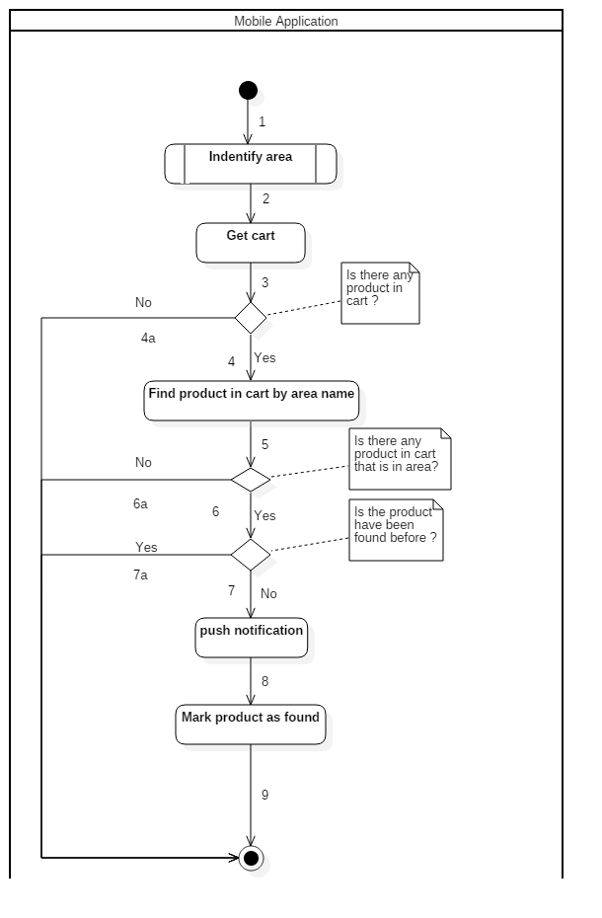

Figure 98 - <Auto Handler> Detect Product AD

## User Interface Design

### Component Interface

Component Interface are Web Service API which will be used by Mobile Application.

| **Signature** | **Description** | **Input** | **Output** | **Output Format** |
| --- | --- | --- | --- | --- |
| registerPhone(phoneInfo, deviceToken) | Mapping customer’s account between chatbot and mobile application by phone number. | phoneInfo: PhoneInfo  deviceToken: String | String response | String |
| getCart(botInfo, deviceToken) | Get cart from server. | botInfo: BotInfo  deviceToken: String | String response | String |
| syncCart(cartInfo, deviceToken) | Sync cart between client and server. | cartInfo: CartInfo  deviceToken: String | String response | String |
| getProduct(deviceToken, lastUpdate) | Get latest information of products for customer. | deviceToken: String  lastUpdate: long | String response | String |
| getBeacon(deviceToken, lastUpdate) | Get latest information of beacons for customer. | deviceToken: String  lastUpdate: long | String response | String |
| getArea(deviceToken, lastUpdate) | Get latest information of areas for customer. | deviceToken: String  lastUpdate: long | String response | String |
| authorize(account) | Validate login info of user. | account: Account | String response | String |
| getFloor(deviceToken, Account) | Get information of floors for staff. | deviceToken: String  account: Account | String response | String |
| getBeaconStaff(deviceToken,  account) | Get information of beacons for staff. | deviceToken: String  account: Account | String response | String |
| generateBeaconMinor(deviceToken,  account) | Generate minor number for a new beacon. | deviceToken: String  account: Account | String response | String |
| getBeaconInfo(deviceToken, MacObj) | Get informantion of a beacon for staff. | deviceToken: String  minorObj: MinorObj | String response | String |
| insertBeacon(deviceToken, beaconObj) | Insert information of a new beacon into storage. | deviceToken: String  beaconObj: BeaconObj | String response | String |
| updateBeacon(deviceToken, beaconObj) | Update information a beacon in storage. | deviceToken: String  beaconObj: BeaconObj | String response | String |
| getAreaStaff(deviceToken,  account) | Get information of areas for staff. | deviceToken: String  account: Account | String response | String |
| getAreaInfo(deviceToken,  nameObj) | Get information of a area for staff. | deviceToken: String  nameObj: NameObj | String response | String |
| insertArea(deviceToken,  areaObj) | Insert information of a new area into storage. | deviceToken: String  areaObj: AreaObj | String response | String |
| updateArea(deviceToken,  areaObj) | Update information an area in storage. | deviceToken: String  areaObj: AreaObj | String response | String |

Table 55 - Component Interface

### User Interface Design

#### Mobile Application For Customer

##### Login

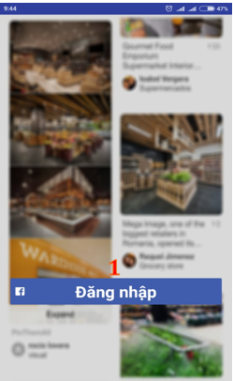

Figure 99 - Login UI

**Fields:** N/A

**Buttons/Hyperlinks**

|  |  |  |  |  |
| --- | --- | --- | --- | --- |
| **No** | **Function** | **Description** | **Validation** | **Outcome** |
| 1 | login | Login with facebook account | N/A | Redirect to insert phone number view |

Table 56 - <Mobile Application for Customer> Login Buttons/Hyperlinks

##### Insert Phone Number

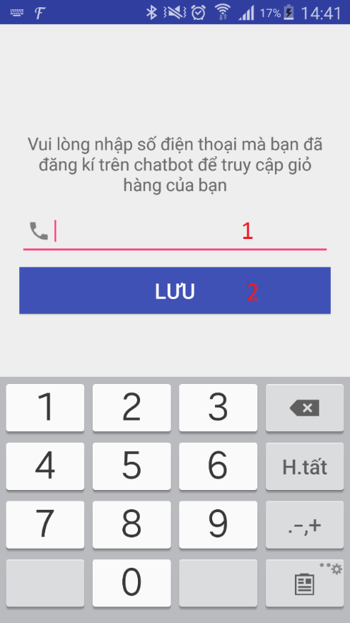

Figure 100 - Insert Phone Number UI

**Fields**

|  |  |  |  |  |  |  |
| --- | --- | --- | --- | --- | --- | --- |
| **No** | **Field Names** | **Description** | **Read Only** | **Mandatory** | **Control Type** | **Data Type** |
| 1 | PhoneNumber | Fill phone number | No | Yes | EditText | String |

Table 57 - <Mobile Application for Customer> Insert Phone Number Fields

**Buttons/Hyperlinks**

|  |  |  |  |  |
| --- | --- | --- | --- | --- |
| **No** | **Function** | **Description** | **Validation** | **Outcome** |
| 2 | insertPhone | Save phone number | All fields required before summit | Redirect to view cart view. |

Table 58 - <Mobile Application for Customer> Insert Phone Number Buttons/Hyperlinks

##### Menu

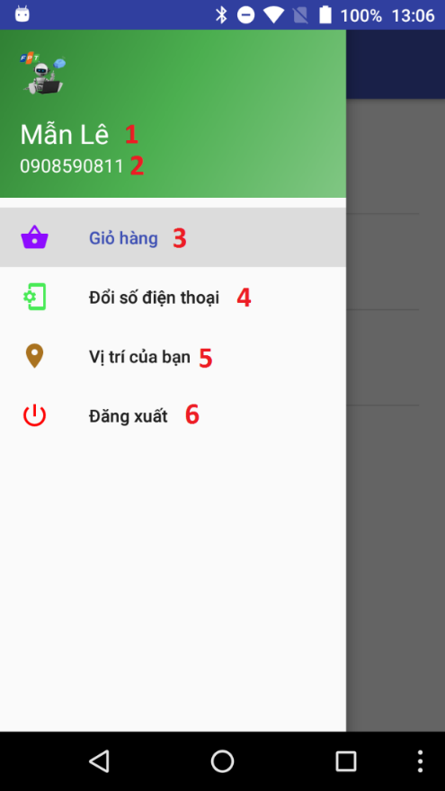

Figure 101 - Menu UI

**Fields**

|  |  |  |  |  |  |  |
| --- | --- | --- | --- | --- | --- | --- |
| **No** | **Field Names** | **Description** | **Read Only** | **Mandatory** | **Control Type** | **Data Type** |
| 1 | Name | Name of user | Yes | Yes | TextView | String |
| 2 | PhoneNumber | Phone of user | Yes | Yes | TextView | String |

Table 59 - <Mobile Application for Customer> Menu Fields

**Buttons/Hyperlinks**

|  |  |  |  |  |
| --- | --- | --- | --- | --- |
| **No** | **Function** | **Description** | **Validation** | **Outcome** |
| 3 | ViewCart | View products in cart | N/A | Redirect to view cart view. |
| 4 | ChangePhone | Change phone number | N/A | Show popup to enter new phone number. |
| 5 | ViewLocation | Show current area of user | N/A | Redirect to view location view. |
| 6 | Logout | Logout of system | N/A | Redirect to login view. |

Table 60 - <Mobile Application for Customer> Menu Buttons/Hyperlinks

##### View Cart

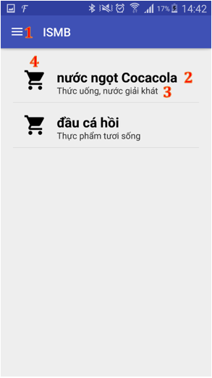

Figure 102 - View Cart UI

**Fields**

|  |  |  |  |  |  |  |
| --- | --- | --- | --- | --- | --- | --- |
| **No** | **Field Names** | **Description** | **Read Only** | **Mandatory** | **Control Type** | **Data Type** |
| 2 | productName | Name of product | Yes | No | TextView | String |
| 3 | areaName | Name of Area | Yes | No | TextView | String |
| 4 | iconItem | Icon present each product | Yes | No | ImageView | N/A |

Table 61 - <Mobile Application for Customer> View Cart Fields

**Buttons/Hyperlinks**

|  |  |  |  |  |
| --- | --- | --- | --- | --- |
| **No** | **Function** | **Description** | **Validation** | **Outcome** |
| 1 | showNavigation | Show navigation view | N/A | Show navigation bar |

Table 62 -<Mobile Application for Customer> View Cart Buttons/Hyperlinks

##### Change Phone Number

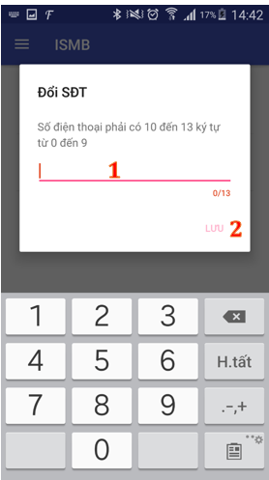

Figure 103 - Change Phone Number UI

**Fields**

|  |  |  |  |  |  |  |
| --- | --- | --- | --- | --- | --- | --- |
| **No** | **Field Names** | **Description** | **Read Only** | **Mandatory** | **Control Type** | **Data Type** |
| 1 | PhoneNumber | Fill phone number | No | Yes | EditText | String |

Table 63 - <Web Application for Customer> Change Phone Number Fields

**Buttons/Hyperlinks**

|  |  |  |  |  |
| --- | --- | --- | --- | --- |
| **No** | **Function** | **Description** | **Validation** | **Outcome** |
| 2 | updatePhone | Update phone number | All fields required before summit | Redirect to view produce cart page |

Table 64 - <Web Application for Customer> Change Phone Number Buttons/Hyperlinks

##### View Location

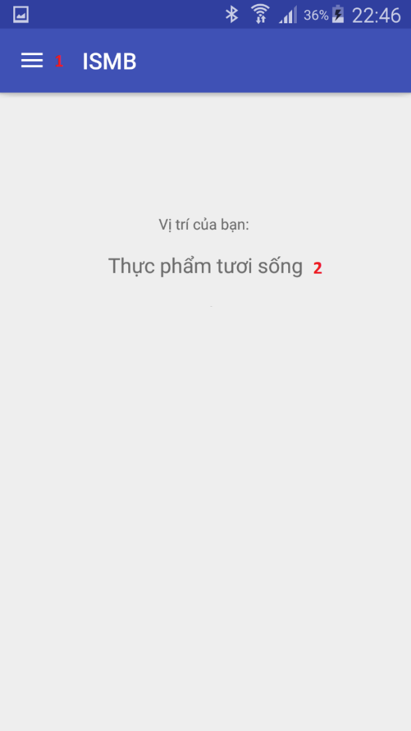

Figure 104 - View Location UI

**Fields**

|  |  |  |  |  |  |  |
| --- | --- | --- | --- | --- | --- | --- |
| **No** | **Field Names** | **Description** | **Read Only** | **Mandatory** | **Control Type** | **Data Type** |
| 2 | AreaName | Name of area | Yes | No | TextView | String |

Table 65 - <Mobile Application for Customer> View Location Fields

**Buttons/Hyperlinks**

|  |  |  |  |  |
| --- | --- | --- | --- | --- |
| **No** | **Function** | **Description** | **Validation** | **Outcome** |
| 1 | showNavigation | Show navigation view | N/A | Show navigation view |

Table 66 - <Mobile Application for Customer> View Location Buttons/Hyperlinks

##### Notify Nearby Product

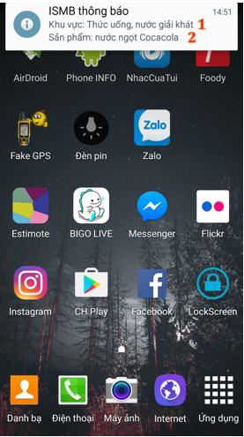

Figure 105 - Notify Nearby Product UI

**Fields**

|  |  |  |  |  |  |  |
| --- | --- | --- | --- | --- | --- | --- |
| **No** | **Field Names** | **Description** | **Read Only** | **Mandatory** | **Control Type** | **Data Type** |
| 1 | AreaName | Name of area | Yes | No | Text | String |
| 2 | ProductName | Name of Product | Yes | No | Text | String |

Table 67 - <Mobile Application for Customer> Notify Nearby Product Fields

**Buttons/Hyperlinks:** N/A

#### Mobile Application for Staff

##### Login

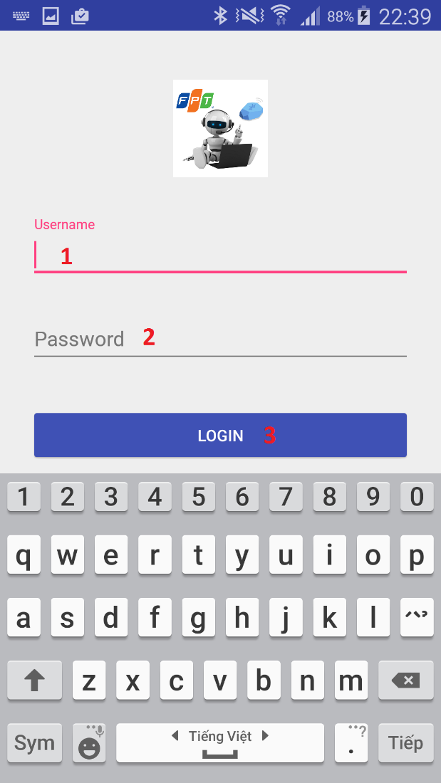

Figure 106 – Login UI

**Fields**

|  |  |  |  |  |  |  |
| --- | --- | --- | --- | --- | --- | --- |
| **No** | **Field Names** | **Description** | **Read Only** | **Mandatory** | **Control Type** | **Data Type** |
| 1 | Username | Username | No | Yes | EditText | String |
| 2 | Password | Password | No | Yes | EditText | String |

Table 68 - <Mobile Application for Staff> Login Fields

**Buttons/Hyperlinks**

|  |  |  |  |  |
| --- | --- | --- | --- | --- |
| **No** | **Function** | **Description** | **Validation** | **Outcome** |
| 3 | login | Login with staff account | All fields required before summit | Redirect to manage beacon view |

Table 69 - <Mobile Application for Staff> Login Buttons/Hyperlinks

##### Beacon Management

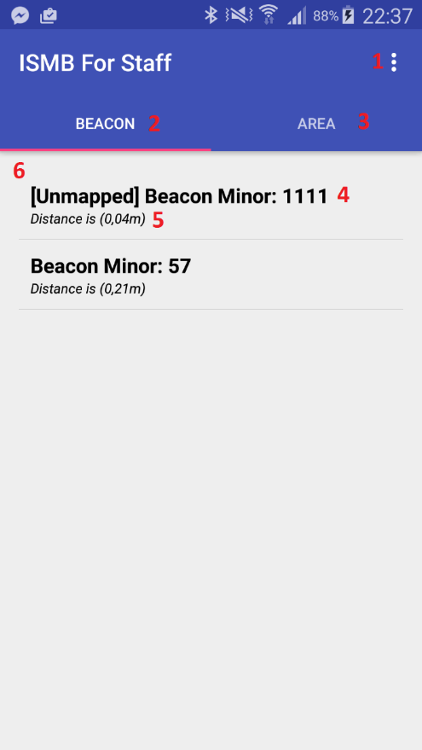

Figure 107 - Beacon Management UI

**Fields**

|  |  |  |  |  |  |  |
| --- | --- | --- | --- | --- | --- | --- |
| **No** | **Field Names** | **Description** | **Read Only** | **Mandatory** | **Control Type** | **Data Type** |
| 4 | StatusAndMinorBeacon | Status of beacon and minor of beacon | Yes | No | TextView | String |
| 5 | DistancePhoneToBeacon | Distance from phone to beacon | Yes | No | TextView | String |

Table 70 - <Mobile Application for Staff> Beacon Management Fields

**Buttons/Hyperlinks**

| **No** | **Function** | **Description** | **Validation** | **Outcome** |
| --- | --- | --- | --- | --- |
| 1 | showNavigation | Show navigation bar | N/A | Show navigation bar |
| 2 | manageBeacon | Show list detected beacon | N/A | List detected beacon. |
| 3 | manageArea | Show list area. | N/A | List area. |
| 6 | viewDetailBeacon | View beacon’s info to add/update | N/A | Show information of beacon. |

Table 71 - <Mobile Application for Staff> Beacon Management Buttons/Hyperlinks

##### Add Beacon

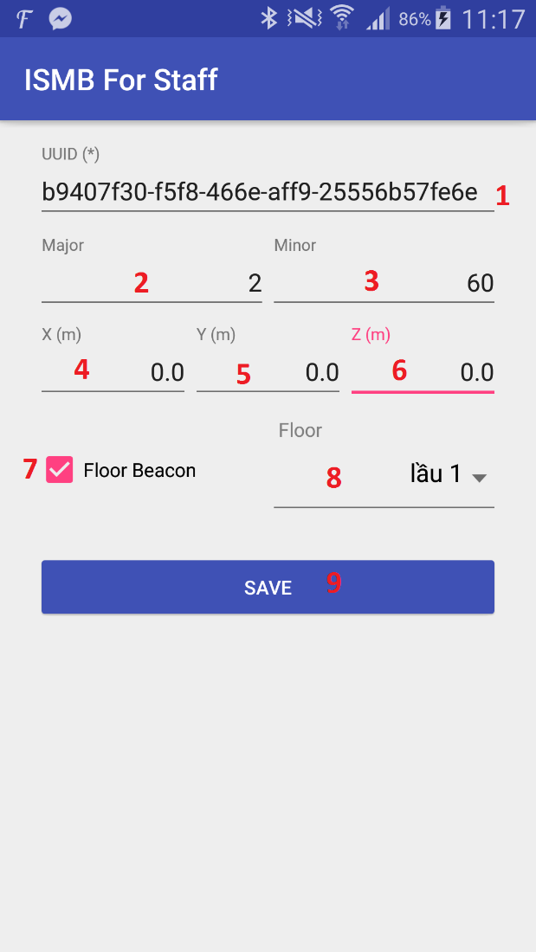

Figure 108 - Add Beacon UI

**Fields**

| **No** | **Field Names** | **Description** | **Read Only** | **Mandatory** | **Control Type** | **Data Type** |
| --- | --- | --- | --- | --- | --- | --- |
| 1 | UUID | Uuid of beacon | Yes | Yes | EditText | String |
| 2 | Major | Major of beacon | Yes | Yes | EditText | String |
| 3 | Minor | Minor of beacon | Yes | Yes | EditText | String |
| 4 | X | X coordinate of beacon | No | Yes | EditText | String |
| 5 | Y | Y coordinate of beacon | No | Yes | EditText | String |
| 6 | Z | Z coordinate of beacon | No | Yes | EditText | String |
| 7 | FloorBeacon | Is beacon to indentify floor | No | No | Checkbox | N/A |
| 8 | FloorName | Name of floor | No | No | Drop down list | N/A |

Table 72 - <Mobile Application for Staff> Add Beacon Fields

**Buttons/Hyperlinks**

|  |  |  |  |  |
| --- | --- | --- | --- | --- |
| **No** | **Function** | **Description** | **Validation** | **Outcome** |
| 9 | AddBeacon | Send add new information beacon command | Some Fields required before summit | Submit add new beacon |

Table 73 - <Mobile Application for Staff> Add Beacon Buttons/Hyperlinks

##### Update Beacon

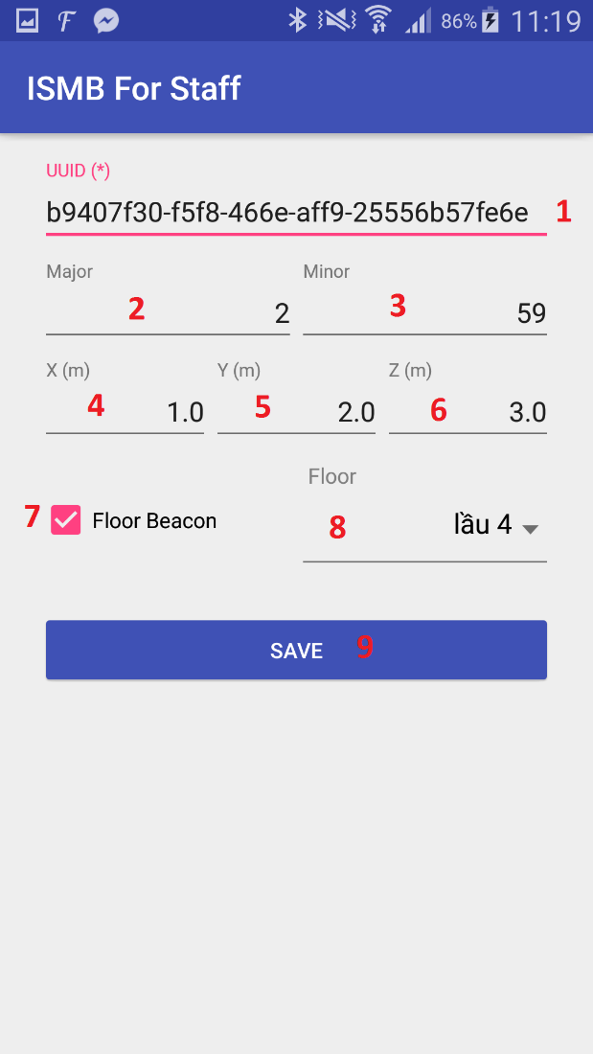

Figure 109 - Update Beacon UI

**Fields**

|  |  |  |  |  |  |  |
| --- | --- | --- | --- | --- | --- | --- |
| **No** | **Field Names** | **Description** | **Read Only** | **Mandatory** | **Control Type** | **Data Type** |
| 1 | UUID | Uuid address of beacon | Yes | Yes | EditText | String |
| 2 | Major | Major of beacon | Yes | Yes | EditText | String |
| 3 | Minor | Minor of beacon | Yes | Yes | EditText | String |
| 4 | X | X coordinate of beacon | No | Yes | EditText | String |
| 5 | Y | Y coordinate of beacon | No | Yes | EditText | String |
| 6 | Z | Z coordinate of beacon | No | Yes | EditText | String |
| 7 | FloorBeacon | Is beacon to indentify floor | No | No | Checkbox | N/A |
| 8 | FloorName | Name of floor | No | No | Drop down list | N/A |

Table 74 - <Mobile Application for Staff> Update Beacon Fields

**Buttons/Hyperlinks**

|  |  |  |  |  |
| --- | --- | --- | --- | --- |
| **No** | **Function** | **Description** | **Validation** | **Outcome** |
| 9 | UpdateBeacon | Send update information of beacon command | Some Fields required before summit | Submit update beacon |

Table 75 - <Mobile Application for Staff> Update Beacon Buttons/Hyperlinks

##### Area Management

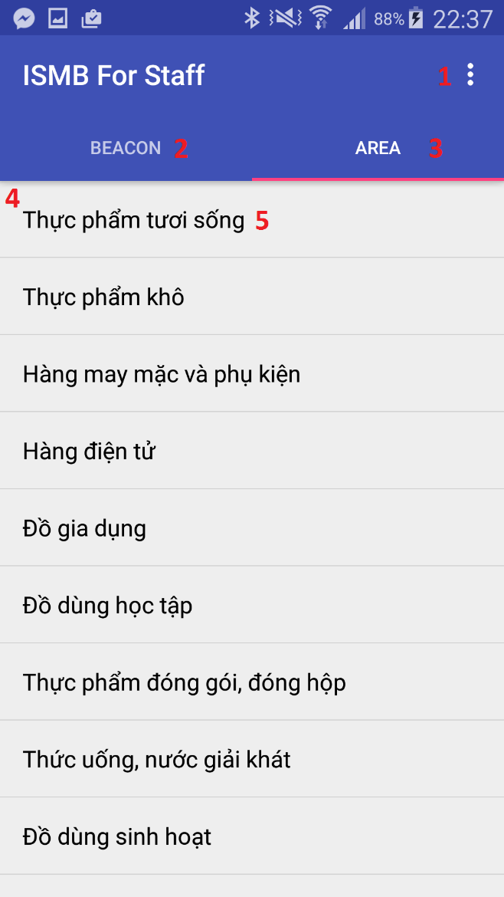

Figure 110 - Area Management UI

**Fields**

|  |  |  |  |  |  |  |
| --- | --- | --- | --- | --- | --- | --- |
| **No** | **Field Names** | **Description** | **Read Only** | **Mandatory** | **Control Type** | **Data Type** |
| 5 | AreaName | Name of area | Yes | No | TextView | String |

Table 76 - <Mobile Application for Staff> Area Management Fields

**Buttons/Hyperlinks**

| **No** | **Function** | **Description** | **Validation** | **Outcome** |
| --- | --- | --- | --- | --- |
| 1 | showNavigation | Show navigation view | N/A | Show navigation bar |
| 2 | manageBeacon | Show list detected beacon | N/A | List detected beacon. |
| 3 | manageArea | Show list area. | N/A | List area. |
| 4 | viewDetailArea | View information to manage area | N/A | Show information area. |

Table 77 - <Mobile Application for Staff> Area Management Buttons/Hyperlinks

##### Add Area

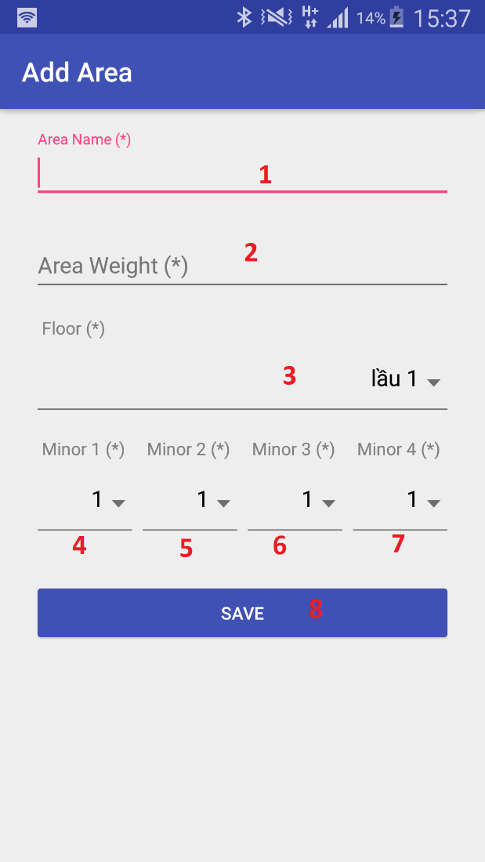

Figure 111 - Add Area UI

**Fields**

| **No** | **Field Names** | **Description** | **Read Only** | **Mandatory** | **Control Type** | **Data Type** |
| --- | --- | --- | --- | --- | --- | --- |
| 1 | AreaName | Name of area | No | Yes | EditText | String |
| 2 | AreaWeight | Weight of area | No | Yes | Drop down list | N/A |
| 3 | FloorName | Name of floor | No | Yes | Drop down list | N/A |
| 4 | Minor1 | Minor of beacon | No | Yes | Drop down list | N/A |
| 5 | Minor2 | Minor of beacon | No | Yes | Drop down list | N/A |
| 6 | Minor3 | Minor of beacon | No | Yes | Drop down list | N/A |
| 7 | Minor4 | Minor of beacon | No | Yes | Drop down list | N/A |

Table 78 - <Mobile Application for Staff> Add Area Fields

**Buttons/Hyperlinks**

|  |  |  |  |  |
| --- | --- | --- | --- | --- |
| **No** | **Function** | **Description** | **Validation** | **Outcome** |
| 8 | AddArea | Send add new area command | All Fields required before submit. | Submit add area |

Table 79 - <Mobile Application for Staff> Add Area Buttons/Hyperlinks

##### Update Area

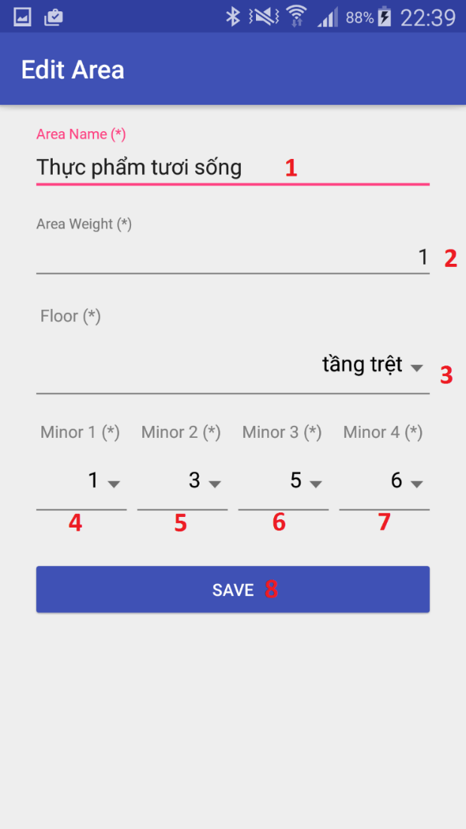

Figure 112 - Update Area UI

**Fields**

|  |  |  |  |  |  |  |
| --- | --- | --- | --- | --- | --- | --- |
| **No** | **Field Names** | **Description** | **Read Only** | **Mandatory** | **Control Type** | **Data Type** |
| 1 | AreaName | Name of area | No | Yes | EditText | String |
| 2 | AreaWeight | Weight of area | No | Yes | Drop down list | N/A |
| 3 | FloorName | Name of floor | No | Yes | Drop down list | N/A |
| 4 | Minor1 | Minor of beacon | No | Yes | Drop down list | N/A |
| 5 | Minor2 | Minor of beacon | No | Yes | Drop down list | N/A |
| 6 | Minor3 | Minor of beacon | No | Yes | Drop down list | N/A |
| 7 | Minor4 | Minor of beacon | No | Yes | Drop down list | N/A |

Table 80 - <Mobile Application for Staff> Update Area Fields

**Buttons/Hyperlinks**

| **No** | **Function** | **Description** | **Validation** | **Outcome** |
| --- | --- | --- | --- | --- |
| 8 | UpdateArea | Send update area command | All Fields required before submit | Submit update area |

Table 81 - <Mobile Application for Staff> Update Area Buttons/Hyperlinks

#### Web Application

##### Login

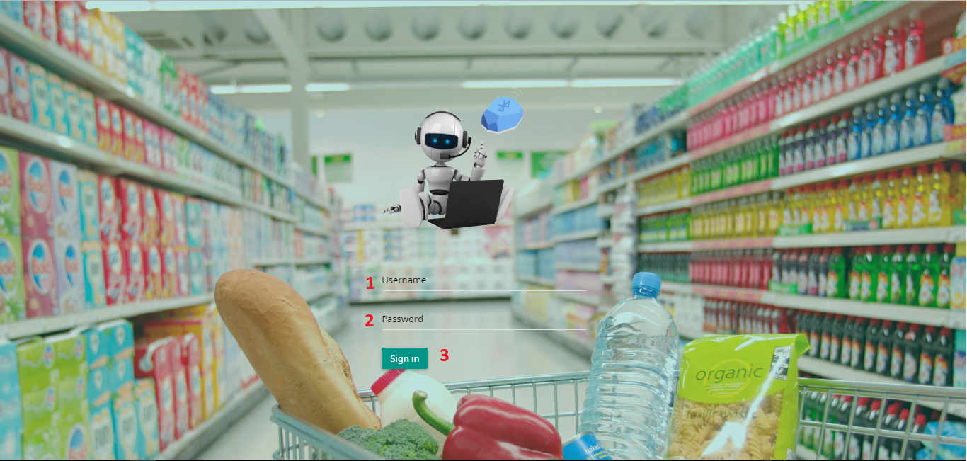

Figure 113 - Login UI

**Fields**

|  |  |  |  |  |  |  |
| --- | --- | --- | --- | --- | --- | --- |
| **No** | **Field Names** | **Description** | **Read Only** | **Mandatory** | **Control Type** | **Data Type** |
| 1 | Username | Fill Username | No | Yes | Textbox | String |
| 2 | Password | Fill Password | No | Yes | Password | String |

Table 82 - <Web Application> Login Fields

**Buttons/Hyperlinks**

|  |  |  |  |  |
| --- | --- | --- | --- | --- |
| **No** | **Function** | **Description** | **Validation** | **Outcome** |
| 3 | Login | Login into system | All fields required before summit | Redirect to manage account page/manage product page based on role. |

Table 83 - <Web Application > Login Buttons/Hyperlinks

##### Account Management

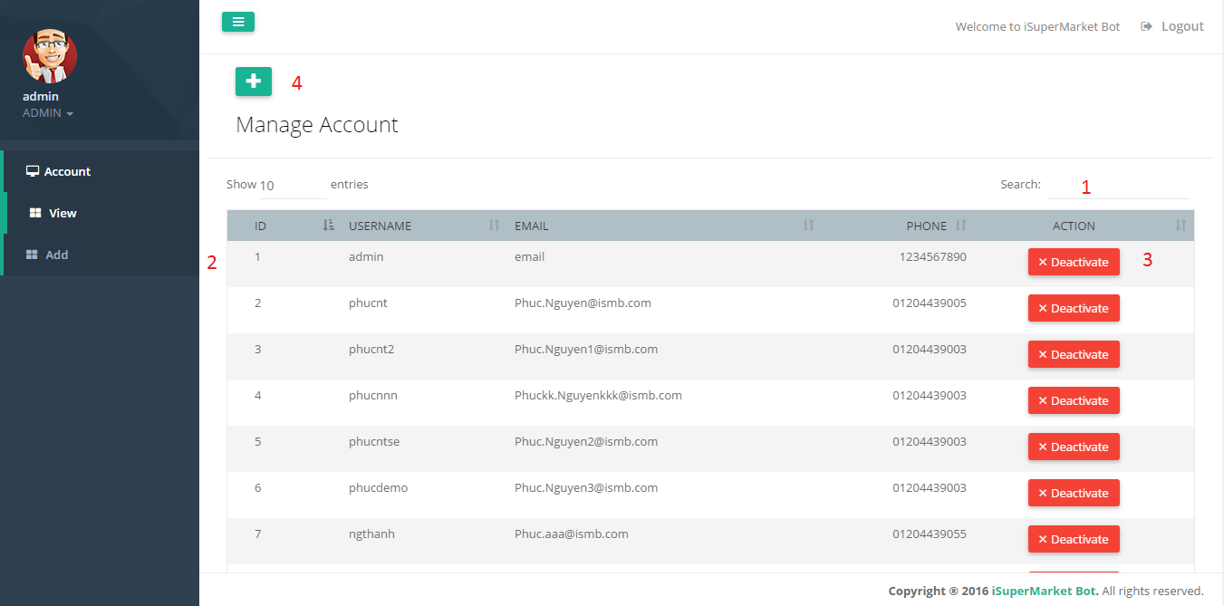

Figure 114 - Account Management UI

**Fields**

|  |  |  |  |  |  |  |
| --- | --- | --- | --- | --- | --- | --- |
| **No** | **Field Names** | **Description** | **Read Only** | **Mandatory** | **Control Type** | **Data Type** |
| 1 | SearchAccount | Search account by all text field | No | No | Textbox | String |
| 2 | AccountData | Information of account | Yes | No | Table | String |

Table 84 - <Web Application> Account Management Fields

**Buttons/Hyperlinks**

|  |  |  |  |  |
| --- | --- | --- | --- | --- |
| **No** | **Function** | **Description** | **Validation** | **Outcome** |
| 3 | ChangeStatus | Deactive/Active account | N/A | Summit change status account |
| 4 | AddAccount | Add new account | N/A | Redirect to add account page |

Table 85 - <Web Application> Account Management Buttons/Hyperlinks

##### Add Account

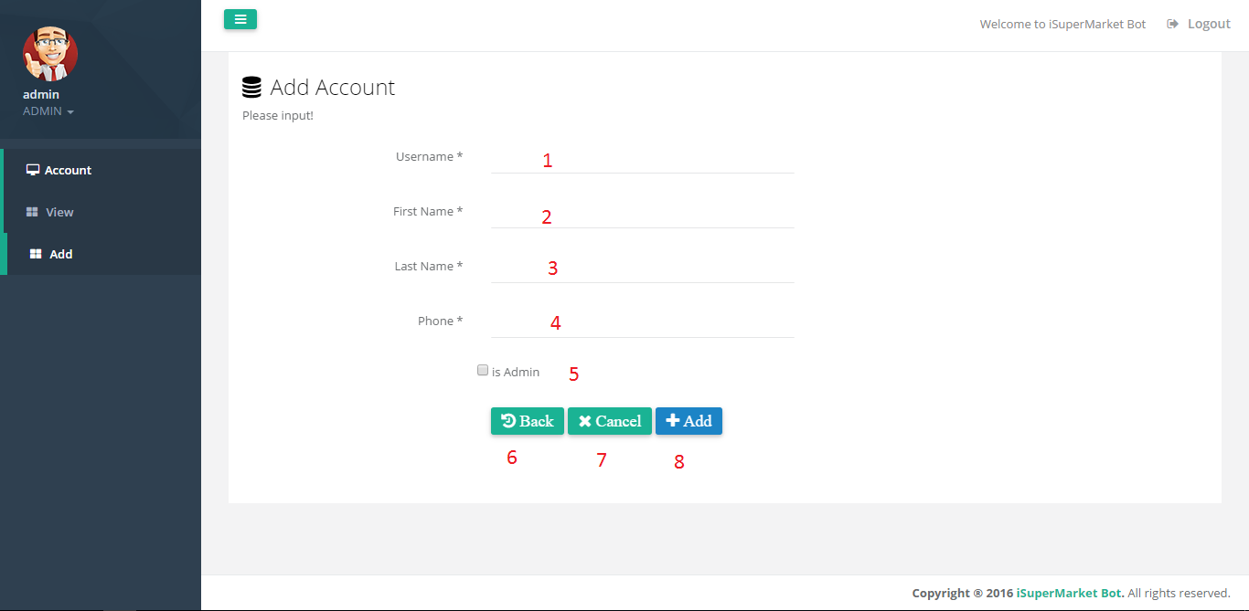

Figure 115 - Add Account UI

**Fields**

|  |  |  |  |  |  |  |
| --- | --- | --- | --- | --- | --- | --- |
| **No** | **Field Names** | **Description** | **Read Only** | **Mandatory** | **Control Type** | **Data Type** |
| 1 | Username | Username of account | No | Yes | Textbox | String |
| 2 | Firstname | Firstname of account | No | Yes | Textbox | String |
| 3 | Lastname | Lastname of account | No | Yes | Textbox | String |
| 4 | Phone | Phone of account | No | Yes | Textbox | String |
| 5 | isAdmin | This account is admin | No | No | Checkbox | String |

Table 86 - <Web Application> Add Account Fields

**Buttons/Hyperlinks**

|  |  |  |  |  |
| --- | --- | --- | --- | --- |
| **No** | **Function** | **Description** | **Validation** | **Outcome** |
| 6 | Back | Back to account management page | N/A | Redirect to account management page |
| 7 | Cancel | Reset all fields | N/A | Reset all fields |
| 8 | Add | Send add account command | Validation all required fields before summit | Submit add account |

Table 87 - <Web Application > Add Account Buttons/Hyperlinks

##### Detativate Account

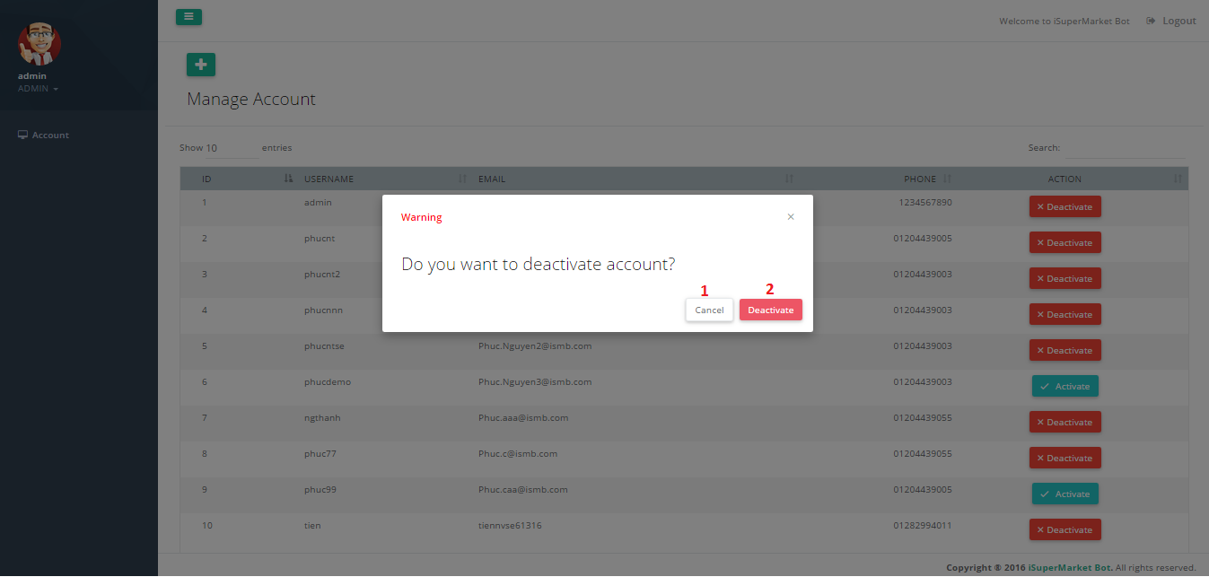Figure 116 - Deactivate Account UI

**Fields:** N/A

**Buttons/Hyperlinks**

|  |  |  |  |  |
| --- | --- | --- | --- | --- |
| **No** | **Function** | **Description** | **Validation** | **Outcome** |
| 1 | Cancel | Cancel action | N/A | Close popup |
| 2 | DeactivateAccount | Confirm deactivate account | N/A | Close popup |

Table 88 - <Web Application> Deactivate Account Buttons/Hyperlinks

##### Activate Account

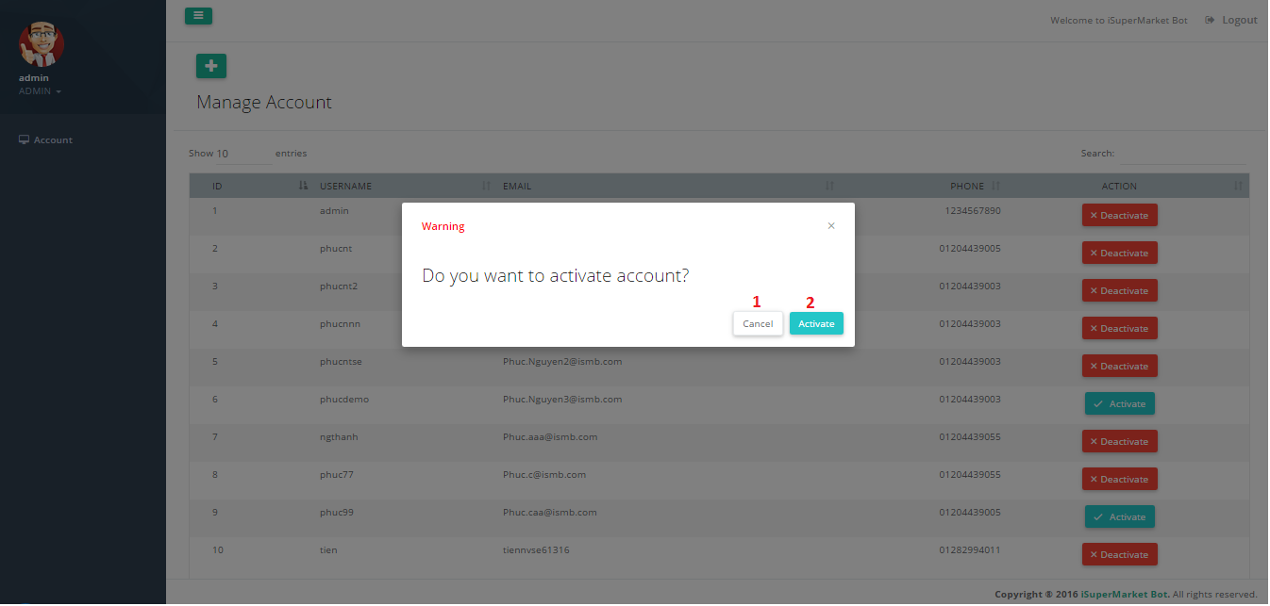

Figure 117 - Activate Account UI

**Fields:** N/A

**Buttons/Hyperlinks**

|  |  |  |  |  |
| --- | --- | --- | --- | --- |
| **No** | **Function** | **Description** | **Validation** | **Outcome** |
| 1 | Cancel | Cancel action | N/A | Close popup |
| 2 | ActivateAccount | Confirm activate account | N/A | Close popup |

Table 89 - <Web Application> Activate Account Buttons/Hyperlinks

##### Update Profile

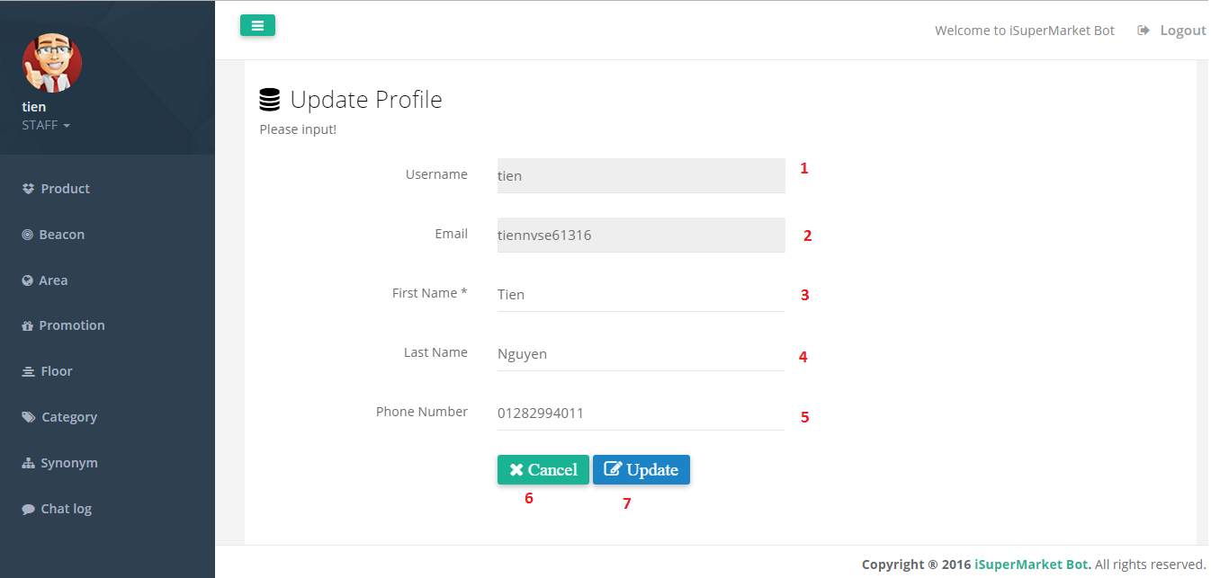

Figure 118 - Update Profile UI

**Fields**

|  |  |  |  |  |  |  |
| --- | --- | --- | --- | --- | --- | --- |
| **No** | **Field Names** | **Description** | **Read Only** | **Mandatory** | **Control Type** | **Data Type** |
| 1 | Username | Username of account | Yes | No | Textbox | String |
| 2 | Email | Email of account | Yes | No | Textbox | String |
| 3 | Firstname | Firstname of account | No | Yes | Textbox | String |
| 4 | Lastname | Lastname of account | No | Yes | Textbox | String |
| 5 | Phone | Phone of account | No | Yes | Textbox | String |

Table 90 - <Web Application> Update Profile Fields

**Buttons/Hyperlinks**

|  |  |  |  |  |
| --- | --- | --- | --- | --- |
| **No** | **Function** | **Description** | **Validation** | **Outcome** |
| 6 | Cancel | Reset change information | N/A | Reset information |
| 7 | Update | Send update account command | Validation all required fields before summit | Submit update account |

Table 91 - <Web Application> Update Profile Buttons/Hyperlinks

##### Beacon Management

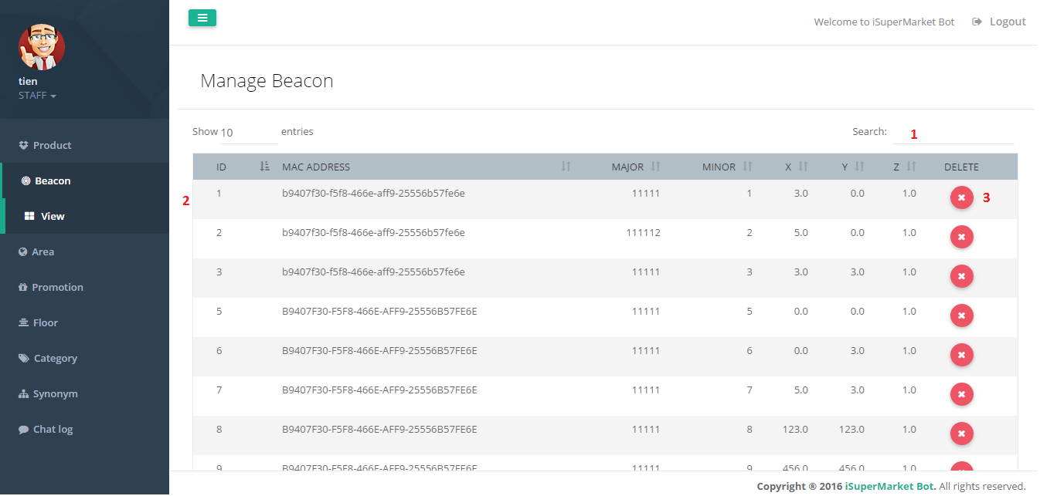

Figure 119 - Beacon Management UI

**Fields**

|  |  |  |  |  |  |  |
| --- | --- | --- | --- | --- | --- | --- |
| **No** | **Field Names** | **Description** | **Read Only** | **Mandatory** | **Control Type** | **Data Type** |
| 1 | SearchBeacon | Search Beacon by all text field | No | No | Textbox | String |
| 2 | BeaconData | Information of Beacon | Yes | No | Table | String |

Table 92 - <Web Application> Beacon Management Fields

**Buttons/Hyperlinks**

|  |  |  |  |  |
| --- | --- | --- | --- | --- |
| **No** | **Function** | **Description** | **Validation** | **Outcome** |
| 3 | Delete | Delete beacon | N/A | Submit delete beacon |

Table 93 - <Web Application> Beacon Management Fields

##### Delete Beacon

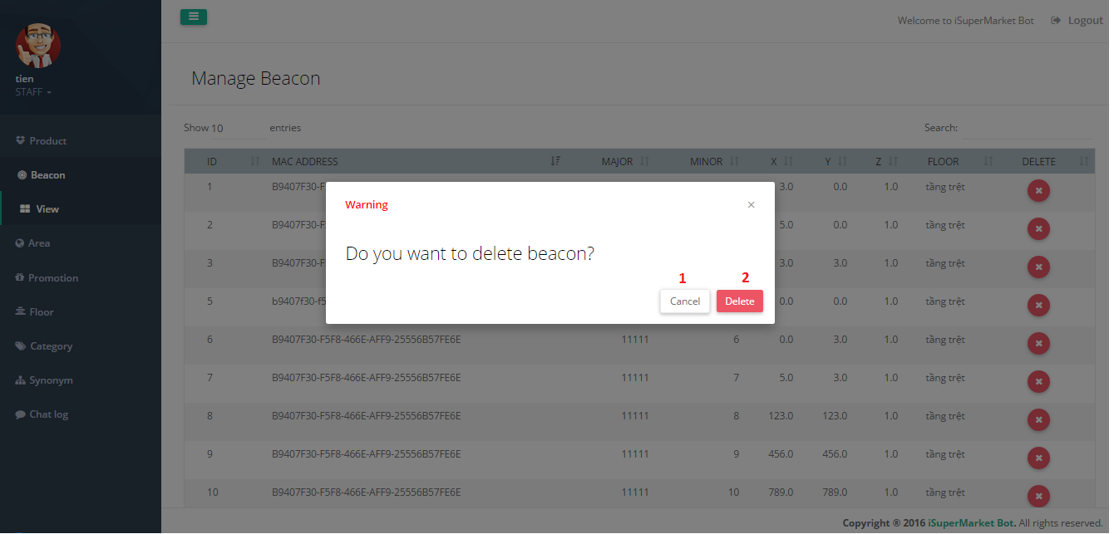

Figure 120 - Delete Beacon UI

**Fields:** N/A

**Buttons/Hyperlinks**

|  |  |  |  |  |
| --- | --- | --- | --- | --- |
| **No** | **Function** | **Description** | **Validation** | **Outcome** |
| 1 | Cancel | Cancel action | N/A | Close popup |
| 2 | DeleteBeacon | Confirm delete | N/A | Show success message |

Table 94 - <Web Application> Delete Beacon Buttons/Hyperlinks

##### Product Management

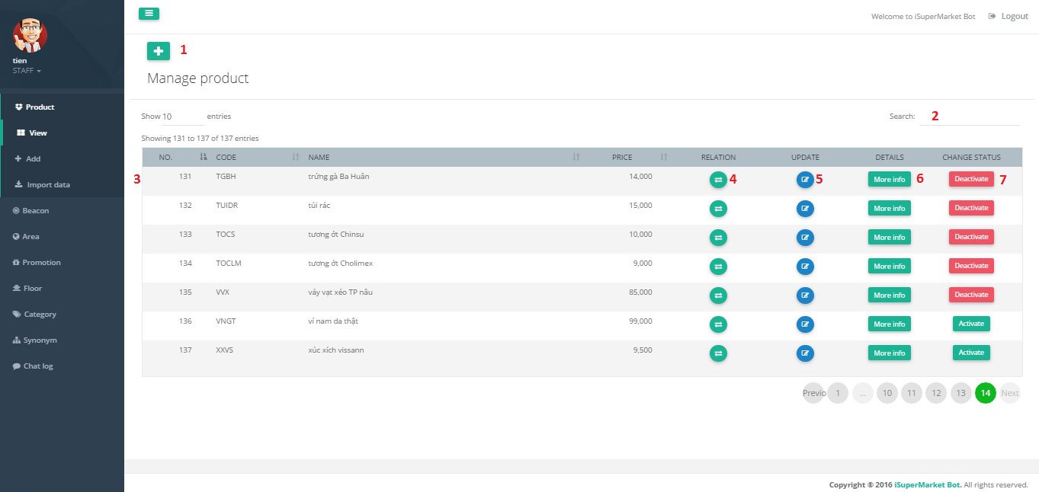

Figure 121 - Product Management UI

**Fields**

|  |  |  |  |  |  |  |
| --- | --- | --- | --- | --- | --- | --- |
| **No** | **Field Names** | **Description** | **Read Only** | **Mandatory** | **Control Type** | **Data Type** |
| 2 | SearchProduct | Search product by all text field | No | No | Textbox | String |
| 3 | ProductData | Information of Product | Yes | No | Table | String |

Table 95 - <Web Application> Product Management Fields

**Buttons/Hyperlinks**

| **No** | **Function** | **Description** | **Validation** | **Outcome** |
| --- | --- | --- | --- | --- |
| 1 | AddProduct | Add new product | N/A | Redirect to add product page |
| 4 | RelationProduct | Add relation product | N/A | Redirect to relation product detail page |
| 5 | UpdateProduct | Update product information | N/A | Redirect to update product page |
| 6 | ViewDetail | View product detail | N/A | Redirect to product detail page |
| 7 | changeStatusProduct | Send deactiavte/activate product command | N/A | Submit change status product |

Table 96 - <Web Application> Product Management Buttons/Hyperlinks

##### Add Product

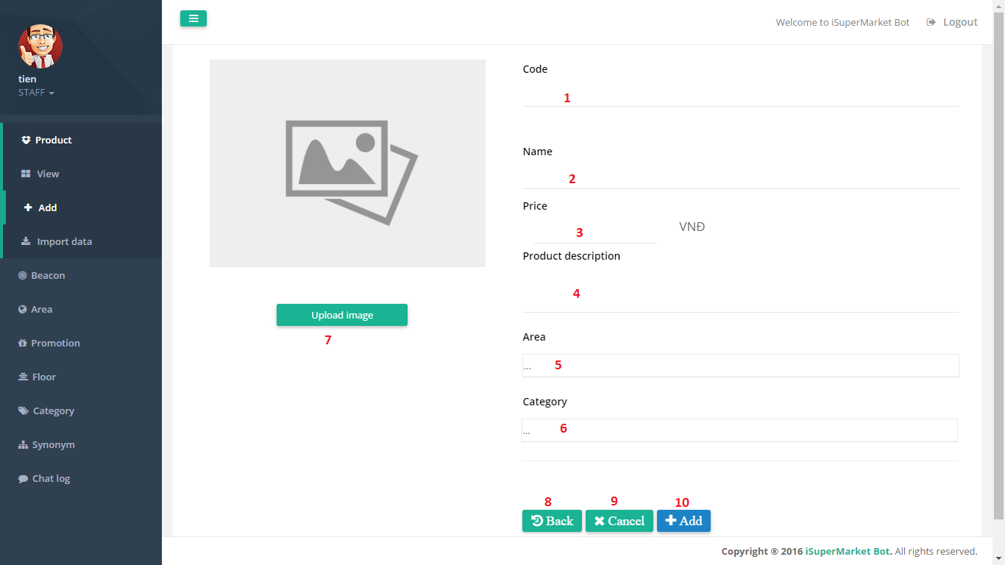

Figure 122 - Add Product UI

**Fields**

|  |  |  |  |  |  |  |
| --- | --- | --- | --- | --- | --- | --- |
| **No** | **Field Names** | **Description** | **Read Only** | **Mandatory** | **Control Type** | **Data Type** |
| 1 | Code | Product’s code | No | Yes | Textbox | String |
| 2 | Name | Product’s name | No | Yes | Textbox | String |
| 3 | Price | Product’s price | No | Yes | Textbox | String |
| 4 | Area | Product’s area | No | Yes | Drop down list | String |
| 5 | Category | Product’s category | No | Yes | Drop down list | String |

Table 97 - <Web Application> Add Product Fields

**Buttons/Hyperlinks**

|  |  |  |  |  |
| --- | --- | --- | --- | --- |
| **No** | **Function** | **Description** | **Validation** | **Outcome** |
| 7 | UploadImage | Send add image command | N/A | Upload product image |
| 8 | Back | Back to product management page | N/A | Redirect to product management page |
| 9 | Cancel | Reset change information | N/A | Reset information |
| 10 | Add | Send add product command | Validation all required fields before summit | Submit add product |

Table 98 - <Web Application> Add Products Buttons/Hyperlinks

##### Update Product

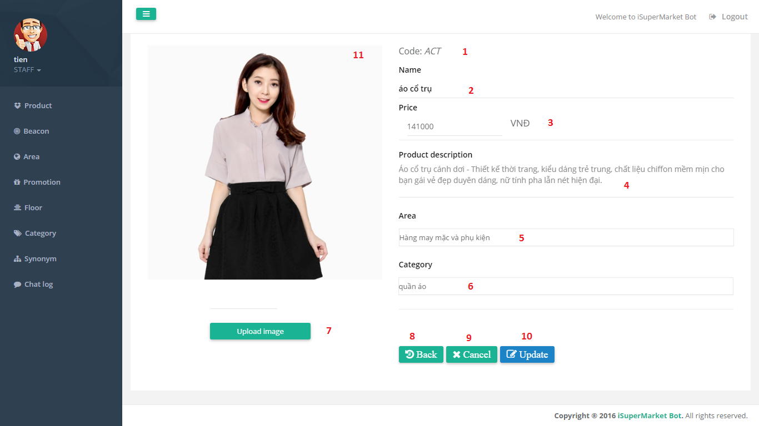

Figure 123 - Update Product UI

**Fields**

|  |  |  |  |  |  |  |
| --- | --- | --- | --- | --- | --- | --- |
| **No** | **Field Names** | **Description** | **Read Only** | **Mandatory** | **Control Type** | **Data Type** |
| 1 | Code | Product’s code | Yes | No | Textbox | String |
| 2 | Name | Product’s name | No | Yes | Textbox | String |
| 3 | Price | Product’s price | No | Yes | Textbox | String |
| 4 | Description | Product’s description | No | Yes | TextArea | String |
| 5 | Area | Product’s area | No | Yes | Drop down list | String |
| 6 | Category | Product’s category | No | Yes | Drop down list | String |
| 11 | Image | Product’s image | No | No | Image | N/A |

Table 99 - <Web Application> Update Product Fields

**Buttons/Hyperlinks**

|  |  |  |  |  |
| --- | --- | --- | --- | --- |
| **No** | **Function** | **Description** | **Validation** | **Outcome** |
| 7 | UploadImage | Send update image command | N/A | Submit update image |
| 8 | Back | Back to product management page | N/A | Redirect to product management page |
| 9 | Cancel | Reset change information | N/A | Reset information |
| 10 | Update | Send update product command | Validation all required fields before summit | Submit update product |

Table 100 - <Web Application> Update Product Buttons/Hyperlinks

##### View Product Details

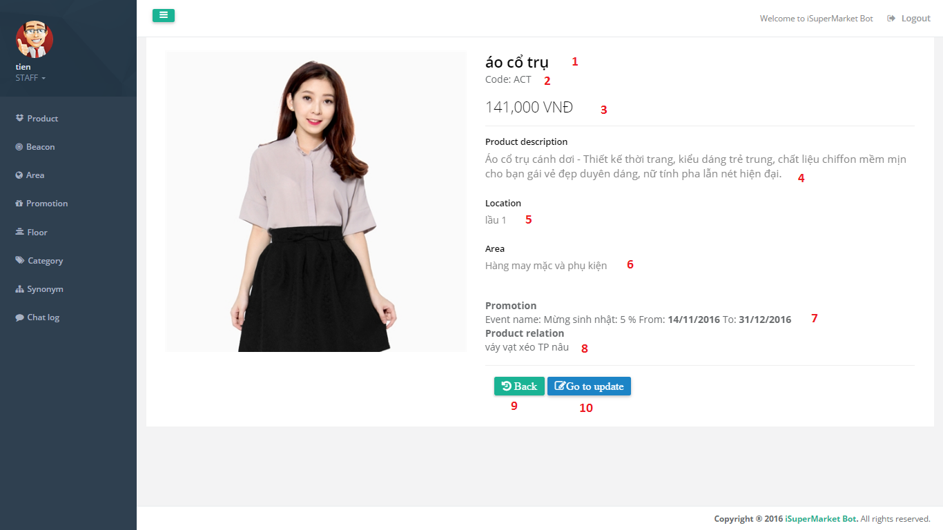

Figure 124 - View Product Details UI

**Fields**

|  |  |  |  |  |  |  |
| --- | --- | --- | --- | --- | --- | --- |
| **No** | **Field Names** | **Description** | **Read Only** | **Mandatory** | **Control Type** | **Data Type** |
| 1 | Name | Product’s name | Yes | No | Textbox | String |
| 2 | Code | Product’s code | Yes | No | Textbox | String |
| 3 | Price | Product’s price | Yes | No | Textbox | String |
| 4 | Description | Product’s Description | Yes | No | Textbox | String |
| 5 | Location | Product’s location | Yes | No | Textbox | String |
| 6 | Area | Product’s area | Yes | No | Textbox | String |
| 7 | Promotion | Product’s promotion | Yes | No | Textbox | String |
| 8 | Relation | Relation products | Yes | No | Textbox | String |

Table 101 - <Web Application> View Product Details Fields

**Buttons/Hyperlinks**

|  |  |  |  |  |
| --- | --- | --- | --- | --- |
| **No** | **Function** | **Description** | **Validation** | **Outcome** |
| 9 | Back | Back to product management page | N/A | Redirect to product management page |
| 10 | GoToUpdate | Go to update product page | N/A | Redirect to update product page |

Table 102 - <Web Application> View Product Details Buttons/Hyperlinks

##### Relation Product

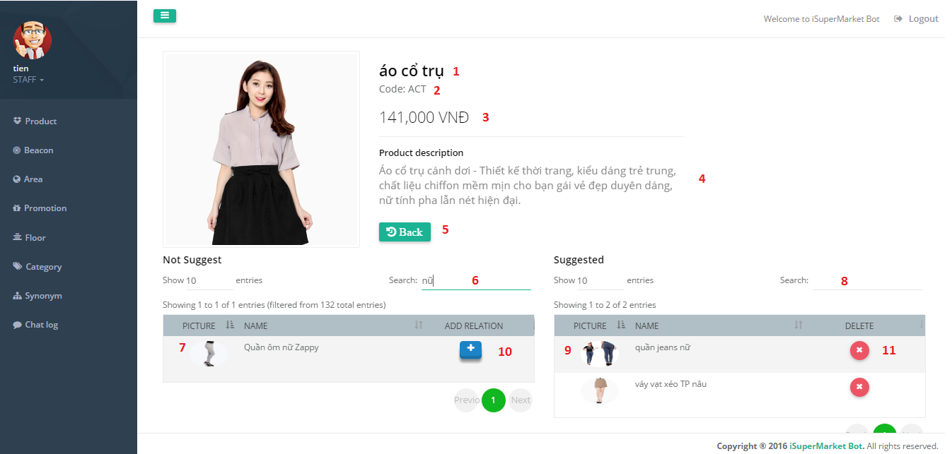

Figure 125 - Relation Product UI

**Fields**

|  |  |  |  |  |  |  |
| --- | --- | --- | --- | --- | --- | --- |
| **No** | **Field Names** | **Description** | **Read Only** | **Mandatory** | **Control Type** | **Data Type** |
| 1 | Name | Product’s name | Yes | No | Textbox | String |
| 2 | Code | Product’s code | Yes | No | Textbox | String |
| 3 | Price | Product’s price | Yes | No | Textbox | String |
| 4 | Description | Product’s Description | Yes | No | Textbox | String |
| 6 | SearchNotSuggest | Search not suggest product | No | No | Textbox | String |
| 8 | SearchSuggested | Search suggested product | No | No | Textbox | String |
| 7 | NotSuggestData | List not suggest product infor | No | No | Table | String |
| 9 | SuggestedData | List suggested product infor | No | No | Table | String |

Table 103 - <Web Application> Relation Porduct Fields

**Buttons/Hyperlinks**

| **No** | **Function** | **Description** | **Validation** | **Outcome** |
| --- | --- | --- | --- | --- |
| 5 | Back | Back product management page | N/A | Redirect to product management page |
| 10 | AddRealation | Send add relation command | N/A | Submit add relation |
| 11 | RemoveRealation | Send remove relation command | N/A | Submit remove relation |

Table 104 - <Web Application> Relation Product Buttons/Hyperlinks

##### Import Products From Excel

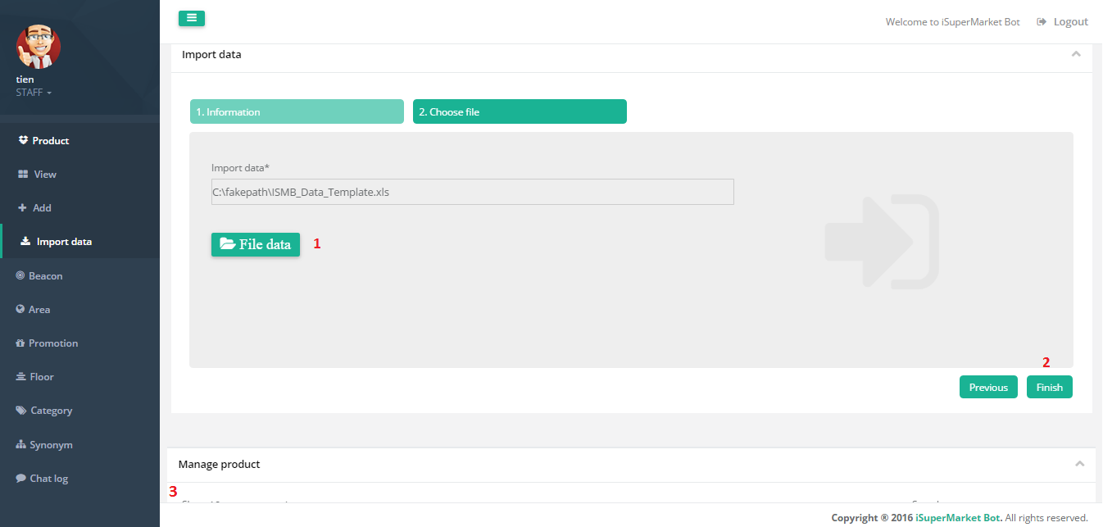

Figure 126 – Import Products From Excel UI

**Fields**

|  |  |  |  |  |  |  |
| --- | --- | --- | --- | --- | --- | --- |
| **No** | **Field Names** | **Description** | **Read Only** | **Mandatory** | **Control Type** | **Data Type** |
| 3 | ProductData | List product information of excel file | Yes | No | Table | String |

Table 105 - <Web Application> Import Products From Excel Fields

**Buttons/Hyperlinks**

|  |  |  |  |  |
| --- | --- | --- | --- | --- |
| **No** | **Function** | **Description** | **Validation** | **Outcome** |
| 1 | FileData | Upload excel file | Validation all required fields before summit. | Submit excel file |
| 2 | Finish | Add list product | N/A | Submit add products |

Table 106 - <Web Application> Import Products From Excel Buttons/Hyperlinks

##### Deactivate Product

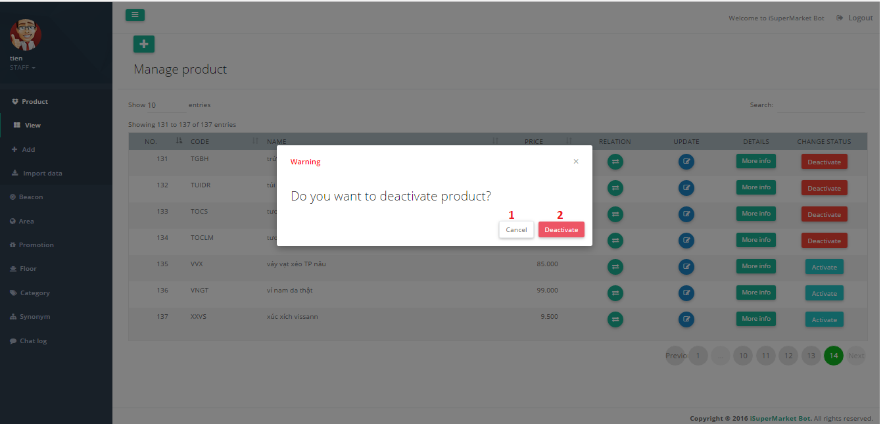

Figure 127 - Deactive Product UI

**Fields:** N/A

**Buttons/Hyperlinks**

|  |  |  |  |  |
| --- | --- | --- | --- | --- |
| **No** | **Function** | **Description** | **Validation** | **Outcome** |
| 1 | Cancel | Cancel action | N/A | Close popup |
| 2 | DeactivateProduct | Confirm deactivate product | N/A | Close popup |

Table 107 - <Web Application> Deactivate Product Buttons/Hyperlinks

##### Activate Product

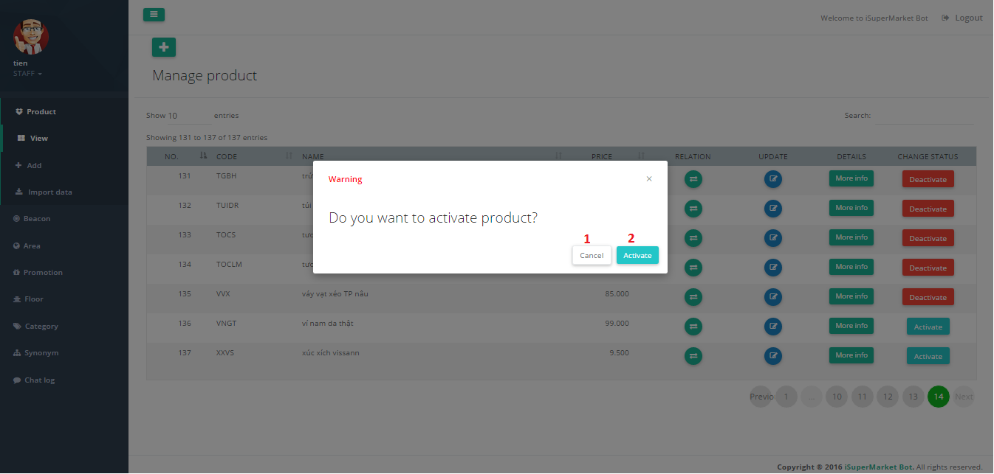

Figure 128 – Activate Product UI

**Fields:** N/A

**Buttons/Hyperlinks**

|  |  |  |  |  |
| --- | --- | --- | --- | --- |
| **No** | **Function** | **Description** | **Validation** | **Outcome** |
| 1 | Cancel | Cancel action | N/A | Close popup |
| 2 | ActivateProduct | Confirm activate product | N/A | Close popup |

Table 108 - <Web Application> Activate Product Buttons/Hyperlinks

##### Area Management

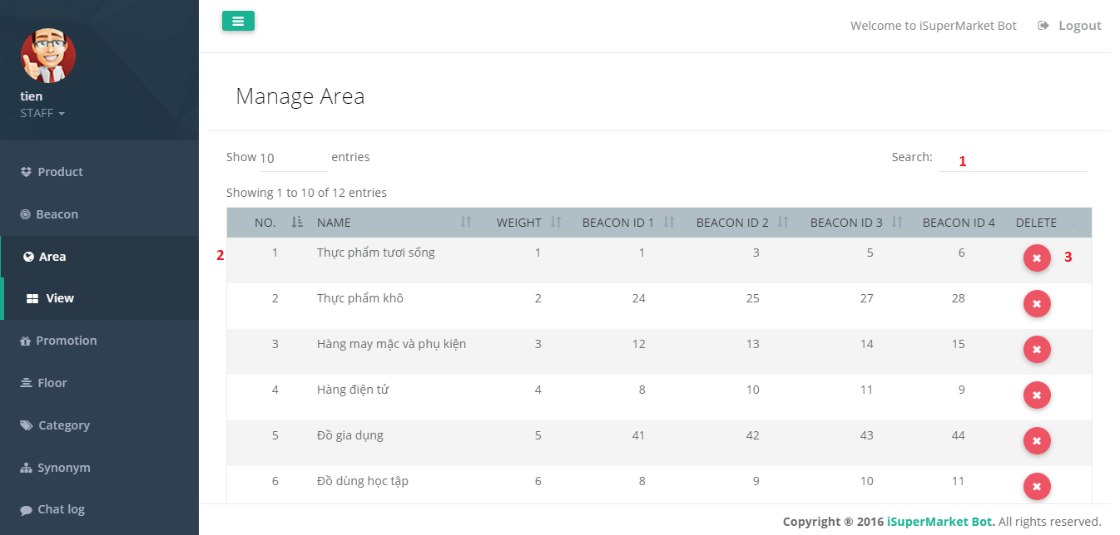

Figure 129 - Area Management UI

**Fields**

|  |  |  |  |  |  |  |
| --- | --- | --- | --- | --- | --- | --- |
| **No** | **Field Names** | **Description** | **Read Only** | **Mandatory** | **Control Type** | **Data Type** |
| 1 | SearchArea | Search Area by | No | No | Textbox | String |
| 2 | AreaData | Information of Areas | Yes | No | Table | String |

Table 109 - <Web Application> Area Management Fields

**Buttons/Hyperlinks**

|  |  |  |  |  |
| --- | --- | --- | --- | --- |
| **No** | **Function** | **Description** | **Validation** | **Outcome** |
| 3 | Delete | Delete area | N/A | Submit delete area |

Table 110 - <Web Application> Area Management Buttons/Hyperlinks

##### Delete Area

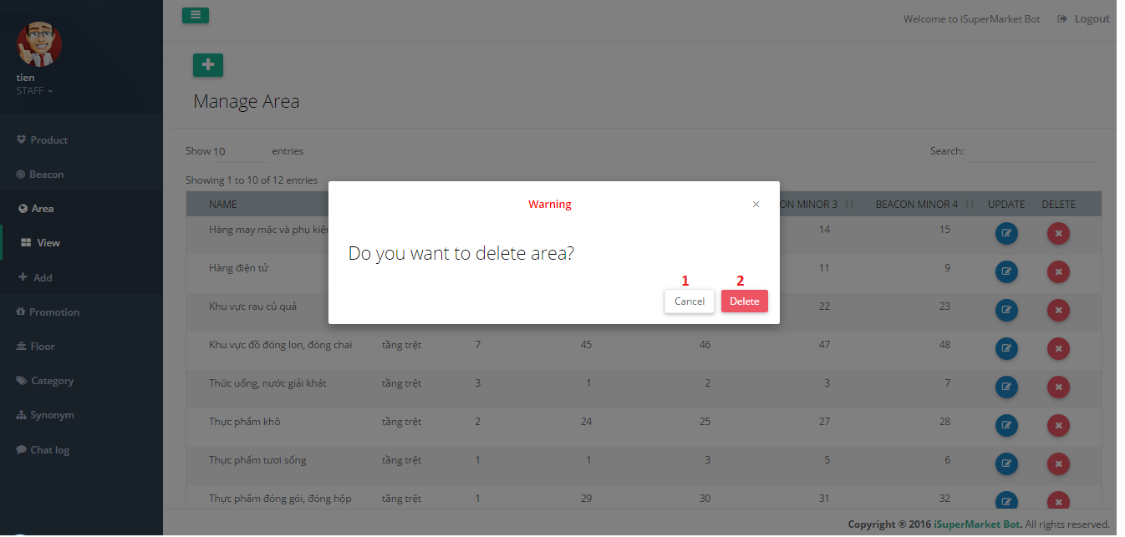

Figure 132 - Delete Area UI

**Fields:** N/A

**Buttons/Hyperlinks**

|  |  |  |  |  |
| --- | --- | --- | --- | --- |
| **No** | **Function** | **Description** | **Validation** | **Outcome** |
| 1 | Cancel | Cancel action | N/A | Close popup |
| 2 | DeleteArea | Confirm delete | N/A | Show success message |

Table 115 - <Web Application> Delete Area Buttons/Hyperlinks

##### Promotion Management

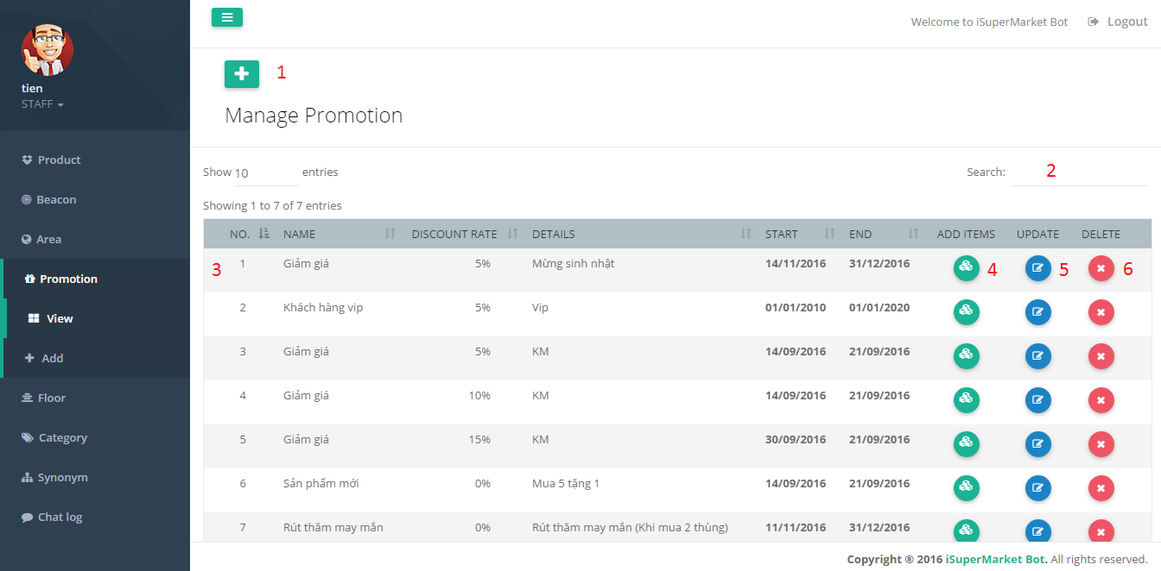

Figure 133 - Promotion Management UI

**Fields**

|  |  |  |  |  |  |  |
| --- | --- | --- | --- | --- | --- | --- |
| **No** | **Field Names** | **Description** | **Read Only** | **Mandatory** | **Control Type** | **Data Type** |
| 2 | SearchPromotion | Search promotion by all text field | No | No | Textbox | String |
| 3 | PromotionData | Information of promotion | No | No | Table | String |

Table 116 - <Web Application> Promotion Management Fields

**Buttons/Hyperlinks**

|  |  |  |  |  |
| --- | --- | --- | --- | --- |
| **No** | **Function** | **Description** | **Validation** | **Outcome** |
| 1 | AddPromotion | Add new promotion | N/A | Redirect to add promotion page |
| 4 | AddItems | Add items to promotion | N/A | Redirect to add items page |
| 5 | UpdatePromotion | Update promotion information | N/A | Redirect to update promotion page |
| 6 | DeleteProduct | Delete promotion | N/A | Submit delete promotion |

Table 117 - <Web Application> Promotion Management Buttons/Hyperlinks

##### Add Promotion

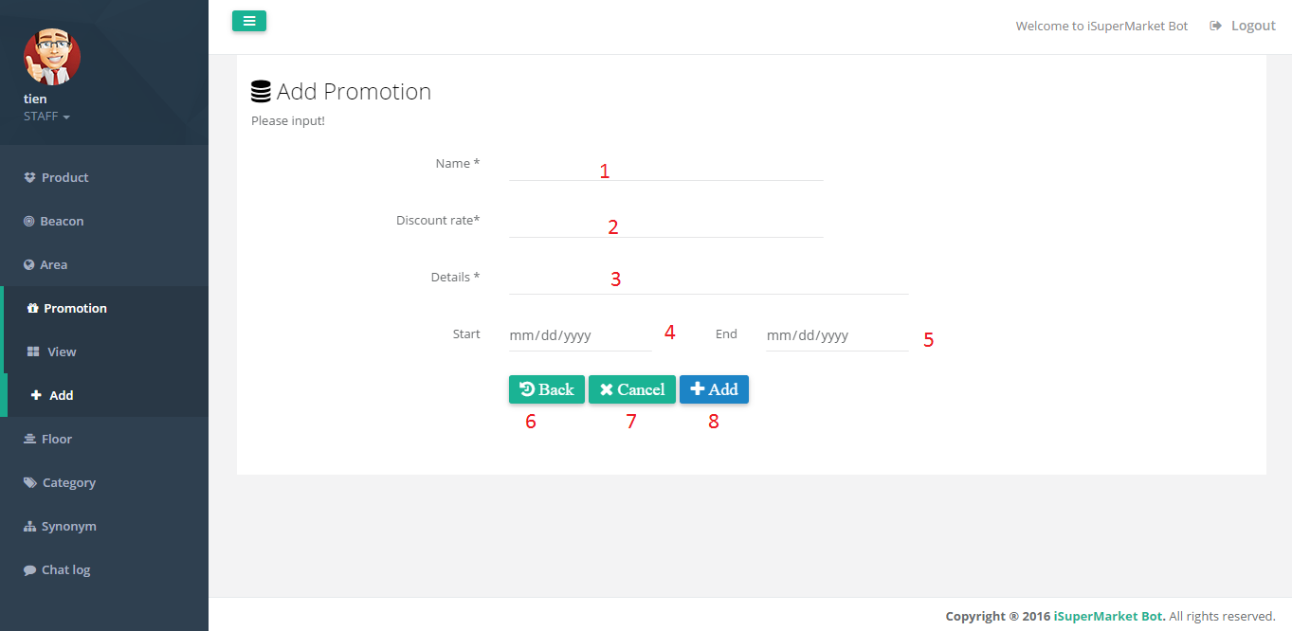

Figure 134 - Add Promotion UI

**Fields**

| **No** | **Field Names** | **Description** | **Read Only** | **Mandatory** | **Control Type** | **Data Type** |
| --- | --- | --- | --- | --- | --- | --- |
| 1 | Name | Promotion name | No | Yes | Textbox | String |
| 2 | DiscountRate | Percent rate of promotion | No | Yes | Textbox | Number |
| 3 | Detail | Detail of promotion | No | Yes | Textbox | String |
| 4 | Start | Start date of promotion | No | Yes | Textbox | Date |
| 5 | End | End date of promotion | No | Yes | Textbox | Date |

Table 118 - <Web Application> Add Promotion Fields

**Buttons/Hyperlinks**

|  |  |  |  |  |
| --- | --- | --- | --- | --- |
| **No** | **Function** | **Description** | **Validation** | **Outcome** |
| 6 | Back | Back to promotion management page | N/A | Redirect to promotion management page |
| 7 | Cancel | Reset change information | N/A | Reset information |
| 8 | Add | Send add promotion command | Validation all required fields before summit | Submit add promotion |

Table 119 - <Web Application> Add Promotion Buttons/Hyperlinks

##### Update Promotion

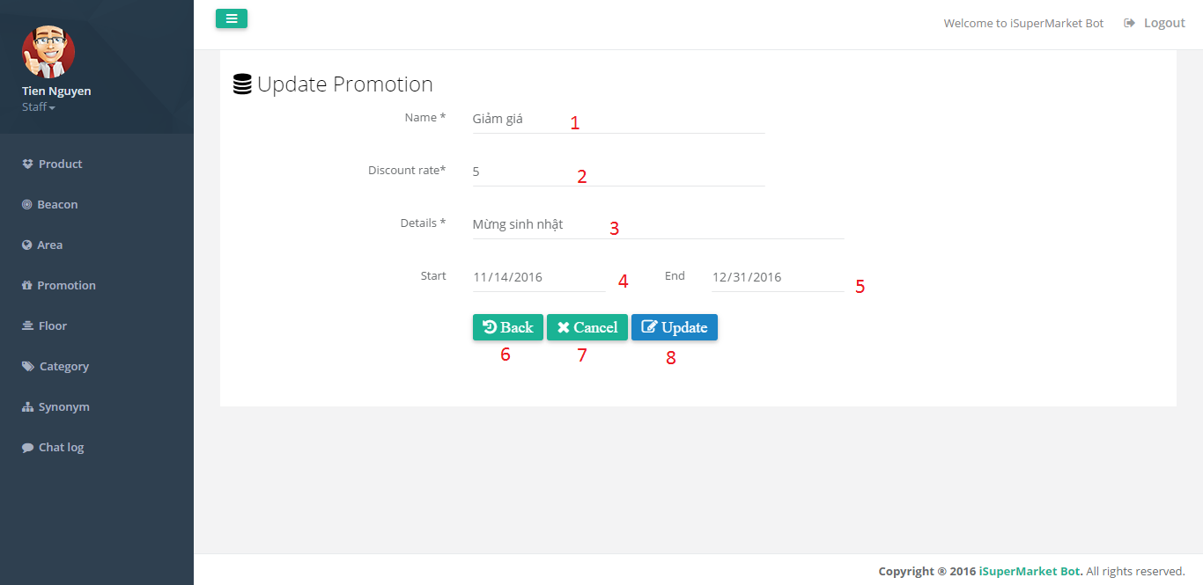

Figure 135 - Update Promotion UI

**Fields**

| **No** | **Field Names** | **Description** | **Read Only** | **Mandatory** | **Control Type** | **Data Type** |
| --- | --- | --- | --- | --- | --- | --- |
| 1 | Name | Promotion name | No | Yes | Textbox | String |
| 2 | DiscountRate | Percent rate of promotion | No | Yes | Textbox | Number |
| 3 | Detail | Detail of promotion | No | Yes | Textbox | String |
| 4 | Start | Start date of promotion | No | Yes | Textbox | Date |
| 5 | End | End date of promotion | No | Yes | Textbox | Date |

Table 120 - <Web Application> Update Promotion Fields

**Buttons/Hyperlinks**

|  |  |  |  |  |
| --- | --- | --- | --- | --- |
| **No** | **Function** | **Description** | **Validation** | **Outcome** |
| 6 | Back | Back to promotion management page | N/A | Redirect to promotion management page |
| 3 | Cancel | Reset change information | N/A | Reset information |
| 4 | Update | Send update promotion command | Validation all required fields before summit | Submit update promotion |

Table 121 - <Web Application> Update Promotion Buttons/Hyperlinks

##### Delete Promotion

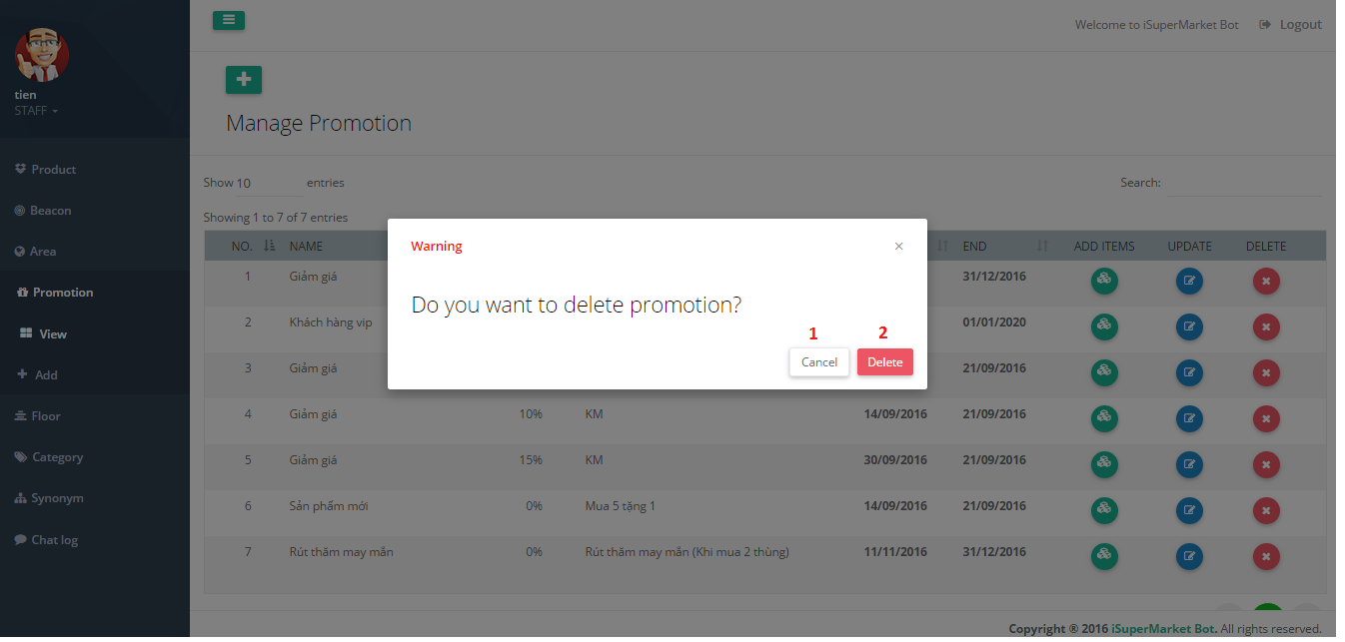

Figure 136 - Delete Promotion UI

**Fields:** N/A

**Buttons/Hyperlinks**

| **No** | **Function** | **Description** | **Validation** | **Outcome** |
| --- | --- | --- | --- | --- |
| 1 | Cancel | Cancel action | N/A | Close popup |
| 2 | DeletePromotion | Confirm delete | N/A | Show success message |

Table 122 - <Web Application> Delete Promotion Buttons/Hyperlinks

##### Promotion Items Management

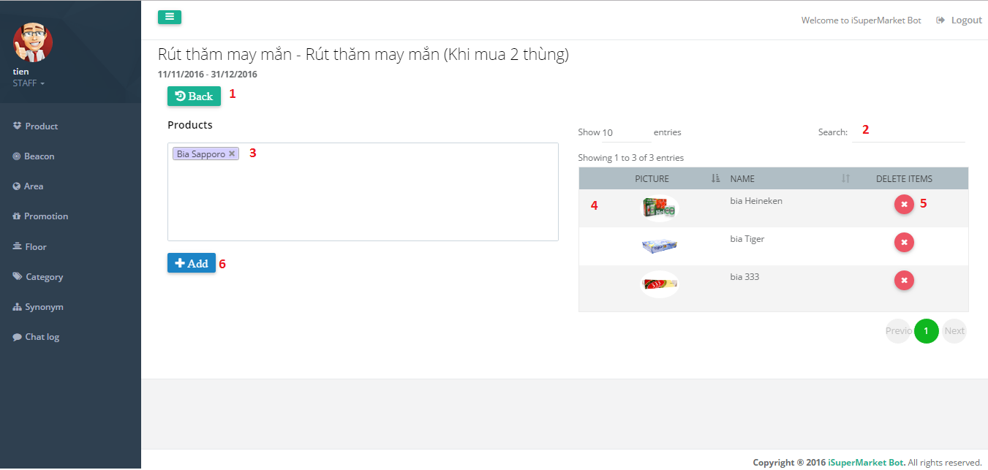

Figure 137 - Promotion Items Management

**Fields**

|  |  |  |  |  |  |  |
| --- | --- | --- | --- | --- | --- | --- |
| **No** | **Field Names** | **Description** | **Read Only** | **Mandatory** | **Control Type** | **Data Type** |
| 2 | SearchProduct | Search product by all text field | No | No | Textbox | String |
| 3 | ProductName | Name of product | No | Yes | Multiple selection drop down list | String |
| 4 | ProductData | Information of product | No | No | Table | String |

Table 123 - <Web Application> Promotion Items Management Fields

**Buttons/Hyperlinks**

| **No** | **Function** | **Description** | **Validation** | **Outcome** |
| --- | --- | --- | --- | --- |
| 1 | Back | Back to promotion management page | N/A | Redirect to promotion management page |
| 5 | DeleteProductInPromotion | Send delete product in promotion command | N/A | Submit delete product |
| 6 | AddProductIntoPromotion | Send add product into promotion command | Validation all required fields before summit | Submit add product |

Table 124 - <Web Application> Promotion Items Management Fields

##### Floor Management

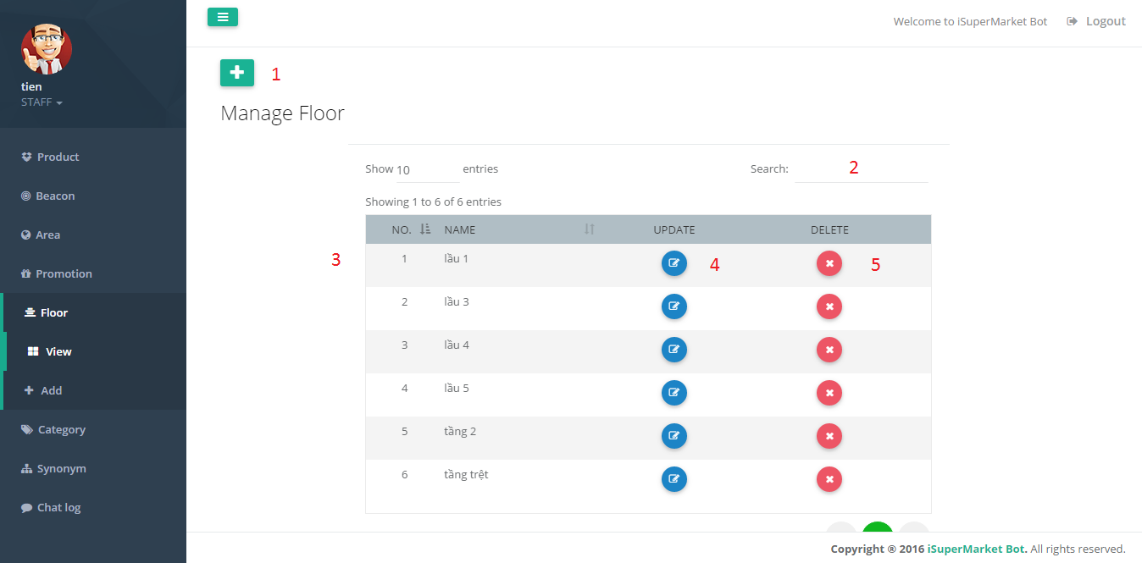

Figure 138 - Floor Management UI

**Fields**

|  |  |  |  |  |  |  |
| --- | --- | --- | --- | --- | --- | --- |
| **No** | **Field Names** | **Description** | **Read Only** | **Mandatory** | **Control Type** | **Data Type** |
| 2 | SearchFloor | Search floor by all text field | No | No | Textbox | String |
| 3 | FloorData | Information of Floor | Yes | No | Table | String |

Table 125 - <Web Application> Floor Management Fields

**Buttons/Hyperlinks**

| **No** | **Function** | **Description** | **Validation** | **Outcome** |
| --- | --- | --- | --- | --- |
| 1 | AddFloor | Add new floor | N/A | Redirect to add floor page |
| 4 | UpdateFloor | Update floor information | N/A | Redirect to update floor page |
| 5 | DeleteFloor | Delete floor | N/A | Submit delete floor |

Table 126 - <Web Application> Floor Management Buttons/Hyperlinks

##### Add Floor

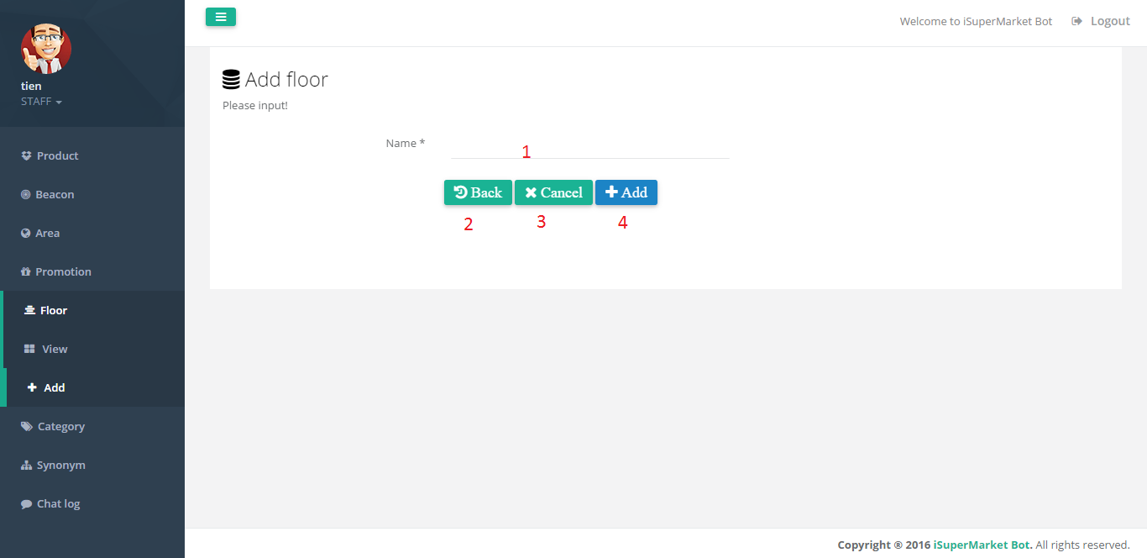

Figure 139 - Add Floor UI

**Fields**

|  |  |  |  |  |  |  |
| --- | --- | --- | --- | --- | --- | --- |
| **No** | **Field Names** | **Description** | **Read Only** | **Mandatory** | **Control Type** | **Data Type** |
| 1 | Name | Floor name | No | Yes | Textbox | String |

Table 127 - <Web Application> Add Floor Fields

**Buttons/Hyperlinks**

|  |  |  |  |  |
| --- | --- | --- | --- | --- |
| **No** | **Function** | **Description** | **Validation** | **Outcome** |
| 2 | Back | Back to floor management page | N/A | Redirect to floor management page |
| 3 | Cancel | Reset change information | N/A | Reset information |
| 4 | Add | Send add floor command | Validation all required fields before summit | Submit add floor |

Table 128 - <Web Application> Add Floor Buttons/Hyperlinks

##### Update Floor

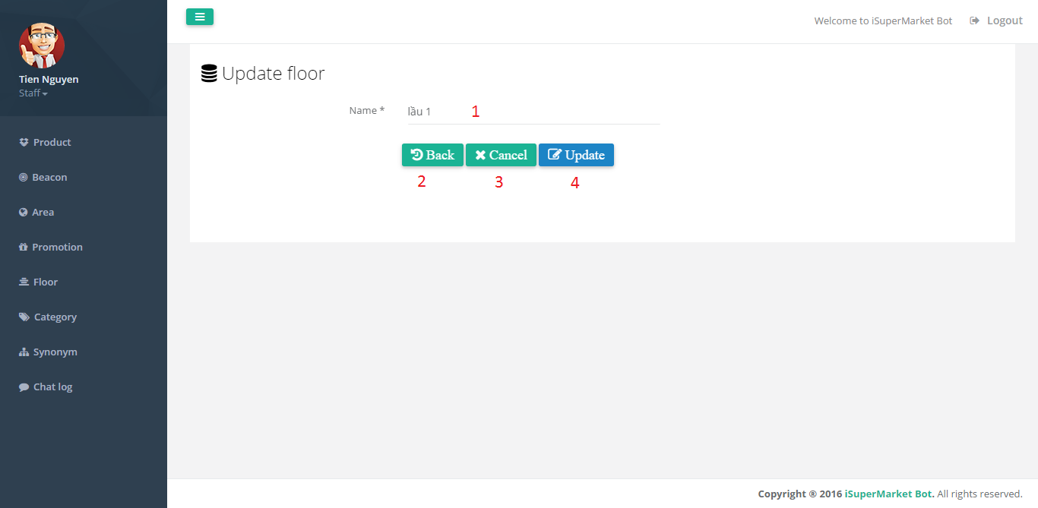

Figure 140 - Update Floor UI

**Fields**

|  |  |  |  |  |  |  |
| --- | --- | --- | --- | --- | --- | --- |
| **No** | **Field Names** | **Description** | **Read Only** | **Mandatory** | **Control Type** | **Data Type** |
| 1 | Name | Floor name | No | Yes | Textbox | String |

Table 129 - <Web Application> Update Floor Fields

**Buttons/Hyperlinks**

|  |  |  |  |  |
| --- | --- | --- | --- | --- |
| **No** | **Function** | **Description** | **Validation** | **Outcome** |
| 2 | Back | Back to floor management page | N/A | Redirect to floor management page |
| 3 | Cancel | Reset change information | N/A | Reset information |
| 4 | UpdateFloor | Send update floor command | Validation all required fields before summit | Submit update floor |

Table 130 - <Web Application> Update Floor Buttons/Hyperlinks

##### Delete Floor

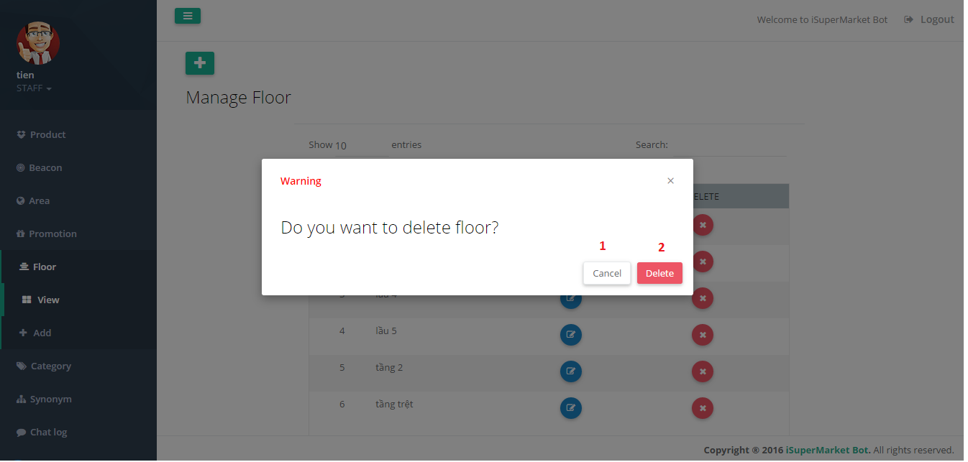

Figure 141 - Delete Floor UI

**Fields:** N/A

**Buttons/Hyperlinks**

|  |  |  |  |  |
| --- | --- | --- | --- | --- |
| **No** | **Function** | **Description** | **Validation** | **Outcome** |
| 1 | Cancel | Cancel action | N/A | Close popup |
| 2 | DeleteFloor | Confirm delete | N/A | Show success message |

Table 131 - <Web Application> Delete Floor Buttons/Hyperlinks

##### Category Management

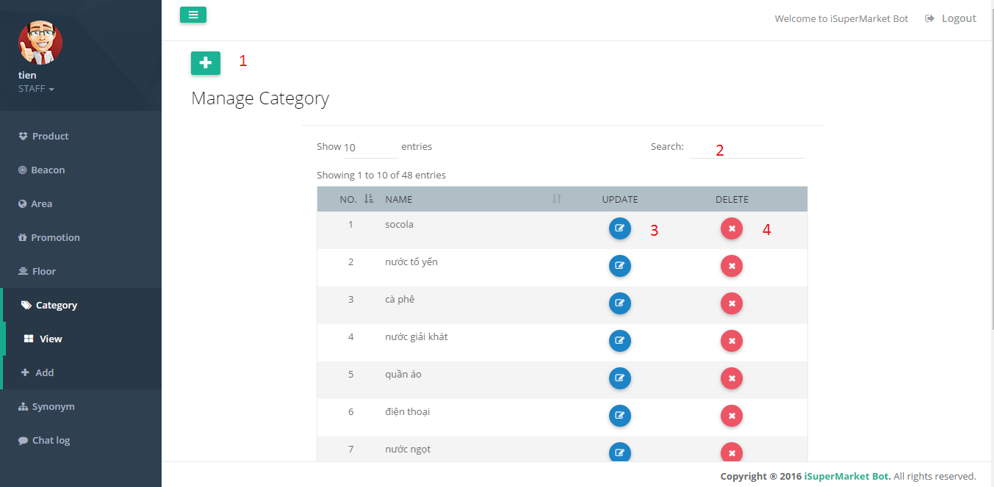

Figure 142 - Category Management UI

**Fields**

|  |  |  |  |  |  |  |
| --- | --- | --- | --- | --- | --- | --- |
| **No** | **Field Names** | **Description** | **Read Only** | **Mandatory** | **Control Type** | **Data Type** |
| 2 | SearchCategory | Search category by all text field | No | No | Textbox | String |
| 3 | CategoryData | Information of Category | Yes | No | Table | String |

Table 132 - <Web Application> Category Management Fields

**Buttons/Hyperlinks**

|  |  |  |  |  |
| --- | --- | --- | --- | --- |
| **No** | **Function** | **Description** | **Validation** | **Outcome** |
| 1 | AddCategory | Add new category | N/A | Redirect to add category page |
| 4 | UpdateCategory | Update category information | N/A | Redirect to update category page |
| 5 | DeletetCategory | Delete category | N/A | Submit delete category |

Table 133 - <Web Application> Category Management Buttons/Hyperlinks

##### Add Category

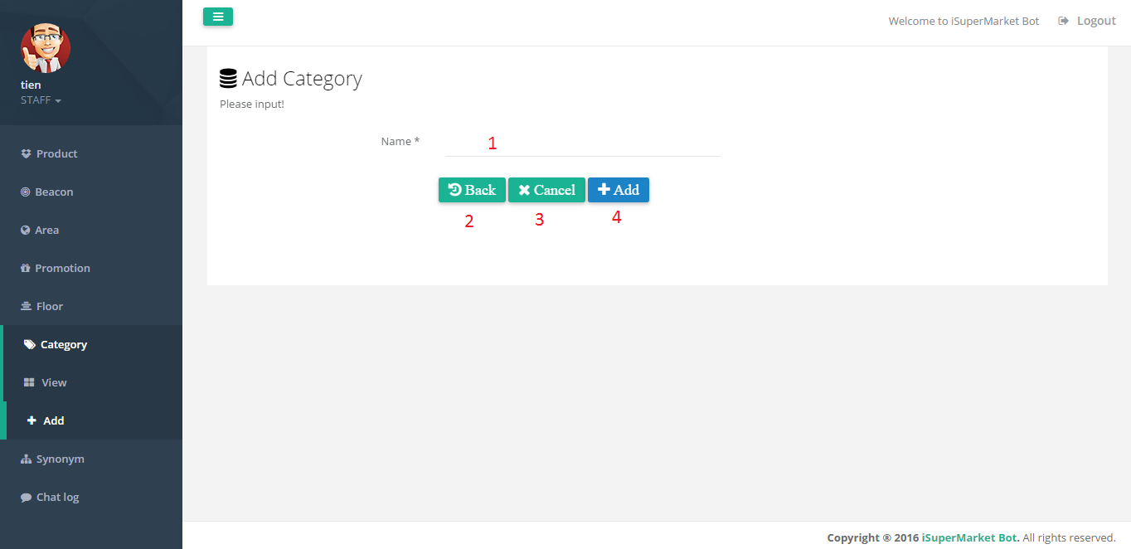

Figure 143 - Add Category UI

**Fields**

|  |  |  |  |  |  |  |
| --- | --- | --- | --- | --- | --- | --- |
| **No** | **Field Names** | **Description** | **Read Only** | **Mandatory** | **Control Type** | **Data Type** |
| 1 | Name | Category name | No | Yes | Textbox | String |

Table 134 - <Web Application> Add Category Fields

**Buttons/Hyperlinks**

| **No** | **Function** | **Description** | **Validation** | **Outcome** |
| --- | --- | --- | --- | --- |
| 2 | Back | Back to category management page | N/A | Redirect to category management page |
| 3 | Cancel | Reset change information | N/A | Reset information |
| 4 | Add | Send add category command | Validation all required fields before summit | Submit add category |

Table 135 - <Web Application> Add Category Buttons/Hyperlinks

##### Update Category

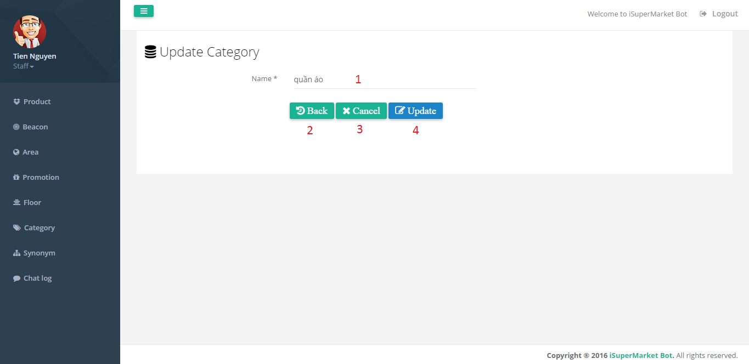

Figure 144 - Update Category UI

**Fields**

|  |  |  |  |  |  |  |
| --- | --- | --- | --- | --- | --- | --- |
| **No** | **Field Names** | **Description** | **Read Only** | **Mandatory** | **Control Type** | **Data Type** |
| 1 | Name | Category name | No | Yes | Textbox | String |

Table 136 - <Web Application> Update Category Fields

**Buttons/Hyperlinks**

|  |  |  |  |  |
| --- | --- | --- | --- | --- |
| **No** | **Function** | **Description** | **Validation** | **Outcome** |
| 2 | Back | Back to previous page | N/A | Redirect to synonym management page |
| 3 | Cancel | Reset change information | N/A | Reset information |
| 4 | Update | Send update synonym command | Validation all required fields before summit | Submit synonym floor |

Table 137 - <Web Application> Update Category Buttons/Hyperlinks

##### Delete Category

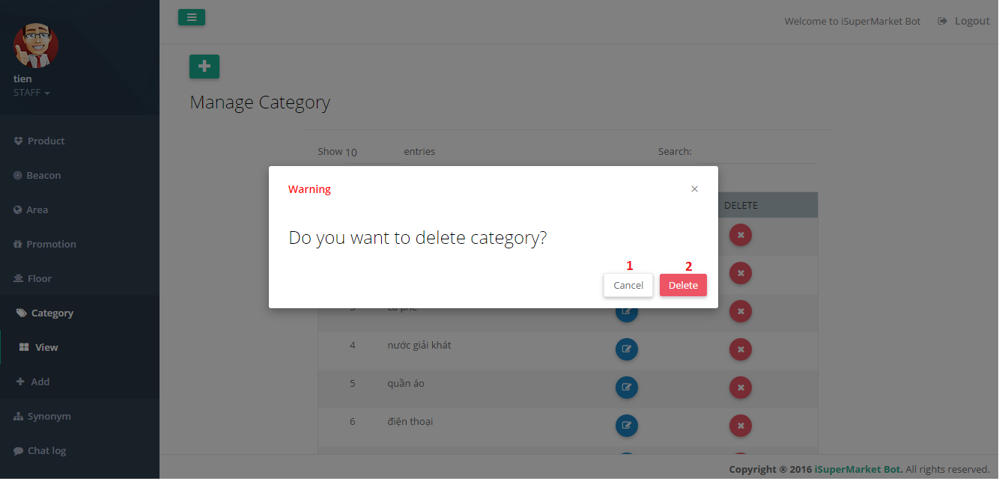

Figure 145 Delete Category UI

**Fields:** N/A

**Buttons/Hyperlinks**

|  |  |  |  |  |
| --- | --- | --- | --- | --- |
| **No** | **Function** | **Description** | **Validation** | **Outcome** |
| 1 | Cancel | Cancel action | N/A | Close popup |
| 2 | DeleteCategory | Confirm delete | N/A | Show success message |

Table 138 - <Web Application> Delete Category Buttons/Hyperlinks

##### Original Word Management

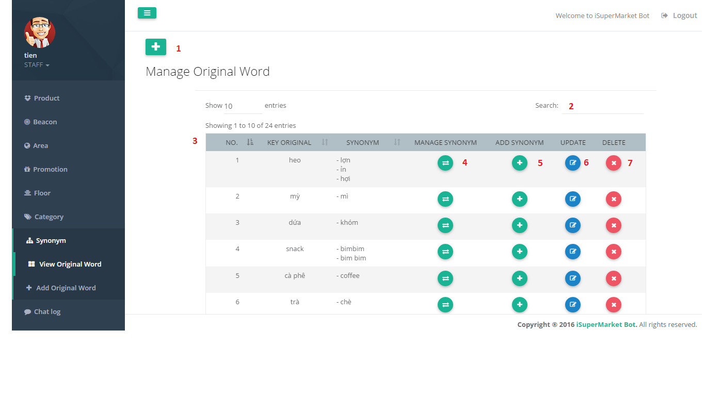

Figure 146 - Original Word Management UI

**Fields**

| **No** | **Field Names** | **Description** | **Read Only** | **Mandatory** | **Control Type** | **Data Type** |
| --- | --- | --- | --- | --- | --- | --- |
| 2 | SearchOriginalWord | Search original word by all text field | No | No | Textbox | String |
| 3 | OriginalWordData | Information of original word | Yes | No | Table | String |

Table 139 - <Web Application> Original Word Management Fields

**Buttons/Hyperlinks**

|  |  |  |  |  |
| --- | --- | --- | --- | --- |
| **No** | **Function** | **Description** | **Validation** | **Outcome** |
| 1 | AddOriginalWord | Add new original word | N/A | Redirect to add original word page |
| 4 | ManageSynonym | Manage synonym of original word | N/A | Redirect to manage synonym page |
| 5 | AddSynonym | Add new synonym | N/A | Redirect to add synonym page |
| 6 | UpdateOriginalWord | Update original word | N/A | Redirect to update original word page |

Table 140 - <Web Application> Original Word Management Buttons/Hyperlinks

##### Add Original Word

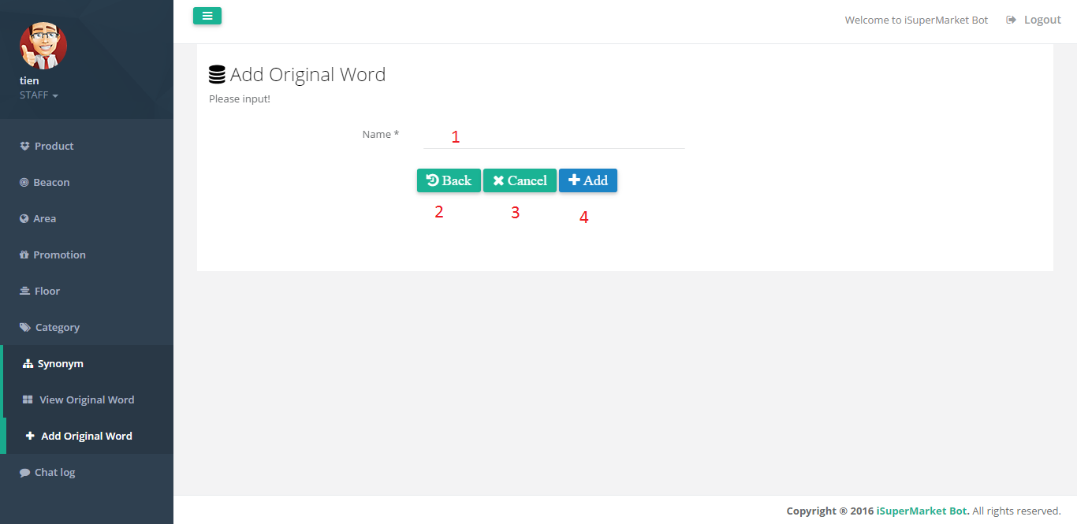

Figure 147 - Add Orignal Word UI

**Fields**

|  |  |  |  |  |  |  |
| --- | --- | --- | --- | --- | --- | --- |
| **No** | **Field Names** | **Description** | **Read Only** | **Mandatory** | **Control Type** | **Data Type** |
| 1 | Name | Original word name | No | Yes | Textbox | String |

Table 141 - <Web Application> Add Orignal Word Fields

**Buttons/Hyperlinks**

|  |  |  |  |  |
| --- | --- | --- | --- | --- |
| **No** | **Function** | **Description** | **Validation** | **Outcome** |
| 2 | Back | Back to previous page | N/A | Redirect to original word management page |
| 3 | Cancel | Reset change information | N/A | Reset information |
| 4 | Add | Send add original word command | Validation all required fields before summit | Submit add original word |

Table 142 - <Web Application> Add Original Word Buttons/Hyperlinks

##### Update Original Word

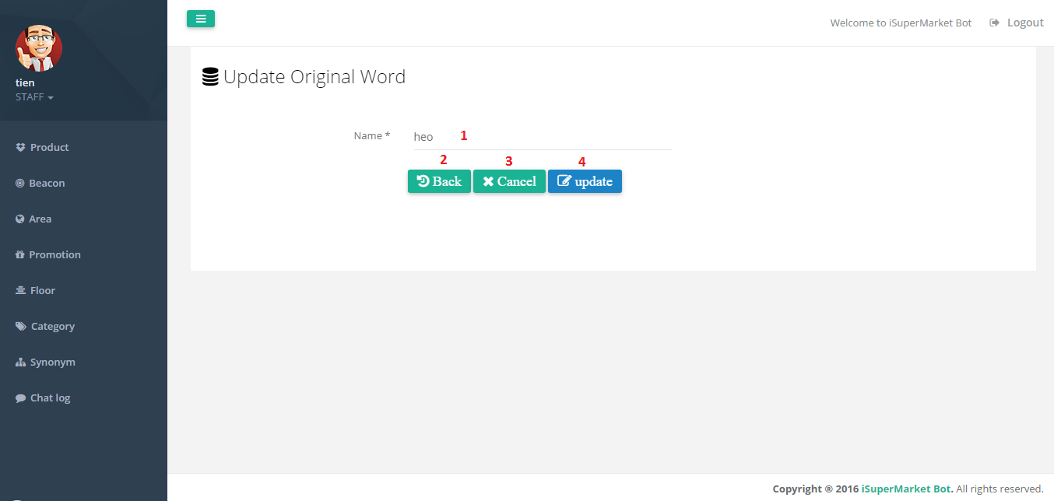

Figure 148 - Update Original Word UI

**Fields**

|  |  |  |  |  |  |  |
| --- | --- | --- | --- | --- | --- | --- |
| **No** | **Field Names** | **Description** | **Read Only** | **Mandatory** | **Control Type** | **Data Type** |
| 1 | Name | Original word name | No | Yes | Textbox | String |

Table 143 - <Web Application> Update Original Word Fields

**Buttons/Hyperlinks**

|  |  |  |  |  |
| --- | --- | --- | --- | --- |
| **No** | **Function** | **Description** | **Validation** | **Outcome** |
| 2 | Back | Back to original word management page | N/A | Redirect to original word management page |
| 3 | Cancel | Reset change information | N/A | Reset information |
| 4 | Update | Send update original word command | Validation all required fields before summit | Submit original word floor |

Table 144 - <Web Application> Update Original Word Buttons/Hyperlink

##### Delete Original Word

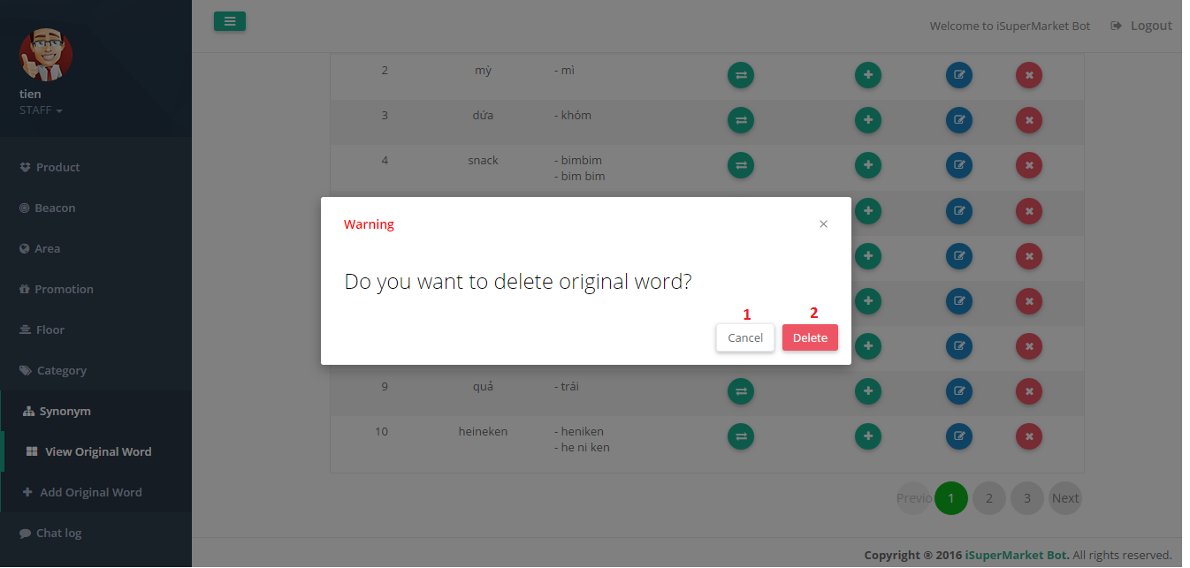

Figure 149 - Delete Original Word UI

**Fields:** N/A

**Buttons/Hyperlinks**

|  |  |  |  |  |
| --- | --- | --- | --- | --- |
| **No** | **Function** | **Description** | **Validation** | **Outcome** |
| 1 | Cancel | Cancel action | N/A | Close popup |
| 2 | DeleteOriginalWord | Confirm delete | N/A | Show success message |

Table 145 - <Web Application> Delete Original Word Buttons/Hyperlinks

##### Synonym Management

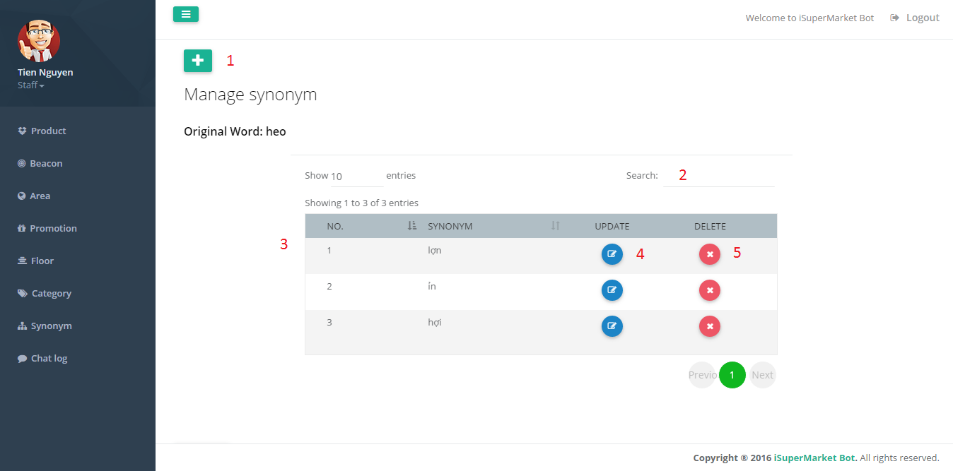

Figure 150 - Synonym Management UI

**Fields**

| **No** | **Field Names** | **Description** | **Read Only** | **Mandatory** | **Control Type** | **Data Type** |
| --- | --- | --- | --- | --- | --- | --- |
| 2 | SearchSynonym | Search synonym by all text field | No | No | Textbox | String |
| 3 | SynonymData | Information of synonym | Yes | No | Table | String |

Table 146 - <Web Application> Synonym Management Fields

**Buttons/Hyperlinks**

|  |  |  |  |  |
| --- | --- | --- | --- | --- |
| **No** | **Function** | **Description** | **Validation** | **Outcome** |
| 1 | AddSynonym | Add new synonym | N/A | Redirect to add synonym page |
| 5 | DeleteSynonym | Send delete synonym command | N/A | Submit delete synonym |
| 4 | UpdateKeyOriginal | Update synonym | N/A | Redirect to update synonym page |

Table 147 - <Web Application> Synonym Management Buttons/Hyperlinks

##### Add Synonym

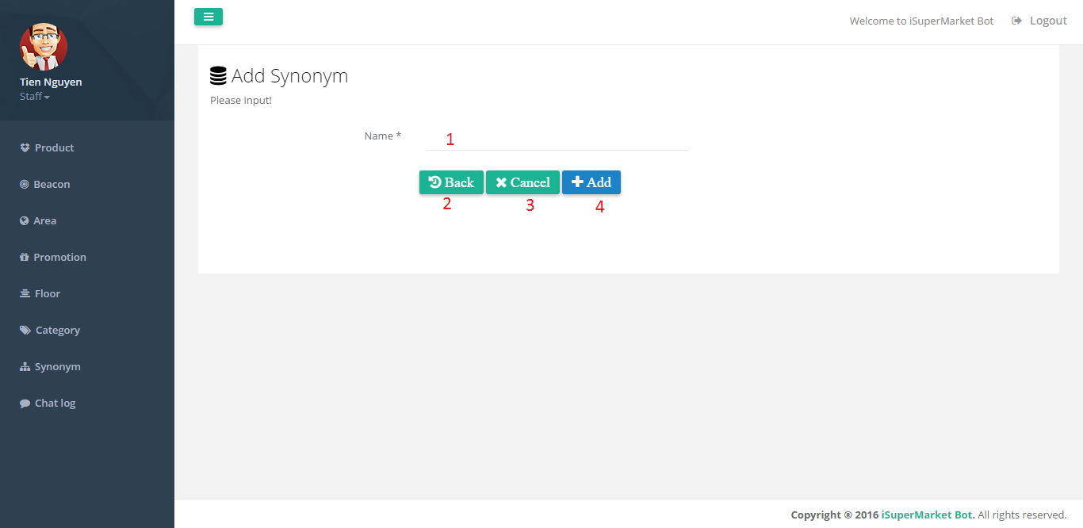

Figure 151 - Add Synonym UI

**Fields**

|  |  |  |  |  |  |  |
| --- | --- | --- | --- | --- | --- | --- |
| **No** | **Field Names** | **Description** | **Read Only** | **Mandatory** | **Control Type** | **Data Type** |
| 1 | Name | Synonym name | No | Yes | Textbox | String |

Table 148 - <Web Application> Add Synonym Fields

**Buttons/Hyperlinks**

| **No** | **Function** | **Description** | **Validation** | **Outcome** |
| --- | --- | --- | --- | --- |
| 2 | Back | Back to synonym management page | N/A | Redirect to synonym management page |
| 3 | Cancel | Reset change information | N/A | Reset information |
| 4 | Add | Send add synonym command | Validation all required fields before summit | Submit add synonym |

Table 149 - <Web Application> Add Synonym Buttons/Hyperlinks

##### Update Synonym

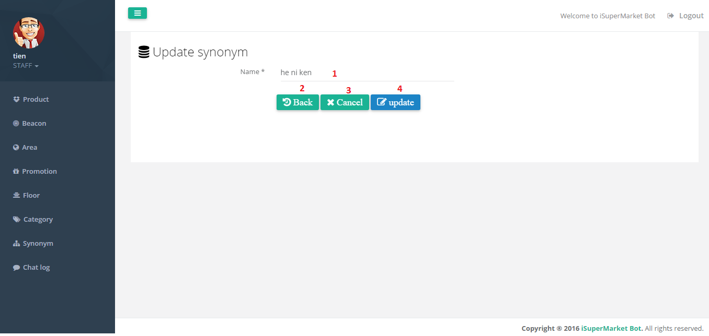

Figure 152 - Update Synonym UI

**Fields**

|  |  |  |  |  |  |  |
| --- | --- | --- | --- | --- | --- | --- |
| **No** | **Field Names** | **Description** | **Read Only** | **Mandatory** | **Control Type** | **Data Type** |
| 1 | Name | Synonym name | No | Yes | Textbox | String |

Table 150 - <Web Application> Update Synonym Fields

**Buttons/Hyperlinks**

|  |  |  |  |  |
| --- | --- | --- | --- | --- |
| **No** | **Function** | **Description** | **Validation** | **Outcome** |
| 2 | Back | Back to synonym management page | N/A | Redirect to synonym management page |
| 3 | Cancel | Reset change information | N/A | Reset information |
| 4 | Update | Send update synonym command | Validation all required fields before summit | Submit synonym floor |

Table 151 - <Web Application> Update Synonym Buttons/Hyperlinks

##### Delete Synonym

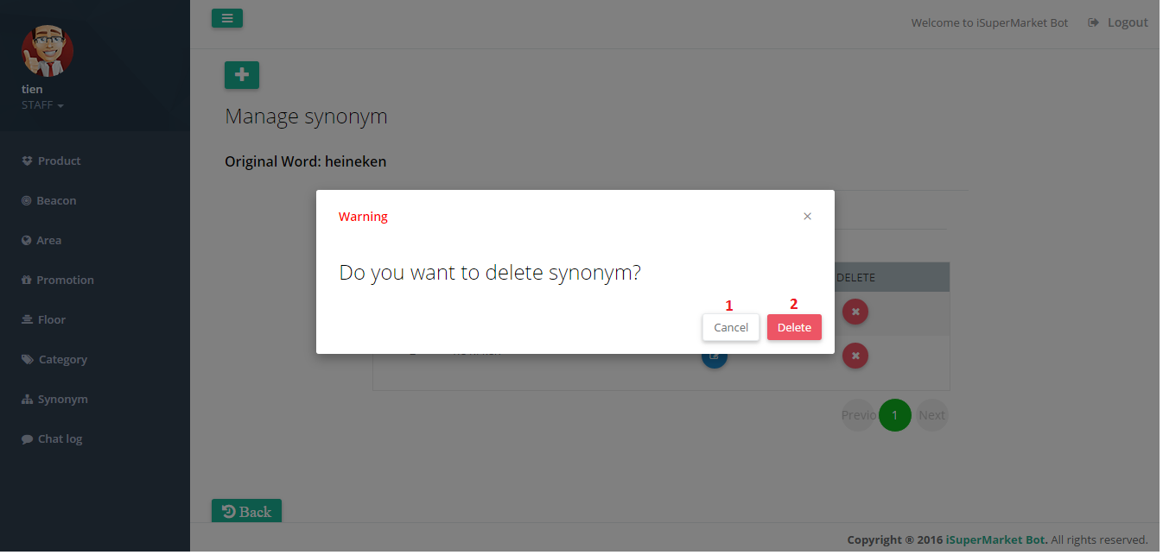

Figure 153 - Delete Synonym UI

**Fields:** N/A

**Buttons/Hyperlinks**

|  |  |  |  |  |
| --- | --- | --- | --- | --- |
| **No** | **Function** | **Description** | **Validation** | **Outcome** |
| 1 | Cancel | Cancel action | N/A | Close popup |
| 2 | DeleteSynonym | Confirm delete | N/A | Show success message |

Table 152 - <Web Application> Delete Synonym Buttons/Hyperlinks

##### Log Management

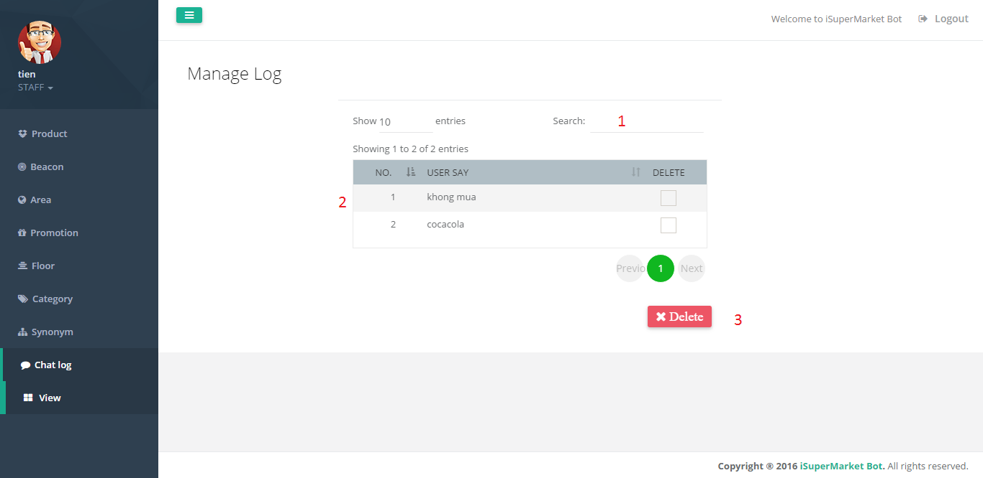

Figure 154 - Log Management UI

**Fields**

| **No** | **Field Names** | **Description** | **Read Only** | **Mandatory** | **Control Type** | **Data Type** |
| --- | --- | --- | --- | --- | --- | --- |
| 2 | SearchLog | Search log by all text field | No | No | Textbox | String |
| 3 | LogData | Information of log | Yes | No | Table | String |

Table 153 - <Web Application> Log Management Fields

**Buttons/Hyperlinks**

|  |  |  |  |  |
| --- | --- | --- | --- | --- |
| **No** | **Function** | **Description** | **Validation** | **Outcome** |
| 1 | Delete | Send delete log command | N/A | Submit delete log |

Table 154 - <Web Application> Log Management Buttons/Hyperlinks

##### Delete Log

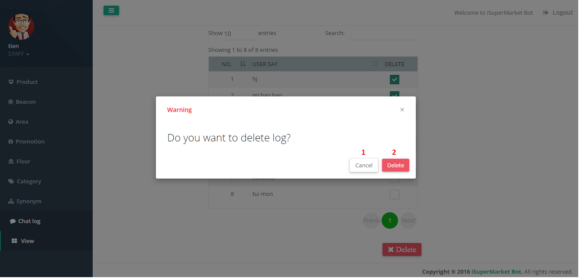

Figure 155 - Delete Log UI

**Fields:** N/A

**Buttons/Hyperlinks**

|  |  |  |  |  |
| --- | --- | --- | --- | --- |
| **No** | **Function** | **Description** | **Validation** | **Outcome** |
| 1 | Cancel | Cancel action | N/A | Close popup |
| 2 | DeleteLog | Confirm delete | N/A | Show success message |

Table 155 - <Web Application> Delete Log Buttons/Hyperlinks

## Database Design

### Entity Relationship Diagram

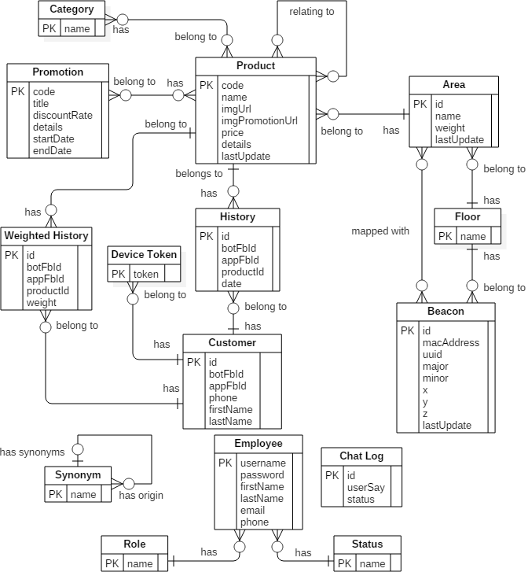

Figure 156 – Entity Relationship Diagram

### Data Dictionary

| **Entity Data Dictionary: Describe content of all entities** | | |
| --- | --- | --- |
| **Entity Name** | **Mapping entity with conceptual diagram** | **Description** |
| Category | Category | Contains information of category. |
| Promotion | Promotion | Contains information of promotion. |
| Floor | Floor | Contains information of floor. |
| Area | Area | Contains information of area. |
| Beacon | Beaconm | Contains information of beacon. |
| Product | Product | Contains information of product. |
| Customer | Customer | Contains information of customer. |
| Device Token | Device Token | Contains customers’ deivce token. |
| History | History | Contains customers’ add to cart history. |
| Weighted History | Weighted History | Contains the number of times a product was added to cart, use to suggest promotion for customers. |
| Synonym | Synonym | Contains original words and its synonyms. |
| Employee | Admin, Staff | Contains information of employee. Combine Admin and Staff entity from conceptual diagram. |
| Role | N/A | Contains information of Employee’s role. |
| Status | N/A | Contains information of Employee’s status. |
| Chat Log | Chat Log | Contains customers’ chat message when they send feedback. |

Table 156 - Entity Relationship Diagram Data Dictionary

## Algorithms

### AES Encryption

#### Definition

AES (acronym of Advanced Encryption Standard) is a symmetric encryption algorithm. The algorithm was developed by two Belgian cryptographer Joan Daemen and Vincent Rijmen. AES was designed to be efficient in both hardware and software, and supports a block length of 128 bits and key lengths of 128, 192, and 256 bits.

#### Define problems

Our Database, Facebook Developer Account, Api.ai Account has private password and access token. We need to encrypt these information to make sure no one else can access our private account.

#### Solution

In order to secure these informations, we use AES Encryption Algorithm.

<http://aesencryption.net/>

#### Complexity

In total, the complexity of this algorithm is O(1).

### MD5 Hashing

#### Definition

MD5 is one in a series of message digest algorithms designed by Professor Ronald Rivest of MIT (Rivest, 1994). When analytic work indicated that MD5’s predecessor MD4 was likely to be insecure, MD5 was designed in 1991 to be a secure replacement. (Weaknesses were indeed later found in MD4 by Hans Dobbertin.).

#### Define Problem

We need to secure our users’ passwords to make sure no one can know them.

#### Solution

In order to secure users’ passwords, we use MD5 Hashing Algorithm.

<https://www.mkyong.com/java/java-md5-hashing-example/>

#### Complexity

In total, the complexity of this algorithm is O(n).

### Identify Floor

#### Definition

Using beacons to detect customers are on which floor of the supermarket.

#### Define problems

In order to know customers are in which areas, we need to detect they are on which floor of the supermarket.

#### Beacons’ Arragement

There are 2 types of beacons in our system:

* + ***Floor Beacon:*** which will be used in this solution
    - Value of major is 2.
    - On each floors, ***Floor Beacons*** should be located near the stairs or elevator, distance about 1 meter and atleast 3 beacons.
    - ***Floor Beacons*** on each floors must be located lower than half of the height of that floor.
    - 2 ***Floor Beacons*** located on 2 consecutive floors must have the same x and y coordinates.
  + ***Area Beacon:*** is defined in next solution.

#### Solution

To solve this problem, we follow these steps:

* + Get distance from customer’s mobile device to 2 beacons which are located in two consecutive floors and are arranged in a straight line.

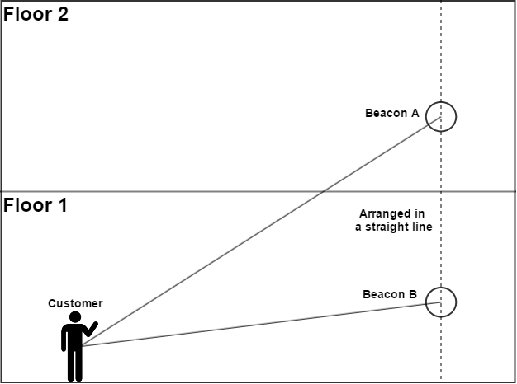

Figure 157 – Detect Floor Beacons Arrangement

* + Assume that customer is at point S , call 2 beacons as point A and point B:
    - If SA > SB: Customer is on the same floor with B.
    - If SA < SB: Customer is on the same floor with A.

#### Complexity

In total, the complexity of this algorithm is O(1).

#### Flowchart

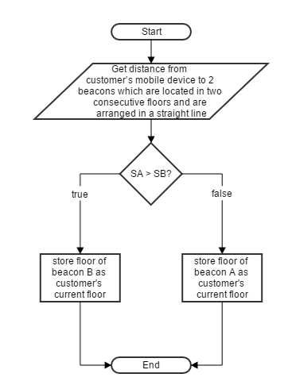

Figure 158 - Detect Floor Flowcart

### Calculate Coordinates

#### Definition

Using beacons to calculate customer’s coordinates in the supermarket.

#### Define problems

In order to tell the customers that they’re in which areas of a floor and notify them when they’re near their needed products, we need to calculate customer’s coordinates in the supermarket.

#### Beacons’ Arrangment

There are 2 types of beacons in our system:

* + ***Floor Beacon:*** is defined in previous solution.
  + ***Area Beacon:*** which will be used in this solution
    - Value of major is 1.
    - ***Area Beacons*** on each floors must be located with the same height, best is at the top of the floor.
    - An area must has 4 ***Area Beacons***.
    - An area must be a square or rectangle and should has max length and width at 10 meters.

#### Solution

To solve this problem, we follow these steps:

* + Beacons on the same floor must be arranged with same altitude (z).
  + Get coordinates of 3 beacons that have the same altitude (z) and nearest to the customer’s mobile device.
  + Set the origin point O at the top left corner of ground floor of the supermarket. We call the customer’s mobile device as S point and 3 beacons as 3 points A, B, C, we have coordinates of each points describe in below table:

|  |  |  |  |
| --- | --- | --- | --- |
| **Point** | **x** | **y** | **z** |
| S | $$x$$ | $$y$$ | $$z$$ |
| A | $$x_{A}$$ | $$y_{A}$$ | $$z_{A}$$ |
| B | $$x_{B}$$ | $$y_{B}$$ | $$z_{B}$$ |
| C |  |  |  |

* + Transform the Oxyz coordinate system into Axyz coordinate system, we have coordinates of each points describe in below table:

|  |  |  |  |
| --- | --- | --- | --- |
| **Point** | **x** | **y** | **z** |
| S | $$x^{'}=x- x_{A}$$ | $$y^{'}=y- y_{A}$$ | $$z^{'}=z- z_{A}$$ |
| A | 0 | 0 | 0 |
| B | $${x'}_{B}=x_{B}- x_{A}$$ | $${y'}_{B}=y_{B}- y_{A}$$ | 0 |
| C | $${x'}_{C}=x_{C}- x_{A}$$ | $${y'}_{C}=y_{C}- y_{A}$$ | 0 |

* + Rotate Ax axis a $φ$ angle, $0$ <= $φ$ <= 2 $π$, so that B ϵ Ax.

Call H as projection of B on Ax, we have:

$\sin\left(φ\right)= \frac{\left\|BH\right\|}{\left\|AB\right\|}= \frac{\left|{y'}_{B}\right|}{\sqrt{{{x'}_{B}}^{2}+{{y'}_{B}}^{2}}}$

$\cos\left(φ\right)= \frac{\left\|AH\right\|}{\left\|AB\right\|}= \frac{\left|{x'}_{B}\right|}{\sqrt{{{x'}_{B}}^{2}+{{y'}_{B}}^{2}}}$

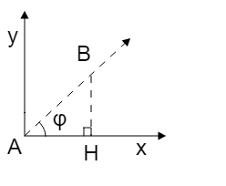

Figure 159 – Ax axis rotation

After the roration, we have coordinates of each points describe in below table:

|  |  |  |  |
| --- | --- | --- | --- |
| **Point** | **x** | **y** | **z** |
| S | $$x^{''}=x^{'}cos⁡(φ)+y^{'}sin⁡(φ)$$ | $$y^{''}=y^{'}cos⁡(φ)-x'sin⁡(φ)$$ | $$z'$$ |
| A | 0 | 0 | 0 |
| B | $${x^{''}}_{B}={x'}_{B}cos⁡(φ)+{y^{'}}_{B}sin⁡(φ)$$ | 0 | 0 |
| C | $${x^{''}}_{C}={x'}_{C}cos⁡(φ)+{y^{'}}_{C}sin⁡(φ)$$ | $${y^{''}}_{C}={y'}_{C}cos⁡(φ)-{x^{'}}_{C}sin⁡(φ)$$ | 0 |

* + S is the intersection point of 3 spheres with following details:

|  |  |  |
| --- | --- | --- |
| **Sphere** | **Center Point** | **r2** |
| (A) | A | **(I)** |
| (B) | B | **(II)** |
| (C) | C | ${r3}^{2}={(x^{''}- {x^{''}}_{C})}^{2}+ {(y^{''}- {y^{''}}_{C})}^{2}+{(z^{'})}^{2}$**(III)** |

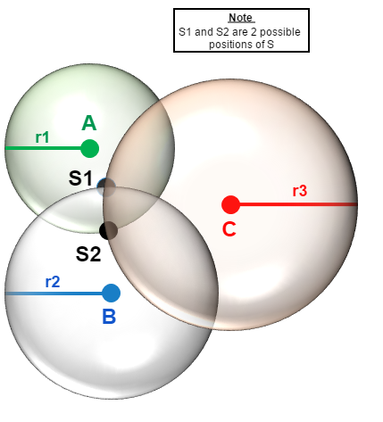

Figure 160 - Intersection of 3 spheres

* + (I) – (II), we have:
 $${r1}^{2}- {r2}^{2}=2{x^{''}}_{B}x^{''}- {({x^{''}}_{B})}^{2}$$

 $$x^{''}=\frac{{r1}^{2}- {r2}^{2}+ {({x^{''}}_{B})}^{2}}{2{x''}_{B}}$$

+ Replace $x''$ into (I), we have:

$${y''}^{2}+ {z''}^{2}= {r1}^{2}- \frac{{[{r1}^{2}- {r2}^{2}+{{{(x}^{''}}_{B})}^{2}]}^{2}}{4{{x''}_{B}}^{2}}$$

${(z^{'})}^{2}= {r1}^{2}-{(x^{''})}^{2}- {(y^{''})}^{2}$**(IV)**

* + Replace ${z''}^{2}$ into (III), we have:
 $$y''= \frac{{r1}^{2}- {r3}^{2}-{(x^{''})}^{2}+{\left(x^{''}-{x^{''}}_{C}\right)}^{2}+{({y^{''}}_{C})}^{2}}{2{{{(y}^{''}}_{C})}^{2}}$$

 $$y''= \frac{{r1}^{2}-{r3}^{2}-{{{(x}^{''}}_{C})}^{2}+{{(y''}_{C})}^{2}}{2{y''}_{C}}-\frac{{x^{''}}_{C}}{{y^{''}}_{C}}x''$$

+ From (IV), we have:
 $$z'=±\sqrt{{r1}^{2}-{\left(x^{''}\right)}^{2}-{(y^{''})}^{2}}$$

 + Rotate Ax axis a ($-φ$) angle, we have:
 $$x^{'}=x^{''}cos⁡(-φ)+y^{''}sin⁡(-φ)$$

 $$y^{'}=y^{''}cos⁡(-φ)-x''sin⁡(-φ)$$

+ Transform the Axyz coordinate system into Oxyz coordinate system, we have:

$$S\left\{\begin{aligned}x=x^{'}+x_{A} \\ y=y^{'}+y_{A} \\ z=z^{'}+z_{A}\end{aligned}\right.$$

#### Complexity

In total, the complexity of this algorithm is O(1).

#### Flowchart

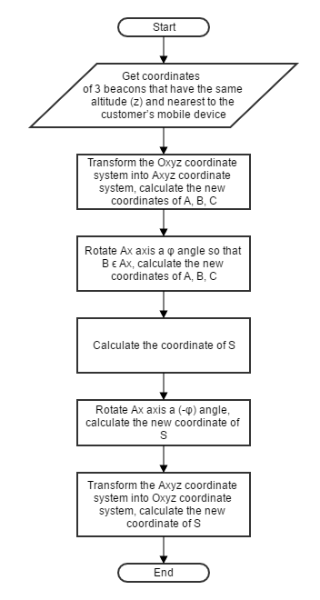

Figure 161 – Calculate Coordinate Flowchart

### Identify Area

#### Definition

Using beacons to detect customers are in which area of the supermarket

#### Define Problem

Knowing customers are on which floor and customers’ coordinates, now we will identify they’re in which area.

#### Areas’ Arrangement

An area must be a square or rectangle and should has max length and width at 10 meters

At every vertices of an area, there’s a beacon with specified coordinates.

Below picture is an example floor with 10 areas:

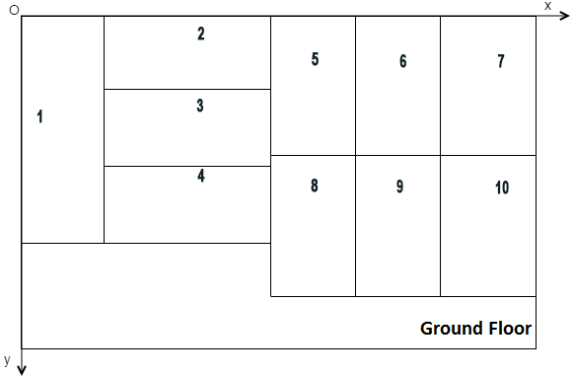

Figure 162 - Area Arrangement

#### Solution

To solve this problem, we follow these steps:

* + Get identified customer’s current floor.
  + Get calculated customer’s coordinates.
  + Suppose we know customer is at point $S(x, y, z)$, with x and y were calculated by previous solution.

Call 4 beacons of customer’s current area as $A(x_{A},y_{A},z_{A})$, $B(x_{B},y_{B},z_{B})$, $C(x_{C},y_{C},z_{C})$, $D(x_{D},y_{D},z_{D})$.

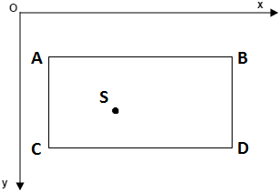

Figure 163 - Customer in an Area

Customer is in area which satisfied these conditions:

* + - On the same floor with customer.

$\left\{\begin{aligned}x_{A}≤x≤x_{B} or x_{C}≤x≤x_{D} \\ y_{A}≤y≤y_{C} or y_{B}≤y≤y_{D}\end{aligned}\right.$

#### Complexity

In total, the complexity of this algorithm is O(n).

#### Flowchart

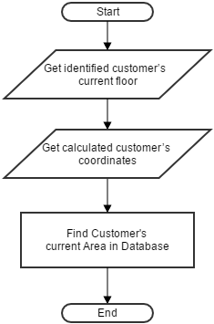

Figure 164 - Identify Area Flowchart

### Define Synonym Name

#### Definition

Define synonyms of categories’ names and products’ names.

#### Define problem

There are groups of words that have the same meaning which customers can use to search for products in the supermarket.

#### Solution

To solve this problem, we follow these steps:

* + Get a list of 1000 product/category, loop until there is no more records of product/category.
  + For earch product/category records, get a list of 1000 words in synonym table, loop until there is no more records of synonym.
  + For earch words, check if product/category name contains that word, case insensitive.
  + If yes, get all synonyms of that word.
  + For each synonym, replace it in every synonym names of product/category.
  + Send all defined synonym names of product/category name to Api.ai.

***Example:***

|  |  |  |
| --- | --- | --- |
| **Name** | **Synonyms** | **Synonym Name** |
| chocolate M&M’s | chocolate  sô cô la  socola | sô cô la M&M’s  socola M&M’s |
| mì hảo hảo | mì  mỳ | mỳ hảo hảo |

#### Complexity

In total, the complexity of this algorithm is O(n6).

#### Flowchart

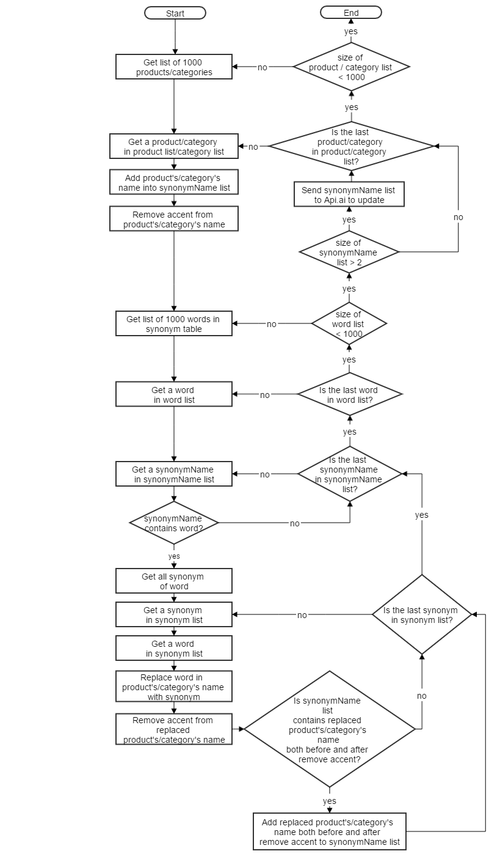

Figure 165 - Define Synonym Name Flow Chart

# System Implementation & Test

## Introduction

### Overview

This section describes the approach and methodlogies used by group to plan, organize and manage the testing process of ISMB system. It provides in detail all necessary information about system implementation information and testing procedure of ISMB, includes test plan, test cases, test results and risk estimations.

### Test Approach

* + Goal: To test the whole system based on the coreflow.
  + Method: Black-box testing.

## Database Relationship Diagram

### Physical Diagram

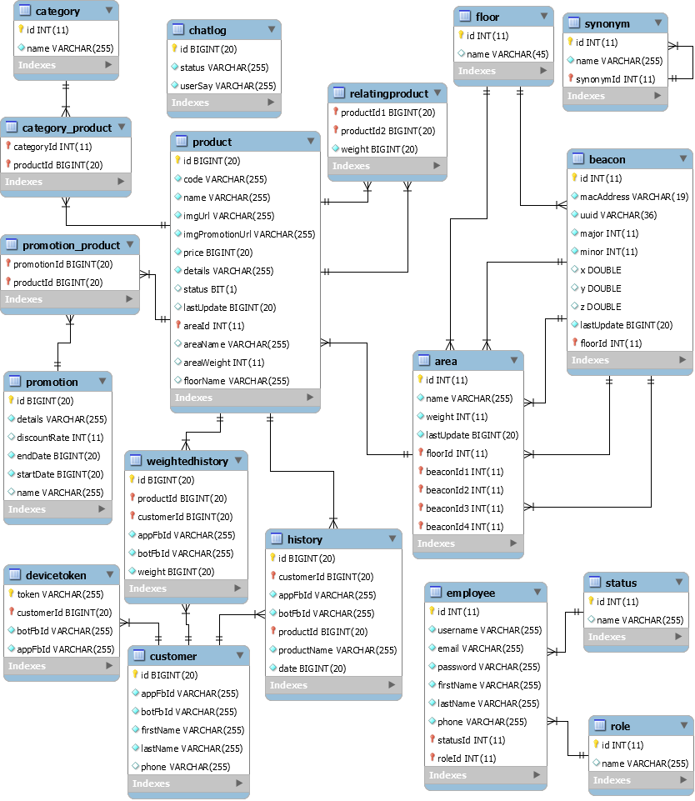

Figure 166 – Physical Diagram

### Data Dictionary

| **Entity Data Dictionary: Describe content of all entities** | | |
| --- | --- | --- |
| **Entity Name** | **Mapping table with class diagram** | **Description** |
| category | category | Contains the information of category. |
| promotion | promotion | Contains the information of promotion. |
| floor | floor | Contains the information of floor. |
| area | area, area_beacon | Contains the information of area. An area has exactly 4 beacons, therefor we add 4 fields beaconId into area table and remove area_beacon table. |
| beacon | beacon | Contains the information of beacon. |
| product | product | Contains the information of product. |
| customer | customer | Contains the information of customer. |
| devicetoken | devicetoken | Contains token of customers’ devices. Token is used for authentication and send message. |
| history | history | Contains the add to cart history of customer. |
| weightedhistory | weightedhistory | Contains the number of times a product was added to cart, use to suggest promotion for customers. |
| category_product | category_product | Contains mapping between category and product. |
| promotion_product | promotion_product | Contains mapping between promotion and product. |
| relatingproduct | relatingproduct | Contains relationship between products, use to suggest product to customer. |
| synonym | synonym | Contains the information of synonym. |
| employee | employee | Contains the information of account in web admin. |
| role | role | Contains information of role. |
| status | status | Contains information of status. |
| chatlog | chatlog | Contains customer’s chat message when they send feedback. |

Table 157 - Physical Diagram Data Dictionary

| **Entity Name** | **Attributes** | **Description** | **Domain** | **Allow Null** |
| --- | --- | --- | --- | --- |
| category | id {PK} | Unique identifier of category | Integer | No |
| name | Name of category | String | No |
| promotion | id {PK} | Unique identifier of promotion | Long | No |
| name | Name of promotion | String | Yes |
| discountRate | The percentage of discount of promotion. | String | Yes |
| details | Details information of promotion | String | No |
| startDate | Date when promotion start | Long | No |
| endDate | Date when promotion end | Long | No |
| floor | id {PK} | Unique identifier of floor | Integer | No |
| name | Name of floor | String | No |
| area | id {PK} | Unique identifier of area | Integer | No |
| code | Code of area | String | No |
| name | Name of area | String | No |
| weight | Weight of area in supermarket, use to suggest which area to go first | Interger | Yes |
| beaconId1 | Id of 1 of 4 beacons which are located in area | Integer | Yes |
| beaconId2 | Id of 1 of 4 beacons which are located in area | Integer | Yes |
| beaconId3 | Id of 1 of 4 beacons which are located in area | Integer | Yes |
| beaconId4 | Id of 1 of 4 beacons which are located in area | Integer | Yes |
| lastUpdate | Time of last record update | Long | No |
| floorId | Unique identifier of floor | Integer | Yes |
| beacon | id {PK} | Unique identifier of beacon | Integer | No |
| macAddress | Unique mac address of beacon | String | No |
| uuid | uuid of beacon | String | No |
| major | major of beacon | Integer | No |
| minor | minor of beacon | Integer | No |
| x | Longitude of beacon (Ox axis) | Double | No |
| y | Lattitude of beacon (Oy axis) | Double | No |
| z | Altitude of beacon (Oz axis) | Double | No |
| lastUpdate | Time of last record update | Long | No |
| floorId | Unique identifier of floor | Integer | Yes |
| product | id {PK} | Unique identifier of product | Integer | No |
| code | Code of product | String | No |
| name | Name of product | String | No |
| details | Details information of product | String | No |
| imgUrl | Image url of product | String | No |
| imgPromotionUrl | Image url of product when has promotion | String | No |
| status | Status of product | Boolean | No |
| lastUpdate | Time of last record update | Long | No |
| areaId | Unique identifier of area | Integer | Yes |
| areaName | Name of area | String | Yes |
| areaWeight | Weight of area in supermarket, use to suggest which area to go first | Integer | Yes |
| floorName | Name of floor | String | Yes |
| customer | id {PK} | Unique identifier of customer | Long | No |
| appFbId | Unique identifier of customer’s facebook account when chat with bot. | String | Yes |
| botFbId | Unique identifier of customer’s facebook account when login mobile application | String | Yes |
| firstName | First name of customer | String | No |
| lastName | Last name of customer | String | No |
| phone | Unique phone number of customer | String | Yes |
| devicetoken | id {PK} | Unique identifier of devicetoken | Long | No |
| token | Unique token that device registers with server | String | No |
| botFbId | Unique identifier of customer’s facebook account when chat with bot. | String | No |
| appFbId | Unique identifier of customer’s facebook account when login mobile application | String | Yes |
| customerId | Unique identifier of customer | Long | No |
| history | id {PK} | Unique identifier of history | Long | No |
| botFbId | Unique identifier of customer’s facebook account when chat with bot. | String | No |
| appFbId | Unique identifier of customer’s facebook account when login mobile application | String | No |
| date | Time when history is recorded. | Long | No |
| productId | Unique identifier of product | Long | No |
| productName | Name of product | String | No |
| customerId | Unique identifier of customer | Long | No |
| weightedhistory | id {PK} | Unique identifier of devicetoken | Long | No |
| botFbId | Unique identifier of customer’s facebook account when chat with bot. | String | No |
| appFbId | Unique identifier of customer’s facebook account when login mobile application | String | No |
| customerId | Unique identifier of customer | Long | No |
| productId | Unique identifier of product | Long | No |
| weight | Number of times a product is add to cart, use to suggest promotion for customer | Integer | No |
| category_product | categoryId {PK} | Unique identifier of category | Integer | No |
| productId {PK} | Unique identifier of product | Long | No |
| promotion_product | productId {PK} | Unique identifier of product | Long | No |
| promotionId {PK} | Unique identifier of promotion | Long | No |
| relatingproduct | productId1 {PK} | Unique identifier of product. | Long | No |
| productId2 {PK} | Unique identifier of product. | Long | No |
| weight | Relevance between 2 products. | Integer | No |
| synonym | id {PK} | Unique identifier of synonym | Integer | No |
| name | Name of synonym | String | No |
| synonymId | Id of synonym | Integer | No |
| employee | id {PK} | Unique identifier of employee. | Integer | No |
| username | Unique username of employee. | String | No |
| password | Password of employee | String | No |
| firstName | First name of employee. | String | No |
| lastName | Last name of employee. | String | No |
| email | Email of employee | String | No |
| phone | Phone number of employee | String | No |
| roleId | Unique identifier of role | Integer | No |
| statusId | Unique identifier of status | Integer | No |
| role | id {PK} | Unique identifier of role | Integer | No |
| name | Unique name of role. | String | No |
| status | id {PK} | Unique identifier of status | Integer | No |
| name | Unique name of status | String | No |
| chatlog | id {PK} | Unique identifier of chat log | Long | No |
| userSay | Chat message of customer | String | No |
| status | Status of chat log | Integer | No |

Table 158 – Attributes Data Dictionay

## Performance Measures

### ISMB Engine Connecting Speed

#### Definition

This section tests the speed when user chat through facebook messenger app and connect to ISMB Sever.

#### Test environment

*Server:*

* + Operating system: Windows Server 2012 R2 64-bit
  + Memory: 1Gb
  + Processor: 2.4Ghz
  + Network: Cable 1.0Gbps

*Client:*

* + Operating system: Android Lollipop 5.0.1
  + Memory: 2Gb
  + Processor: 4x1.6Ghz + 4x1.2Ghz

#### Test cases

Using mobile to send request to server through facebook messenger app.

List of web services to be tested:

|  |  |  |
| --- | --- | --- |
| **No.** | **Function name** | **Description** |
| 1 | Chat by text | User type text to search different products. |
| 2 | Chat by image | User send images to search different products. |
| 3 | Click button in chat box | User click menu button or item button in facebook messenger chat box. |

Table 159 – Chat with ISMB Server speed test cases

#### Results

The test is run 500 times. Each times we run all the listed test cases and record the average time of web services respoding.

|  |  |  |  |
| --- | --- | --- | --- |
| **Test cases** | **1** | **2** | **3** |
| **Average Time (Unit: second)** | 4.93 | 7.52 | 3.44 |

Table 160 - ISMB Engine Connecting Speed Test Result

*Test details:*

<https://drive.google.com/open?id=0B1br9KKyTlJPRzIzVFIwbjR5eVk>

Sheet “ISMB Engine Connecting Speed”

### Mobile Application Detection Speed & Accuracy

#### Definition

This section tests the speed and accuracy when mobile application detect customer’s current area in the supermarket.

#### Test environment

*Mobile:*

* + Operating system: Android Lollipop 5.0.1
  + Memory: 2Gb
  + Processor: 4x1.6Ghz + 4x1.2Ghz
  + Bluetooth: Bluetooth 4.0 BLE (Bluetooth Less Energy)

#### Test cases

Using mobile application to detect current area.

#### Results

The test is run 500 times. Each times we run all the listed test cases and record the area detection‘s time and accuracy of mobile application.

|  |  |
| --- | --- |
| **Average Time (Unit: second)** | **Accuracy** |
| 26.69 | 74.20% |

Table 161 – Mobile Application Area Detection Speed & Accuracy Test Result

*Test details:*

<https://drive.google.com/open?id=0B1br9KKyTlJPRzIzVFIwbjR5eVk>

Sheet “Area Detection Speed & Accuracy”

## Test Plan

The purpose of this section is to verify and ensure that ISMB meets its design specification and other requirements from user. The following part will describe which features to be tested and which will not.

### Features to be tested

* + ISMB Engine
  + Mobile application:
    - Auto handler: Indentify Area, Detect Product.

### Features not to be tested

* + Web application:
    - Guest: Login.
    - Authenticated user: Logout, Update profile.
    - Admin: Manage Account
    - Staff: Manage floor, Manage beacon, Manage category, Manage area, Manage promotion, Manage log, Manage synonym, Manage product.
    - Scheduler: Train by synonym.
  + Mobile application:
    - Customer: Login, Logout, Insert phone, Change phone.
    - Auto handler: Indentify Floor, Detect Product.

## System Testing Test Case

### Communication Diagram

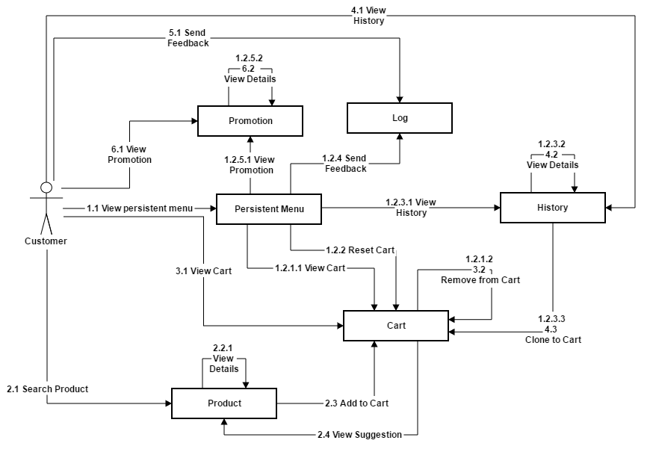

Figure 167 - Communication Diagram

### Test cases

#### ISMB Engine Test Cases

| **ID** | **Test Case Description** | **Test Case Procedure** | **Expected Output** | **Result**  **(Passed /Failed)** | **Test Date** |
| --- | --- | --- | --- | --- | --- |
| 1 | Send text message to search product | 1. Tester logins her/his account. 2. Tester taps on the conversation with bot on Facebook Messenger application to open chat box. 3. Tester sends text message to search product | Bot replies message with list of products. | Passed | From 15/09/2016  to 12/12/2016 |
| 2 | Test send image message to search product | 1. Tester logins her/his account. 2. Tester taps on the conversation with bot on Facebook Messenger application to open chat box. 3. Tester sends image message to search product. | Bot replies message with list of products. | Passed | From 15/09/2016  to 12/12/2016 |
| 3 | Test view product’s details | 1. Tester logins her/his account. 2. Tester taps on the conversation with bot on Facebook Messenger application to open chat box. 3. Tester send message to search product. 4. Tester selects option “Xem chi tiết” | Bot replies details information of product. | Passed | From 15/09/2016  to 12/12/2016 |
| 4 | Test add product to cart | 1. Tester logins her/his account. 2. Tester taps on the conversation with bot on Facebook Messenger application to open chat box. 3. Tester send message to search product. 4. Tester selects option “Thêm vào giỏ hàng”. 5. Tester taps on persistent menu. 6. Tester selects option “Xem giỏ hàng”. | Bot replies list of products in cart, which must contains the product that has just been added. | Passed | From 16/09/2016  to 13/12/2016 |
| 5 | Test suggest product | 1. Tester logins her/his account. 2. Tester taps on the conversation with bot on Facebook Messenger application to open chat box. 3. Tester send message to search product. 4. Tester selects option “Thêm vào giỏ hàng”. 5. Tester selects option “Gợi ý”. | Bot replies list of products in cart, which is relating to the product that has just been added. | Passed | From 16/09/2016  to 12/12/2016 |
| 6 | Test the appearance of “Persistent Menu” | 1. Tester logins her/his account. 2. Tester taps on the conversation with bot on Facebook Messenger application to open chat box. | Persistent menu appears on bottom left corner with 5 buttons:   * “Xem giỏ hàng” * “Tạo mới giỏ hàng” * “Khuyến mãi hôm nay” * “Lịch sử mua hàng” * “Phản hồi kết quả” | Passed | From 18/09/2016  to 12/12/2016 |
| 7 | Test view cart button on persistent menu | 1. Tester logins her/his account. 2. Tester taps on the conversation with bot on Facebook Messenger application to open chat box. 3. Tester must add atleast 1 product to cart. 4. Tester taps on persistent menu. 5. Tester selects option “Xem giỏ hàng”. | Bot replies with list of products in cart. | Passed | From 18/09/2016  to 12/12/2016 |
| 8 | Test remove product from cart | 1. Tester logins her/his account. 2. Tester taps on the conversation with bot on Facebook Messenger application to open chat box. 3. Tester must add atleast 1 product to cart. 4. Tester taps on persistent menu. 5. Tester selects option “Xem giỏ hàng”. 6. Tester selects option “Xóa sản phẩm” of a product in cart. 7. Tester taps on persistent menu. 8. Tester selects option “Xem giỏ hàng”. | Bot replies list of products in cart, which must not contains the product that has just been removed. | Passed | From 18/09/2016  to 12/12/2016 |
| 9 | Test reset cart button on persistent menu | 1. Tester logins her/his account. 2. Tester taps on the conversation with bot on Facebook Messenger application to open chat box. 3. Tester taps on persistent menu. 4. Tester selects option “Tạo mới giỏ hàng”. 5. Tester taps on persistent menu. 6. Tester selects option “Xem giỏ hàng”. | Bot replies “Giỏ hàng đang trống”. |  | From 18/09/2016  to 12/12/2016 |
| 10 | Test promotion button on persistent menu | 1. Tester logins her/his account. 2. Tester taps on the conversation with bot on Facebook Messenger application to open chat box. 3. Tester taps on persistent menu. 4. Tester selects option “Khuyến mãi hôm nay”. | Bot replies list of products which are available on current date. | Passed | From 18/09/2016  to 12/12/2016 |
| 11 | Test history button on persistent menu | 1. Tester logins her/his account. 2. Tester taps on the conversation with bot on Facebook Messenger application to open chat box. 3. Tester taps on persistent menu. 4. Tester selects option “Lịch sử mua hàng”. | Bot replies with list of 10 most recent shopping days. | Passed | From 18/09/2016  to 12/12/2016 |
| 12 | Test view history details | 1. Tester logins her/his account. 2. Tester taps on the conversation with bot on Facebook Messenger application to open chat box. 3. Tester taps on persistent menu. 4. Tester selects option “Lịch sử mua hàng”. 5. Test selects option “Xem chi tiết” of a shopping day. | Bot replies list of products that were bought on that day. | Passed | From 18/09/2016  to 12/12/2016 |
| 13 | Test clone cart from history | 1. Tester must have shopping history of atleast 1 day. 2. Tester logins her/his account. 3. Tester taps on the conversation with bot on Facebook Messenger application to open chat box. 4. Tester taps on persistent menu. 5. Tester selects option “Lịch sử mua hàng”. 6. Test selects option “Thêm vào giỏ hàng” of a shopping day. 7. Tester taps on persistent menu. 8. Tester selects option “Xem giỏ hàng”. | Bot replies list of products in cart, which must contain all products that were bought on selected shopping day. | Passed | From 18/09/2016  to 12/12/2016 |
| 14 | Test feed back button on persistent menu | 1. Tester logins her/his account. 2. Tester taps on the conversation with bot on Facebook Messenger application to open chat box. 3. Tester send message to search product. 4. Tester taps on persistent menu. 5. Tester selects option “Phản hồi kết quả”. | Log is recorded and bot replies “Cảm ơn bạn đã phản hồi”. | Passed | From 18/09/2016  to 12/12/2016 |
| 15 | Test view cart shortkey | 1. Tester logins her/his account. 2. Tester taps on the conversation with bot on Facebook Messenger application to open chat box. 3. Tester must add atleast 1 product to cart. 4. Tester sends message “@gh”. | Bot replies with list of products in cart. | Passed | From 20/09/2016  to 12/12/2016 |
| 16 | Test reset cart shortkey | 1. Tester logins her/his account. 2. Tester taps on the conversation with bot on Facebook Messenger application to open chat box. 3. Tester sends message “@xoa”. 4. Tester sends message “@gh”. | Bot replies “Giỏ hàng đang trống”. | Passed | From 18/09/2016  to 12/12/2016 |
| 17 | Test promotion shortkey | 1. Tester logins her/his account. 2. Tester taps on the conversation with bot on Facebook Messenger application to open chat box. 3. Tester sends message “@km”. | Bot replies list of products which are available on current date. | Passed | From 20/09/2016  to 12/12/2016 |
| 18 | Test history shortkey | 1. Tester logins her/his account. 2. Tester taps on the conversation with bot on Facebook Messenger application to open chat box. 3. Tester sends message “@ls”. | Bot replies with list of 10 most recent shopping days. | Passed | From 20/09/2016  to 12/12/2016 |
| 19 | Test feedback shortkey | 1. Tester logins her/his account. 2. Tester taps on the conversation with bot on Facebook Messenger application to open chat box. 3. Tester sends message “@ph”. | Log is recorded and bot replies “Cảm ơn bạn đã phản hồi”. | Passed | From 20/09/2016  to 12/12/2016 |

Table 162 - ISMB Enginge Test Cases

#### Mobile Application Test Cases

|  |  |  |  |  |  |
| --- | --- | --- | --- | --- | --- |
| **ID** | **Test Case Description** | **Test Case Procedure** | **Expected Output** | **Result**  **(Passed /Failed)** | **Test Date** |
| 1 | Indentify Area | 1. Tester logins mobile application by facebook account. 2. Tester walks into arragned areas. | Application display the name of the area where tester is standing. | Passed | From 05/10/2016  to 10/12/2016 |
| 2 | Detect Products | 1. Tester chat with bot and add products into cart. 2. Testers logins mobile application by facebook account. 3. Tester walks into arragned areas, which has products that were added to cart. | Application notify list of products located in area where testers is standing. | Passed | From 05/10/2016  to 10/12/2016 |

Table 163 – Mobile Application Test Cases

# Software User’s Manual

## Installation Guide

### Setting up environment at server side

#### Hardware Requirements

Personal computer for developing with the minimum configuration:

* Intel® Core Dual 1.8Ghz
* RAM: 4GB
* 20Gb of hard disk
* Internet connection: 4Mbps

#### Software Requirements

The following software must be installed into the sever machine:

* Operating System: Microsoft Windows Server 2012 R2
* Java: 1.8.0_102
* Web Server: Apache Tomcat 8.5.4
* Database: MySQL 5.7.11
* Google Cloud SDK 134.0.0
* Ngrok version 2.1.18

### Deployment at Server Side

#### Prepare deployment packages

* Build *.war files:

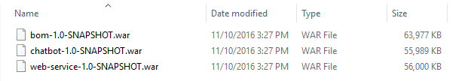

#### Deploy web application on server

* Copy *.war files to webapps folder of Apache Tomcat (Tomcat sever must be already running).

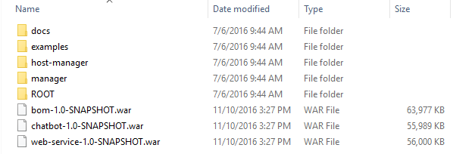

#### Create a Facebook App & Page

* Prepare a Page on Facebook.

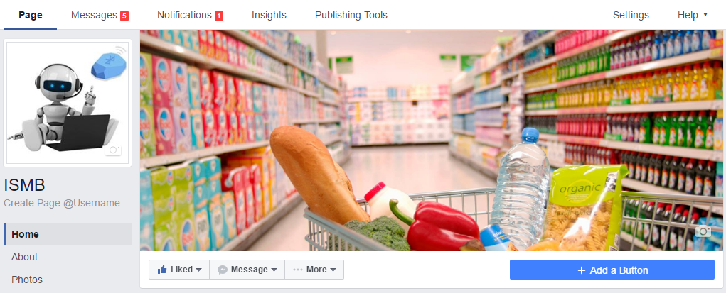

* Prepare an App on Facebook for Developers.

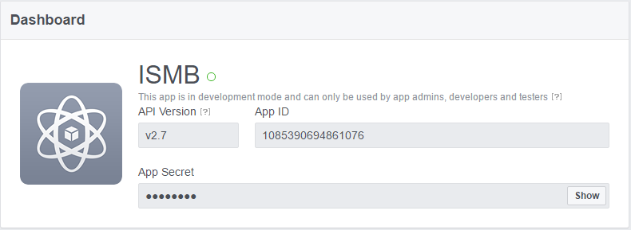

#### Intergration

* Configure Webhooks
* Choose “Messenger” at left sidebar of Facebook for developers page.
* Click button “Setup Webhook”
* At “Callback URL”: input hostname with sub domain /webhook
* Input “Verify token”
* Select events: **message_deliveries**, **messages**, **messaging_account_linking**, **messaging_optins**, **messaging_postbacks**
* Verify and Save

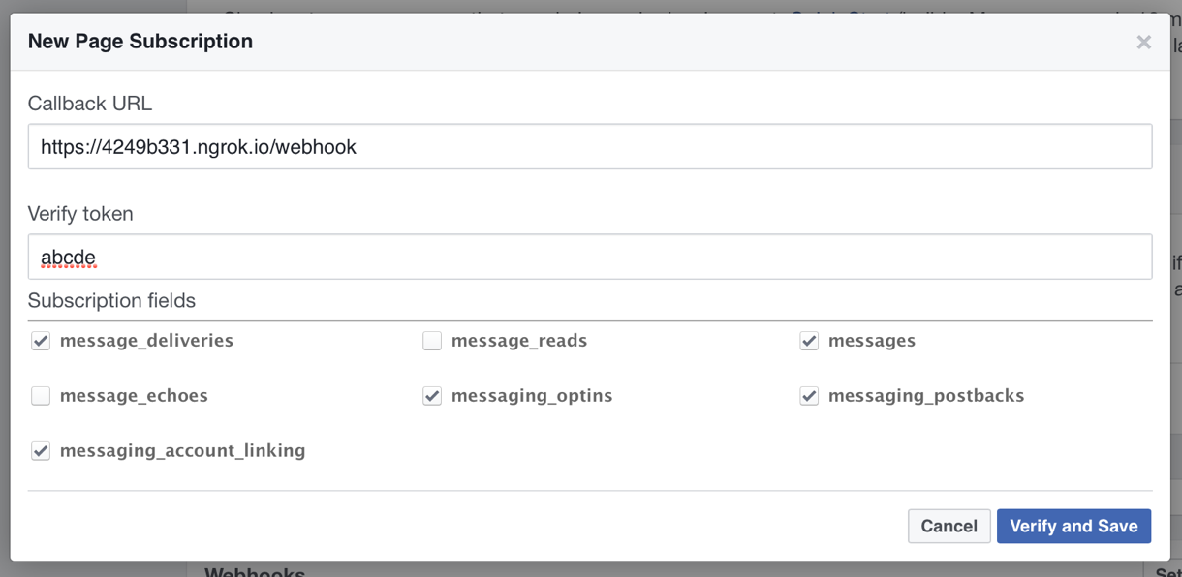

### Deployment at Client Side

* On mobile deivce, open “Google Play Store” application.

*For Staff:*

* + Search “pub:Henchmen Asia”
  + Install “ISMB Staff”

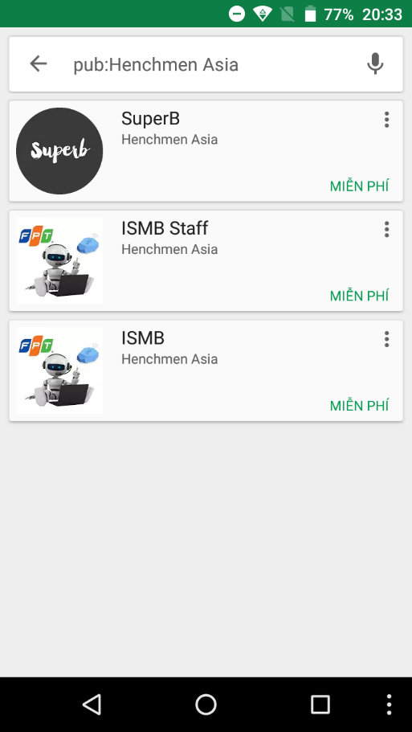 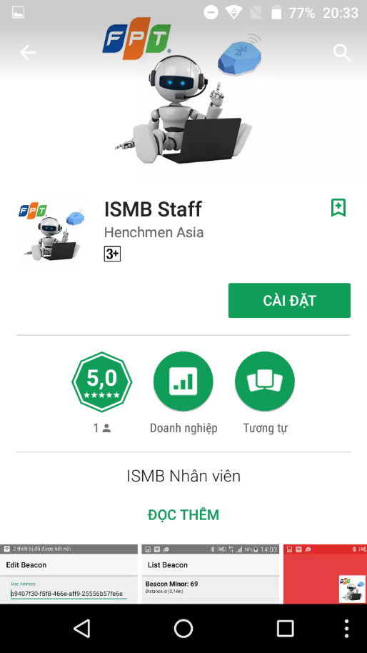

*For Customer:*

* + Search “facebook messenger”
  + Install “Messenger”

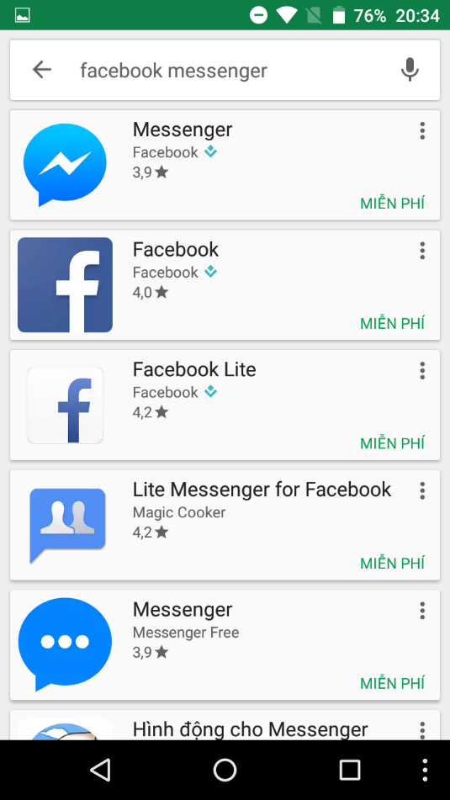 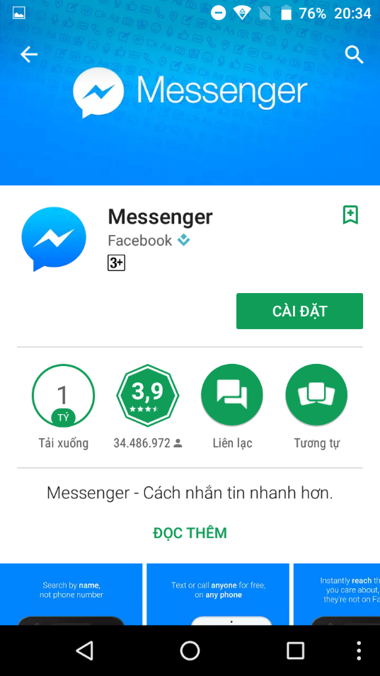

* + Search “pub:Henchmen Asia”
  + Install “ISMB”

 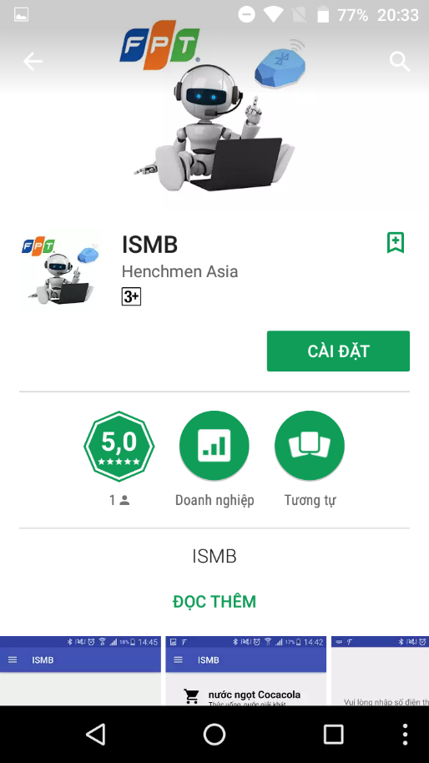

## User Guide

### ISMB Engine

Using Facebook Messenger Application

<https://www.facebook.com/help/messenger-app/?_rdr>

### Mobile Application for Customer

#### Login By Facebook Account

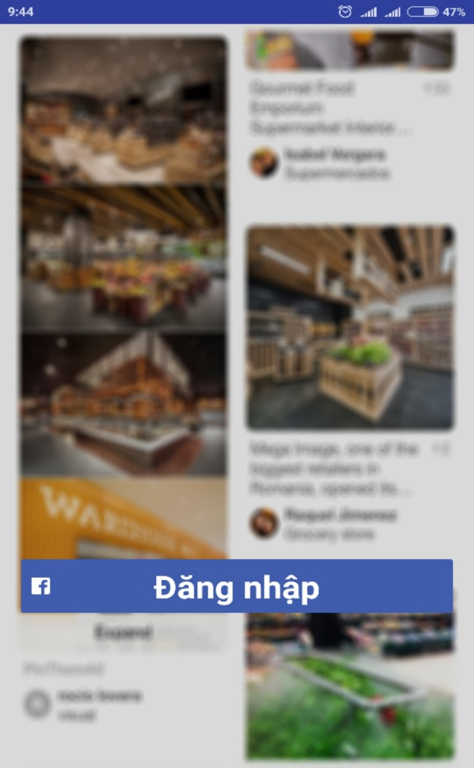

Figure 168 - <Customer> Login by Facebook Account UG

|  |  |
| --- | --- |
| **Step** | **Description** |
| 1 | Tap “Đăng nhập” button |

Table 164 - <Customer> Login by Facebook Account UG

#### Enter Phone Number

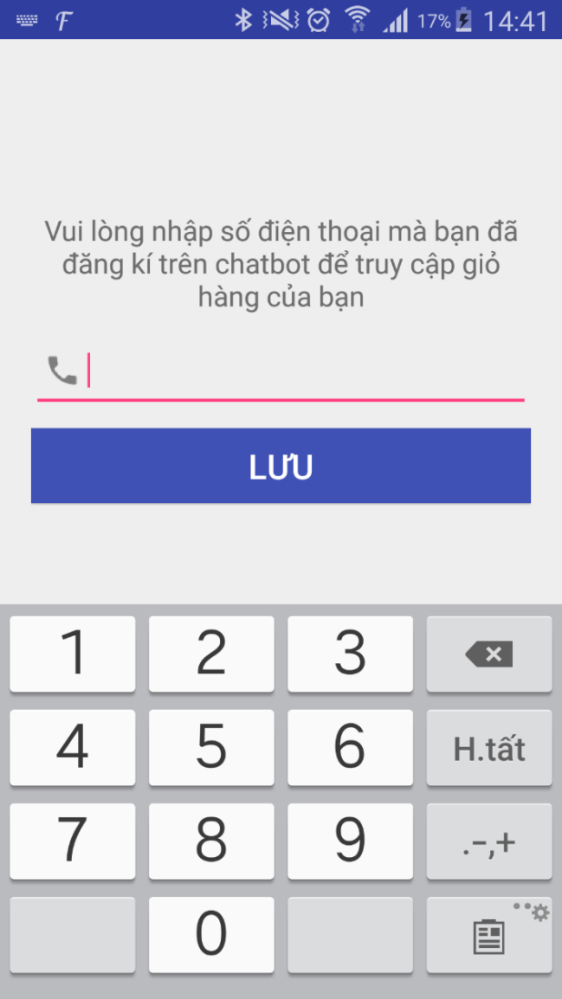

Figure 169 - <Customer> Enter Phone Number UG

|  |  |
| --- | --- |
| **Step** | **Description** |
| 1 | Enter phone |
| 2 | Tap “Lưu” button |

Table 165 - <Customer> Enter Phone Number UG

#### View Cart

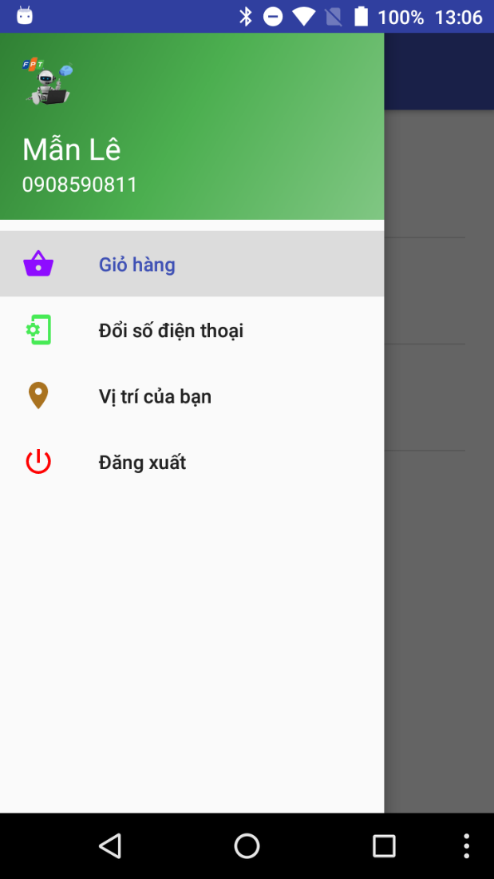 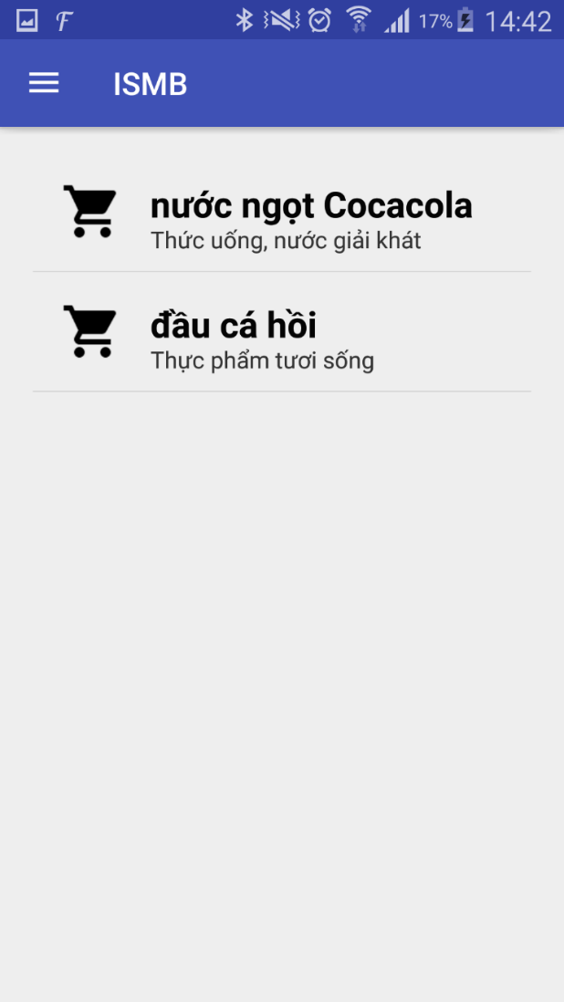

Figure 170 - <Customer> View Cart UG

|  |  |
| --- | --- |
| **Step** | **Description** |
| 1 | Tap “Giỏ hàng” on menu |

Table 166 - <Customer> View Cart UG

#### Change Phone Number

 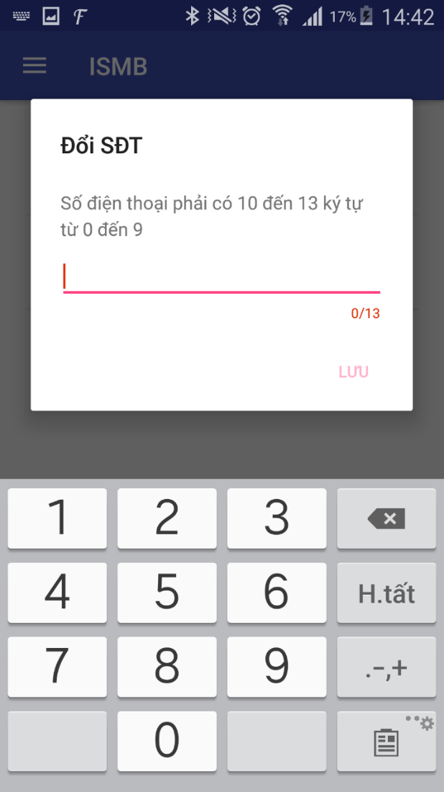

Figure 171 - <Customer> Change Phone Number UG

|  |  |
| --- | --- |
| **Step** | **Description** |
| 1 | Tap “Đổi số điện thoại” on menu |
| 2 | Enter new phone |
| 3 | Tap “Lưu” button |

Table 167 - <Customer> Change Phone Number UG

#### View Location

 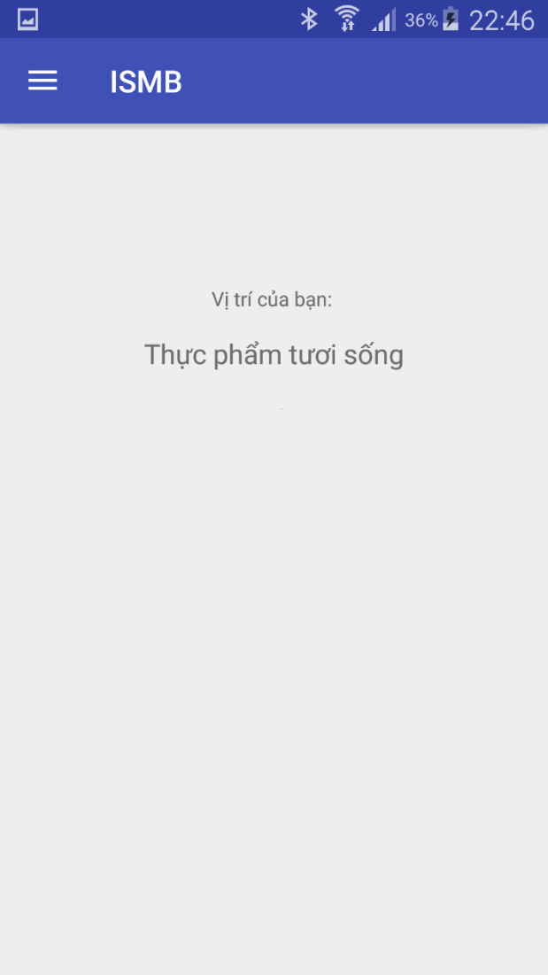

Figure 172 - <Customer> View Location UG

|  |  |
| --- | --- |
| **Step** | **Description** |
| 1 | Tap “Xem vị trí” on menu |

Table 168 - <Customer> View Location UG

#### Notify Nearby Product

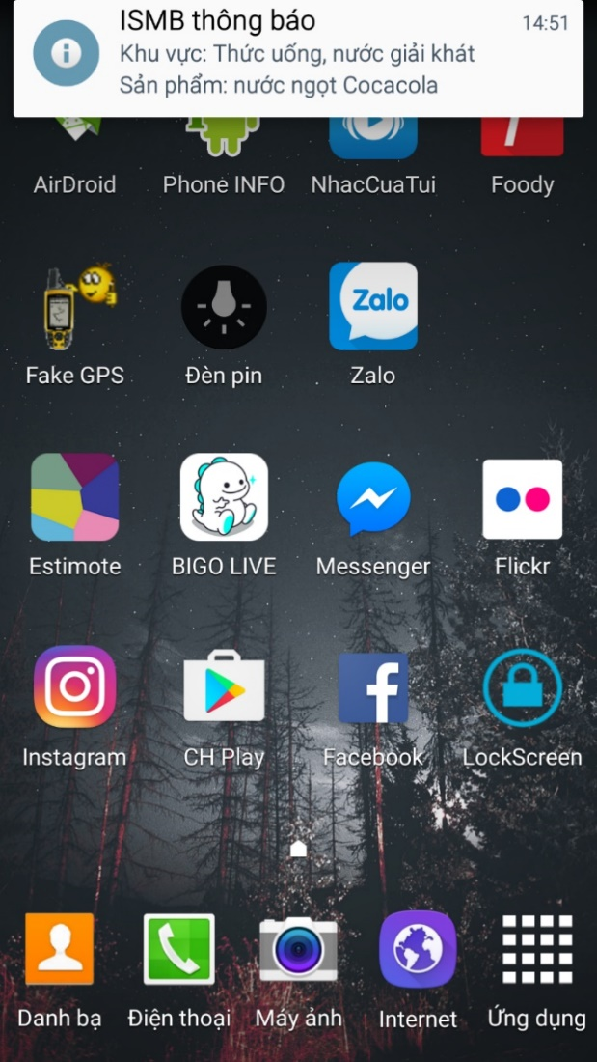

Figure 173 - <Customer> Notify Nearby Product UG

|  |  |
| --- | --- |
| **Step** | **Description** |
| 1 | Go into area which has atleast one product in cart |

Table 169 - <Customer> Notify Nearby Product UG

### Mobile Application for Staff

#### Login

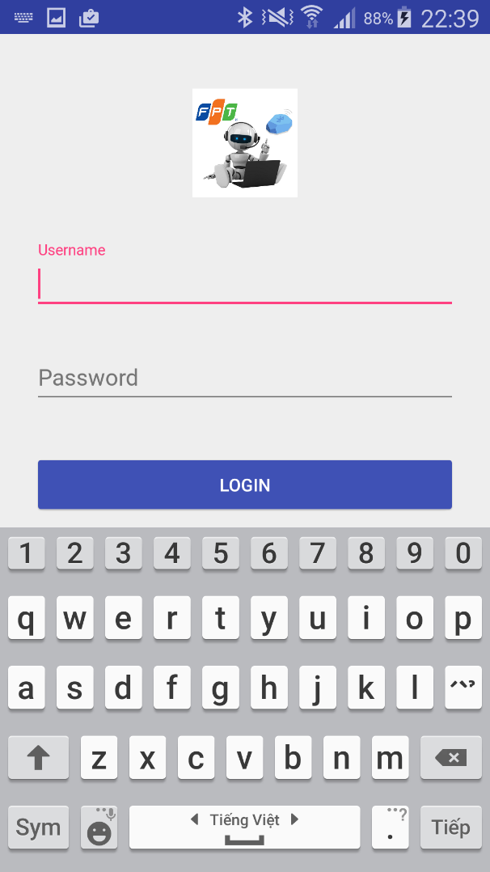

Figure 174 - <Staff> Login UG

|  |  |
| --- | --- |
| **Step** | **Description** |
| 1 | Enter “Username” and “Password” |
| 2 | Tap “Login” button |

Table 170 - <Staff> Login UG

#### Manage Beacon

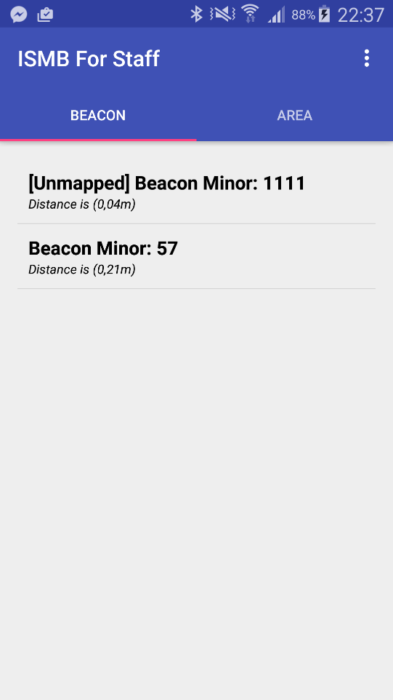

Figure 175 - <Staff> Manage Beacon UG

|  |  |
| --- | --- |
| **Step** | **Description** |
| 1 | Tap “Beacon” tab |
| 2 | Show list detected beacon |

Table 171 - <Staff> Manage Beacon UG

#### Add Beacon

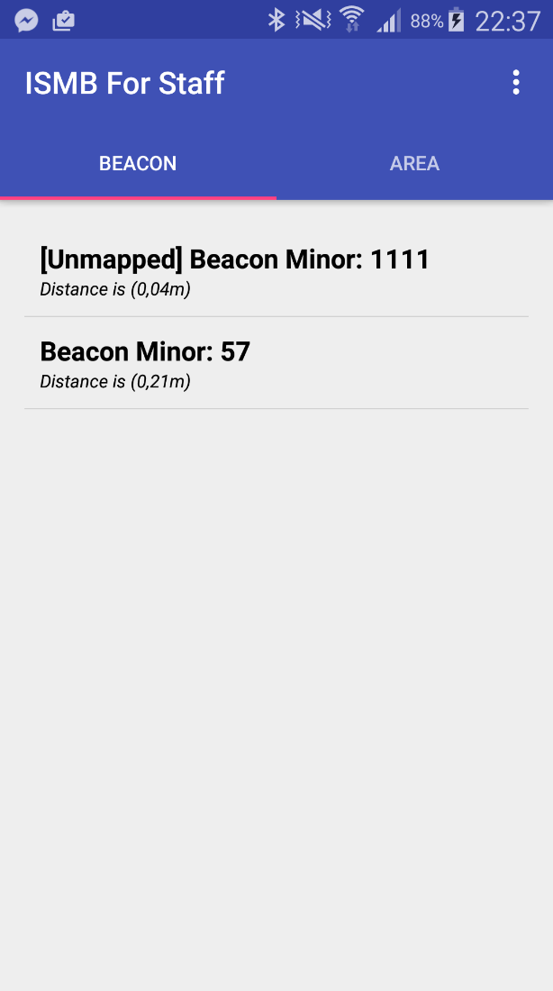 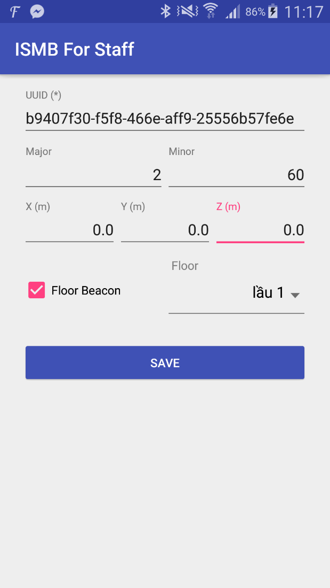

Figure 176 - <Staff> Add Beacon UG

|  |  |
| --- | --- |
| **Step** | **Description** |
| 1 | Select one beacon in list detected beacon |
| 2 | Show form add beacon |
| 3 | Enter “x(m)”, “y(m)”, “z(m)”  Tap “Floor Beacon” checkbox (not required)  Choose Floor (not required) |
| 4 | Tap “SAVE” button |

Table 172 - <Staff> Add Beacon UG

#### Update Beacon

 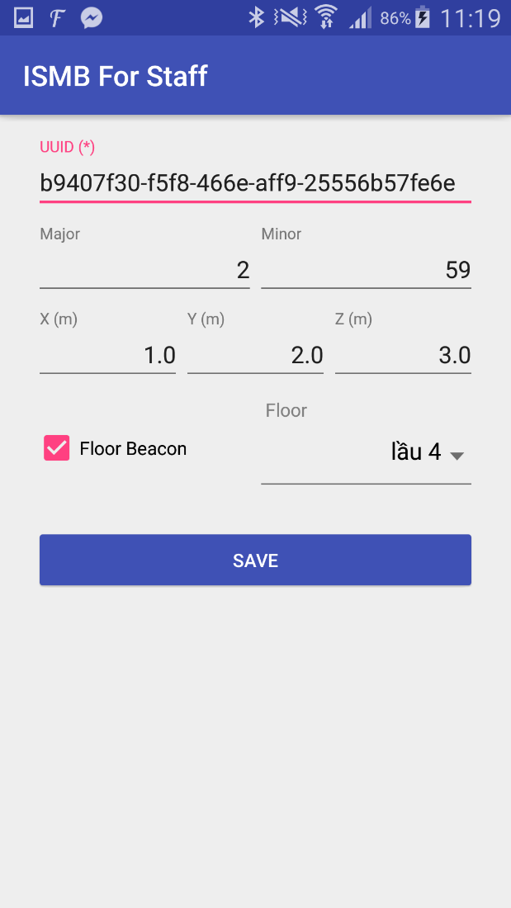

Figure 177 - <Staff> Update Beacon UG

|  |  |
| --- | --- |
| **Step** | **Description** |
| 1 | Select one beacon in list detected beacon |
| 2 | Show form update beacon |
| 3 | Enter “x(m)”, “y(m)”, “z(m)”  Tap “Floor Beacon” checkbox (not required)  Choose Floor (not required) |
| 4 | Tap “SAVE” button |

Table 173 - <Staff> Update Beacon UG

#### Manage Area

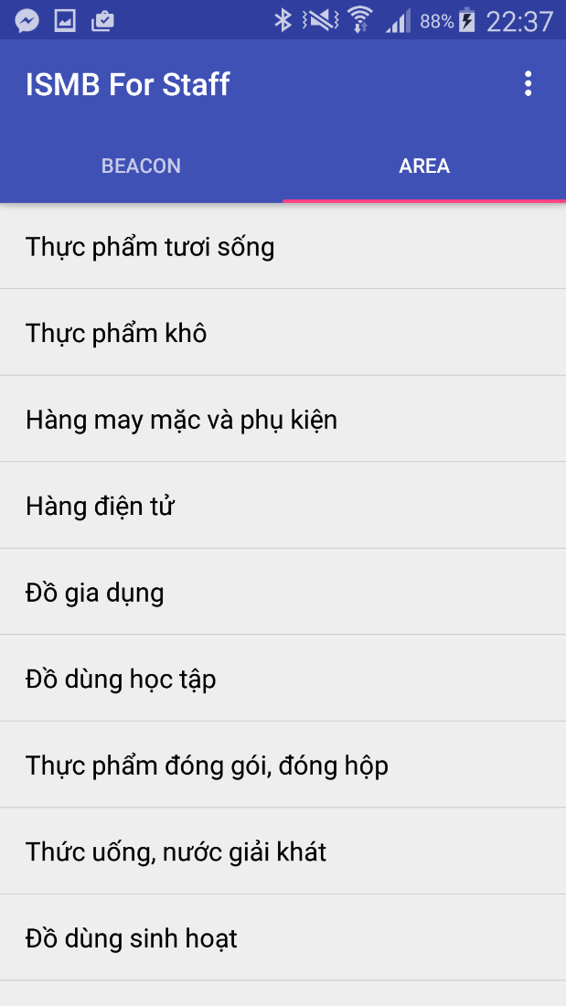

Figure 178 - <Staff> Manage Area UG

|  |  |
| --- | --- |
| **Step** | **Description** |
| 1 | Tap “Area” tab |
| 2 | Show list area |

Table 174 - <Staff> Manage Area UG

#### Add Area

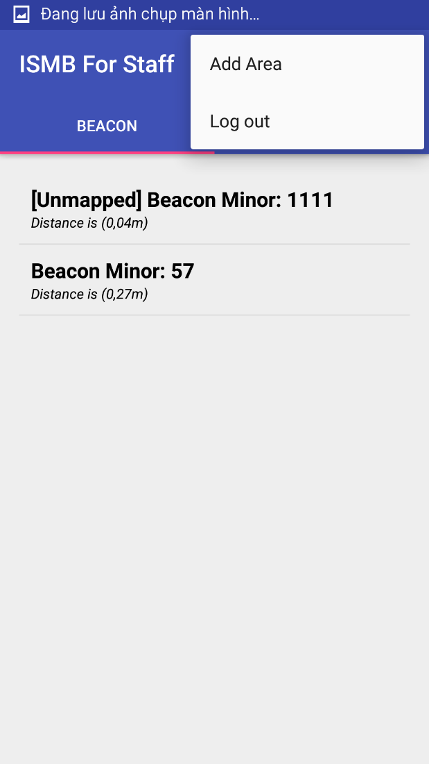 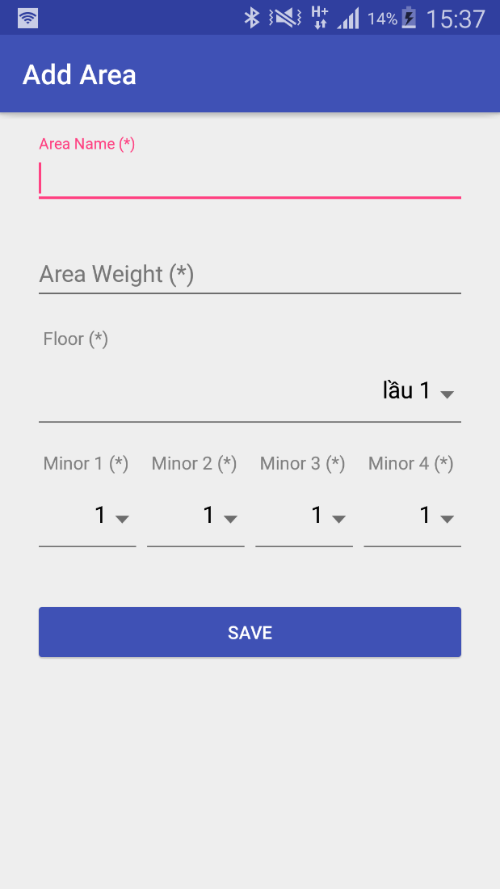

Figure 179 - <Staff> Add Area UG

|  |  |
| --- | --- |
| **Step** | **Description** |
| 1 | Tap navigation view |
| 2 | Tap “Add Area” |
| 3 | Show form “Add Area” |
| 4 | Enter “Area Name”  Enter “Area Weight”  Choose “Floor”, “Minor1”, “Minor2”, “Minor3”, “Minor4” |
| 5 | Tap “SAVE” button |

Table 175 - <Staff> Add Area UG

#### Update Area

 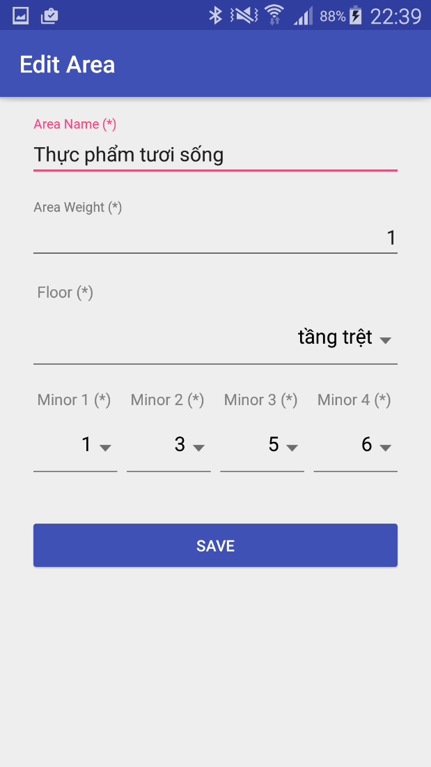

Figure 180 - <Staff> Update Area UG

|  |  |
| --- | --- |
| **Step** | **Description** |
| 1 | Select one area in list area |
| 2 | Show form “Edit Area” |
| 3 | Enter “Area Name”  Enter “Area Weight”  Choose “Floor”, “Minor1”, “Minor2”, “Minor3”, “Minor4” |
| 4 | Tap “SAVE” button |

Table 176 - <Staff> Update Area UG

### Web Application

#### Manage Account

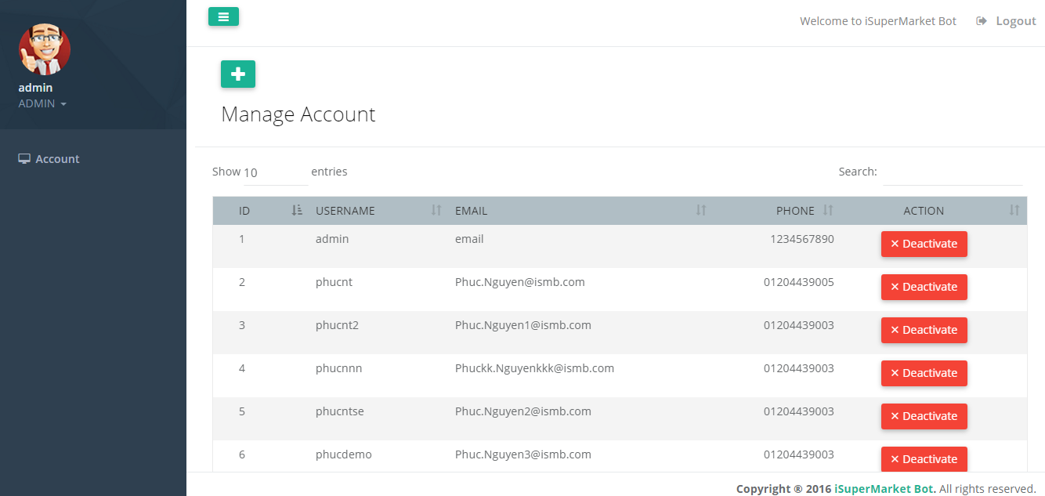

Figure 181 - < Admin > Manage Account UG

|  |  |
| --- | --- |
| **Step** | **Description** |
| 1 | Click “Account” on menu |
| 2 | Click “View” tab |
| 3 | Show list account |

Table 177 - <Admin> Manage Account UG

#### Add Account

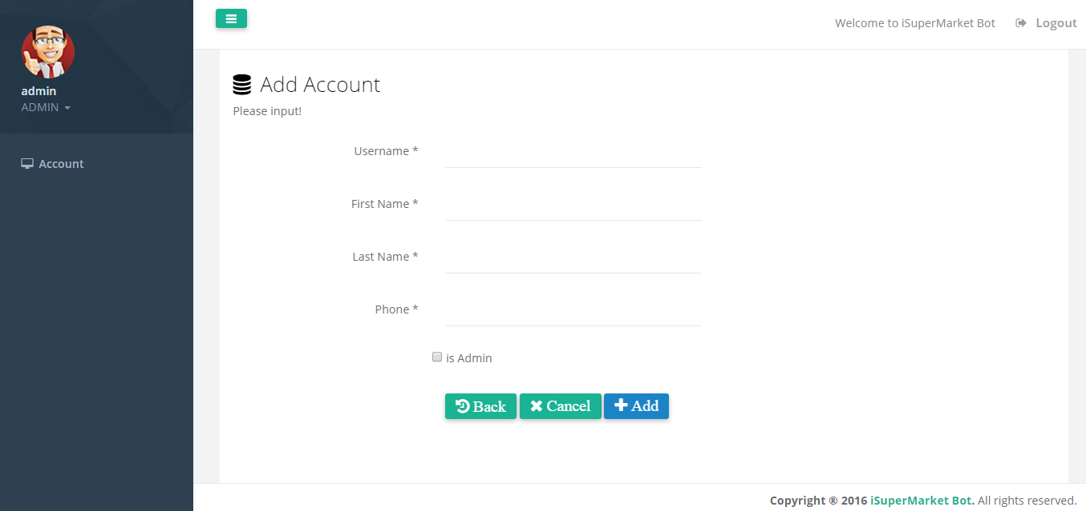

Figure 182 - <Admin> Add Account UG

| **Step** | **Description** |
| --- | --- |
| 1 | Click “Account” on menu |
| 2 | Click “Add” tab |
| 3 | Fill in fields:  Username: username for new employee  First Name: Employee first name  Last Name: Employee last name  Phone: Employee phone  Check box:  isAdmin: Role for account |
| 4 | Click “Add” button |

Table 178 - <Admin> Add Account UG

#### Deactivate Acount

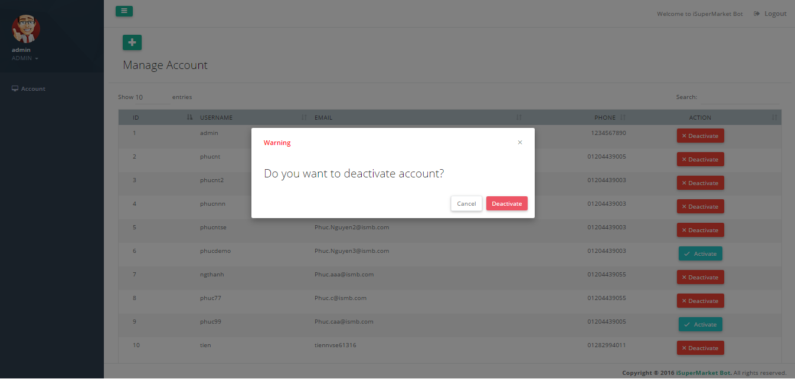

Figure 183 - <Admin> Deactivate Account UG

|  |  |
| --- | --- |
| **Step** | **Description** |
| 1 | Click “Deactivate” button on row |
| 2 | Click “Deactivate” to confirm |

Table 179 - <Admin> Deactivate Account UG

#### Activate Account

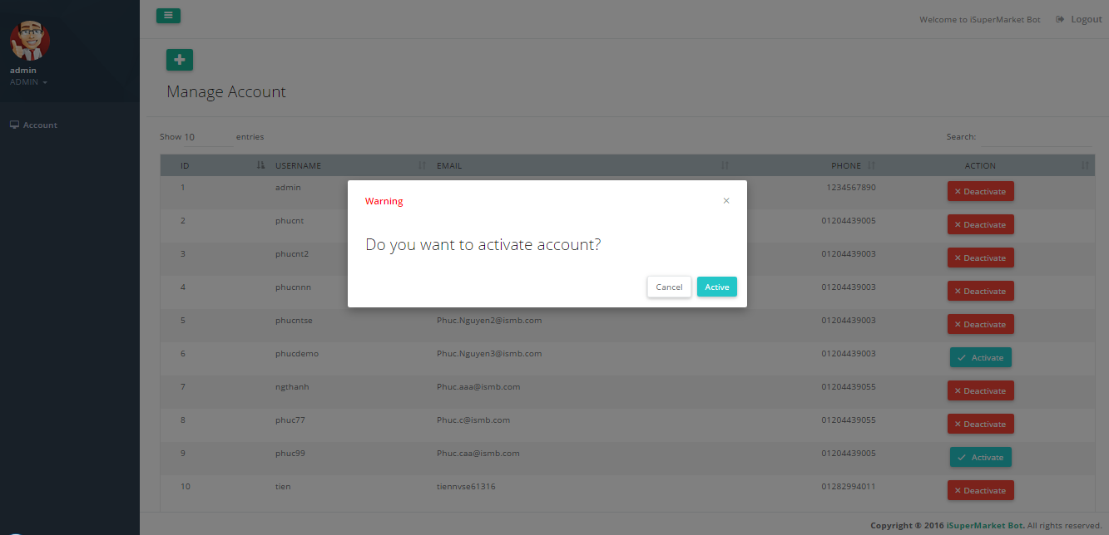

Figure 184 - <Admin> Activate Account UG

|  |  |
| --- | --- |
| **Step** | **Description** |
| 1 | Click “Activate” button on row |
| 2 | Click “Activate” to confirm |

Table 180 - <Admin> Activate Account UG

#### Update Profile

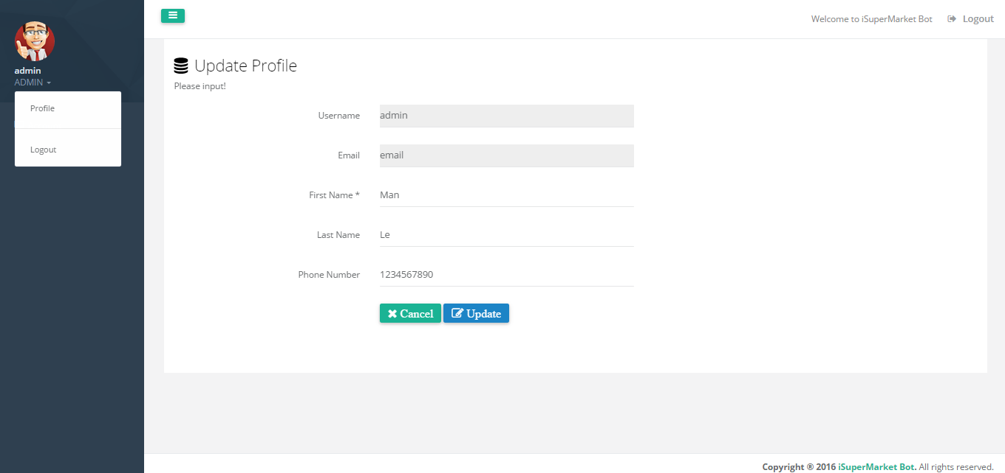

Figure 185 - <Admin/Staff> Update Profile UG

|  |  |
| --- | --- |
| **Step** | **Description** |
| 1 | Click text role below avatar |
| 2 | Click “Profile” tab |
| 2 | Fill in Field:  First Name: employee first name.  Last Name: employee last name.  Phone number: employee phone number. |
| 3 | Click “Update” button |

Table 181 - <Admin/Staff> Update Profile UG

#### Manage Beacon

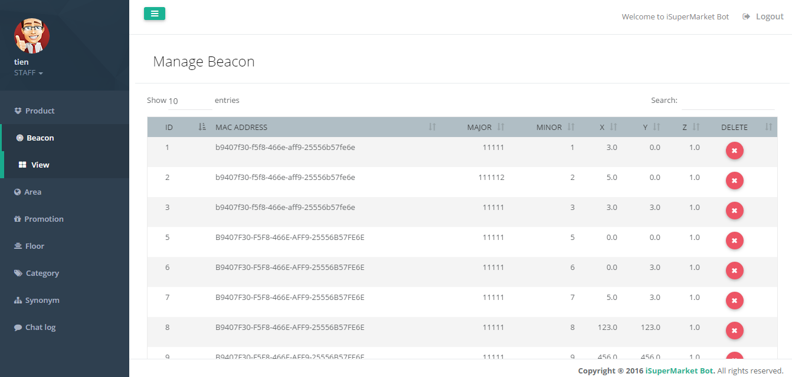

Figure 186 - <Staff> Manage Beacon UG

|  |  |
| --- | --- |
| **Step** | **Description** |
| 1 | Click “Beacon” on menu |
| 2 | Click “View” tab |

Table 182 - <Staff> Manage Beacon UG

#### Delete Beacon

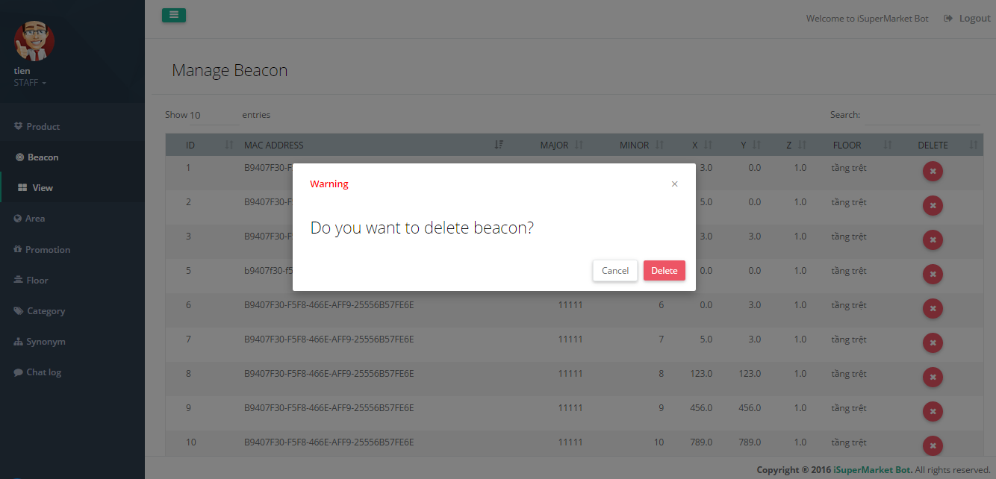

Figure 187 - <Staff> Delete Beacon UG

|  |  |
| --- | --- |
| **Step** | **Description** |
| 1 | Click “” button on row |
| 2 | Click “Delete” button |

Table 183 - <Staff> Delete Beacon UG

#### Manage Product

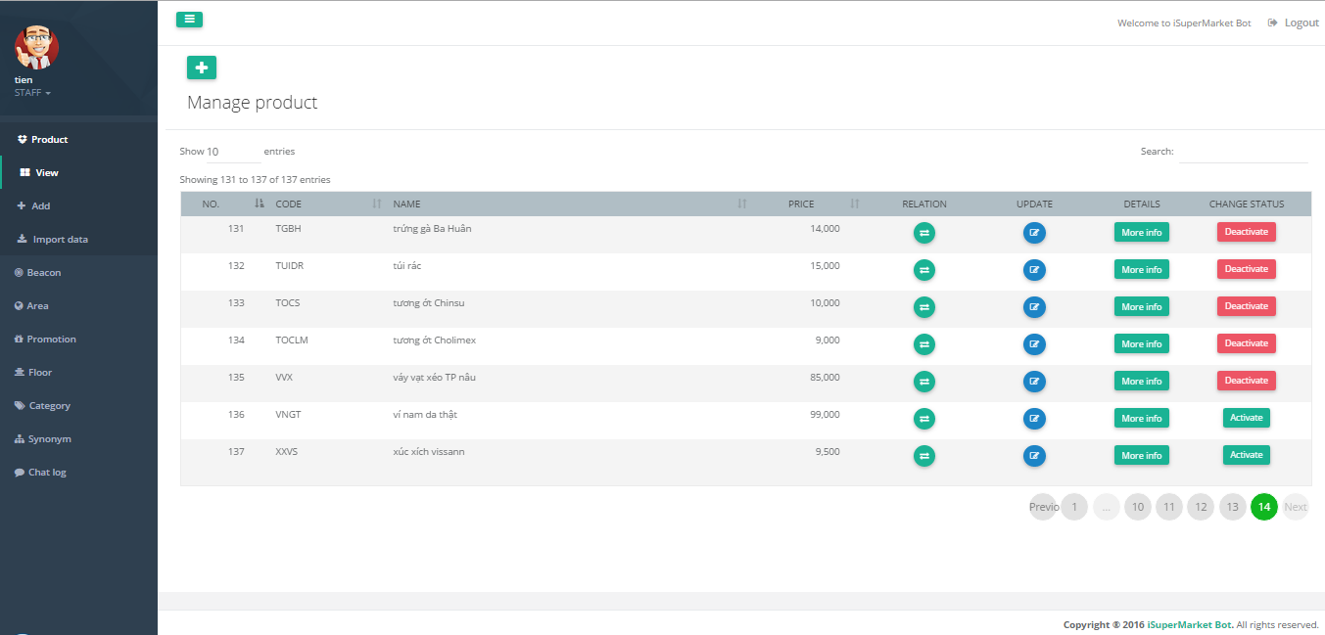

Figure 188 - <Staff> Manage Product UG

| **Step** | **Description** |
| --- | --- |
| 1 | Click “Product” on menu |
| 2 | Click “View” tab |
| 3 | Show list product |

Table 184 - <Staff> Manage Product UG

#### Add Product

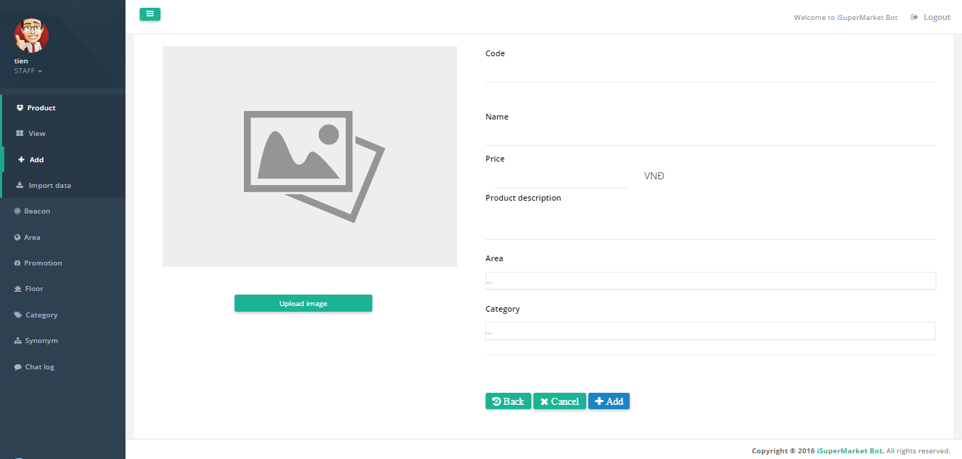

Figure 189 - <Staff> Add Product UG

| **Step** | **Description** |
| --- | --- |
| 1 | Click “Product” on menu |
| 2 | Click “Add” tab |
| 3 | Fill in fields:  “Code”: product code  “Name”: product name  “Price”: product price  “Product description”: product description  Select in fields:  “Area”: area in supermarket  “Category”: category of product  Select image:  Choose image from computer by click “Upload image” button |
| 4 | Click “Add” button |

Table 185 - <Staff> Add Product UG

#### Update Product

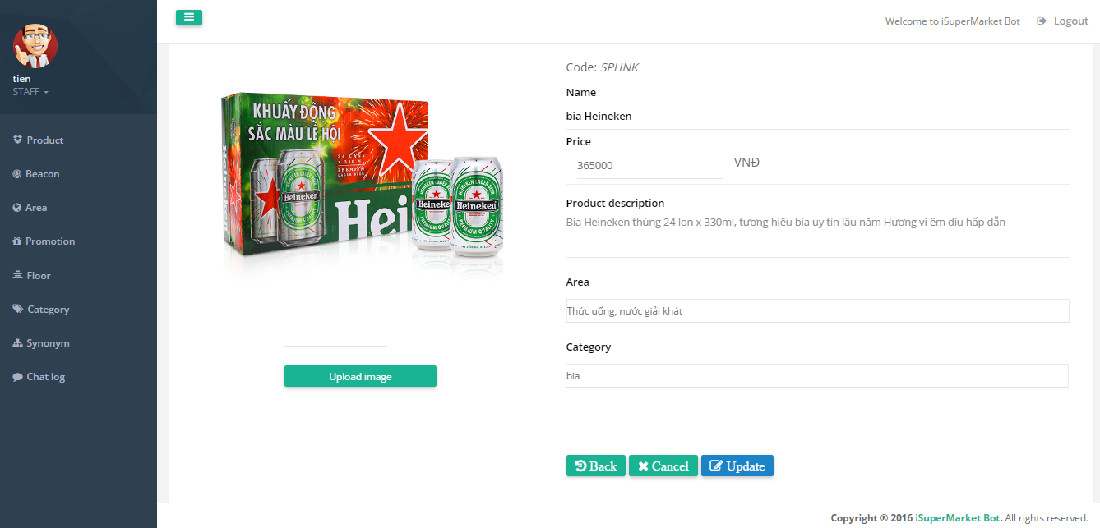

Figure 190 - <Staff> Update Product UG

|  |  |
| --- | --- |
| **Step** | **Description** |
| 1 | Click “” button on row(in view manage product page) |
| 2 | Fill in fields:  “Name”: product name  “Price”: product price  “Product description”: product description  Select in fields:  “Area”: area in supermarket  “Category”: category of product  Select image:  Choose image from computer by click “Upload image” button |
| 3 | Click “Update” button |

Table 186 - <Staff> Update Product UG

#### Deactivate Product

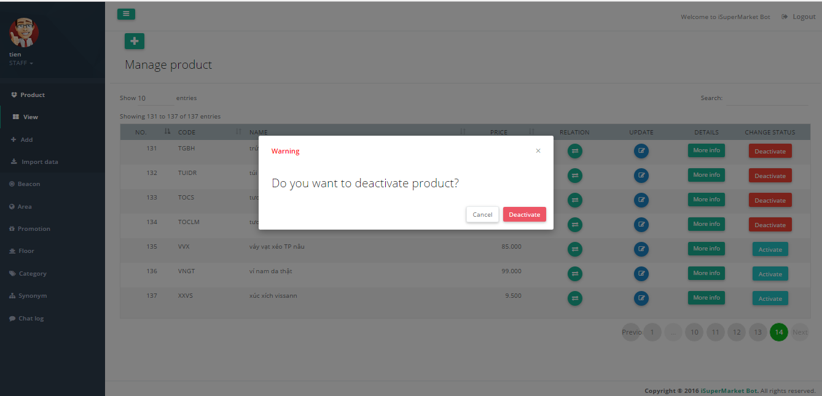

Figure 191 - <Staff> Deactivate Product UG

|  |  |
| --- | --- |
| **Step** | **Description** |
| 1 | Click “Deactivate” button on row |
| 2 | Click “Deactivate” to confirm |

Table 187 - <Staff> Deactivate Product UG

#### Activate Product

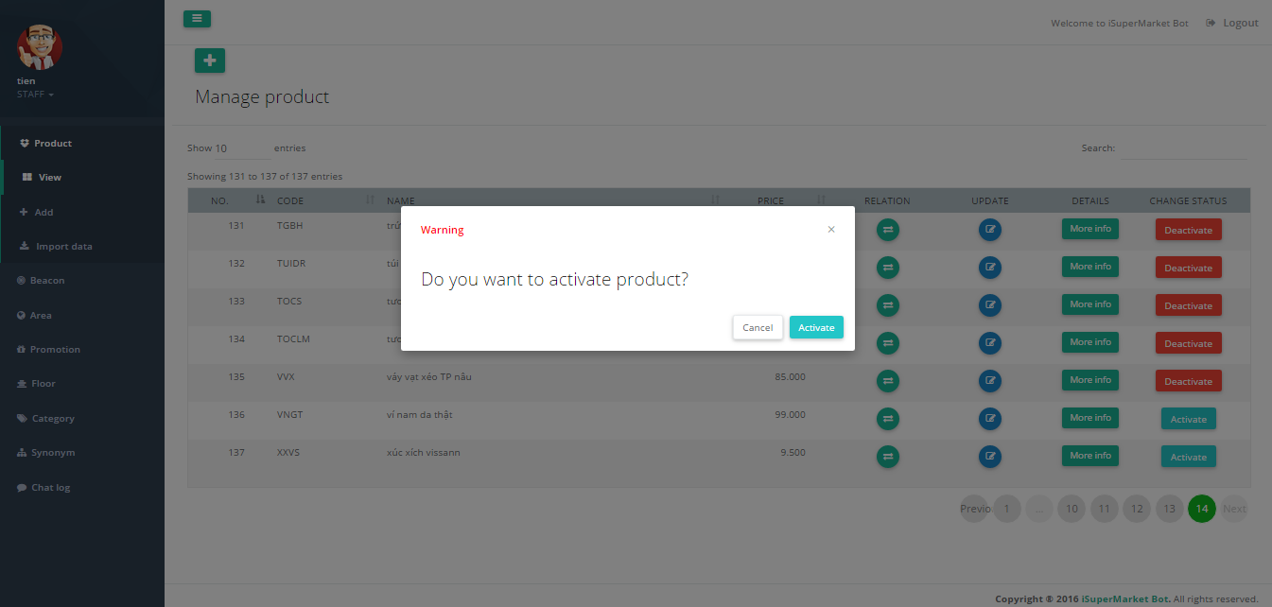

Figure 192 - <Staff> Activate Product UG

|  |  |
| --- | --- |
| **Step** | **Description** |
| 1 | Click “Activate” button on row |
| 2 | Click “Activate” to confirm |

Table 188 - <Staff> Activate Product UG

#### Mapping Relating Product

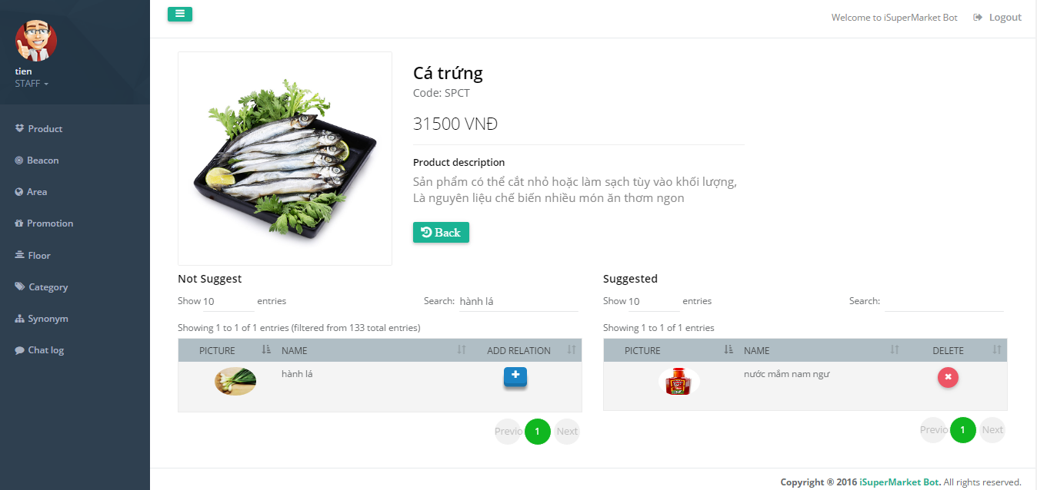

Figure 193 - <Staff> Mapping Relating Product UG

| **Step** | **Description** |
| --- | --- |
| 1 | Click “”button on row (in view manage product page) |
| 2 | Click “” button on row |

Table 189 - <Staff> Mapping Retaling Product UG

#### Import Data

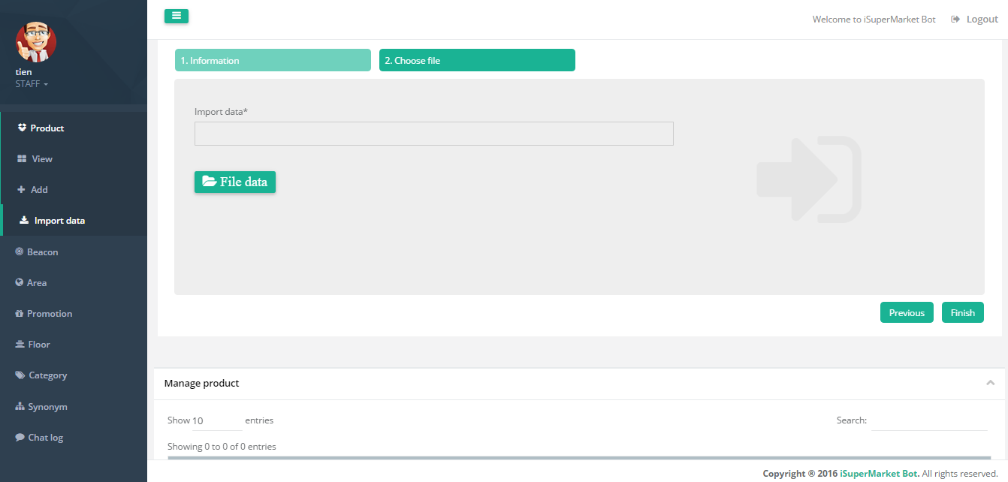

Figure 194 - <Staff> Import Data UG

|  |  |
| --- | --- |
| **Step** | **Description** |
| 1 | Click “Product” on menu |
| 2 | Click “Import data” tab |
| 3 | Select file:  Choose file to import by click “File data” button |
| 4 | Click “Finish” button |

Table 190 - <Staff> Import Data UG

#### Manage Area

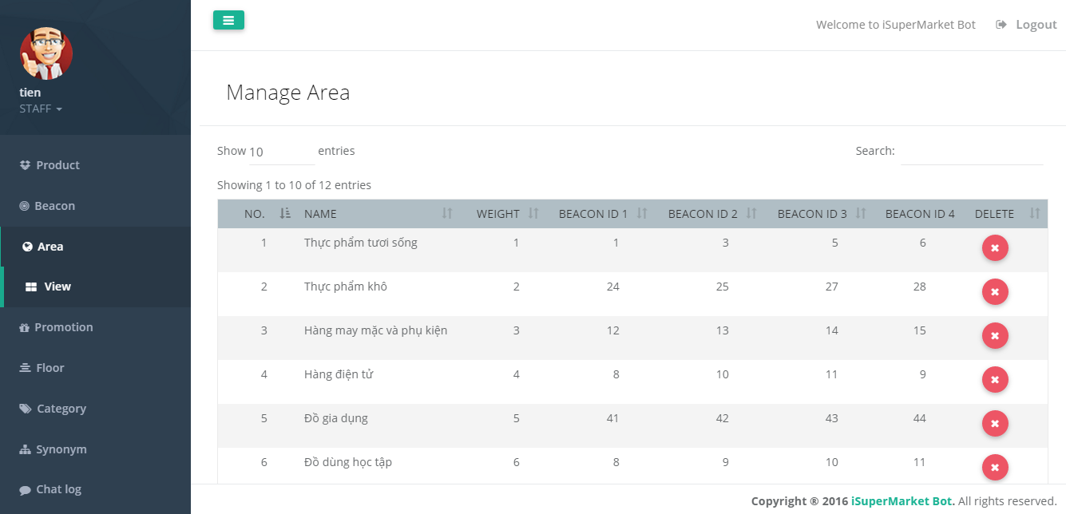

Figure 195 - <Staff> Manage Area UG

|  |  |
| --- | --- |
| **Step** | **Description** |
| 1 | Click “Area” on menu |
| 2 | Click “View” tab |
| 3 | Show list area |

Table 191 - <Staff> Mange Area UG

#### Delete Area

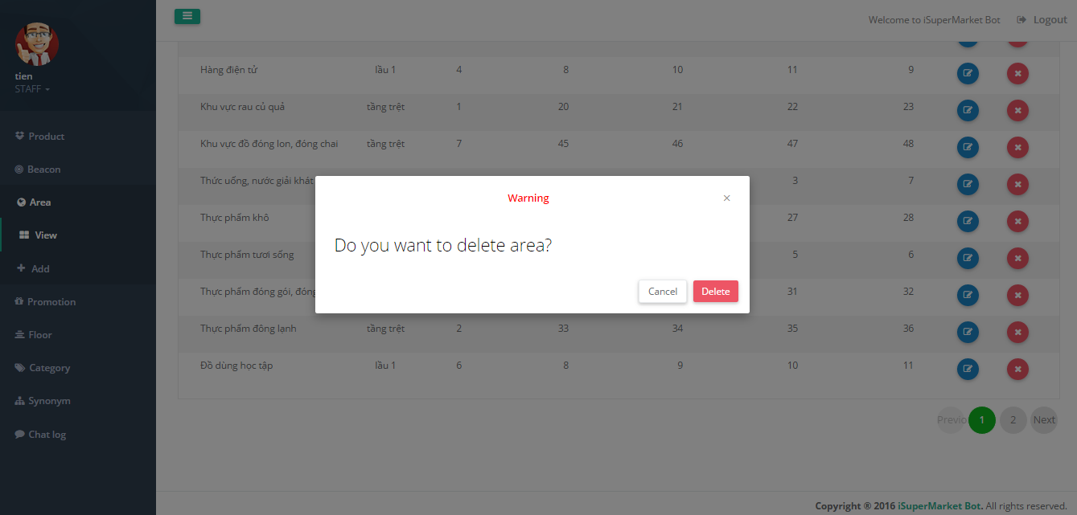

Figure 198 - <Staff> Delete Area UG

|  |  |
| --- | --- |
| **Step** | **Description** |
| 1 | Click “” button on row |
| 2 | Click “Delete” button |

Table 194 - <Staff> Delete Area UG

#### Manage Promotion

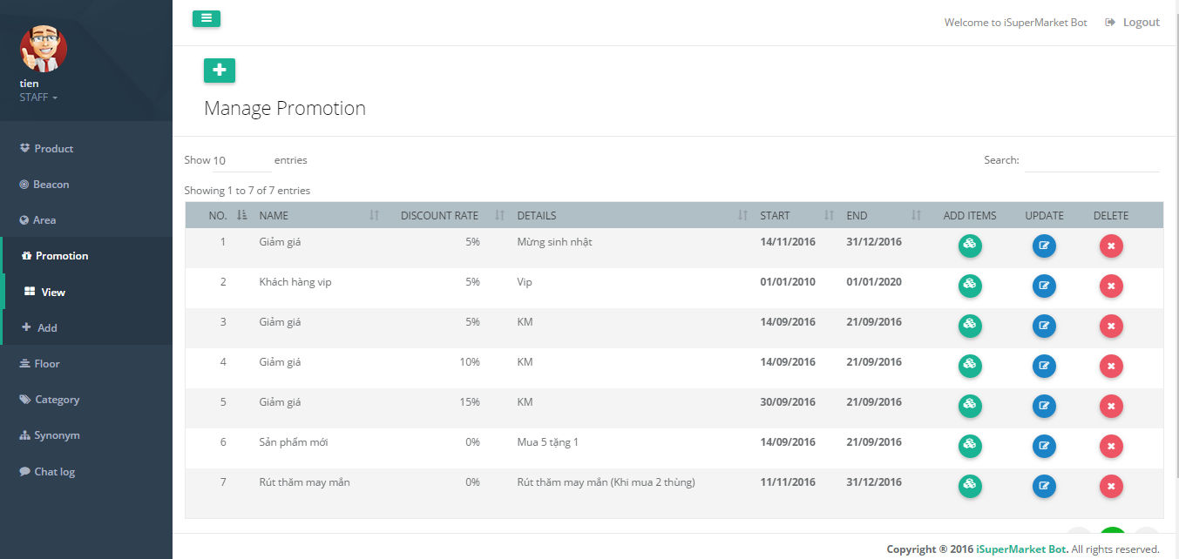

Figure 199 - <Staff> Manage Promotion UG

| **Step** | **Description** |
| --- | --- |
| 1 | Click “Promotion” on menu |
| 2 | Click “View” tab |
| 3 | Show list promotion |

Table 195 - <Staff> Manage Promotion UG

#### Add Promotion

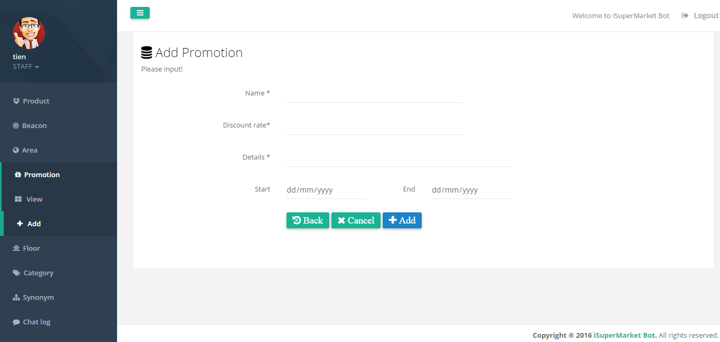

Figure 200 - <Staff> Add Promotion UG

|  |  |
| --- | --- |
| **Step** | **Description** |
| 1 | Click “Promotion” on menu |
| 2 | Click “Add” tab |
| 3 | Fill in fields:  “Name”: promotion name  “Discount rate”: Discount rate  “Details”: promotion details  “Start”: start date of promotion  “End”: end date of promotion |
| 4 | Click “Add” button |

Table 196 - <Staff> Add Promotion UG

#### Update Promotion

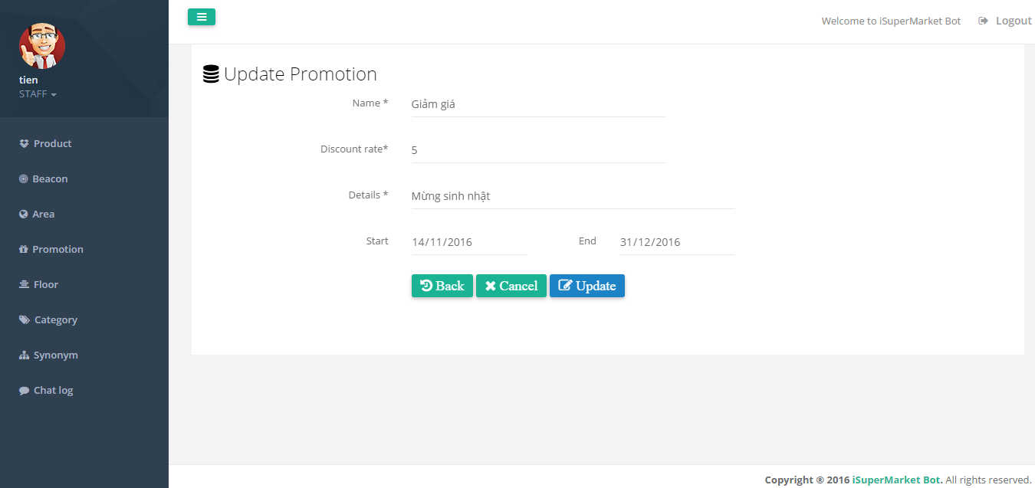

Figure 201 - <Staff> Update Promotion UG

|  |  |
| --- | --- |
| **Step** | **Description** |
| 1 | Click “” button on row(in view manage promotion page) |
| 2 | Fill in fields:  “Name”: promotion name  “Discount rate”: Discount rate  “Details”: promotion details  “Start”: start date of promotion  “End”: end date of promotion |
| 3 | Click “Update” button |

Table 197 - <Staff> Update Promotion UG

#### Delete Promotion

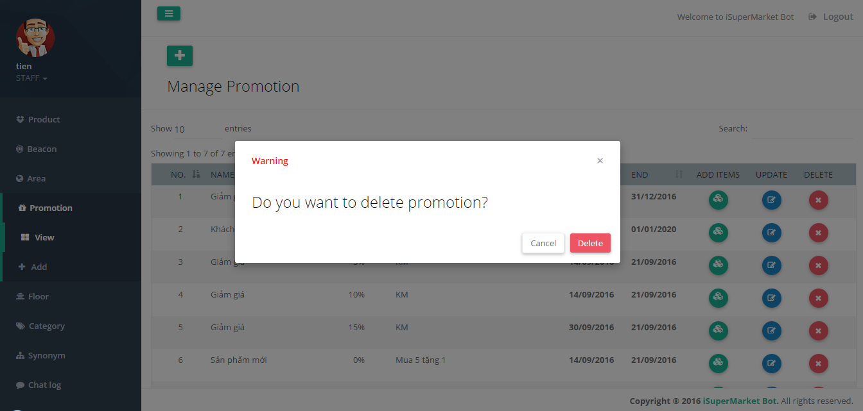

Figure 202 - <Staff> Delete Promotion UG

| **Step** | **Description** |
| --- | --- |
| 1 | Click “” button on row |
| 2 | Click “Delete” button |

Table 198 - <Staff> Delete Promotion UG

#### Add Items For Promotion

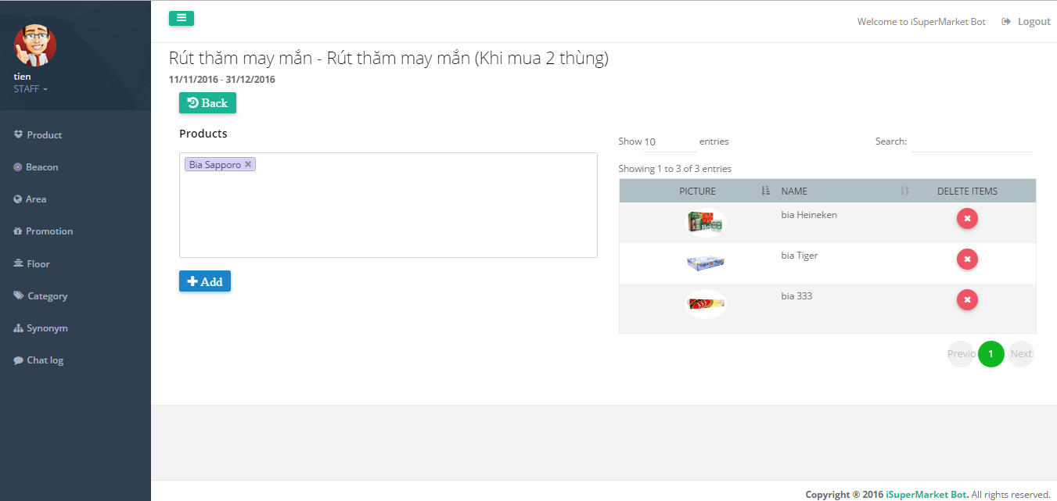

Figure 203 - <Staff> Add Items For Promotion UG

|  |  |
| --- | --- |
| **Step** | **Description** |
| 1 | Click “” button on row(in view manage promotion page) |
| 2 | Select in field:  Products |
| 3 | Click “Add” button |

Table 199 - <Staff> Add Items For Promotion UG

#### Manage Floor

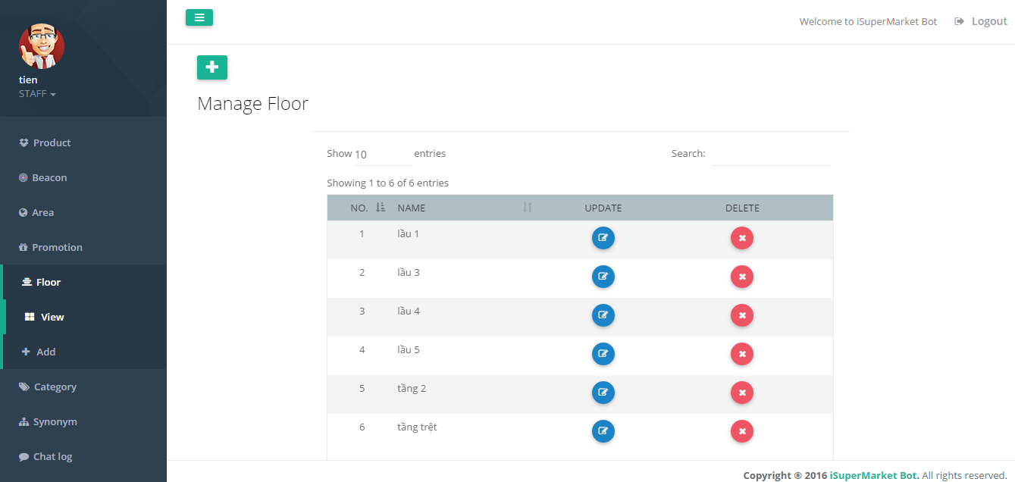

Figure 204 - <Staff> Manage Floor UG

| **Step** | **Description** |
| --- | --- |
| 1 | Click “Floor” on menu |
| 2 | Click “View” tab |
| 3 | Show list floor |

Table 200 - <Staff> Manage Floor UG

#### Add Floor

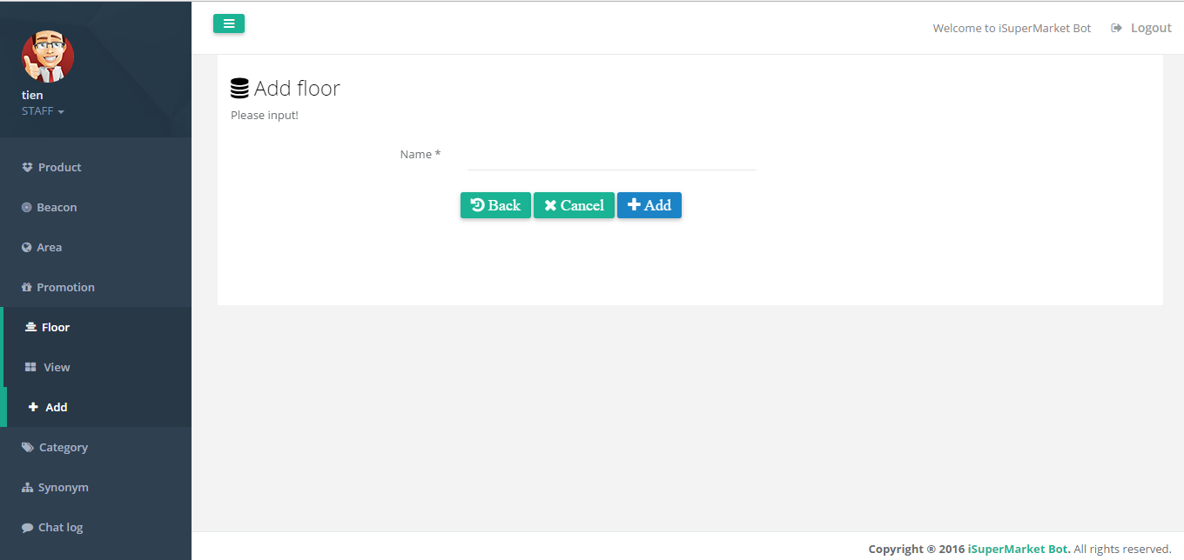

Figure 205 - <Staff> Manage Floor UG

|  |  |
| --- | --- |
| **Step** | **Description** |
| 1 | Click “Floor” on menu |
| 2 | Click “Add” tab |
| 3 | Fill in field:  “Name”: floor name |
| 4 | Click “Add” button |

Table 201 - <Staff> Manage Floor UG

#### Update Floor

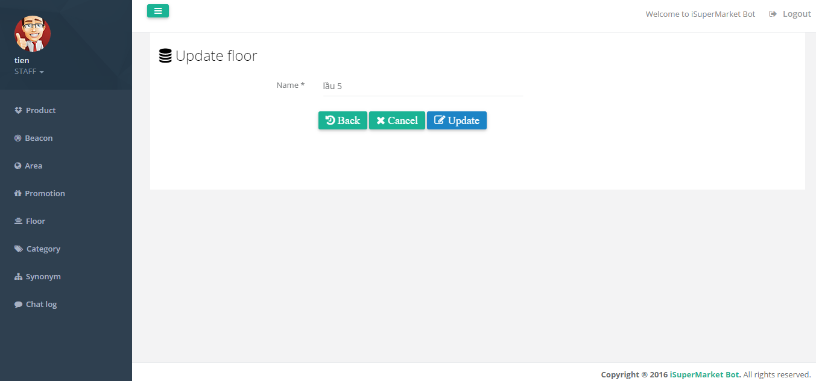

Figure 206 - <Staff> Update Floor UG

|  |  |
| --- | --- |
| **Step** | **Description** |
| 1 | Click “” button on row(in view manage floor page) |
| 2 | Fill in field:  “Name”: floor name |
| 3 | Click “Update” button |

Table 202 - <Staff> Update Floor UG

#### Delete Floor

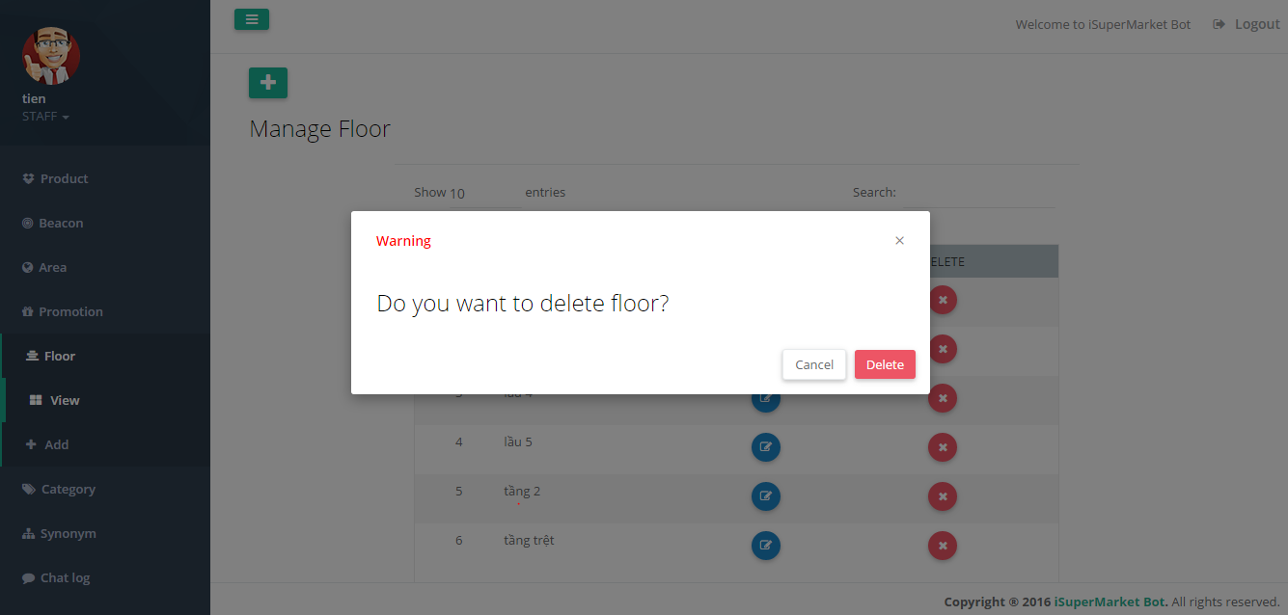

Figure 207 - <Staff> Delete Floor UG

|  |  |
| --- | --- |
| **Step** | **Description** |
| 1 | Click “” button on row |
| 2 | Click “Delete” button |

Table 203 - <Staff> Delete Floor UG

#### Manage Category

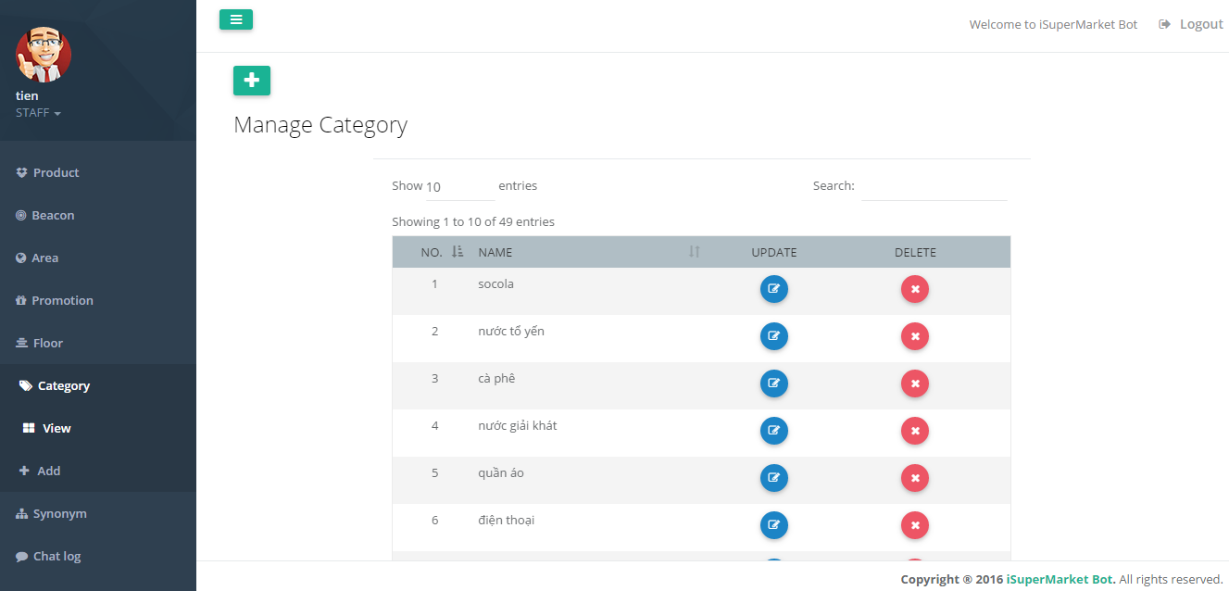

Figure 208 - <Staff> Manage Category UG

| **Step** | **Description** |
| --- | --- |
| 1 | Click “Category” on menu |
| 2 | Click “View” tab |
| 3 | Show list category |

Table 204 - <Staff> Manage Category UG

#### Add Category

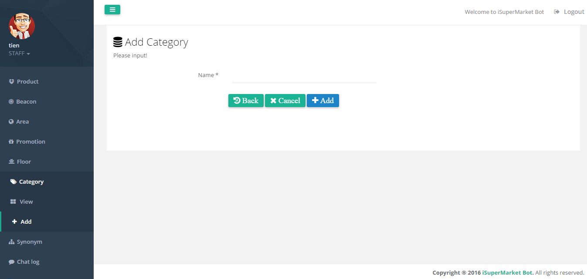

Figure 209 - <Staff> Add Category UG

|  |  |
| --- | --- |
| **Step** | **Description** |
| 1 | Click “Category” on menu |
| 2 | Click “Add” tab |
| 3 | Fill in field:  “Name”: category name |
| 4 | Click “Add” button |

Table 205 - <Staff> Add Category UG

#### Update Category

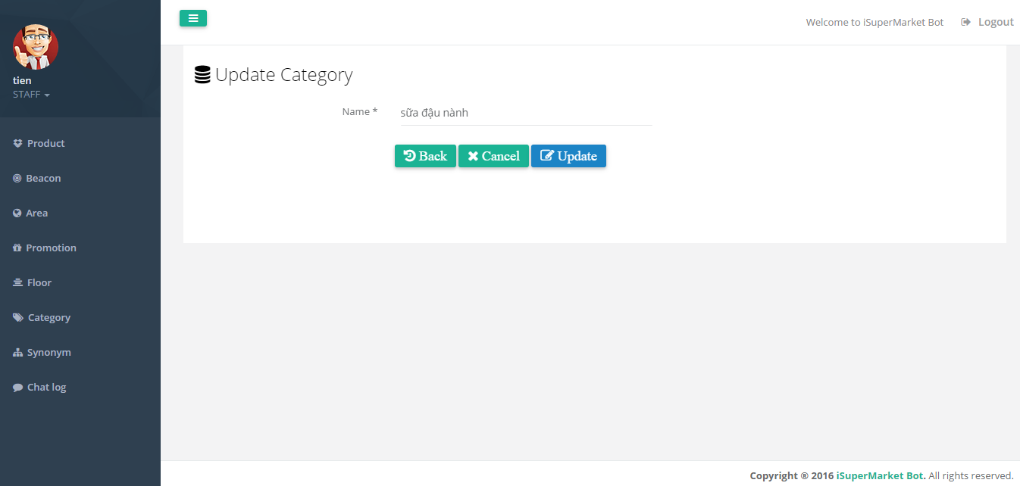

Figure 210 - <Staff> Update Category UG

| **Step** | **Description** |
| --- | --- |
| 1 | Click “” button on row(in view manage category page) |
| 2 | Fill in field:  “Name”: category name |
| 3 | Click “Update” button |

Table 206 - <Staff> Update Category UG

#### Delete Category

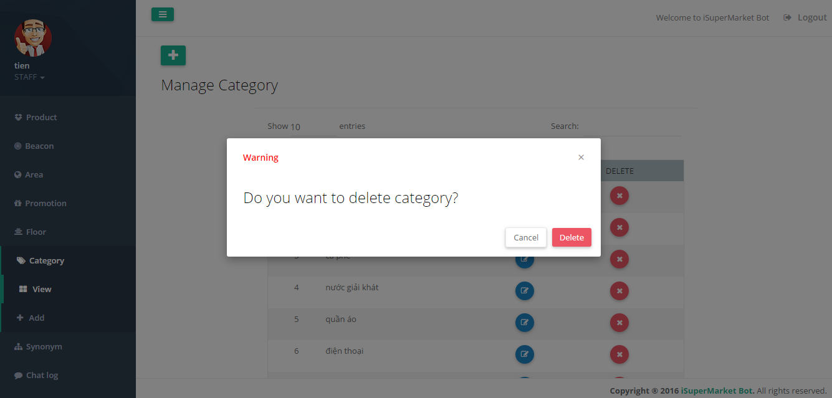

Figure 211 - <Staff> Delete Category UG

|  |  |
| --- | --- |
| **Step** | **Description** |
| 1 | Click “” button on row |
| 2 | Click “Delete” button |

Figure 212 - <Staff> Delete Category UG

#### Manage Original Word

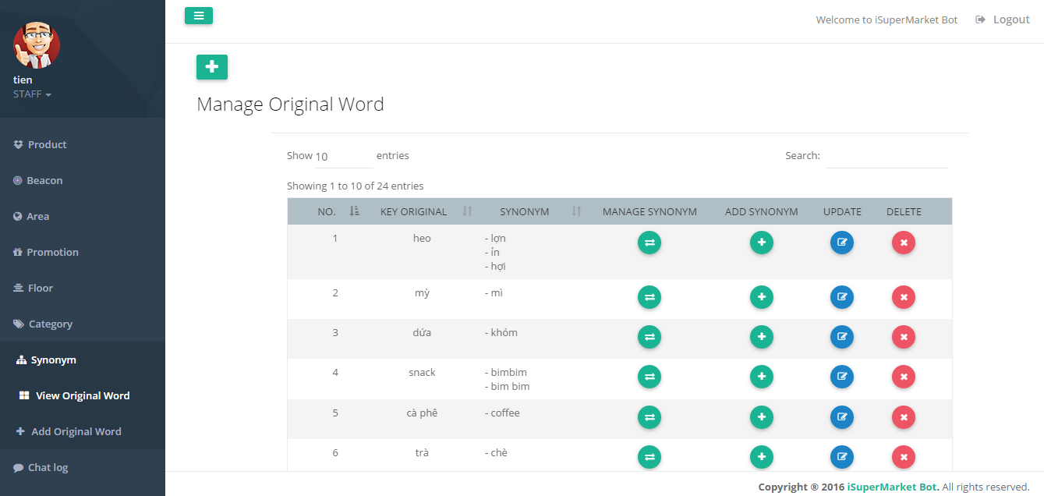

Figure 213 - <Staff> Manage Original Word UG

|  |  |
| --- | --- |
| **Step** | **Description** |
| 1 | Click “Synonym” on menu |
| 2 | Click “View Original Word” tab |
| 3 | Show list original word |

Table 207 – <Staff> Manage Original Word UG

#### Add Original Word

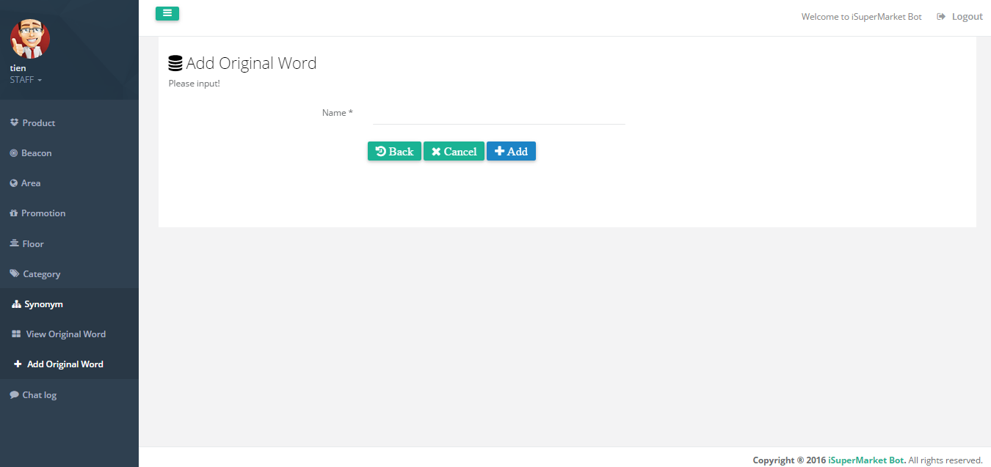

Figure 214 - <Staff> Add Original Word UG

|  |  |
| --- | --- |
| **Step** | **Description** |
| 1 | Click “Synonym” on menu |
| 2 | Click “Add Original Word” tab |
| 3 | Fill in field:  “Name”: Original word name |
| 4 | Click “Add” button |

Table 208 - <Staff> Add Original Word UG

#### Update Original Word

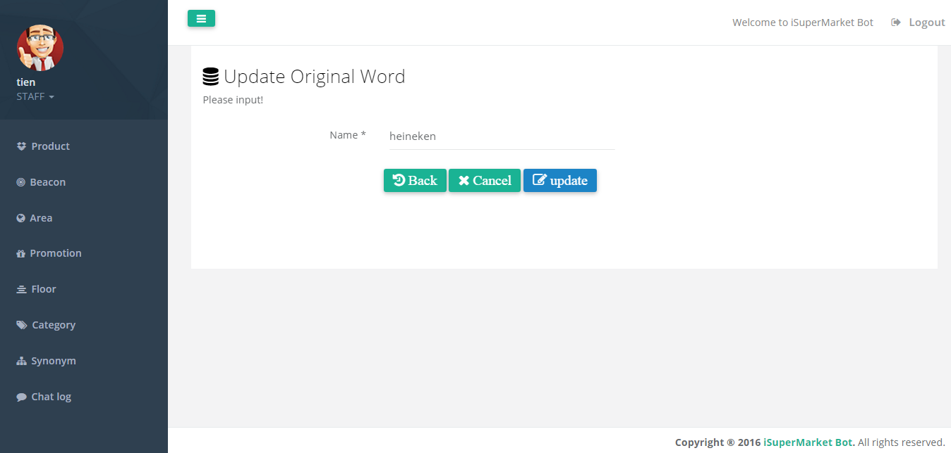

Figure 215 - <Staff> Update Original Word UG

|  |  |
| --- | --- |
| **Step** | **Description** |
| 1 | Click “” button on row(in view manage original word page) |
| 2 | Fill in field:  “Name”: Original word name |
| 3 | Click “Update” button |

Table 209 - <Staff> Update Original Word UG

#### Delete Original Word

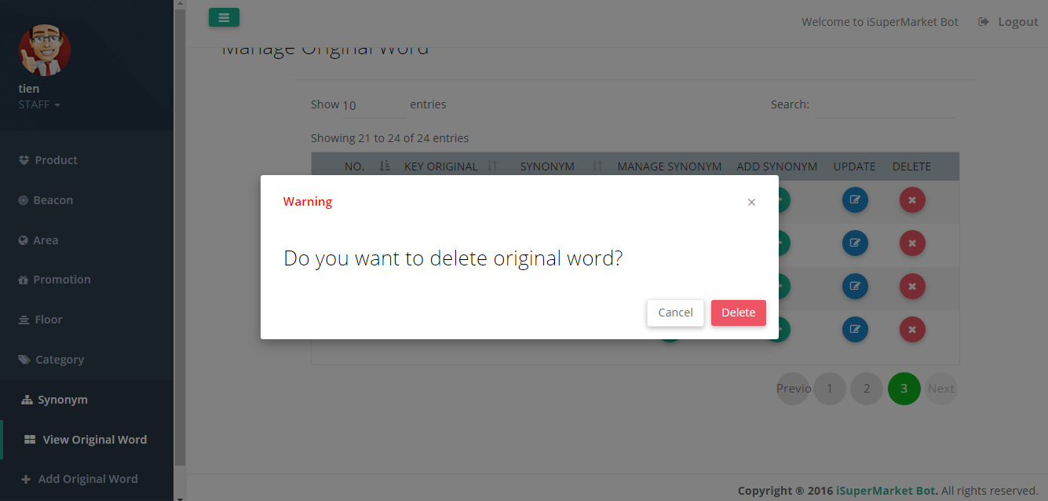

Figure 216 - <Staff> Delete Original Word UG

|  |  |
| --- | --- |
| **Step** | **Description** |
| 1 | Click “” button on row |
| 2 | Click “Delete” button |

Table 210 - <Staff> Delete Original Word UG

#### Manage Synonym of each Original Words

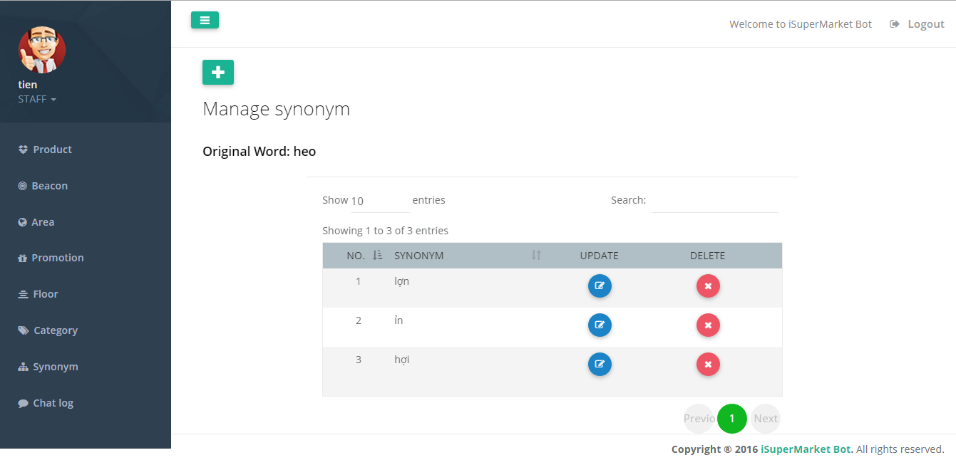

Figure 217 - <Staff> Manage Synonym UG

|  |  |
| --- | --- |
| **Step** | **Description** |
| 1 | Click “”button on row(in view manage original word page) |
| 2 | Show list synonyms of original word |

Table 211 - <Staff> Manage Synonym UG

#### Add Synonym

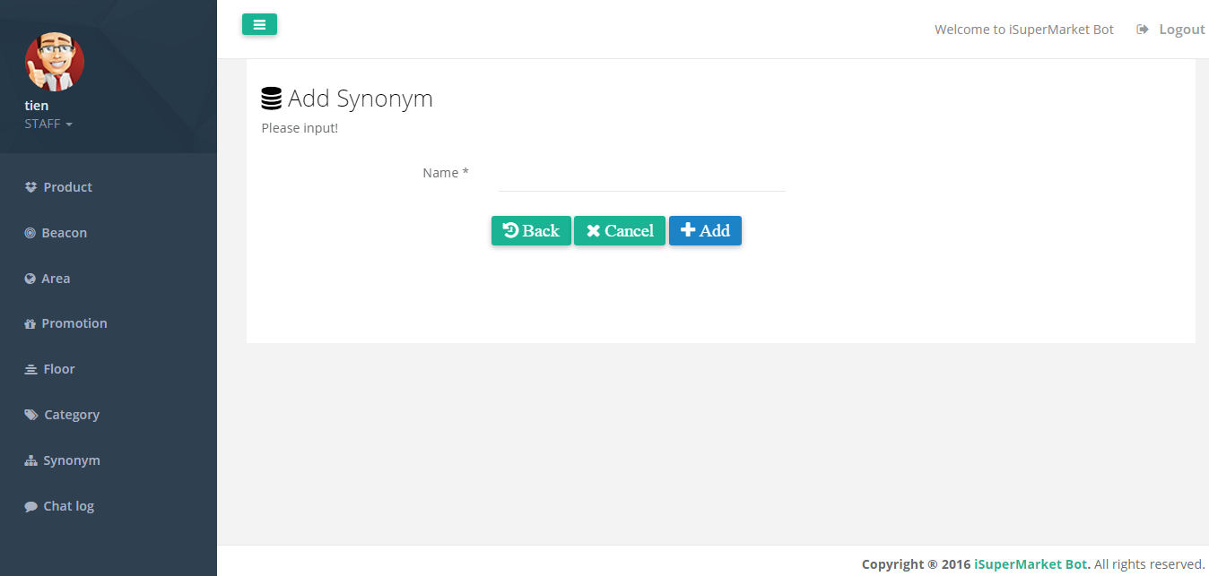

Figure 218 - <Staff> Add Synonym UG

|  |  |
| --- | --- |
| **Step** | **Description** |
| 1 | Click “” button in view manage synonym page |
| 3 | Fill in field:  “Name”: Synonym name |
| 4 | Click “Add” button |

Table 212 - <Staff> Add Synonym UG

#### Update Synonym

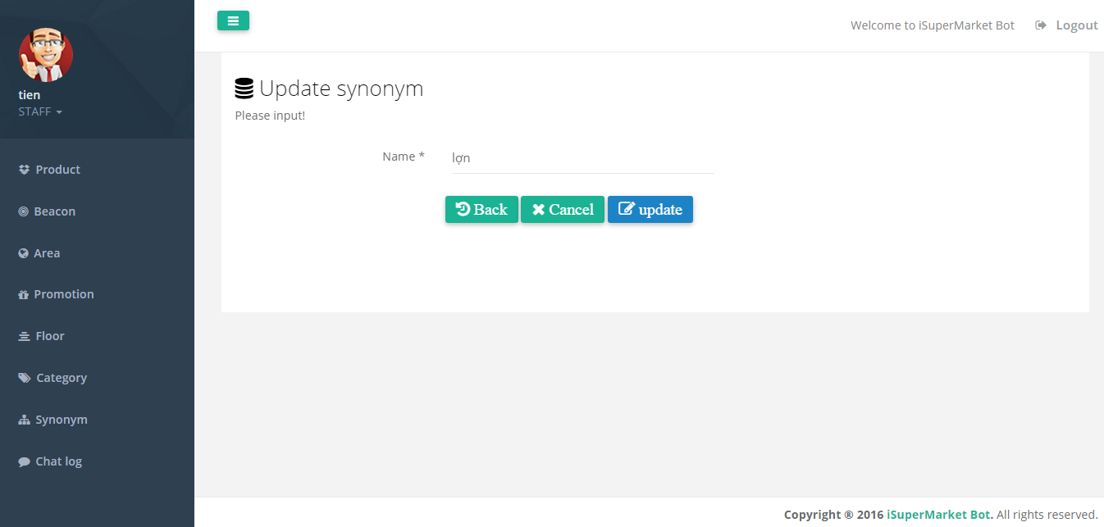

Figure 219 - <Staff> Update Synonym UG

|  |  |
| --- | --- |
| **Step** | **Description** |
| 1 | Click “” button on row(in view manage synonym page) |
| 2 | Fill in field:  “Name”: synonym name |
| 3 | Click “Update” button |

Table 213 - <Staff> Update Synonym UG

#### Delete Synonym

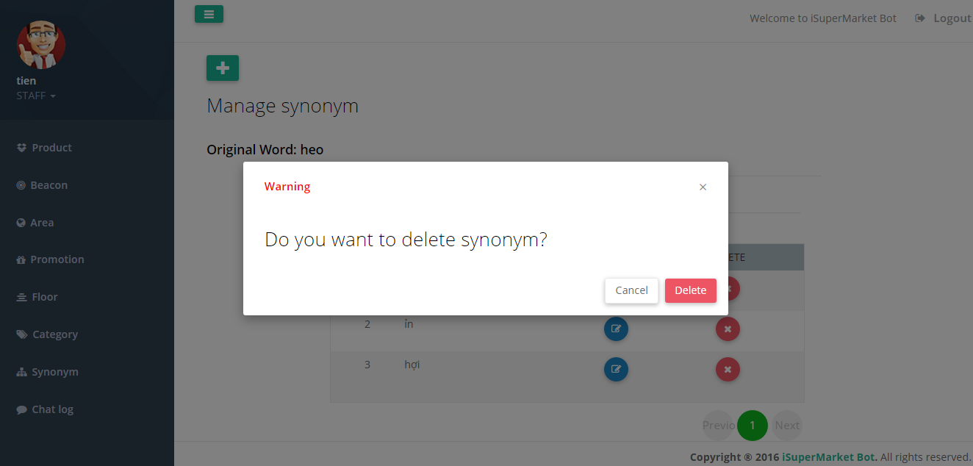

Figure 220 - <Staff> Delete Synonym UG

|  |  |
| --- | --- |
| **Step** | **Description** |
| 1 | Click “” button on row |
| 2 | Click “Delete” button |

Table 214 - <Staff> Delete Synonym UG

# Appendix

1. UML Documentation of IBM <http://www.ibm.com/developerworks/rational/library/769.html?ca=drs->
2. Facebook Developer Documentation For Messenger Platform

<https://developers.facebook.com/docs/messenger-platform>

1. Api.ai Documentation

<https://docs.api.ai/>

1. Android Developer Guide – Application Fundamentals

<https://developer.android.com/guide/components/fundamentals.html>

1. Estimote Beacon Developer

<http://developer.estimote.com/>

1. FPT Vietnamese Accentizer

[http://doc.openfpt.vn/services/vnaccent/documentation.html#/README](http://doc.openfpt.vn/services/vnaccent/documentation.html%23/README)

1. Google Vision Api

<https://cloud.google.com/vision/docs/>